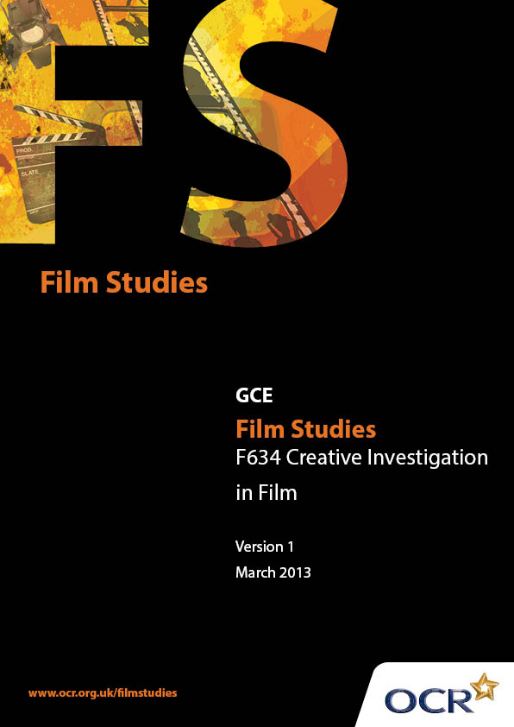
Introduction
OCR involves teachers in the development of new support materials to capture current teaching practices tailored to our new specifications. These support materials are designed to inspire teachers and facilitate different ideas and teaching practices. Each Scheme of Work and set of sample Lesson Plans is provided in Word format – so that you can use it as a foundation to build upon and amend the content to suit your teaching style and students’ needs.
The Scheme of Work and sample Lesson plans provide examples of how to teach this unit and the teaching hours are suggestions only. Some or all of it may be applicable to your teaching.
The Specification is the document on which assessment is based and specifies what content and skills need to be covered in delivering the course. At all times, therefore, this Support Material booklet should be read in conjunction with the Specification. If clarification on a particular point is sought then that clarification should be found in the Specification itself.
Introduction

Sample Scheme of Work
GCE Film Studies H067
F634: Creative Investigation in Film

Suggested teaching time | 36 hours | Topic | Creative Investigation in Film - Independent Research, Planning, Creative Realisation (non-filmed option), Critical Evaluation

Topic outline | Suggested teaching and homework activities | Suggested resources | Points to note
Research | Model a mini project i.e. an exploration of the adaptation of novels to the screen, to outline the skills needed to link research to finished project.  Starting to research: brainstorm different types of secondary sources. In small groups students to use one of these sources to give mini presentations on topics chosen by the class and moderated by teacher.  How to use the internet successfully. Give students exploration topics and ask them to find out ten interesting points about the topic without using Wikipedia.  Model the use of search engines and Wikipedia as a starting point. Demonstrate the ‘advanced search’ features of Google and other search engines. Demonstrate the use of reference links in Wikipedia. This can also be used to demonstrate how students should use references in their own work.  Library work - using indexes to find topics in multiple texts. Ask students to find references to famous film directors or actors. | Researching Media and Film Studies Vanessa Clare, (BFI)  Literature Into Film: Theory And Practical Approaches Linda Costanzo Cahir  www.google.co.uk/advanced_search  //en.wikipedia.org/wiki/  Wikipedia:Citing_sources | Lessons focussing on how to:  - make sense of ideas and theories  - contextualise their investigation using secondary research sources (the work of recognised theorists for example)  - analyse primary materials (this could be to revise methods of textual analysis employed throughout the AS level course)  - formulate hypotheses  - evaluate and draw conclusions from their findings  - present findings  - reference source materials appropriately.

 | Investigate the use of web applications - journals, social media, iTunes U etc to gain information.  Ask students to search ‘film adaptations’. Task to explain how they can narrow their findings, and select appropriate sources.  Demonstrate how to use key words in search engines.  Using the extract from Google books ask students to construct questions for each other to answer. Can they use what they have found to create a hypothesis about film adaptations of novels?  Presentations - pitch individual ideas for research. Students should also present ideas about how to link research to their artefacts.  Feedback from class/teacher.  One to ones - monitoring  Homework - research and produce essay.  (This can be produced and monitored whilst the next block(s) of lessons are taking place as long as students have a clear idea about the link between research and artefact.) | //books.google.co.uk/  //tinyurl.com/b7vrv44

Suggested teaching time | 9 hours | Topic | Creative Investigation in Film - Independent Research, Planning, Creative Realisation (non-filmed option), Critical Evaluation

Topic outline | Suggested teaching and homework activities | Suggested resources | Points to note
Planning | Demonstration - how to produce:  - a synopsis  - a written script  - a treatment  - a recce report  - evidence of casting considerations  - layouts for the 20 key frame stills  - a risk assessment.  Homework - construction of planning materials.  Presentation of materials to class for peer feedback. | Teaching Scriptwriting, Screenplays & Storyboards for Film & TV - Mark Readman (BFI)  On Screenwriting - Freddie Gaffney (Auteur)  Centre produced exemplar material. | Note the weighting of marks for this element.

Suggested teaching time | 27 hours | Topic | Creative Investigation in Film - Independent Research, Planning, Creative Realisation (non-filmed option), Critical Evaluation

Topic outline | Suggested teaching and homework activities | Suggested resources | Points to note
Non-Filmed Sequence - a  screenplay (or extracts from a  series of screenplays) for a film  sequence that would total no  more than five minutes in  duration, together with 20 key  frame stills that demonstrate  careful construction of mise-en-  scène. The screenplay(s) and  20 key frames should be  influenced by the research and  based upon the planning. | Demonstration - screenplay with twenty key frames exploring the representation of young people in 21st century British cinema.  Class and Homework - construction of artefact.  Presentation of materials to class for peer feedback. | The following can be used for student research and for exemplar teaching:  imsdb.com  simplyscripts.com  mymoviescripts.com  Centre produced exemplar material. | Monitor construction through one-to-one meetings, interim presentations, etc.

Suggested teaching time | 18 hours | Topic | Creative Investigation in Film - Independent Research, Planning, Creative Realisation (non-filmed option), Critical Evaluation

Topic outline | Suggested teaching and homework activities | Suggested resources | Points to note
Critical Evaluation | Students to load creative artefact to social network site (eg Pinterest linked to Facebook) ask for constructive feedback from "friends". It is important that students make aims of artefact clear to those viewing/reading.  Presentation of key findings from research and artefact. Peer and teacher feedback.  Homework - writing up evaluation, compiling portfolio for submission. | www.pinterest.com | Stretch and challenge may be to use academic readings that students can read and summarise for the rest of the class.  French National  Cinema - Masculinity  European Cinemas, Film and Television History, The Open University

Sample Lesson Plan
GCE Film Studies H067
F634 – Creative Investigation in Film

Exploring wider, social, historical, political and cultural issues in non English language film
OCR recognises that the teaching of this qualification above will vary greatly from school to school and from teacher to teacher. With that in mind this lesson plan is offered as a possible approach but will be subject to modifications by the individual teacher.
Lesson length is assumed to be one hour.

Learning Objectives for the Lesson
Objective 1 | Students will be able to search a text, extract information, form questions, and construct a hypothesis.

Content
Time | Content
5 minutes | Recap prior learning - research, questions, hypothesis.
5 minutes | Using a projector and whiteboard/interactive whiteboard demonstrate how to search a text in Google Books. Select 3-5 pieces of information and formulate questions based on the information. For example - the text states that cats are black, your question could be what colour are cats? Construct a hypothesis - all cats are black.
15 minutes | Individually students extract information from //tinyurl.com/b7vrv44 (Literature Into Film: Theory And Practical Approaches by Linda Costanzo Cahir) and create questions based on this information for a partner to respond to.
15 minutes | In pairs students present each other with their questions. Partners to find information in the text. Pairs to construct a hypothesis based on the text.

Consolidation
Time | Content
15 minutes | Presentation of findings and hypotheses. Oral presentation followed by class discussion about process.
5 minutes | Q&A. Recap and reinforce learning.

