Experiment 7. The region of growth and response in radicles

You are provided with four pea seedlings with fairly straight radicles and a device of wire and cotton for marking them.

(a) Dip the cotton in the ink, wipe off any drops and use the inked cotton to make a series of marks along each of the radicles. Start from the very tip, spacing the marks out evenly and as close together as possible without letting them run together (Fig. 1).

(b) Place a strip of cotton wool in one side of a Petri dish as in Fig. 2 and run a little water on to
it to make it moist but do not compress it.

(c) Arrange two of the marked seedlings as shown in Fig. 2 and cover them with a second piece of cotton wool leaving the radicles clear.

(d) Run water over the top layer of cotton wool to saturate it but do not let it run on to the radicles or it will wash off the marks.

(e) Replace the lid and hold it in position with an elastic band. Ensure that the lid holds the seedlings firmly in place and that the radicles are not touching the base or lid of the dish. Repeat this procedure for the second pair of seedlings.

(f) Write the letter A on one lid and B on the other, and put your initials on both. Stand each dish on edge so that the radicles in A are pointing vertically downwards and those in B are horizontal.
(Fig. 2). With a spirit marker put a line on the uppermost edge of the Petri dish (Fig. 3).

(g) Place the dishes, still on their sides with the mark upwards, in a box and leave them for
2 days.

(h) After 2 days, without removing the lids, examine the radicles through the Petri dish looking for evidence of growth and change in direction of growth.

(i) Carefully remove the lids and top layer of cotton wool and draw the appearance of each seedling showing the exact number of marks, where they appear on the radicle and how they are spaced out.
If possible, answer the discussion questions while the seedlings are in front of you and available for close study.

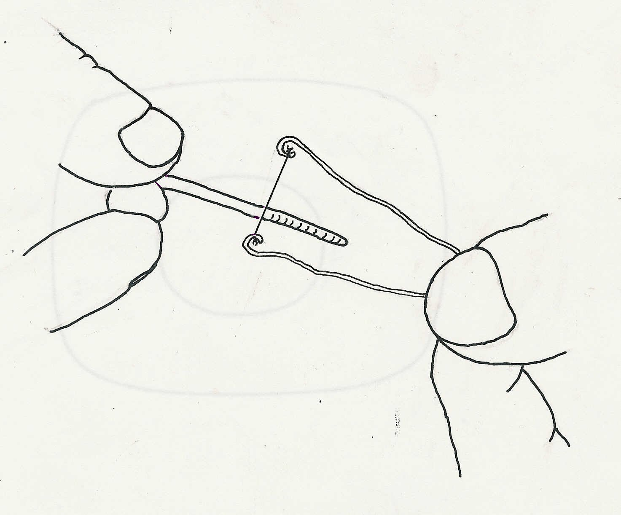
Fig. 1

