Experiment 6. Discussion

I What changes did you observe in the lime water and in the tubes containing the yeast and glucose ?

2 How do these observations support the idea that respiration is taking place in the yeast?

3 Suppose it is argued that the results are due not to respiration but to a simple chemical reaction between the yeast and glucose, in much the same way as hydrochloric acid and calcium carbonate react, what evidence do you have from the experiment to refute this argument ?

4 It is further argued that by bubbling air through lime water, the same results could be achieved. What control experiment could you carry out to show that this was not the case in your experiment ?

5 Assuming that the results are due to respiration in the yeast, how was the experiment designed to show that it was anaerobic respiration (i.e. respiration in the absence of oxygen) ?

6 What was the role of the glucose solution in this experiment?
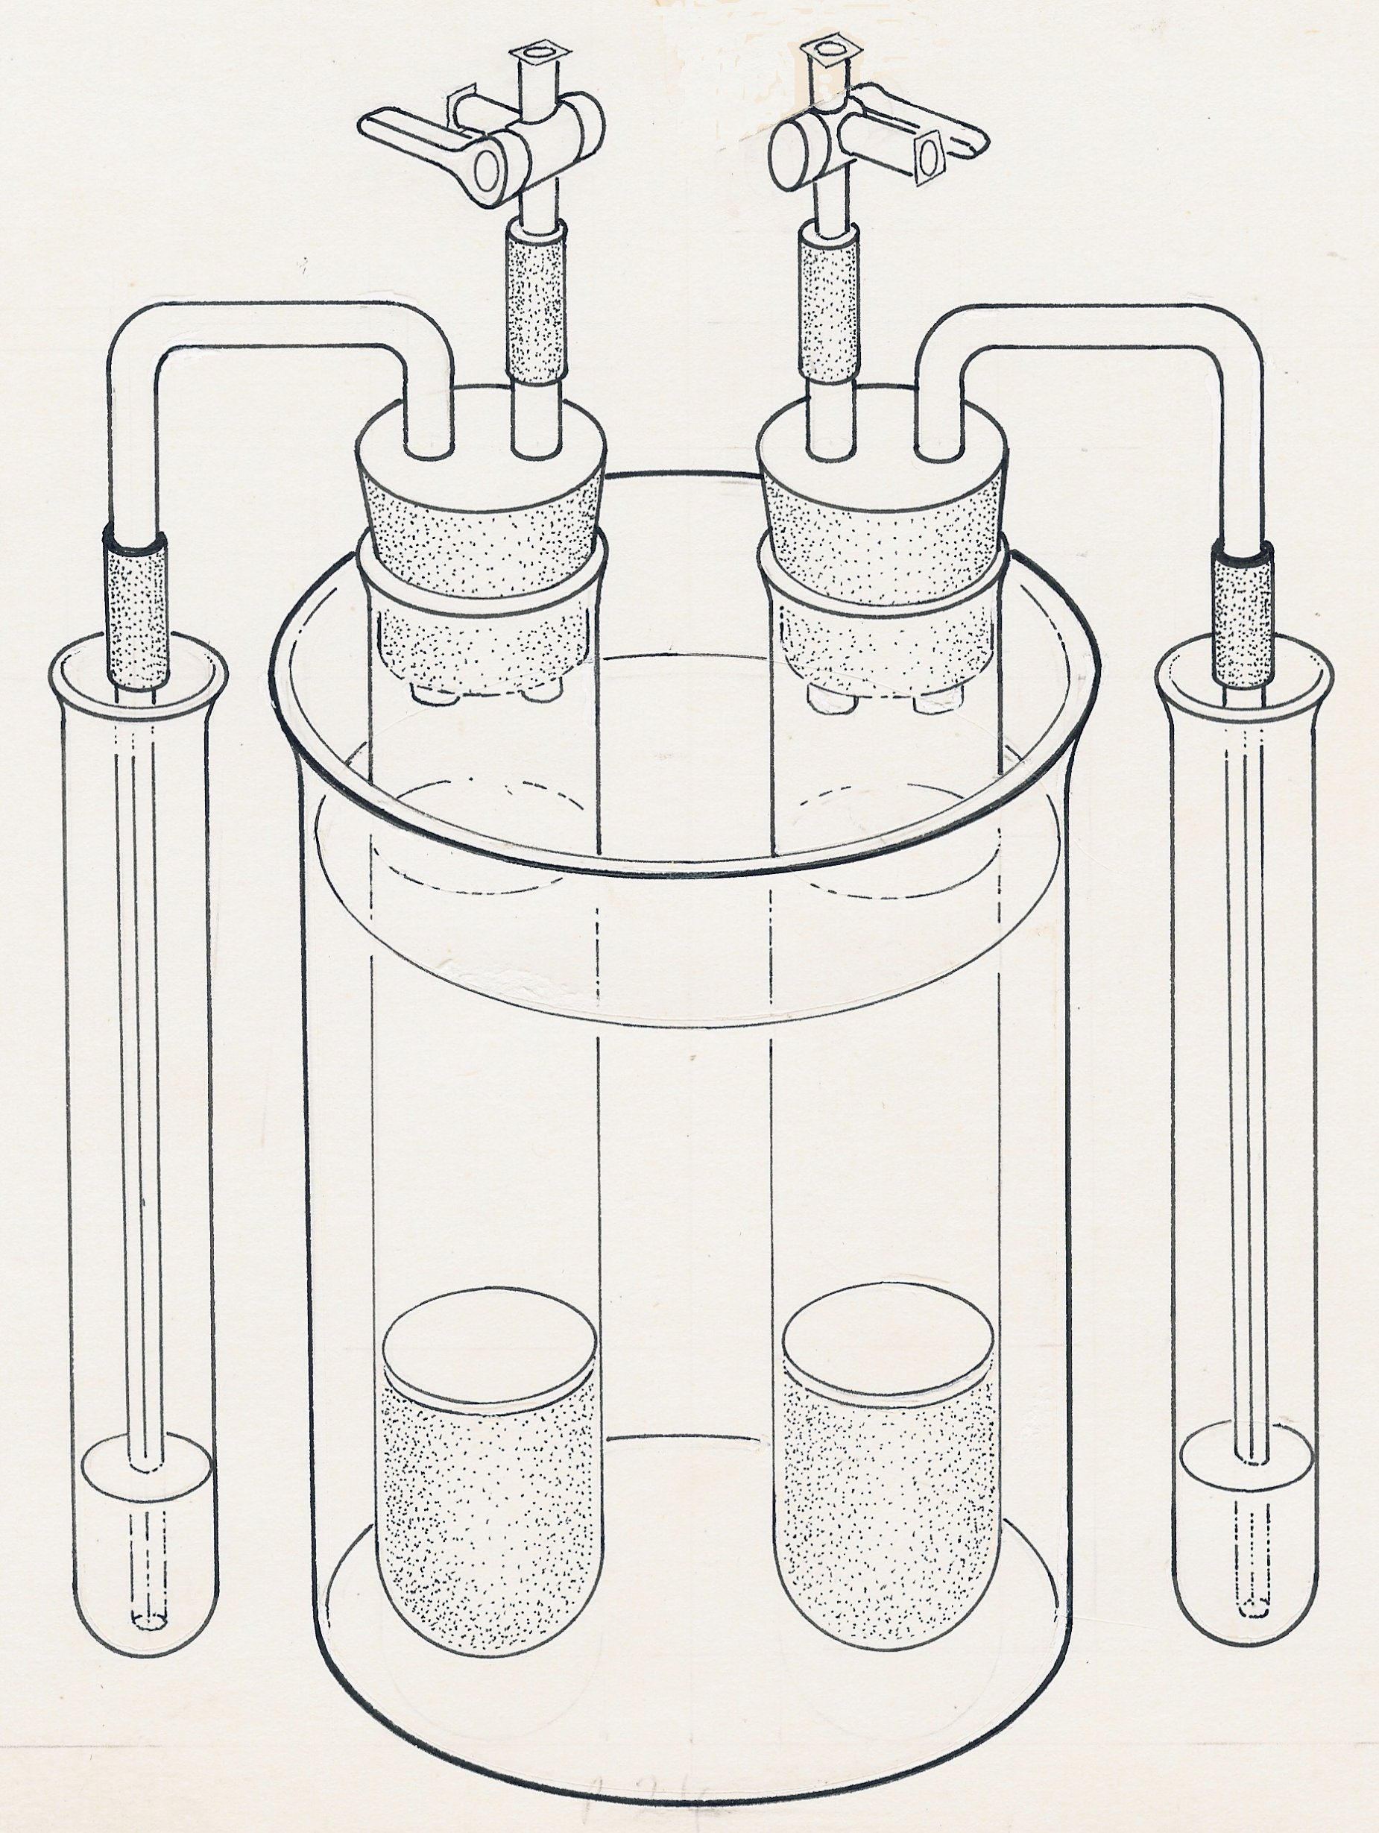
3-way tap
(open)
water bath
yeast and glucose A
lime water
thin layer of oil
tap open
tap closed
capillary tube
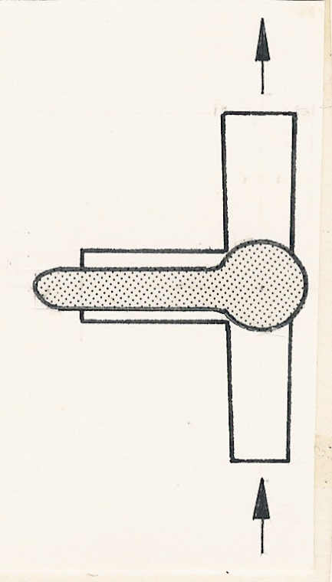
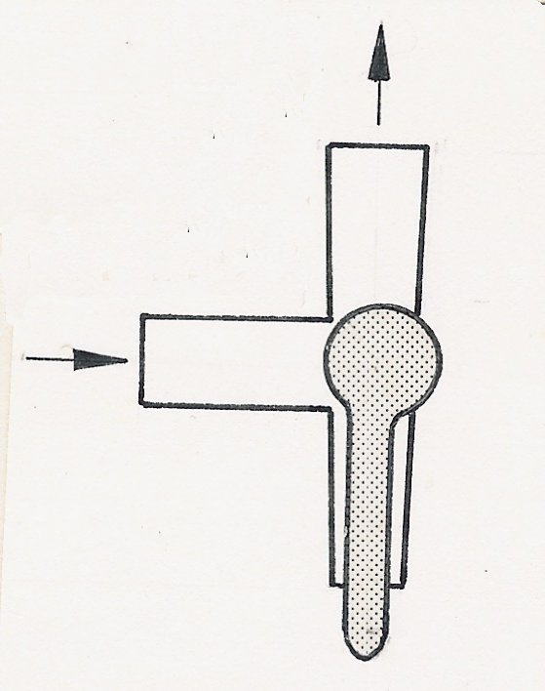
dead yeast and glucose B

