Mass or number ………….. Organisms ……………………..
Temperature
Tube A reading
Tube B reading
Net uptake (A - B)
Uptake of O₂ in cm³ per hour
Average uptake of O₂ at ……ºC …….cm³/h

Class results
Temperature
Oxygen uptake

Experiment 10. Discussion

1 Why was it necessary to subtract readings B from readings A?

2 How much difference was there between your three readings? Suggest reasons for the differences, if any.

3 From the graph, comment on any trend in the oxygen uptake with increasing temperature. Suggest reasons why changes in temperature should affect the rate of oxygen uptake.

4 If your results include temperatures above 50 °C, comment on and suggest reasons for the results. If you do not have results for the high temperatures, say whether you think that the trend in results for the lower temperatures would continue with temperatures of 50, 60 and 70 °c. Give
reasons.
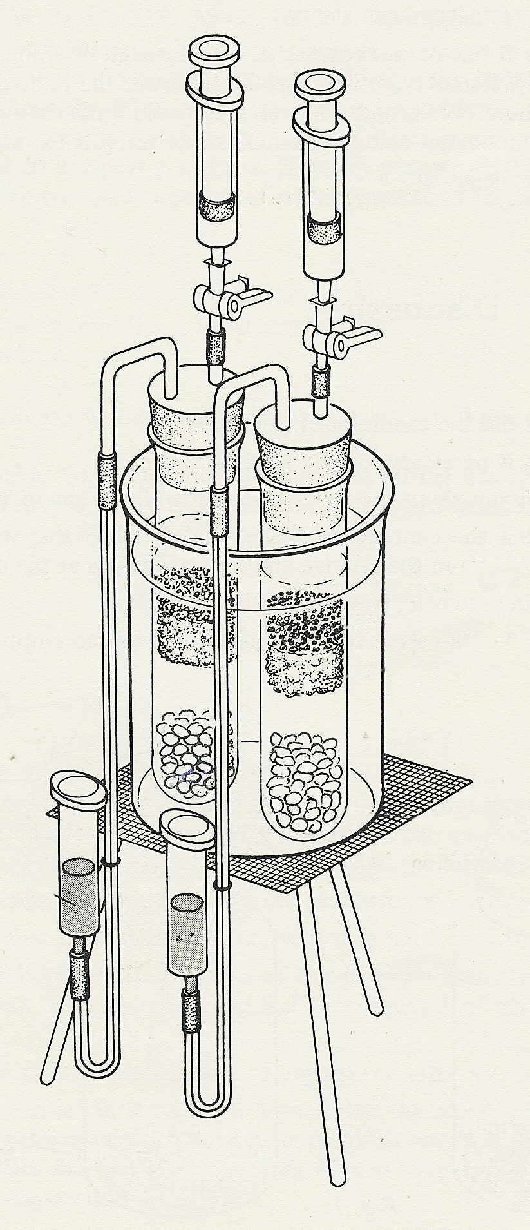

3- way taps


living seeds
control
(dead seeds)
water bath

