1. The diagram below shows some limpets. Limpets are cone-shaped molluscs which are found attached to rocks on many seashores.
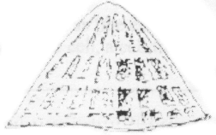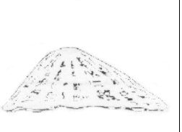
Some students carried out an investigation to compare the shape of limpets on a sheltered shore with their shape on a shore exposed to the action of waves. They measured the height (H) and length (L) of 15 limpets on each shore. They then used the ratio of height to length to describe the overall shape of the limpets.
An extract from their field records is shown below.
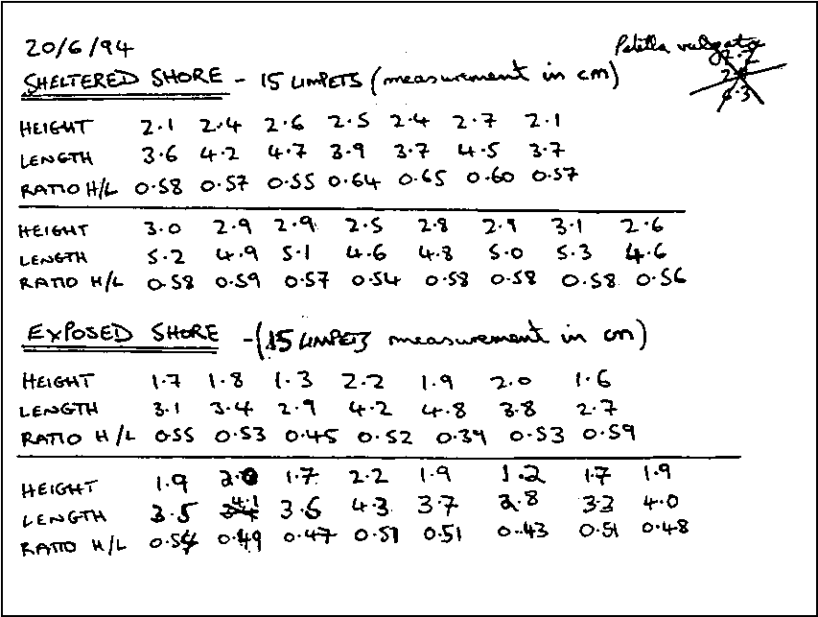
(a) Prepare a table and organise the data in a suitable way so that the range of shapes of limpets on the two shores can be compared.
(4)
(b) Use the data in your table to present the information in a suitable graphical form.
(4)

(c) Name the statistical test you would use to analyse your data.
(1)
(d) What conclusions can you draw from this investigation?
(2)
(Total 11 marks)

2. Many fruits and seeds contain germination inhibitors which delay germination until the inhibitors have been washed away by rain or become inactivated. In tomatoes, the inhibitors delay germination until the fleshy tomato fruit has rotted away releasing the seeds.
It has been suggested that, in tomatoes, the inhibitor of seed germination is present in the fleshy tissues of the fruit rather than in the seed coats.
Plan an investigation, which you could personally carry out, to test this hypothesis. Your answer should give details under the following headings.
(a) Plan of the investigation to be carried out.
(9)
(b) Recording of raw data measurements, presentation of results and methods of data analysis.
(7)
(c) Limitations of your method, and an indication of further work which could be undertaken.
(5)
(Total 21 marks)

