1. The diagram below shows a part of the beef tapeworm Taenia saginata.
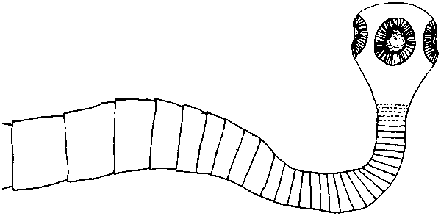
(a) Explain the importance of the part labelled A in the life of the tapeworm.
…........……………………………………………………………………………….
…........……………………………………………………………………………….
…........……………………………………………………………………………….
…........……………………………………………………………………………….
…........……………………………………………………………………………….
(2)
(b) Describe how the tapeworm obtains its nutrition.
…........……………………………………………………………………………….
…........……………………………………………………………………………….
…........……………………………………………………………………………….
…........……………………………………………………………………………….
(2)
(c) How does the nutrition of Rhizopus differ from that of the tapeworm?
…........……………………………………………………………………………….
…........……………………………………………………………………………….
…........……………………………………………………………………………….
…........……………………………………………………………………………….
(2)
(Total 6 marks)

2. Between 1882 and 1952 the proportion of the Earth's land surface classified as desert increased from 9.4% to 23.3%. The shift to desert is still going on. The most affected areas are the semi-arid lands around the fringes of deserts, such as the Sahel, the belt of land lying to the south of the Sahara Desert in Africa (Figure 1). Rainfall records from the Sahel (Figure 2) show that rainfall has been below average for the last 20 years and the decline is getting worse. The degradation of semi-arid land into desert is called desertification.
Figure 1 Map of Africa and the Middle East showing the extent of desert and arid zones,
with areas under threat from desertification.
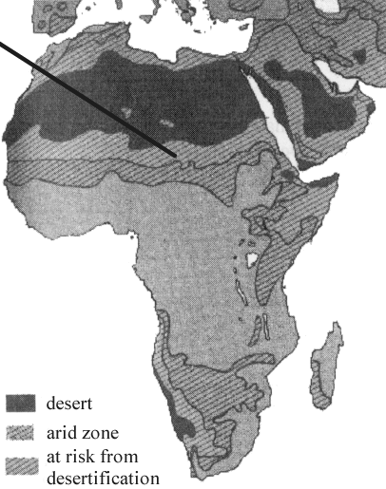
Figure 2 The rainfall pattern in the Sahel. The bars show the departure from the normal
rainfall.
Diagrams from Atlas of living world, Weidenfeld and Nicolson.

(a) Describe the effects of overgrazing and the collecting of wood for fuel on semi-arid land.
…........……………………………………………………………………………….
…........……………………………………………………………………………….
…........……………………………………………………………………………….
…........……………………………………………………………………………….
…........……………………………………………………………………………….
…........……………………………………………………………………………….
(3)
(b) People living in the Sahel have kept herds of sheep and goats for hundreds of years. Suggest one reason why overgrazing has become a problem in the last 20 years.
…........……………………………………………………………………………….
…........……………………………………………………………………………….
(1)
(c) Figure 2 shows that the rainfall in the Sahel between 1950 and 1968 was above average. How would the increased rainfall have affected farming in the Sahel?
…........……………………………………………………………………………….
…........……………………………………………………………………………….
…........……………………………………………………………………………….
…........……………………………………………………………………………….
(2)
(d) Describe the effects of the drought which occurred during the 1970s.
…........……………………………………………………………………………….
…........……………………………………………………………………………….
…........……………………………………………………………………………….
…........……………………………………………………………………………….
(2)
(e) How might the changes to the global climate have affected desertification in the Sahel?
…........……………………………………………………………………………….
…........……………………………………………………………………………….
…........……………………………………………………………………………….
…........……………………………………………………………………………….
(2)

(f) Describe how people can protect their land from desertification.
…........……………………………………………………………………………….
…........……………………………………………………………………………….
…........……………………………………………………………………………….
…........……………………………………………………………………………….
(2)
(Total 12 marks)

3. Study the passage and data below and then answer the questions that follow.
Acid rain and its effect on fresh water and fisheries
It is difficult to obtain direct evidence that, as a result of the increased acidity of precipitation, certain lakes and streams with fishery problems are now more acid that they were in the past.
Nevertheless, indirect evidence that surface water acidification has occurred comes from the remains of diatoms in lake sediments.
Historical records of pH are rare and subject to a great deal of uncertainty, since analytical methods have changed over the years. Moreover, pH is naturally variable on a daily and annual basis and occasional spot measurements can give a misleading impression. Diatom analysis provides a way round these difficulties. Diatoms are microscopic algae which live free floating in the lake water. They have skeletons made of silica which are resistant to decay. When a diatom dies it sinks to the bottom of the lake where the remains accumulate as sediment.
Different diatom species have different pH preferences. Those preferring the least acid water are called alkalibiontic. Acidibiontic species prefer more acidic water. If a core of the lake sediment is taken and it is discovered that alkalibiontic diatoms predominate in the deepest layers and they are replaced by more acid-loving species towards the surface of the sediment, that is a good evidence that the lake has acidified over historical time. Moreover, if the sediments can be dated, by radiotracer methods for example, then the acidification can be correlated in time to events such as the Industrial Revolution and forest clearance. Studies were made of the diatoms in the sediments of Loch Fleet in Galloway, an acid lake.
It may take a long time, following the reduction in the acidity of the precipitation, before the recovery of the surface water quality is sufficient to allow restoration of fish stocks. Recovery can be speeded up by the application of calcium to neutralise the acid and suppress the release of aluminium. Experiments were conducted involving the application of calcium in the form of 300 tonnes of limestone to soils surrounding the lake during April 1986. The subsequent changes in the levels of aluminium and calcium in the water were monitored over the next year.

Figure 1 The pH reconstruction for diatoms from Loch Fleet.

Figures 2a and 2b. The effect of varying levels of calcium application on the survival of brown trout fry (newly hatched fish) in a range of pH, aluminium and calcium concentrations.
Text and data adapted from Freshwater acidification and fisheries decline by D.J.A Brown, CEGB Research (1987).
(a) How is acid rain formed?
…........……………………………………………………………………………….
…........……………………………………………………………………………….
…........……………………………………………………………………………….
…........……………………………………………………………………………….
…........……………………………………………………………………………….
…........……………………………………………………………………………….
…........……………………………………………………………………………….
…........……………………………………………………………………………….
(4)

(b) Describe the changes in the acidity of the water of Loch Fleet over the last 100 years.
Explain why these changes occurred.
…........……………………………………………………………………………….
…........……………………………………………………………………………….
…........……………………………………………………………………………….
…........……………………………………………………………………………….
…........……………………………………………………………………………….
…........……………………………………………………………………………….
…........……………………………………………………………………………….
…........……………………………………………………………………………….
(4)
(c) The use of diatoms may not be a fool-proof method of studying the changes in pH.
Suggest ONE way in which the data could be misleading.
…........……………………………………………………………………………….
…........……………………………………………………………………………….
(1)
(d) Describe the effect of aluminium ions on fresh water organisms.
…........……………………………………………………………………………….
…........……………………………………………………………………………….
…........……………………………………………………………………………….
…........……………………………………………………………………………….
…........……………………………………………………………………………….
…........……………………………………………………………………………….
(3)

(e) Study the information provided in Figures 2a and 2b. Describe the effect of the calcium treatment on the survival of the brown trout fry.
…........……………………………………………………………………………….
…........……………………………………………………………………………….
…........……………………………………………………………………………….
…........……………………………………………………………………………….
…........……………………………………………………………………………….
…........……………………………………………………………………………….
…........……………………………………………………………………………….
…........……………………………………………………………………………….
(4)
(f) Suggest why it is preferable to add the limestone to the surrounding soils rather than directly to the surface of the water.
…........……………………………………………………………………………….
…........……………………………………………………………………………….
…........……………………………………………………………………………….
…........……………………………………………………………………………….
(2)
(g) Describe TWO methods used by European countries to reduce the production of acid rain.
1 ………………………………………………………………………………………
………………………………………………………………………………………..
2 ………………………………………………………………………………………
………………………………………………………………………………………..
(2)
(Total 20 marks)

