1. Read through the following account of the digestion of starch, then write on the dotted lines the most appropriate word or words to complete the account.
Food taken into the mouth cavity is ................................................ by the teeth and
mixed with saliva. Saliva contains ................................................ to lubricate the food
and the enzyme ................................................ to hydrolyse starch to
produce ................................................ .
The food is swallowed and any starch still undigested is hydrolysed in the duodenum by
an enzyme secreted by the ................................................ .
(Total 5 marks)

2. (a) The table below refers to mammalian blood plasma and tissue fluid. If the statement is correct, place a tick () in the appropriate box and if the statement is incorrect, place a cross () in the appropriate box.
Statement | Blood plasma | Tissue fluid
Contained in vessels
Very low hydrostatic
pressure
Contains white blood cells
(3)
(b) Most of the tissue fluid is reabsorbed into the blood in the capillaries. Suggest why this reabsorption is reduced in people whose diet is very low in protein.
……………………………………………………………………………………………
……………………………………………………………………………………………
……………………………………………………………………………………………
……………………………………………………………………………………………
(2)
(Total 5 marks)

3. Describe the functions of each of the following hormones in women.
(a) Progesterone
……………………………………………………………………………………………
……………………………………………………………………………………………
……………………………………………………………………………………………
……………………………………………………………………………………………
(2)
(b) Follicle stimulating hormone (FSH)
……………………………………………………………………………………………
……………………………………………………………………………………………
……………………………………………………………………………………………
……………………………………………………………………………………………
(2)
(c) Oxytocin
……………………………………………………………………………………………
……………………………………………………………………………………………
……………………………………………………………………………………………
……………………………………………………………………………………………
(2)
(Total 6 marks)

4. When a person breathes in and out, the pressure of air inside the alveoli (alveolar pressure) changes in relation to atmospheric pressure.
The graph below shows these changes.
(a) Describe the changes in alveolar pressure during inspiration.
……………………………………………………………………………………………
……………………………………………………………………………………………
……………………………………………………………………………………………
……………………………………………………………………………………………
……………………………………………………………………………………………
……………………………………………………………………………………………
(3)
(b) Using the information in the graph, calculate the difference in alveolar pressure between the minimum during inspiration and the maximum during expiration. Show your working.

Answer ...................................
(2)
(c) Explain how the changes in pressure are brought about during inspiration and during expiration.
(i) Inspiration
………………………………………………………………………………………
………………………………………………………………………………………
………………………………………………………………………………………
………………………………………………………………………………………
………………………………………………………………………………………
………………………………………………………………………………………
(3)

(ii) Expiration
………………………………………………………………………………………
………………………………………………………………………………………
………………………………………………………………………………………
………………………………………………………………………………………
………………………………………………………………………………………
………………………………………………………………………………………
(3)
(Total 11 marks)

5. The diagram below shows a section through lung tissue, as seen using a microscope.
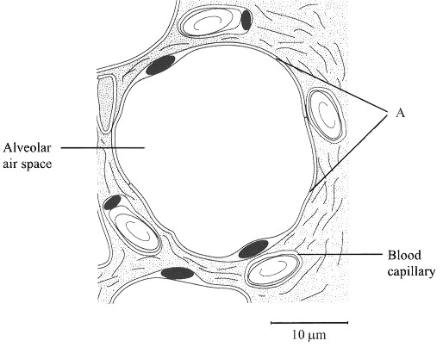

(a) Explain how the cells labelled A are adapted to their function.
……………………………………………………………………………………………
……………………………………………………………………………………………
……………………………………………………………………………………………
……………………………………………………………………………………………
……………………………………………………………………………………………
……………………………………………………………………………………………
(3)
(b) Give two ways in which carbon dioxide is transported in the blood.
1 .........................................................................................................................................
2 .........................................................................................................................................
(2)
(c) At rest, the total blood flow through the lungs is about 5 dm3 per minute. During exercise, this increases to about 30 dm3 per minute. Suggest how this increase in blood flow through the lungs is brought about.
……………………………………………………………………………………………
……………………………………………………………………………………………
(1)
(Total 6 marks)

6. The diagram below shows a longitudinal section through cells from a flowering plant.
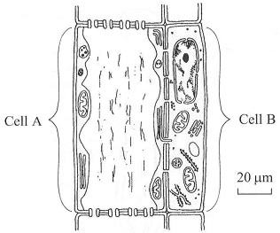

(a) Name the cells labelled A and B.
Cell A .................................................................................................................................
Cell B .................................................................................................................................
(2)
(b) (i) Name the tissue shown in the diagram.
.....................................................................................................................................
(1)
(ii) Describe the function of the tissue shown in the diagram.
………………………………………………………………………………………
………………………………………………………………………………………
………………………………………………………………………………………
………………………………………………………………………………………
………………………………………………………………………………………
………………………………………………………………………………………
………………………………………………………………………………………
………………………………………………………………………………………
(4)
(Total 7 marks)

7. The diagrams below show the structure of two different types of primrose flowers, known as ‘pin-eyed’ and ‘thrum-eyed’. These flowers are pollinated by insects.
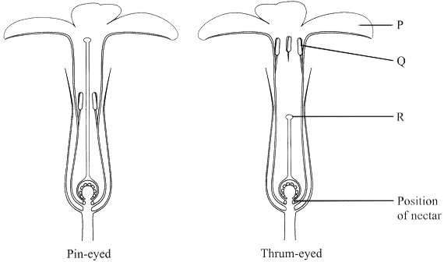

(a) Name the parts labelled P, Q and R.
P ........................................................................................................................................
Q ........................................................................................................................................
R ........................................................................................................................................
(3)
(b) Pin-eyed and thrum-eyed flowers are found on different primrose plants.
Explain how the relative positions of the parts labelled Q and R in pin-eyed and thrum-eyed flowers could help to increase the chances of cross-pollination.
……………………………………………………………………………………………
……………………………………………………………………………………………
……………………………………………………………………………………………
……………………………………………………………………………………………
……………………………………………………………………………………………
……………………………………………………………………………………………
……………………………………………………………………………………………
……………………………………………………………………………………………
……………………………………………………………………………………………
……………………………………………………………………………………………
(5)
(Total 8 marks)

8. An investigation was carried out to compare the rates of transpiration in lilac and laurel leaves. Two leaves of each type of plant were weighed, and then hung up by their petiole (leaf stalk). One leaf of each type of plant was hung up in still air and the other leaf of each type was hung up in moving air.
Each leaf was then re-weighed after 15 minutes. The percentage changes in mass were then calculated.
The results are shown in the table below.
 | Lilac leaf |  |  | Laurel leaf
Conditions | Initial mass  /g | Final mass  /g | Percentage  change in mass | Initial mass  /g | Final mass  /g | Percentage  change in mass
Still air | 2.28 | 2.27 | –0.44 | 4.49 | 4.48 | –0.22
Moving air | 3.27 | 3.08 | –5.81 | 3.43 | 3.32 | –3.21

(a) Suggest why the changes in mass were expressed as percentages, rather than just changes in mass.
……………………………………………………………………………………………
……………………………………………………………………………………………
……………………………………………………………………………………………
……………………………………………………………………………………………
(2)
(b) (i) Compare the percentage changes in mass for lilac leaves in still air and in moving air.
………………………………………………………………………………………
………………………………………………………………………………………
(1)
(ii) Suggest an explanation for the difference you have described in part (i).
………………………………………………………………………………………
………………………………………………………………………………………
………………………………………………………………………………………
………………………………………………………………………………………
(2)
(c) The numbers of stomata on the lower surface of lilac and laurel leaves were then determined. The results are shown in the table below.
Type of leaf | Mean number of stomata per mm2
Lilac | 120
Laurel | 109
(i) Describe a suitable method to find the mean number of stomata on the lower surface of a leaf.
………………………………………………………………………………………
………………………………………………………………………………………
………………………………………………………………………………………
………………………………………………………………………………………
………………………………………………………………………………………
………………………………………………………………………………………
(3)

(ii) Describe the relationship between the number of stomata and the percentage changes in mass for leaves in still air.
………………………………………………………………………………………
………………………………………………………………………………………
………………………………………………………………………………………
………………………………………………………………………………………
(2)
(d) Transpiration is also affected by other environmental factors, including temperature.
Explain why an increase in temperature increases the rate of transpiration.
……………………………………………………………………………………………
……………………………………………………………………………………………
……………………………………………………………………………………………
……………………………………………………………………………………………
(2)
(Total 12 marks)

