1. The following table refers to organelles found in eukaryotic cells. Complete the table by writing the name of the organelle, two features of its structure or one function of the organelle in each of the four empty boxes as appropriate.
Name of organelle | Two features of structure | One function
 | 1. Stack of curved cisternae  2. Surrounded by many vesicles | Modification  of proteins
Rough endoplasmic  reticulum | 1.  2.
Chloroplast | 1.  2. | Site of  photosynthesis
(Total 6 marks)

2. The diagram below shows four molecules of water.
(a) Name the type of bond labelled A on the diagram.
……………………………………………………………………………………………
(1)
(b) Explain why water molecules are described as dipolar.
……………………………………………………………………………………………
……………………………………………………………………………………………
……………………………………………………………………………………………
……………………………………………………………………………………………
(2)
(c) One of the properties of water is that it has a high specific heat capacity. Explain why this property is important for organisms that live in water.
……………………………………………………………………………………………
……………………………………………………………………………………………
(2)
(Total 5 marks)

3. (a) The table below describes three carbohydrates.
Complete the table by writing the name of each carbohydrate next to its description.
Description of carbohydrate | Name of carbohydrate
A pentose found in transfer RNA
A disaccharide consisting of glucose
and galactose
The carbohydrate transported in the
phloem of plants
(3)

(b) Describe the structure of cellulose.
……………………………………………………………………………………………
……………………………………………………………………………………………
……………………………………………………………………………………………
……………………………………………………………………………………………
……………………………………………………………………………………………
……………………………………………………………………………………………
(3)
(Total 6 marks)

4. The micrograph below shows a section through a typical mesophytic leaf, as seen using a light microscope.
(a) In the space below draw a plan to show the tissues of this leaf. The scale of your drawing should be ×1. You should not draw individual cells.

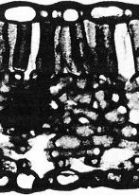

(3)
(b) (i) Name two tissues that would be found in a typical mesophytic leaf.
1. .............................................................................................................................
2. .............................................................................................................................
(2)

(ii) Explain why a leaf is described as an organ.
…………………………………………………………………………………..
…………………………………………………………………………………..
(1)
(Total 6 marks)

5. The flow diagram below shows a method for preparing and staining cells in order to study stages of mitosis.
(a) Name a suitable part of a plant to use, giving a reason for your choice.
……………………………………………………………………………………………
……………………………………………………………………………………………
……………………………………………………………………………………………
(2)
(b) (i) Explain why staining is necessary in this preparation.
………………………………………………………………………………………
………………………………………………………………………………………
(1)
(ii) Name a suitable stain for this technique.
.....................................................................................................................................
(1)

(c) Explain why it is necessary to squash the preparation.
……………………………………………………………………………………………
……………………………………………………………………………………………
(1)
(Total 5 marks)

6. Protein synthesis involves transcription and translation.
(a) (i) Where does transcription take place in a eukaryotic cell?
………………………………………………………………………………………
(1)
(ii) Name the type of chemical reaction that occurs when a strand of messenger RNA is formed from individual nucleotides.
………………………………………………………………………………………
(1)
(b) The diagram below shows part of a messenger RNA (mRNA) molecule.
(i) What is the maximum number of amino acids coded for by this strand of mRNA?
.....................................................................................................................................
(1)
(ii) Complete the diagram below to show the sequence of bases on the strand of DNA that coded for this mRNA.
(2)
(c) A strand of mRNA was found to have 53 codons but the protein produced from it contained only 51 amino acids. Suggest two reasons for this difference.
……………………………………………………………………………………………
……………………………………………………………………………………………
……………………………………………………………………………………………
……………………………………………………………………………………………
(2)

(d) Describe the process of translation.
……………………………………………………………………………………………
……………………………………………………………………………………………
……………………………………………………………………………………………
……………………………………………………………………………………………
……………………………………………………………………………………………
……………………………………………………………………………………………
……………………………………………………………………………………………
……………………………………………………………………………………………
……………………………………………………………………………………………
……………………………………………………………………………………………
(5)
(Total 12 marks)

7. Urease is an enzyme which catalyses the breakdown of urea to ammonia and carbon dioxide.
An experiment was carried out into the effect of pH on the activity of immobilised and non- immobilised urease. 10 cm3 of pH 9 buffer solution was mixed with 10 cm3 of urea solution. This was mixed with urease and the concentration of ammonia in the mixture was measured after 30 minutes.
The procedure was repeated at different pH values for both immobilised and non-immobilised urease, at the same concentrations of enzyme. The results are shown in the graph below.
(a) Describe how the immobilised urease could be prepared for this experiment.
……………………………………………………………………………………………
……………………………………………………………………………………………
……………………………………………………………………………………………
……………………………………………………………………………………………
(2)

(b) The rate of ammonia production for immobilised urease at pH 7 was 2.6 arbitrary units per minute.
(i) Calculate the rate of ammonia production for non-immobilised urease at pH 7. Show your working.

Answer = .............................................
(2)
(ii) Compare the effect of pH on the activity of immobilised and non-immobilised urease.
……………………………………………………………………………………………
……………………………………………………………………………………………
……………………………………………………………………………………………
……………………………………………………………………………………………
……………………………………………………………………………………………
……………………………………………………………………………………………
(3)
(iii) Suggest why immobilisation has this effect on the activity of urease.
……………………………………………………………………………………………
……………………………………………………………………………………………
……………………………………………………………………………………………
……………………………………………………………………………………………
(2)
(Total 9 marks)

8. (a) DNA is replicated by a process called semi-conservative replication. Explain what is meant by the term semi-conservative replication.
……………………………………………………………………………………………
……………………………………………………………………………………………
……………………………………………………………………………………………
……………………………………………………………………………………………
……………………………………………………………………………………………
……………………………………………………………………………………………
……………………………………………………………………………………………
……………………………………………………………………………………………
(4)
(b) When bacteria grow and reproduce they need a nitrogen source. The nitrogen becomes part of their DNA.
Bacteria were placed in a culture medium containing a heavy form of nitrogen. The bacteria were grown and allowed to reproduce for several generations until all the nitrogen in their DNA was heavy nitrogen.
The bacteria were removed, washed thoroughly and then divided into five batches labelled A, B, C, D and E. They were then placed in fresh culture medium and allowed to grow for different periods of time.
Batch A was placed into fresh culture medium containing heavy nitrogen, and left for four generations. The other four batches were placed into fresh culture medium containing light nitrogen and left for different periods of time.
The treatments are shown in the table below.
Batch | First treatment | Second treatment
A | All | Grown in heavy nitrogen for four generations
B | grown | Grown in light nitrogen for one generation
C | in | Grown in light nitrogen for two generations
D | heavy | Grown in light nitrogen for three generations
E | nitrogen | Grown in light nitrogen for four generations
The DNA from the five batches of bacteria was then removed, placed on separating solutions and centrifuged (spun). The mass of DNA added to each separating solution was the same.
DNA containing different proportions of heavy and light nitrogen can be seen as separate bands after centrifugation. The heavier molecules are lower down in the separating solution than the lighter molecules. The wide bands contain more molecules than the narrow bands.

Figure 1 shows an example of the results of centrifuging a mixture of heavy and light DNA.
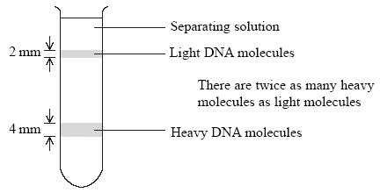
Figure 1
Figure 2 shows the results for the batches A, B, C and D.
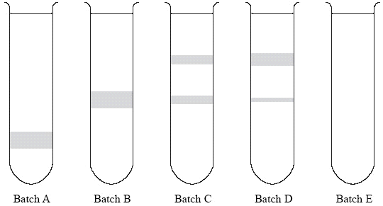
Figure 2
(i) Explain why the DNA from batch B is higher up in the separating solution than the DNA from batch A.
………………………………………………………………………………………
………………………………………………………………………………………
………………………………………………………………………………………
………………………………………………………………………………………
(2)

(ii) Explain the results for batch C.
………………………………………………………………………………………
………………………………………………………………………………………
………………………………………………………………………………………
………………………………………………………………………………………
………………………………………………………………………………………
………………………………………………………………………………………
(3)
(iii) On Figure 2, draw in the bands you would expect to see for the DNA separated from the bacteria grown in batch E.
(2)
(Total 11 marks)

