1. (a) Describe the role of gibberellins in the germination of seeds such as barley.
............................................................................................................................................
............................................................................................................................................
............................................................................................................................................
............................................................................................................................................
............................................................................................................................................
............................................................................................................................................
............................................................................................................................................
............................................................................................................................................
(4)
(b) Samples of lettuce and carrot seeds were soaked in water for 12 hours. The seeds were then spread onto the surface of damp filter paper in some dishes.
The dishes were placed in a dark cabinet and were exposed to a short burst of either red light or far-red light. They were left for several days to allow the seeds to germinate.
The results of the investigation are shown in the table below.
Type of seeds | Light treatment | Percentage germination
Lettuce | Red | 74
 | Far-red | 6
Carrot | Red | 76
 | Far-red | 79

(i) Suggest why the seeds were given the burst of light after they were placed in the cabinet.
.....................................................................................................................................
.....................................................................................................................................
.....................................................................................................................................
.....................................................................................................................................
(2)
(ii) It has been suggested that phytochrome pigments may be involved in the germination of some seeds. Explain how the data in the table support this suggestion.
.....................................................................................................................................
.....................................................................................................................................
.....................................................................................................................................
.....................................................................................................................................
.....................................................................................................................................
.....................................................................................................................................
(3)
(Total 9 marks)

2. The photograph below shows a garden snail.
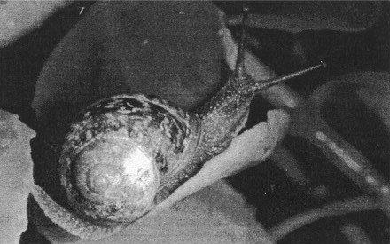
Papilio/Pickett
(a) Describe one method by which a snail population living in an area of grassland could be sampled.
............................................................................................................................................
............................................................................................................................................
............................................................................................................................................
............................................................................................................................................
(2)
(b) A biologist was asked to produce an estimate of the number of snails living in the area of grassland. A total of 85 snails was captured. Each snail was marked and then released.
Four days later a total of 69 snails was collected. There were 48 marked snails.
(i) Using the figures provided, calculate the estimated size of the snail population. Show your working.

Answer ........................................
(2)

(ii) The snails can be marked in various ways. State one factor that should be taken into account when selecting a method of marking.
.....................................................................................................................................
.....................................................................................................................................
(1)
(Total 5 marks)

3. (a) Explain what is meant by each of the following terms.
Gene .....................................................................................................................................
...............................................................................................................................................
...............................................................................................................................................
...............................................................................................................................................
Allele ...................................................................................................................................
...............................................................................................................................................
...............................................................................................................................................
...............................................................................................................................................
(4)

(b) A dwarf tomato plant with round leaves (genotype ttRr) was crossed with a tall plant with round leaves.
The following offspring were produced.
76 tall with round leaves
78 dwarf with round leaves
29 tall with oval leaves
25 dwarf with oval leaves
Determine the genotype of the other parent and draw a genetic diagram to explain the results of this cross.

(4)
(c) Suggest how the results might have differed if the gene for height was linked to the gene for leaf shape. Explain your answer.
............................................................................................................................................
............................................................................................................................................
............................................................................................................................................
............................................................................................................................................
(2)
(Total 10 marks)

4. The moose is a ruminant herbivore that is found widely distributed across North America. An isolated population of moose has been established on Isle Royale, Lake Superior, since the early part of the twentieth century.
Wolves are predators and reached this island in 1949. Although wolves are usually unable to catch healthy adult moose, they are able to prey upon the young, sick or elderly moose.
A moose  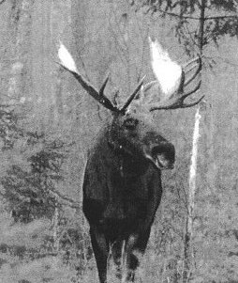  Papilio/Harron | A wolf  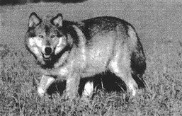  Papilio/Pickett
The graph below shows the changes in the numbers of wolves and moose on Isle Royale between 1960 and 2000.
(a) State what is meant by the term predator.
............................................................................................................................................
............................................................................................................................................
(1)

(b) Describe the relationship between the changes in the numbers of wolves and moose on Isle Royale between 1960 and 2000. Suggest explanations for the relationship you have described.
..............................................................................................................................................
..............................................................................................................................................
..............................................................................................................................................
..............................................................................................................................................
..............................................................................................................................................
..............................................................................................................................................
..............................................................................................................................................
..............................................................................................................................................
(4)
(c) Suggest a reason, other than shortage of food, for the rapid decline in the number of wolves between 1980 and 1985.
..............................................................................................................................................
..............................................................................................................................................
(1)

(d) The photograph below shows some of the premolars and molars of a wolf. The large teeth shown are sometimes called the carnassial teeth.
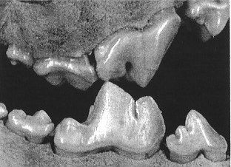
Phil Squires/University of Michigan Museum of Zoology
Describe how the carnassial teeth of the wolf are adapted to enable it to feed efficiently upon the flesh of its prey.
..............................................................................................................................................
..............................................................................................................................................
..............................................................................................................................................
..............................................................................................................................................
..............................................................................................................................................
..............................................................................................................................................
(3)

(e) Suggest how moose are able to gain nutrients from the cellulose in the grass that they eat.
..............................................................................................................................................
..............................................................................................................................................
..............................................................................................................................................
..............................................................................................................................................
..............................................................................................................................................
..............................................................................................................................................
(3)
(Total 12 marks)

5. The diagram below shows an outline of the light-independent stage of photosynthesis, together with some of the products.
(a) Using the information provided in the diagram, identify substances X and Y and state the number of carbon atoms present in each.
X ........................................................................................................................................
Y .....................................................................................................................................
(2)

(b) Explain how substance Y is converted to triose phosphate.
............................................................................................................................................
............................................................................................................................................
............................................................................................................................................
............................................................................................................................................
(2)

(c) Triose phosphate is converted to a phosphorylated 6-carbon sugar which in turn can be converted to a number of products such as sucrose and glucose. Sucrose is translocated around the plant in phloem.
Describe how phloem tissue is adapted for this function.
............................................................................................................................................
............................................................................................................................................
............................................................................................................................................
............................................................................................................................................
............................................................................................................................................
............................................................................................................................................
............................................................................................................................................
............................................................................................................................................
............................................................................................................................................
............................................................................................................................................
............................................................................................................................................
............................................................................................................................................
(6)
(Total 10 marks)

6. (a) Define each of the following terms.
Biomass
............................................................................................................................................
............................................................................................................................................
Abiotic factor
............................................................................................................................................
............................................................................................................................................
(2)
(b) A traditional form of management in woodlands is coppicing. The diagram below shows the structure of a coppiced woodland. The area of woodland marked A was coppiced the previous year. The area marked B was coppiced five years before.
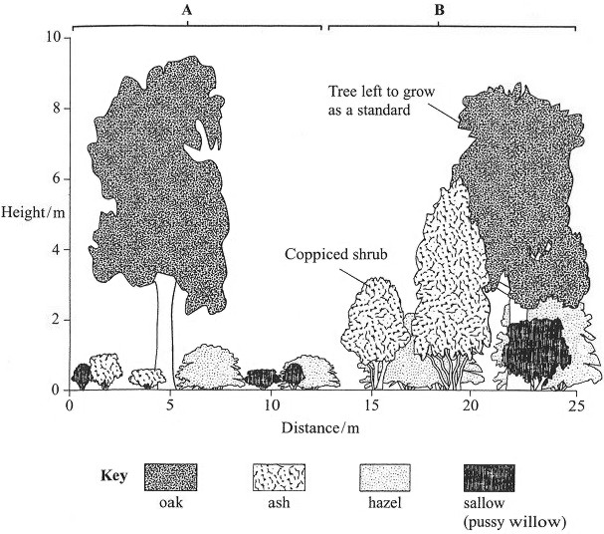

(i) Using the information provided in the diagram, describe the similarities and differences between the two areas of woodland.
.....................................................................................................................................
.....................................................................................................................................
.....................................................................................................................................
.....................................................................................................................................
(2)
(ii) Suggest how the differences you have described in (b) (i) would affect the abiotic factors in these two areas of woodland.
.....................................................................................................................................
.....................................................................................................................................
.....................................................................................................................................
.....................................................................................................................................
.....................................................................................................................................
.....................................................................................................................................
(3)

(c) After coppicing, the biomass of the coppiced shrubs increases as they regrow. The graph below shows how the biomass of the coppiced shrubs affects the biomass of the small plants growing on the woodland floor.
Describe and explain the changes in the biomass of the small plants.
............................................................................................................................................
............................................................................................................................................
............................................................................................................................................
............................................................................................................................................
............................................................................................................................................
............................................................................................................................................
(3)

(d) Explain how the management of woodlands by coppicing could provide a sustainable supply of fuel.
............................................................................................................................................
............................................................................................................................................
............................................................................................................................................
............................................................................................................................................
(2)
(Total 12 marks)

7. Malaria is one of the most serious diseases in many parts of the world. Malaria is caused by the parasite Plasmodium, a unicellular eukaryotic organism that has a complex life cycle.
The diagram below shows a simplified life cycle of Plasmodium.
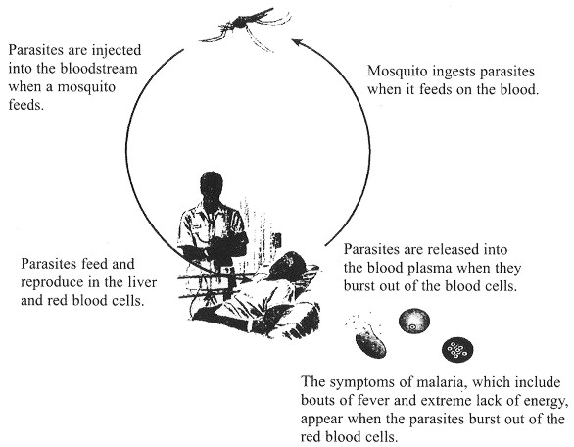
(a) Name the kingdom used in classification that includes Plasmodium.
...............................................................................................................................................
(1)
(b) Using the information provided, explain why Plasmodium is considered to be a parasite.
...............................................................................................................................................
...............................................................................................................................................
...............................................................................................................................................
...............................................................................................................................................
(2)
(c) Suggest why the presence of Plasmodium in the blood might lead to an extreme lack of energy.
...............................................................................................................................................
...............................................................................................................................................
...............................................................................................................................................
...............................................................................................................................................
...............................................................................................................................................
...............................................................................................................................................
(3)

(d) Mosquitoes can be controlled by using chemical insecticides such as DDT. Describe the possible disadvantages of using such insecticides.
...............................................................................................................................................
...............................................................................................................................................
...............................................................................................................................................
...............................................................................................................................................
...............................................................................................................................................
...............................................................................................................................................
...............................................................................................................................................
...............................................................................................................................................
...............................................................................................................................................
...............................................................................................................................................
...............................................................................................................................................
...............................................................................................................................................
(6)
(Total 12 marks)

