1. The information in the table below refers to some carbohydrates and their roles in living organisms.
Complete the table by writing the name of the carbohydrate, or one role, in each of the empty boxes.
Carbohydrate | One role in living organisms
 | Form in which carbohydrate is transported in mammals
Sucrose
 | Form in which carbohydrate is stored in mammals
Cellulose
(Total 4 marks)

2. Distinguish between each of the following pairs of terms.
(a) Tissues and organs
.......................................................................................................................................
.......................................................................................................................................
.......................................................................................................................................
.......................................................................................................................................
(2)
(b) Magnification and resolution
.......................................................................................................................................
.......................................................................................................................................
.......................................................................................................................................
.......................................................................................................................................
(2)
(Total 4 marks)

3. The diagram below shows the structure of a triglyceride molecule.
(a) (i) Name the part of the molecule labelled A.
...............................................................................................................................................
(1)
(ii) Name the type of bond formed between part A and a fatty acid.
...............................................................................................................................................
(1)
(b) Stearic acid and oleic acid are both examples of fatty acids. Each has a hydrocarbon chain containing 17 carbon atoms. Stearic acid is a saturated fatty acid but oleic acid is an unsaturated fatty acid.
Give two ways in which the structure of a stearic acid molecule differs from the structure of an oleic acid molecule.
1 ............................................................................................................................................
...............................................................................................................................................
2 ............................................................................................................................................
...............................................................................................................................................
(2)

(c) Describe two functions of lipids in animals.
1 ............................................................................................................................................
...............................................................................................................................................
...............................................................................................................................................
...............................................................................................................................................
2 ............................................................................................................................................
...............................................................................................................................................
...............................................................................................................................................
...............................................................................................................................................
(4)
(Total 8 marks)

4. The diagram below shows a stage in the process of translation during protein synthesis. This process is occurring on a ribosome.
(a) Describe the structure of a ribosome.
...............................................................................................................................................
...............................................................................................................................................
...............................................................................................................................................
...............................................................................................................................................
(2)

(b) The table below shows the anticodons of some tRNA molecules and the specific amino acids that each one carries.
tRNA anticodon | Amino acid
GGU | Proline
CCA | Glycine
AAA | Phenylalanine
CGA | Alanine
ACC | Tryptophan
UUU | Lysine
Using the information in the table, identify amino acids 2 and 3 shown in the diagram on the previous page.
Amino acid 2 .........................................................................................................................
Amino acid 3 .........................................................................................................................
(2)
(c) During translation, amino acids are linked by a peptide bond.
(i) Draw a diagram to show two amino acids linked by a peptide bond.

(3)
(ii) Name the type of reaction that occurs during the formation of a peptide bond.
.....................................................................................................................................
(1)
(Total 8 marks)

5. The diagrams below show four stages of mitosis.
(a) (i) Write the letters of the stages in the sequence in which they occur during mitosis.
........... .......... .......... ...........
(1)
(ii) Name stage D.
.................................................................................................................................
(1)

(b) The graph below shows how the quantity of DNA varies with time in a cell cycle.
(i) Explain the changes in the quantity of DNA that take place:
between 10 to 15 hours
.....................................................................................................................................
.....................................................................................................................................
at 20 hours
.....................................................................................................................................
.....................................................................................................................................
(2)
(ii) What is happening- in the cell between 15 and 20 hours?
.....................................................................................................................................
.....................................................................................................................................
(1)
(iii) What is the minimum length of time that interphase would occupy in this cell cycle?
.....................................................................................................................................
(1)
(Total 6 marks)

6. The photograph below-shows part of an animal cell, as seen using an electron microscope. The magnification is ×5000.
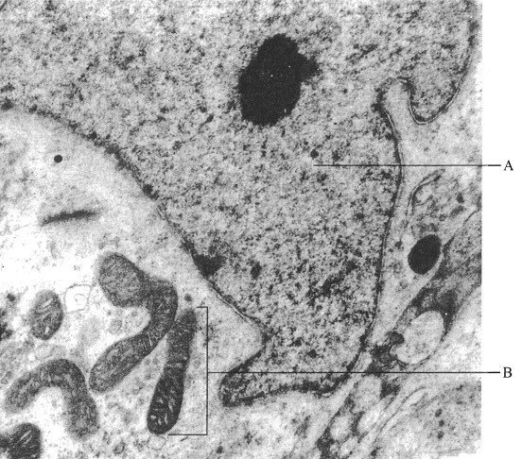
(a) Name the structures labelled A and B.
A............................................................................................................................................
B............................................................................................................................................
(2)
(b) Calculate the actual length of the structure labelled B in μm. Show your working.

Actual length of B .................. μm
(3)

(c) Describe how proteins synthesised on the rough endoplasmic reticulum are processed and transported out of the cell.
...............................................................................................................................................
...............................................................................................................................................
...............................................................................................................................................
...............................................................................................................................................
...............................................................................................................................................
...............................................................................................................................................
...............................................................................................................................................
...............................................................................................................................................
...............................................................................................................................................
...............................................................................................................................................
(5)
(Total 10 marks)

7. (a) A student prepared solutions of glucose, maltose and sucrose of varying concentrations. A sample of each one was heated with Benedict's reagent. The results are shown in Table 1.
Table 1
 | Concentration of solution/mol dm–3
Solution | 0.0001 | 0.001 | 0.01
Glucose | Blue solution | Green precipitate | Orange precipitate
Maltose | Blue solution | Green precipitate | Orange precipitate
Sucrose | Blue solution | Blue solution | Blue solution
A fresh sample of each solution was boiled with dilute acid, neutralised, then heated with Benedict's reagent. The results are shown in Table 2.
Table 2
 | Concentration of solution /mol dm–3
Solution | 0.0001 | 0.001 | 0.01
Glucose | Blue solution | Green precipitate | Orange precipitate
Maltose | Green precipitate | Green precipitate | Orange precipitate
Sucrose | Green precipitate | Green precipitate | Orange precipitate

(i) Use the information in Table I and Table 2 to explain the results for sucrose.
.....................................................................................................................................
.....................................................................................................................................
.....................................................................................................................................
.....................................................................................................................................
(2)
(ii) Explain the difference shown in Table 2 between the results obtained for glucose and those obtained for maltose.
.....................................................................................................................................
.....................................................................................................................................
.....................................................................................................................................
.....................................................................................................................................
(2)
(b) Describe how you would test two solutions of the same protein to find out which contains the higher concentration of the protein.
...............................................................................................................................................
...............................................................................................................................................
...............................................................................................................................................
...............................................................................................................................................
...............................................................................................................................................
...............................................................................................................................................
...............................................................................................................................................
...............................................................................................................................................
(4)
(Total 8 marks)

8. The following table refers to organelles found in eukaryotic cells. Complete the table by writing the name of the organelle, two features of its structure or one function of the organelle in each of the four empty boxes as appropriate.
Name of organelle | Two features of structure | One function
 | 1. Stack of curved cisternae  2. Surrounded by many vesicles | Modification  of proteins
Rough endoplasmic  reticulum | 1.  2.
Chloroplast | 1.  2. | Site of  photosynthesis
(Total 6 marks)

