1. The diagram below illustrates the structure of Rhizopus.
(a) State the mode of nutrition carried out by Rhizopus.
...........................................................................................................................................
(1)
(b) Name the structure labelled A.
............................................................................................................................................
(1)
(c) Explain how structure A is involved in the nutrition of Rhizopus.
.............................................................................................................................................
.............................................................................................................................................
.............................................................................................................................................
.............................................................................................................................................
.............................................................................................................................................
.............................................................................................................................................
(3)
(d) Rhizopus is an example of a heterotrophic organism. Explain how heterotrophic nutrition differs from autotrophic nutrition.
............................................................................................................................................
............................................................................................................................................
............................................................................................................................................
.............................................................................................................................................
(2)
(Total 7 marks)

2. (a) Explain what is meant by each of the following terms.
(i) Ecosystem
.....................................................................................................................................
.....................................................................................................................................
.....................................................................................................................................
.....................................................................................................................................
(2)
(ii) Trophic level
.....................................................................................................................................
.....................................................................................................................................
.....................................................................................................................................
.....................................................................................................................................
(2)
(b) The table below compares the biomass of organisms from an area of grassland and from a lake.
 | Biomass/g m–2
 | Grassland | Lake
Producers | 600 | 9
Primary consumers | 38 | 28
Secondary consumers | 2 | 3
(i) Calculate the percentage difference in biomass between the producers and the primary consumers of the grassland. Show your working.

Answer = .............................
(2)

(ii) Give two reasons for the decrease in biomass between primary consumers and the secondary consumers of the grassland.
.....................................................................................................................................
.....................................................................................................................................
.....................................................................................................................................
.....................................................................................................................................
(2)
(iii) In the lake, the biomass of the primary consumers is larger than that of the producers. Explain how this is possible.
.....................................................................................................................................
.....................................................................................................................................
.....................................................................................................................................
.....................................................................................................................................
.....................................................................................................................................
.....................................................................................................................................
(3)
(c) Describe how you would collect data to enable you to produce a pyramid of fresh biomass for a grassland food chain.
.............................................................................................................................................
.............................................................................................................................................
.............................................................................................................................................
.............................................................................................................................................
.............................................................................................................................................
.............................................................................................................................................
.............................................................................................................................................
.............................................................................................................................................
(4)
(Total 15 marks)

3. The siting of a new sewage treatment works and the discharge of its effluent need careful consideration in order to minimise ecological damage. Figure 1 shows two possible sites for a new sewage works near to the coast in North Devon.
Figure 1 – Plan of proposed sites for sewage treatment works, underground
pipelines and marine discharge pipelines
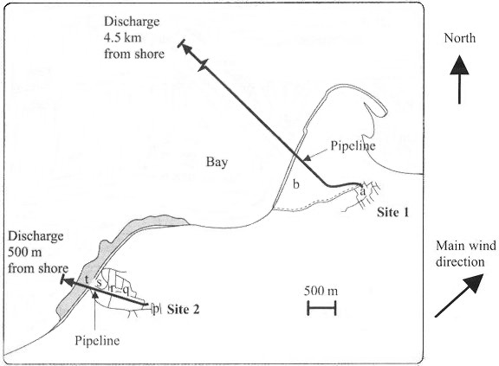
Site 2 p = field Site 1 a = field
q = field b = conservation area
r = field
s = cliff grassland
t = rocky shore
This development would involve the permanent siting of the buildings for the main sewage treatment plant, an underground pipeline and a marine discharge pipe. A strip of land 10 metres wide would need to be removed during the laying of the underground pipeline. The land would be returned to its previous condition after the work is completed.
An ecological assessment must be carried out before any development can go ahead. The assessment compares the possible effects of the development on the terrestrial areas of the two sites. The first stage is to assign each area to a particular ecological category, using the criteria in Figure 2.

Figure 2 – Criteria for assigning ecological categories to an area
Criteria
Very high species diversity and highest number of different habitats or rare habitats |  | ———► | Very low species diversity and lowest number of different habitats or rare habitats
Ecological category
5 | ———► |  | 1
The second stage is to calculate the impact of the proposed development within each area using the following formula:
area (m2) × ecological category = units of damage
Finally, consideration is given to whether the damage is reversible or irreversible. Figure 3 shows the results of this ecological assessment survey for Site 1 and Site 2.
Figure 3 – A comparison of the results of the ecological assessment survey for Site 1 and Site 2
Site 1
Area | Type of  development | Area/m2 | Ecological  category | Units of  damage | Reversible  damage | Irreversible  damage
a | Building | 10 500 | 2 | 21 000 | – | 21 000
b* | Pipeline | 150 000 | 5 | 750 000 | 750 000 | –
 |  |  | Totals | 771 000 | 750 000 | 21 000
Site 2
Area | Type of  development | Area/m2 | Ecological  category | Units of  damage | Reversible  damage | Irreversible  damage
p | Building | 21 000 | 2
q* | Pipeline | 2 500 | 1
r* | Pipeline | 3 000 | 1
s* | Pipeline | 500 | 5
t* | Pipeline | 2 000 | 5 | 10 000
 |  |  | Totals
* involves laying of underground pipeline only.
Data adapted from JBE Vol 32 Number 2 Summer 1998

(a) Suggest why some damage is considered to be reversible and some damage is considered to be irreversible.
............................................................................................................................................
............................................................................................................................................
............................................................................................................................................
............................................................................................................................................
(2)
(b) Complete the data for Site 2 in Figure 3.
(3)
(c) Using the data in Figure 3, compare the ecological effect that the development of the sewage treatment works would have at Site 1 and Site 2.
............................................................................................................................................
............................................................................................................................................
............................................................................................................................................
............................................................................................................................................
............................................................................................................................................
............................................................................................................................................
(3)
(d) State what is meant by species diversity.
............................................................................................................................................
............................................................................................................................................
(1)
(e) The ecological impact on the marine environment also needs to be considered. Using information from Figure 1, suggest three factors affecting the marine environment that should be considered when comparing Site 1 with Site 2.
1 ………………………………………………………………………………………...
2 ………………………………………………………………………………………...
3 ………………………………………………………………………………………...
(3)

(f) Suggest why an accidental discharge of raw sewage from the treatment works might lead to an increase in the numbers of carnivorous fish around the discharge pipe.
............................................................................................................................................
............................................................................................................................................
............................................................................................................................................
............................................................................................................................................
............................................................................................................................................
............................................................................................................................................
............................................................................................................................................
............................................................................................................................................
(4)
(Total 16 marks)

