1. The photograph below shows human blood cells as seen under a microscope.
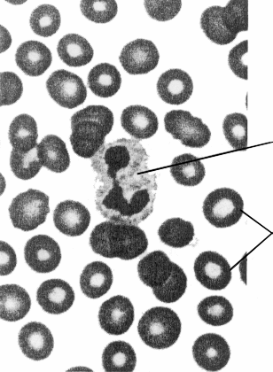
(a) Name the cell labelled A and describe its function.
Name ...........................................................................................................................
Function ......................................................................................................................
.....................................................................................................................................
.....................................................................................................................................
.....................................................................................................................................
(3)
(b) Describe how the shape of the cells labelled B is related to their function.
.....................................................................................................................................
.....................................................................................................................................
.....................................................................................................................................
.....................................................................................................................................
.....................................................................................................................................
.....................................................................................................................................
(3)
(Total 6 marks)

2. (a) Describe two ways in which alveoli are adapted for their function.
1 ..................................................................................................................................
.....................................................................................................................................
.....................................................................................................................................
.....................................................................................................................................
2 ..................................................................................................................................
.....................................................................................................................................
.....................................................................................................................................
.....................................................................................................................................
(4)
(b) Describe how the process of inspiration (breathing in) is brought about in mammals.
.....................................................................................................................................
.....................................................................................................................................
.....................................................................................................................................
.....................................................................................................................................
.....................................................................................................................................
.....................................................................................................................................
(3)
(Total 7 marks)

3. The diagrams below show some of the structures in the ovary during a menstrual cycle.
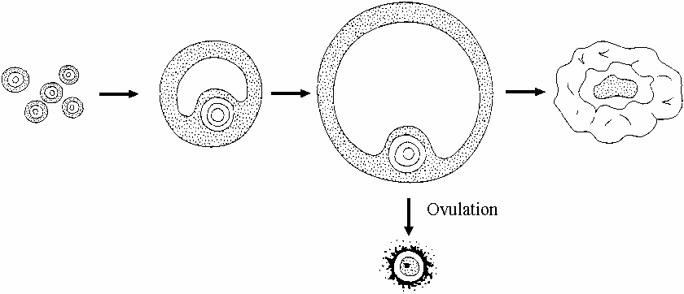

(a) During the development of the follicles, oocytes undergo meiotic division.
Explain the importance of meiosis in the formation of gametes.
.....................................................................................................................................
.....................................................................................................................................
.....................................................................................................................................
.....................................................................................................................................
(2)
(b) Name cell A.
.....................................................................................................................................
(1)
(c) Name two hormones secreted by the corpus luteum.
1 ..................................................................................................................................
2 ..................................................................................................................................
(2)
(d) Describe two differences between oogenesis and spermatogenesis.
1 ..................................................................................................................................
.....................................................................................................................................
2 ..................................................................................................................................
.....................................................................................................................................
(2)
(Total 7 marks)

4. The graph below shows the oxygen dissociation curve for adult human haemoglobin at a partial pressure of carbon dioxide of 4 kPa.
The loading tension is the partial pressure of oxygen at which 95% of the haemoglobin is saturated with oxygen. The unloading tension is the partial pressure of oxygen at which 50% of the pigment is saturated with oxygen.
(a) Use the graph to find the loading and unloading tensions for human haemoglobin.
Loading tension ........................................................................................................
Unloading tension ....................................................................................................
(2)
(b) An increase in the carbon dioxide partial pressure to 6 kPa will have an effect on the loading and unloading tensions. Suggest what this effect will be.
.....................................................................................................................................
.....................................................................................................................................
.....................................................................................................................................
.....................................................................................................................................
(2)

(c) Give one location in the body where such an increase in the partial pressure of carbon dioxide may be expected. Give a reason for your answer.
Location .....................................................................................................................
Reason .......................................................................................................................
....................................................................................................................................
(2)
(d) The oxygen dissociation curve for fetal haemoglobin lies to the left of the curve for adult haemoglobin. Explain why this is important to the developing fetus.
.....................................................................................................................................
.....................................................................................................................................
.....................................................................................................................................
.....................................................................................................................................
(3)
(Total 9 marks)

5. The photomicrograph below shows part of a transverse section through the stem of Juncus, a hydrophyte (a plant that lives in water).
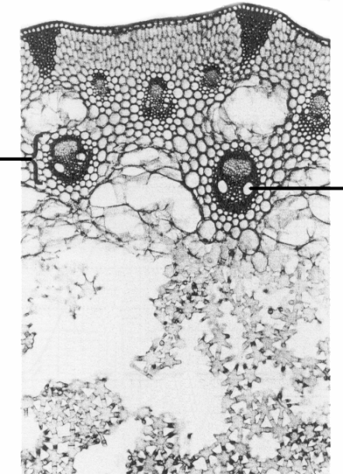

(a) Name the parts labelled A and B.
A .................................................................................................................................
B .................................................................................................................................
(2)
(b) Suggest two roles for the tissue labelled C.
1 .................................................................................................................................
....................................................................................................................................
2 .................................................................................................................................
....................................................................................................................................
(2)
(c) Some hydrophytes have finely divided, feathery submerged leaves and spreading leaves floating on the surface of the water. Explain how each of these features is an adaptation to the environment in which hydrophytes live.
Finely divided, feathery submerged leaves
....................................................................................................................................
....................................................................................................................................
....................................................................................................................................
....................................................................................................................................
Spreading leaves floating on the surface of the water
....................................................................................................................................
....................................................................................................................................
....................................................................................................................................
....................................................................................................................................
(4)
(Total 8 marks)

6. The diagram below shows the structure of a flower.
(a) Name the parts labelled A and B.
A .................................................................................................................................
B .................................................................................................................................
(2)
(b) Suggest the role of part C in the pollination of this flower.
....................................................................................................................................
....................................................................................................................................
....................................................................................................................................
....................................................................................................................................
....................................................................................................................................
....................................................................................................................................
(3)
(Total 5 marks)

7. The diagram below shows part of a tissue from a flowering plant.
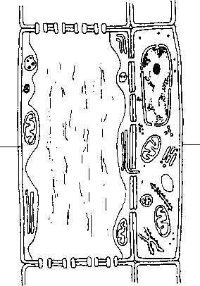
(a) Name the cells labelled A and B.
A .................................................................................................................................
B .................................................................................................................................
(2)
(b) Describe one way in which the cell labelled A is adapted for its function.
....................................................................................................................................
....................................................................................................................................
....................................................................................................................................
....................................................................................................................................
(2)
(c) The table below shows the concentrations of some of the solutes present in the xylem and phloem sap of a white lupin.
Solute | Concentration in xylem  sap / μg per cm3 | Concentration in phloem  sap / μg per cm3
Sucrose | 0 | 154 000
Sodium ions | 60 | 120
Nitrate ions | 10 | 0
(i) Compare the composition of xylem sap with phloem sap.
..........................................................................................................................
..........................................................................................................................
..........................................................................................................................
..........................................................................................................................
(2)
(ii) Suggest where the sucrose may be transported to and what will happen to it when it arrives.
..........................................................................................................................
..........................................................................................................................
..........................................................................................................................
..........................................................................................................................
(2)
(Total 8 marks)

8. The mean number of stomata on the lower surface of a leaf of two different species, A and B, was found. An experiment was also carried out to determine the rate of water loss from each leaf in one hour.
The mean number of stomata and the rate of water loss for each leaf is given in the table below.
(a) (i) Suggest how you could find the surface area of a leaf.
..........................................................................................................................
..........................................................................................................................
..........................................................................................................................
..........................................................................................................................
(2)
(ii) Describe how you would find the mean number of stomata per cm2 of a leaf.
..........................................................................................................................
..........................................................................................................................
..........................................................................................................................
..........................................................................................................................
..........................................................................................................................
..........................................................................................................................
..........................................................................................................................
..........................................................................................................................
(4)
(b) Describe the relationship between the number of stomata and the rate of water loss.
....................................................................................................................................
....................................................................................................................................
(1)

(c) Give one environmental factor that influences water loss from a leaf and explain its effect.
....................................................................................................................................
....................................................................................................................................
....................................................................................................................................
....................................................................................................................................
....................................................................................................................................
....................................................................................................................................
(3)
(Total 10 marks)

