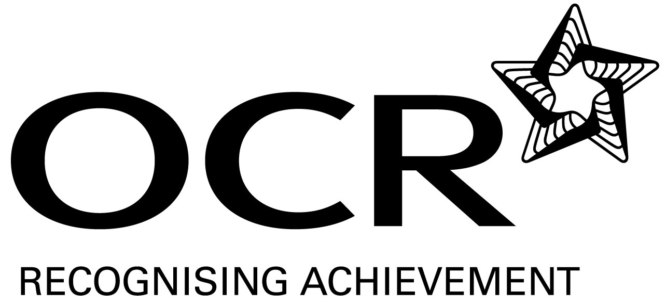
Support Material
GCE Religious Studies
OCR Advanced GCE in Religious Studies: H572
Unit: G582

This Support Material booklet is designed to accompany the OCR Advanced GCE specification in Religious Studies for teaching from September 2008.

Contents
Contents 2
Introduction 3
Religious Studies H572: Religious Ethics G582 5
Sample Lesson Plan: Religious Studies H572 Religious Ethics G582 17
Other forms of Support 19

Introduction

Background
A new structure of assessment for A Level has been introduced, for first teaching from September 2008. Some of the changes include:
- The introduction of stretch and challenge (including the new A* grade at A2) – to ensure that every young person has the opportunity to reach their full potential
- The reduction or removal of coursework components for many qualifications – to lessen the volume of marking for teachers
- A reduction in the number of units for many qualifications – to lessen the amount of assessment for learners
- Amendments to the content of specifications – to ensure that content is up-to-date and relevant.
OCR has produced an overview document, which summarises the changes to Religious Studies. This can be found at www.ocr.org.uk, along with the new specification.
In order to help you plan effectively for the implementation of the new specification we have produced this Scheme of Work and Sample Lesson Plans for Religious Studies. These Support Materials are designed for guidance only and play a secondary role to the Specification.

Our Ethos
All our Support Materials were produced ‘by teachers for teachers’ in order to capture real life current teaching practices and they are based around OCR’s revised specifications. The aim is for the support materials to inspire teachers and facilitate different ideas and teaching practices.

Each Scheme of Work and set of sample Lesson Plans is provided in:

- PDF format – for immediate use

- Word format – so that you can use it as a foundation to build upon and amend the content to suit your teaching style and students’ needs.

The Scheme of Work and sample Lesson plans provide examples of how to teach this unit and the teaching hours are suggestions only. Some or all of it may be applicable to your teaching.

The Specification is the document on which assessment is based and specifies what content and skills need to be covered in delivering the course. At all times, therefore, this Support Material booklet should be read in conjunction with the Specification. If clarification on a particular point is sought then that clarification should be found in the Specification itself.

A Guided Tour through the Scheme of Work


= Innovative Teaching Idea
All the teaching ideas contained in the SOW are innovative, but the icon is used to
Highlight exceptionally innovative ideas.

= Stretch & Challenge Activity
This icon is added at the end of text when there is an explicit opportunity to offer
Stretch and Challenge.

= ICT Opportunity
This icon is used to illustrate when an activity could be taught using ICT facilities.

Religious Studies H572: Religious Ethics G582
Suggested teaching time | 6 hours | Topic | Meta Ethics
Topic outline |  | Suggested teaching and homework activities | Suggested resources | Points to note
The use of ethical language – the ways in which different scholars understand how words like ‘good’, ‘bad’, ‘right’, ‘wrong’ are used when ethical statements are made. |  | - Ask students what does “Murder is wrong” actually mean? Students unpack the word ‘wrong’ and try to define it.  - Introduce meta-ethics. Show students the difficulty of trying to define words like: good, bad, right and wrong. Start with What David Hume said about ethical language. Ask students to evaluate Hume’s view. | - Jones Chapter 3. | - Jones has a really good chapter on meta-ethics with activities but it is very detailed.
How meta-ethics differ from normative ethics. |  | - Recap on what Normative ethics means. Ask students to summarise what meta-ethics means. Ask students to list the similarities and differences between normative ethics and meta-ethics. | - Bowie has a simple but effective definition.
The different approaches: Cognitive and non- cognitive. Ethical Naturalism, Intuitionism, Emotivism and Perscriptivism and how these apply to ethical statements |  | - Explain each approach. Students write and illustrate each approach. | - Ahluwalia and Bowie are good. Jones is more detailed. | - Junk modelling is a really good way of consolidating student’s knowledge.
Strengths and weaknesses of each approach.  = Innovative teaching idea  = Stretch and challenge opportunity idea  = ICT opportunity |  | - In small groups evaluate each approach. Students list the strengths and weaknesses for each approach.  - Beat the text book activity is a good way of evaluating the theories.  - ‘Everyone knows what good means.’ Discuss (35 marks) | - Bowie.  - Peer mark essays. Use the specimen marking scheme. | - Bowie’s chapter summaries are good for beat the text book.

Religious Studies H572: Religious Ethics G582
Suggested teaching time | 7 hours | Topic | Free Will And Determinism
Topic outline |  | Suggested teaching and homework activities | Suggested resources | Points to note
Hard Determinism, Soft determinism and libertarianism |  | - Ask students to define ‘free will’. What does it mean? Are people free to act? What stops people from being free? Can they be both free and constrained?  - Define hard and soft determinism and libertarianism. Students will need to be able to explain each concept and give examples. | - Robertson.  - www.dialogue.org.uk
The views of Darrow, Honderich, Hume, Kant, Leibniz and Locke. |  | - Give students a thinker each to research. Each student needs to provide a handout and a presentation on the ideas of the thinker.  - Handouts need to include pictures to explain and illustrate the concepts which help to consolidate knowledge. | - Philosophers online. | - ICT opportunity
Theological determinism (predestination) and religious ideas of free will. |  | - Ask students if God controls their actions and/ or destiny? Why/ why not? Explain the concept of theological determinism. Evaluate the theory. List the strengths and weaknesses for each idea. | - Bowie.  - Robertson. | - Kant could be used here but remember he is a Christian who is a philosopher not a Christian philosopher.
The influences of genetics, psychology, environment or social conditioning on moral choices.  = Innovative teaching idea  = Stretch and challenge opportunity idea  = ICT opportunity |  | - Divide class into four groups each group to write a different essay. ‘To what extent are people conditioned by … (Genetics, psychology, environment or social conditioning)’ (30) Peer mark the essays.  - Ask students to use the essays from other groups to produce a summary of each influence and evaluate the strengths and weaknesses of each. |  | - Some A level Psychology text have this information.
The implications of these views for moral responsibility. |  | - Ask students to explain what they think the term ‘moral responsibility’ means. Group students so that there is at least one from each group from the last lesson activity. Ask students to use their knowledge from the last lesson to decide what implications each of the influences might have on moral responsibility. |  | - Getting the students to discuss their ideas in groups helps to develop their ability to explain but they must write up their ideas at the end of the lesson.
The link between free will, determinism and moral responsibility. |  | - A good introduction to this is the idea of punishment for a crime. Should a person be punished for a crime if there are not morally responsible? (Recap Darrow) Ask students to evaluate how free a person needs to be before they have moral responsibility. | - (The first 20 minutes of the film ‘Minority Report’ is excellent for this).
The strengths and weaknesses of each approach. |  | - Evaluate the strengths and weaknesses of free will, hard and soft determinism. (30)  - If we are not free to act can we still be morally responsible for our actions. (30)  - Divide students into two groups, each groups writes one of the essays as a group. Then swap essays with the other group and peer mark. Write a list of strengths and weaknesses of each others essays.
= Innovative teaching idea
= Stretch and challenge opportunity idea
= ICT opportunity

Religious Studies H572: Religious Ethics G582
Suggested teaching time | 5 hours | Topic | The Nature Of Role Of Conscience
Topic outline |  | Suggested teaching and homework activities | Suggested resources | Points to note
The different views of the conscience as God-given, innate or the voice of reason or instilled by society, parents, authority figure. |  | - Ask students if they have ever done something that they know is wrong and felt guilty about it afterwards. Is this feeling of guilt the conscience or is it the knowing if the action was right or wrong? Ask students to find a definition of conscience. Use the internet, dictionaries, and text books. Is there any commonality between these definitions? Why/ Why not?  - Ask students to list where they think conscience comes from and link these ideas to the different views of the conscience. | - Robertson.
The views of St. Paul, Augustine, Aquinas, Butler, Newman, Freud, Fromm, Piaget, Kohlberg. |  | - Give students a basic introduction to each scholar’s ideas but leave out the scholar’s name. Get the students to find out who said what and to add more specific detail to each one. | - www.rsrevision.com | - For research ask students to use more than two different sources so that they don’t use copy stuff from one web site or text book.
Whether conscience is a reliable guide to ethical decision making  = Innovative teaching idea  = Stretch and challenge opportunity idea  = ICT opportunity |  | - ‘Conscience is a reliable guide to moral decision making.’ Ask students to think of views for and against this statement. They could write this as an essay or produce a mind map to show the variety of ideas. |  | - Mind maps need colour and pictures in order to engage the learner’s memory.
The strengths and weaknesses of each approach. |  | - Students need to evaluate each of the scholar’s views. Students could work in groups to do this to try and draw out the strengths and weaknesses of each theory.  - Discuss the strengths and weaknesses orally then write up ideas at home.  - Essay: ‘Conscience is the voice of God.’ Discuss. (30 marks) |  | - Peer mark essay using the marking scheme from the specification.
= Innovative teaching idea
= Stretch and challenge opportunity idea
= ICT opportunity

Religious Studies H572: Religious Ethics G582
Suggested teaching time | 6 hours | Topic | Virtue Ethics
Topic outline |  | Suggested teaching and homework activities | Suggested resources | Points to note
The principles of virtue ethics from Aristotle |  | - Ask students what they think are the best sorts of characteristics a person can have. (Good character traits) From the individual lists make a class list. How similar are the student’s ideas? Would it be possible to build a moral system on the idea of good character traits? What would be the strengths and weaknesses of a system like this?  - Link these ideas to the concept of ‘virtues’. Students need to explain in their own words what a virtue is. | - Aristotle ‘Ethics’ Penguin Classics.
The ‘agent centred’ nature of Virtue ethics. |  | - V.E is concerned with being a good person (agent-centred). Students research each type of virtue in Aristotle’s ‘Ethics’ and make a list of Aristotle’s virtues. Student’s then try to define each word on their list of virtues independently. Student’s then compare their definitions. Do they all have the same ideas? Is this strength or a weakness of V.E? | - Aristotle ‘Ethics’ (Penguin translation).
The concepts of eudaimonia and the Golden mean  = Innovative teaching idea  = Stretch and challenge opportunity idea  = ICT opportunity |  | - Recap eudaimonia from AS. What did it mean? What do students think it means in the context of V.E?  - Golden Mean – Ask students to draw a table with three columns. In the centre column write down the virtues. Label the column Golden Mean. Ask a class try to work out and write down the excess and the deficiency for each mean. Students compare ideas. Has every one got the same ideas? Is this strength or a weakness of V.E? | - Bowie.  - Aristotle ‘Ethics’ (Penguin translation).
The importance of practising the virtues and the example of virtuous people. |  | - Ask students to invent a situation for each virtue to show how someone could actually practice doing these virtues.  - Make a list of all the people students look up to. Are they all people that could be considered virtuous? Is this strength or a weakness of V.E?
More modern approaches to virtue ethics. |  | - Ask students to research the modern resurgence of V.E. Why is it such a popular idea? Ask students to make notes in the form of mind maps using as much colour and as many pictures as possible. Copy student’s ideas and let every one have a copy of everyone else’s. | - Robertson.
The strengths and weaknesses of virtue ethics. |  | - Essay: Evaluate the strengths and weaknesses of Virtue Ethics. (30) | - Peer mark essays using the specimen marking scheme. | - Junk modelling could be a good way of showing strengths and weaknesses.
= Innovative teaching idea
= Stretch and challenge opportunity idea
= ICT opportunity

Religious Studies H572: Religious Ethics G582
Suggested teaching time | 8 hours | Topic | Applied Ethics: Environmental and Business Ethics  The ethical theories: Natural Law, Kantian Ethics, Situation Ethics, Utilitarianism, Religious Ethics, Virtue Ethics.
Topic outline |  | Suggested teaching and homework activities | Suggested resources | Points to note
The issue of how humans should relate to the environment, its resources and species. |  | - Singer has a good activity at the start of the chapter on Environmental ethics. Read the description on decide what happened next.  - The key areas for environmental ethics are: Conservation, Libertarian extension, Ecological extension and Bio-centric theories.  - Students need to be able to explain each of these giving examples of theorists from each and strengths and weaknesses for each. | - Vardy.  - Robertson.  - Singer ‘Practical ethics’. | - There is a huge amount of info on the internet about environmental ethics.
Secular approaches – the Gaia hypothesis. |  | - Students need to be able to explain and evaluate the Gaia hypothesis. To help evaluation: Is this theory believable? Could this be what is happening to the world now, instead of global warming? | - Vardy.  - Robertson.  - Singer ‘Practical ethics’. | - Look for Lovelock’s web site.
Issues in Business ethics: the relationship between business and consumers;  = Innovative teaching idea  = Stretch and challenge opportunity idea  = ICT opportunity |  | - Ask students what the relationship between business and consumers s based on? Suggest: the legal requirements governing the sale of goods or limits to advertising? Or even the profit motive? Ask students to try to give arguments for and against each suggestion.  - To evaluate: What would be an ethical relationship between business and consumers? | - Vardy.  - Robertson.  - Singer ‘Practical ethics’. | - Most A’ Level Business Studies text books have a section on business ethics which student could be referred to.
Issues in Business ethics: the relationship between employers and employees |  | - Ask students what the relationship between employers and employees is based on. Ask students to try to think of examples when this relationship works well for both parties; when it suits the employer and when it suits the employee.  - To evaluate: What would be an ethical relationship between an employer and an employee? | - Vardy.  - Robertson.  - Singer ‘Practical ethics’.
The relationship between business and the environment; business and globalisation. |  | - Essay: Do businesses have a moral responsibility to protect the environment? (30) Brain storm and discuss the ideas first, then ask students to go and research information in include in the answer. Get students to share their research findings and plan the essay as a class. Students write the essay independently and then peer mark each others essays.  - Business and Globalisation could be dealt with separately. Define globalisation. How is it affecting the world/ world markets? What impact does it have on less economically developed countries? Is it ethically right? |  | - An avenue to explore could be that if customers demand ethically sourced/ manufactured produce then business has a moral responsibility to do this.
= Innovative teaching idea
= Stretch and challenge opportunity idea
= ICT opportunity

Religious Studies H572: Religious Ethics G582
Suggested teaching time | 8 hours | Topic | Applied Ethics: Environmental and Business Ethics  The ethical theories: Natural Law, Kantian Ethics, Situation Ethics, Utilitarianism, Religious Ethics, Virtue Ethics.
Topic outline |  | Suggested teaching and homework activities | Suggested resources | Points to note
The application and the different approaches of the ethical theories listed to environmental ethics. |  | - Apply the following ethical theories to environmental ethics: Natural Law, Kantian Ethics, Situation Ethics, Utilitarianism, Religious Ethics, Virtue Ethics.  - Give each student an ethical theory to look at and ask them to produce a presentation and a handout for their theory. Students give presentations and handout to the class. After each presentation discuss the strengths and weaknesses of each theory. | - Vardy.  - Robertson.  - Singer ‘Practical ethics’.
The application and the different approaches of the ethical theories listed to business ethics. |  | - Apply the following ethical theories to business ethics: Natural Law, Kantian Ethics, Situation Ethics, Utilitarianism, Religious Ethics, Virtue Ethics.  - Ask students to design board game which takes others through each ethical theory and how it can be applied to business ethics. Play each others games and use the experience to evaluate the strengths and weakness of each theory.
Essay |  | - ‘Kant’s ethical theory is the most useful ethical theory for a business to use.’ Discuss. (30)
= Innovative teaching idea
= Stretch and challenge opportunity idea
= ICT opportunity

Religious Studies H572: Religious Ethics G582
Suggested teaching time | 6 hours | Topic | Applied Ethics: Sexual Ethics  The ethical theories: Natural Law, Kantian Ethics, Situation Ethics, Utilitarianism, Religious Ethics, Virtue Ethics.
Topic outline |  | Suggested teaching and homework activities | Suggested resources | Points to note
The issues surrounding sexual ethics – pre-marital and extra-marital sex, contraception and homosexuality.  = Innovative teaching idea  = Stretch and challenge opportunity idea  = ICT opportunity |  | - Pre-marital sex- Why might this be a good thing? Why might this be a bad thing? Why do some religions see this as a bad thing? What effects could it have on the sexual health of the individual? Is this really an issue with so few people actually getting married?  - Extra-marital sex- Discuss the issues of fidelity, trust and loyalty and compare them to the social acceptance of affairs and divorce. Is it harmful to the children who experience their parents separating after an affair? Which is more important loyalty or the right to choose to find a new partner? Ask students to evaluate whether polygamy is the answer.  - Contraception- Outline religious objections to contraception and the health benefits of using condoms in stopping/ limiting the spread of STD’s. Question whether it should be given put free to school children. Evaluate whether contraception is ever right.  - Homosexuality- Religious reasons against homosexuality. Secular/ biological reasons against homosexuality. (continuation of the species, etc)Arguments in favour of homosexuality. Human rights arguments. Ask students whether they agree that the media seem to think that lesbians are more acceptable than homosexual men. (use magazines such as ‘Nuts’ and ‘Zoo’ as examples) Have depictions of homosexuals on TV soaps changed peoples attitudes towards homosexuality? | - www.rsrevision.com/ethicaltheory  - Vardy- ‘Puzzle of sex’.  - Robertson. | - Useful links to sexual health (PSHE).  - As students work through these topics it would be beneficial to look at what different religious and ethical theories say about each issue and evaluate how effective each religious or ethical theory is when discussing this issue.
The application of the different ethical theories listed to sexual ethics. |  | - Apply the following ethical theories to sexual ethics: Natural Law, Kantian Ethics, Situation Ethics, Utilitarianism, Religious Ethics, Virtue Ethics.  - Students could make a display showing each of these issues arguments for and against each one and how the different ethical theories could be applied to them. |  | - Students will need to research these ideas before they can produce the display work.
Essay |  | - Critically asses the view that N.L is of no use when discussing sexual ethics. (30) | - Peer mark essays.
= Innovative teaching idea
= Stretch and challenge opportunity idea
= ICT opportunity

Sample Lesson Plan: Religious Studies H572 Religious Ethics G582

An introduction to the use of Ethical Language
OCR recognises that the teaching of this qualification will vary greatly from school to school and from teacher to teacher. With that in mind, this lesson plan is offered as a possible approach but will be subject to modifications by the individual teacher.
Lesson length is assumed to be one hour.

Learning objectives for the lesson
Objective 1 | Students to understand the key premises behind the use of ethical language.
Objective 2 | Students to be able to begin to distinguish for themselves the ways in which words like ‘good’, ‘bad’, ‘right’, ‘wrong’ are used when ethical statements are made.
Objective 3 | Students to evaluate the strengths and weaknesses of Ethical Language in light of their new learning.

Recap of previous experience and prior knowledge
- Ask students to define the word ‘ethics’. What does it actually mean? Use Q&A to get students to explain their definitions. (You need to get students to try and define the ideas of right and wrong/ good and bad.)

Content
Time | Content
5 minutes | Q&A: Ask students to write down on their own what “Murder is wrong” actually means. Feedback to the whole class. Again get students to think carefully about defining the word wrong.
10 minutes | Working in small groups, ask the students unpack the word ‘wrong’ and try to define it. (Big sheet of paper and board pen!) Feedback ideas to the whole class. How much similarity is their between groups.
5 minutes | Introduce meta-ethics. Explain what the term means. Use the previous activities to show students the difficulty of trying to define words like: good, bad, right and wrong. Ask student to explain what Meta-Ethics is in their own words.
10 minutes | Explain what David Hume said about ethical language. For example; As an empiricist he stated that virtually all knowledge has to come through the senses. But if you can see rightness or wrongness then ethical statements can not be empirically proven. Also explain the ‘Is-Ought gap’ ie You can not logically jump from ‘murder is wrong’ to ‘you ought not to murder’.
20 minutes | Ask students to explain and evaluate Hume’s view by producing a PowerPoint presentation. They will need to show how words like right, wrong, good and bad are used in ethical statements but that ethical statements are not empirical statements. Students also need to show how it is not logical to move from an IS to an Ought statement. Students will also need to evaluate Hume’s views; they need to try to give views both for and against.

Consolidation
Time | Content
5 minutes | Return to the phrase “murder is wrong” and ask students to explain it in meta-ethical terms. Use this to show students what they have learnt. Ask students whether or not they agree with these ideas.

Other forms of Support
In order to help you implement these new specification effectively, OCR offers a comprehensive package of support. This includes:

OCR Training

Get Ready…introducing the new specifications
A series of FREE half-day training events are being run during Autumn 2007, to give you an overview of the new specifications.

Get Started…towards successful delivery of the new specifications
These full-day events will run from Spring 2008 and will look at the new specifications in more depth, with emphasis on first delivery.
Visit www.ocr.org.uk for more details.

Mill Wharf Training
Additional events are also available through our partner, Mill Wharf Training. It offers a range of courses on innovative teaching practice and whole-school issues - www.mill-wharf-training.co.uk.

e-Communities
Over 70 e-Communities offer you a fast, dynamic communication channel to make contact with other subject specialists. Our online mailing list covers a wide range of subjects and enables you to share knowledge and views via email.
Visit https://community.ocr.org.uk, choose your community and join the discussion!

Interchange
OCR Interchange has been developed to help you to carry out day to day administration functions online, quickly and easily. The site allows you to register and enter candidates online. In addition, you can gain immediate a free access to candidate information at you convenience. Sign up at https://interchange.ocr.org.uk

Published Resources
Published Resources
OCR offers centres a wealth of quality published support with a fantastic choice of ‘Official Publisher Partner’ and ‘Approved Publication’ resources, all endorsed by OCR for use with OCR specifications.

Publisher partners
OCR works in close collaboration with three Publisher Partners; Hodder, Heinemann and Oxford University Press (OUP) to ensure centres have access to:

- Better published support, available when you need it, tailored to OCR specifications
- Quality resources produced in consultation with OCR subject teams, which are linked to OCR’s teacher support materials
- More resources for specifications with lower candidate entries
- Materials that are subject to a thorough quality assurance process to achieve endorsement

Heinemann is the publisher partner for OCR GCE Religious Studies

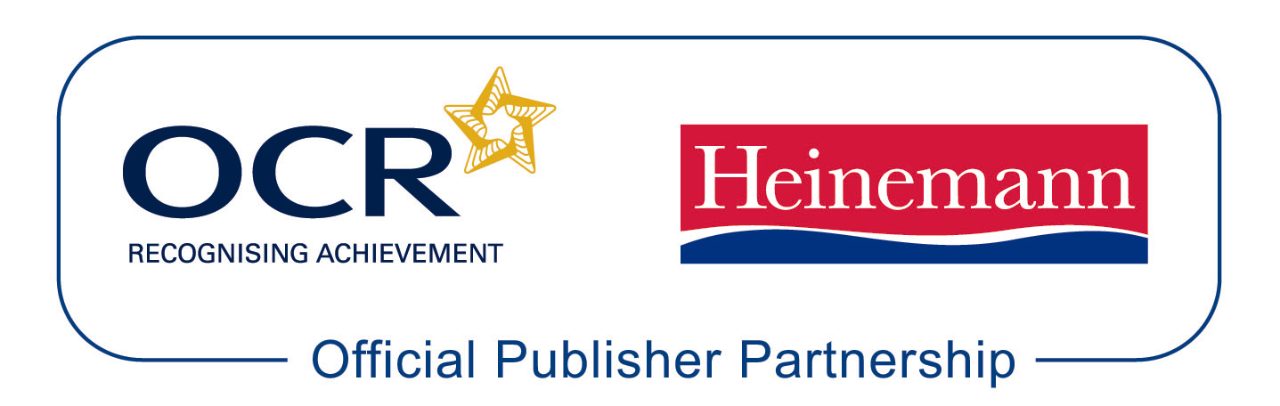

Heinemann is producing the following resources for OCR GCE Religious Studies for first teaching in September 2008.

Taylor, I, Eyre, C and Knight, R. AS Philosophy and Ethics Student Book.
ISBN: 978-0-435-30362-4

Eyre, C and Knight, R. AS Philosophy and Ethics Teacher Planning and Delivery Pack.
ISBN: 978-0-435-30363-1

Eyre, C and Knight, R. A2 Philosophy and Ethics Student Book. ISBN: 978-0-435-30358-7

Eyre, C and Knight, R. A2 Philosophy and Ethics Teacher Planning and Delivery Pack.
ISBN: 978-0-435-30358-7

Approved publications OCR still endorses other publisher materials, which undergo a thorough quality assurance process to achieve endorsement. By offering a choice of endorsed materials, centres can be assured of quality support for all OCR qualifications.

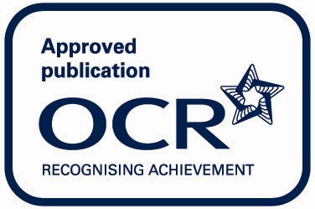

Endorsement
OCR endorses a range of publisher materials to provide quality support for centres delivering its qualifications. You can be confident that materials branded with OCR’s “Official Publishing Partner” or “Approved publication” logos have undergone a thorough quality assurance process to achieve endorsement. All responsibility for the content of the publisher’s materials rests with the publisher.

These endorsements do not mean that the materials are the only suitable resources available or necessary to achieve an OCR qualification. Any resource lists which are produced by OCR shall include a range of appropriate texts.

