1. The diagram (not to scale) shows a satellite of mass ms in circular orbit at speed υ_{s} around the Earth, mass M_{E}.
The satellite is at a height h above the Earth’s surface and the radius of the Earth is R_{E}.
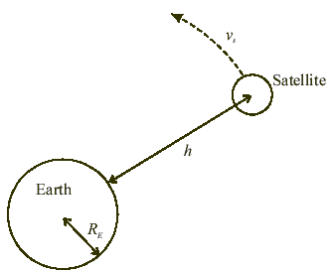
Explain why, although the speed of the satellite is constant, its velocity varies. (1 mark)
Using the symbols above, write down an expression for the centripetal force needed to maintain the satellite in this orbit. (2 marks)
Write down an expression for the Earth’s gravitational field strength in the region of the satellite.
State an appropriate unit for this quantity. (3 marks)
Use your two expressions to show that the greater the height of the satellite above the Earth, the smaller will be its orbital speed. (3 marks)
(Total 9 marks)

2. Write down an equation for the force between two point charges, Q₁ and Q₂, separated by a distance r. (1 mark)
A speck of dust has a mass of 1.0 x 10⁻¹⁸ kg and carries a charge equal to that of one electron. Near to the Earth’s surface it experiences a uniform downward electric field of strength 100 N C⁻¹ and a uniform gravitational field of strength 9.8 N kg⁻¹.
Draw a free-body force diagram for the speck of dust. Label the forces clearly.
Calculate the magnitude and direction of the resultant force on the speck of dust. (6 marks)
(Total 7 marks)

3. A 200 μF capacitor is connected in series with a 470 Ω resistor, a switch and a 4.5 V battery.
Draw a circuit diagram of this arrangement. (1 mark)
On the axes below, draw a graph showing how the potential difference V across the capacitor varies as the charge Q stored in it increases.
Add a scale to both axes. (3 marks)
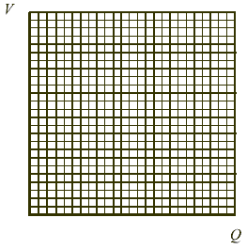
Calculate the energy stored by the fully charged capacitor. (2 marks)
(Total 6 marks)
4. The magnitude of the force on a current-carrying conductor in a magnetic field is directly proportional to the magnitude of the current in the conductor.
Draw a fully labelled diagram of the apparatus you would use to verify this relationship.
State what measurements you would make and how you would use your results.
You may be awarded a mark for the clarity of your answer. (6 marks)
At a certain point on the Earth’s surface the horizontal component of the Earth’s magnetic field is 1.8 x 10⁻⁵ T.
A straight piece of conducting wire 2.0 m long, of mass 1.5 g , lies on a horizontal wooden bench in an East-West direction. When a very large current flows momentarily in the wire it is just sufficient to cause the wire to lift up off the surface of the bench. Calculate the current. (2 marks)
(Total 8 marks)

5. Two long parallel wires R and S carry steady currents I₁ and I₂ respectively in the same direction.
The diagram is a plan view of this arrangement. The directions of the currents are out of the page.
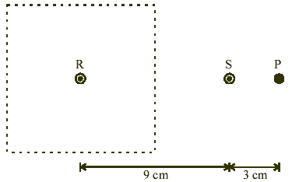
In the region enclosed by the dotted lines, draw the magnetic field pattern due to the current in wire R alone.
Show at least three field lines. (2 marks)
The current I₁ is 4 A and I₂ is 2 A.
Mark on the diagram a point N where the magnetic flux density due to the currents in the wires is zero. (1 mark)
Show on the diagram the direction of the magnetic field at P. (1 mark)
(Total 4 marks)

6. Complete the diagram below of a transformer designed to step down a potential difference of 11 kV to 415 V.
(2 marks)
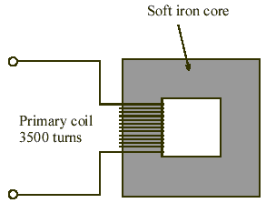
Explain why the transformer could not be used to step down the potential difference of a d.c. supply. (1 mark)
Show that for an ideal transformer (100% efficient)

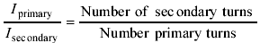
(2 marks)
Transformers are not 100% efficient. State one cause of energy loss in a transformer. (1 mark)
(Total 6 marks)

