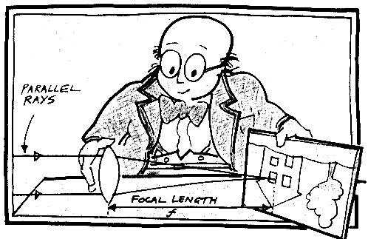
Apparatus:
two different convex lenses, screen, metre rule, blutack [L25]

1. Focal length measurement
Place one of your the lenses so that it casts a clear image of a
distant scene like that shown in the diagram opposite.
Measure, to the nearest cm, the distance between the
lens and the screen. This is the focal length (f) of your lens.
The focal length of the first lens is _________ cm.
Repeat the above with your other lens.
The focal length of the second lens is _________ cm.

2. Telescope set up
- Use the blutack to attach the lens of smaller focal length to about the 1cm mark of the metre ruler.
- Look at a distant scene through this lens as shown in the diagram. It will be out of focus.

eye
to distant scene
smaller focal length lens
longer focal length lens

- Place the other lens somewhere along the ruler so that when you are looking through both lenses you can see an in focus, magnified image of the distant scene. You will need to vary the distance between the lenses to achieve this.

3. Further measurements
Note the positions of the lenses and so calculate their distance apart.
The distance between the lenses = _________ cm
Try to estimate the magnifying power of your telescope by observing how much bigger the telescope makes the distant scene appear to be. You could try to do this by using one eye to look through the telescope and the other eye to view the distant scene directly. If, for example, the distant scene appears to be three times bigger then the magnifying power is 3X.
Estimated magnifying power = __________ X

4. Repeat
Change one of your lenses for another one that is different from your first two.
Measure the focal length of this third lens as above in stage 1.
The focal length of the third lens is _________ cm.
Repeat stages 2 & 3 with this third lens.
The distance between the lenses = _________ cm
Estimated magnifying power = __________ X

5. Analysis
Can you spot any relationship between the focal lengths of the lenses and:
(a) their distance apart when the image is in focus?

(b) the magnifying power of the telescope?

6. Further repeats
Try other lens pairs to check your statements above.
Which pair of lenses gives the greatest magnifying power?

