L6th Passage Analysis Homework – Based on Q1 from PH6 – June 1997

Read the passage and then answer the questions at the end.

Brownian Motion
Brownian motion is named after the English botanist Robert Brown who in 1827 discovered that pollen particles suspended in water showed a continuous random motion when viewed under a microscope. It was not until 1905 that a theory of Brownian motion was developed by Albert Einstein. The basic assumption made by Einstein was that particles suspended in a liquid or a gas share in the thermal motions of the medium and that on average the translational kinetic energy of each particle is 3kT / 2, in accordance with the principle of equipartition of energy. In this view the Brownian motion of particles results from impacts by molecules of the fluid and the suspended particles acquire the same mean kinetic energy as the molecules of the fluid.
The suspended particles are extremely large compared to the molecules of the fluid and are being continually bombarded on all sides by them. If the particles are sufficiently large and the number of molecules is sufficiently great, equal numbers of molecules strike the particles on all sides at each instant. For smaller particles and fewer molecules the number of molecules striking various sides of the particle at any instant, being merely a matter of chance, may not be equal; that is, fluctuations occur. Hence the particle at each instant suffers an unbalanced force causing it to move this way or that. If the Avogadro number were infinite, there would be no fluctuations and no Brownian motion. If the Avogadro number were very small, the Brownian motion would be very large. Hence we should be able to deduce the value of the Avogadro number from observations of the Brownian motion. A study of Brownian motion therefore offers a striking experimental test of the kinetic theory hypothesis.
The suspended particles are influenced by gravity and would settle to the bottom of the fluid were it not for the molecular bombardment opposing this tendency. Since the suspended particles behave like gas molecules we are not surprised to learn that, as for molecules in the atmosphere, their density drops off exponentially with respect to height in the fluid; they form a "miniature atmosphere". Jean Perrin, a French physical chemist, confirmed this prediction in 1908 by determining the numbers of small particles of gum resin suspended at different heights in a drop of liquid. From his data he deduced a value for the Avogadro number of N_{A} = 6 x 10²³ mol ⁻¹. Perrin also made measurements of the displacements of particles undergoing Brownian motion during many equal time intervals and found that they have the statistical distribution required by kinetic theory and the root-mean-square displacement predicted by Einstein.

(a) Draw a diagram to illustrate the meaning of the phrase random motion as used in the first sentence of the passage. Explain what is meant by root-mean-square displacement used in the last sentence of the passage. (4)
(b) Calculate the average translational kinetic energy of air molecules at 20°C.
Take the Boltzmann constant k to be 1.38 x 10 ^{– 23} JK ^{– 1}. Assuming that a smoke particle has a mass of 1.0 x 10 ^{– 16} kg, show that the average speed of a smoke particle in air at 20°C is about 10mms^{– 1}. State any assumption you make. (7)
(c) The passage discusses two factors which influence the fluctuations of a particle undergoing Brownian motion. State what these factors are and describe how one of them affects the fluctuations. (4)
(d) What is meant by the kinetic theory hypothesis mentioned at the end of the second paragraph? State one prediction, other than those dealt with in the passage, which results from the kinetic theory. (5)
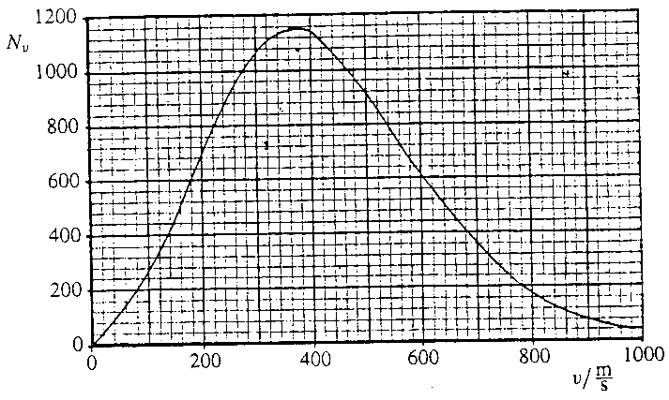
(e) Explain why all the molecules in the
atmosphere do not settle on the ground
under the influence of gravity.
Draw a sketch to illustrate how the density
of small particles of gum resin varies in a
drop of liquid (paragraph 3). (5)
(f) The graph shows the distribution of speeds
for half a million oxygen molecules at 0°C. N_{v}
on the vertical axis represents the number of
molecules with a speed within ±1 ms ⁻¹ of v.
What is the most probable (median) speed?
Suggest a value for the average (mean) speed.
Estimate how many molecules have a speed
greater than 800 ms ⁻¹.
Explain how you made your estimate. (5)

TOTAL = 30 MARKS

