L6 PHYSICS
1. Copy out the table opposite and then
classify each of the terms in the left-hand
column by placing a tick in the relevant
box. [5]

2. Complete each of the following statements in words:
The resistance of an ammeter is assumed to be …….
The resistance of a voltmeter is assumed to be …….. [2]

3. The table gives four word equations.
Copy and complete the table with the quantity defined by each word equation. [4]
Word Equation | Quantity Defined
Voltage ÷ Current
Voltage x Current
Charge ÷ Time
Work Done ÷ Charge
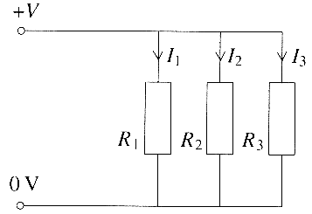
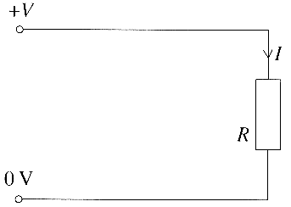
4. Three resistors R₁ R₂ and R₃ are connected in parallel with each other. They could be replaced by a single resistor of resistance R.

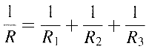
Show that the resistance, R, of the equivalent resistor can be calculated from: [3]
A student has four identical resistors each of resistance 10 Ω.
She connects them to form the different networks shown below.
Calculate the equivalent total resistance of each network. [3]
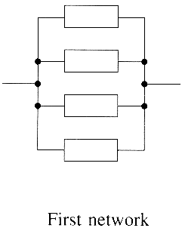
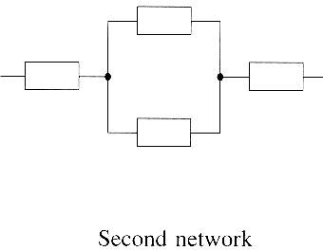
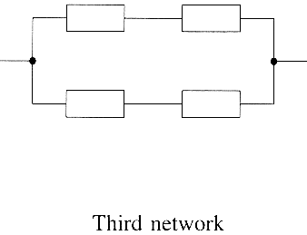

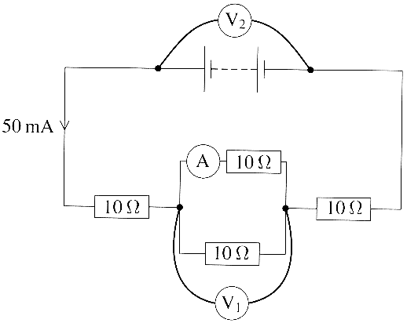

She then connects a battery across the second network and adds
meters to make the circuit shown opposite. A current of 50 mA is
drawn from the battery.
Determine the reading on each of the three meters. [5]

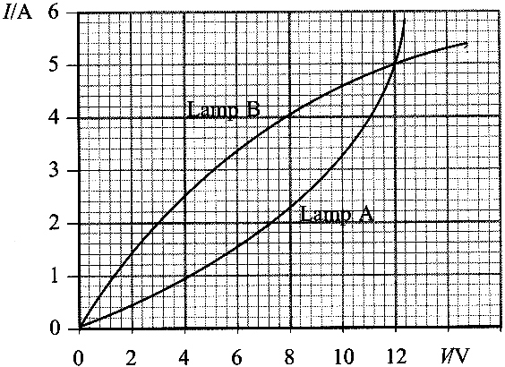
5. A student is provided with two filament lamps A and B.
Each is rated 12 V 60 W, but lamp A has a carbon filament
and lamp B a tungsten filament.
Calculate the resistance of each filament lamp under
normal operating conditions. (3)

The graph shows the relationship between the current I
and the potential difference V for the two filament lamps.
Describe how the resistances of lamp A and lamp B vary
with current. (2)

6. A 500 W electric toaster operates from the 230 V mains.
Calculate the current in the heating element of the toaster. (3)

The heating element of the toaster is made of much thinner wire than the wire in its supply cable. In which of these two wires do the electrons have the greater drift velocity? (1)

Explain your answer.
You may be awarded a mark for the clarity of your answer. (4)

7. The current / flowing through a conductor of cross-sectional area A is given by the formula:
I = nAQv where Q is the charge on a charge carrier. Give the meanings of n and v. [2]
Show that the equation is homogeneous with respect to units. [3]
With reference to the equation, explain the difference between a metal conductor and a plastic insulator. [2]

8. A physics textbook states that the electron beam in a TV set transfers a charge Q to the screen in a time t
such that Q = net What do n and e represent in this equation? (3 marks)
A student attempting to prove the equation shows that Q = ½ net.
Why will testing the homogeneity of this relationship not reveal that the student has made a mistake in his proof?
(1 mark)
(Total 4 marks)

9. The diagram shows two methods of connecting eight heating elements which make up a car rear window heater. The heater is connected to a 12 V car battery. Each element used in circuit P has a resistance 24Ω; each used in circuit S has a resistance of 0.50Ω.
(a) Calculate the current drawn from the battery for each circuit. Show your working. (5 marks)
(b) Elements 3 and 4 burn out in each circuit and no longer conduct electricity. What are the new values of the currents in each circuit? (2 marks)

