Spring energy simulation
[Demo set up – M57]
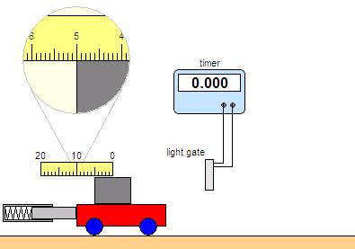
1. On your desktop:
Open the Science folder
– then Science Investigations 1 (NOTE the 1!)
– then select ‘Physics’ – then select
‘Energy stored in a spring’.
You should see a display like that opposite:

2. Note the effect of pressing the ‘release’ and
‘reset’ buttons.

3. Note the effect of changing the
‘spring position’ and ‘trolley mass’ sliders.

4. You are going to use this simulation to
investigate how the compression of
the spring affects the kinetic energy gained by the trolley.

5. Check that the spring compression is “5 cm” and that the trolley mass is “1 kg”, as shown in the diagram. Press ‘release’ and note the timer reading here: ______________ seconds.

6. This time is how long it takes the grey card on the trolley to interrupt the light beam of the light gate. This card has a width of 10 cm. The speed of the trolley past the light gate is therefore given by:
speed = card width (0.10 m)
timer reading
Calculate this speed.
Speed for spring compression of 5 cm = ________________ m/s

7. The mass of the trolley is 1 kg.
Calculate its kinetic energy using the equation: kinetic energy = ½ x mass x speed²
Kinetic energy = _________________ J

8. Using EXCEL to produce a results table, repeat the above twice more and so obtain an average value for the kinetic energy.

9. Repeat the above for spring compressions of 2cm, 4cm, 6cm, 8cm & 10cm.

10. Use EXCEL to plot a line graph of kinetic energy of the trolley (y-axis) against
spring compression (x-axis).
You may prefer to hand draw a graph for this.

11. How does the strength of the kinetic energy vary with the spring compression?
_________________________________________________________________________
_________________________________________________________________________
_________________________________________________________________________
_________________________________________________________________________
_________________________________________________________________________

12. Investigate the effect of using a different trolley mass.

