Cooling simulation
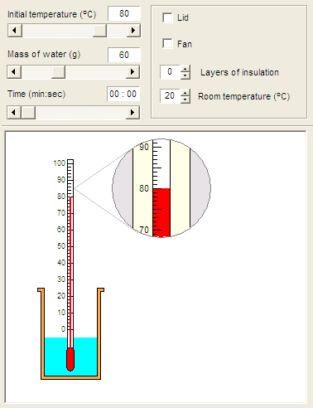
[Demo set up –H9]

1. On your desktop:
Open the Science folder
- then Science Investigations 2 (NOTE the 2!)
- then select ‘Physics’
- then select ‘Rates of cooling’.
You should see a display like that opposite:

2. Note the effect of moving the ‘Time’
slider rightwards

3. Check that the initial settings are as shown:
Initial temperature = 80ºC
Mass of water = 60g
Lid – unchecked
Fan – unchecked
Layers of insulation = 0
Room temperature = 20ºC

4. You are to investigate how the layers of
insulation affects the cooling of water.
Use the time slider to find the temperature
of the water after 10 minutes. = _________ ºC
By how much has the water’s
temperature fallen? = _____________ ºC

5. Repeat the above for up to 10 layers of insulation.
Use EXCEL to produce a results table.

6. Produce a bar chart of your results. You may wish to use EXCEL for this.

7. Answer the following questions:
(a) Does the temperature drop rise or fall as you increase the layers of insulation?
(b) Does the temperature drop halve if you double the layers of insulation?
(c) If your answer to (b) is NO what does happen?
(d) What is the independent variable in this experiment?
(e) What is the dependent variable in this experiment?

8. How does the temperature drop depend on:
(a) the use of the lid?
(b) the use of the fan?
(c) the mass of water?
(d) room temperature?
(e) the initial temperature?
(f) the time of cooling?

