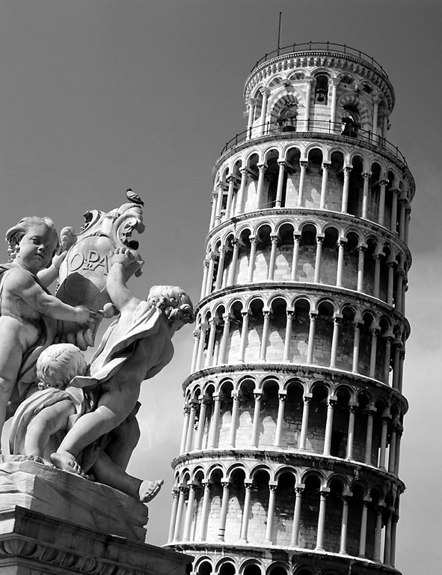

The Brew Tower!

You are set the task of constructing a tower . The materials available to you are;

25 straws @ £2 each
5 pieces of A4 paper @ £5 each
1 metre of sellotape free!
1 plastic cup
water

The conditions of the task are;

It must be freestanding and not attached to anything else including the bench!
It must be as high as possible.
You have 45 minutes to build your tower.
The tower must support half a paper cup of water.
The height will be measured to the water level.

You must first provide a plan of your structure. Your teacher must be given a labelled copy – you have about 10 minutes for this stage.
Think what makes high buildings stable?
What sort of framework should you use?
How many different ways could you use your material?

Each team member must be given a clearly defined role and explain their responsibility for the task.
Do not be afraid to modify the plan if things don’t work out as you would expect.

Your team must include 3 members only.
You will be awarded marks for;
Plan/ Evaluation / Teamwork/ Height / Cost / Clearing up.

