Section I
1. Read the passage and then answer the questions at the end.

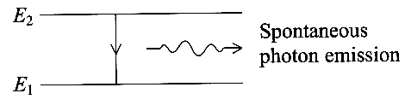
Spontaneous and stimulated emission of radiation
An atom in an excited state emits radiation by dropping to a state of lower
energy, often the ground state. This is a random process in which each atom has an
average lifetime in the excited state. The diagram shows this random process of
spontaneous emission.
Einstein proposed that in addition to this process, the transition from an excited state could also be triggered by radiation of the correct frequency. This type of emission is known as stimulated emission. In stimulated emission an incoming photon, which is not absorbed, triggers a transition to the lower energy state, thus producing a second identical photon.
The emitted photons in both spontaneous and stimulated emission have clearly defined frequencies determined by the atom's energy levels. However, other effects, such as Doppler shifts caused by the motion of the atoms, broaden what should be a very sharp line in the emission spectrum into a narrow band.
When a large number of gas atoms are in thermal equilibrium at an absolute temperature T, the number of atoms in each of the energy levels depends only on the temperature. The higher the energy level, the smaller the number of atoms raised to that energy by thermal agitation. N₁ is the number of atoms at level E₁, the ground state, and N₂ the number of atoms at level E₂, then
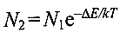
where ΔE = E₂ - E₁ and k is a constant. Similar equations relate N₃ to N₂ and N₄ to N₃ etc An incoming photon may be absorbed and excite an atom in the ground state E₁ a process which subsequently results in spontaneous emission. However, an incoming photon is hardly ever going to interact with an atom already in an excited state such as E₂ to give rise to stimulated emission. This is because N₂ << N₁, even at high temperatures, and is why the emission of visible light from excited atoms is usually regarded as a completely random process.
In certain circumstances, however, it is possible to arrange for N₂ > N₁, a situation known as population inversion. In this case the gas atoms are not in thermal equilibrium, indeed the 'temperature' of the gas can be thought of as being negative. Each photon now entering the gas is more likely to produce stimulated emission than to be absorbed. In these circumstances the photon flux is increased - a situation described as light amplification by the stimulated emission of radiation or as laser action.
[This passage is adapted from Masers and lasers by R A Smith in Endeavour, April 1962.]

(a) Explain the meaning of the following phrases as used in the passage: (i) absolute temperature (paragraph 4),
(ii) Doppler shifts (paragraph 3), (iii) a random process (paragraphs 1 and 4). (5)

(b) The diagram in the passage illustrates the spontaneous emission of a photon when an atom has a transition from an excited state E₂ to the ground state E₁. (i) Calculate the wavelength of the emitted photon when E₂ - E₁ = 2.0 eV. To which region of the electromagnetic spectrum does this radiation belong?
(ii) Sketch an energy level diagram showing the ground state and three possible excited states for an atom. Explain, using your diagram, why there can be six possible wavelengths for photons emitted from atoms occupying such a set of excited states. (7)

(c) (i) Draw a diagram, similar to the diagram in the passage, to illustrate what happens in the stimulated emission of a photon. (ii) Explain in your own words how light amplification is achieved in a laser. (4)

(d) State the circumstances under which the 'temperature' of a gas can be thought of as being negative. (2)

(e) The average kinetic energy of helium atoms of mass 6.7 x 10 ⁻²⁷ kg at room temperature is 6.0 x 10 ⁻²² J.
(i) Calculate the average speed of helium atoms at room temperature.
(ii) Show that these helium atoms produce a Doppler shift Δλ of less than 10 ⁻¹² m for photons of wavelength 600 nm.
(iii) Suggest why the spectral line at 600 nm is found to be broader than 10 ⁻¹² m. (6)
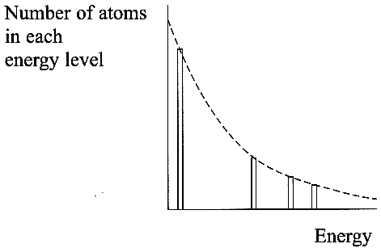
(f) The diagram shows the number of atoms in some energy levels for a gas in
thermal equilibrium at a temperature T.
(i) What determines the number of atoms in each energy level?
(ii) State how atoms are raised to higher energy levels.(2)

(g) Suppose that a very large number of hydrogen atoms are in thermal equilibrium at a
temperature of 1150 K and that two million of these atoms are raised to level E₃
i.e. N₃ = 2.00 x 10⁶.
(i) Use N₄ = N₃ e ^{- ΔE / kT} to show that the number of atoms N₄ in level E₄ is just over 2500,
given that ΔE = E₄ - E₃ = 1.06 x 10 ⁻¹⁹ J and k = 1.38 x 10 ⁻²³ JK⁻¹
Show all your working.
(ii) Calculate the number of atoms N₅ in level E₅ given that E₅ - E₄ = 0.49 x 10 ⁻¹⁹ J

TOTAL FOR SECTION I: 31 MARKS
SECTION II Answer ALL questions
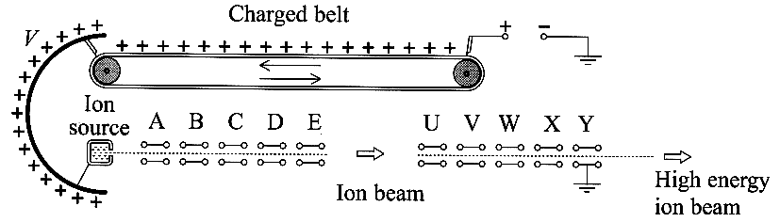
2. A Van de Graaff generator can produce a very
high voltage V relative to earth using a charged belt.
The diagram shows how this voltage can be used to
accelerate positively charged ions to high energies.
(a) The voltage V is used to charge the ion source and a series of cylindrical conducting tubes A to Y. The potential differences between the source and A, A and B, B and C, etc are each 120kV. Thus the kinetic energy of the singly charged ions emerging from the accelerator is 3.0 MeV. (i) Show that the mass equivalent of this kinetic energy is about 5 x 10 ⁻³⁰ kg and express this as a percentage of the rest mass, 7.0u, of a lithium atom.
(ii) Calculate the speed with which a singly charged lithium ion, ⁷₃Li⁺ emerges from the accelerator. (7)

(b) The energy of the particles emerging from a Van de Graaff generator can be further increased by injecting them into a linear accelerator (or linac). (i) Explain the principle of a linac. You may be awarded a mark for the clarity of your answer.
(ii) What fundamental property of matter was first revealed using high energy electrons from such a linac? (5)

(c) The cylindrical conducting tubes A, B, C...Y in the Van de Graaff generator can be treated as the plates of capacitors connected in series. Thus the first capacitor is formed by tubes A and B between which there is a voltage, the next capacitor by tubes B and C, and so on. (i) If the capacitance of each capacitor is C, what is the total capacitance of N such capacitors connected in series?
(ii) Draw a diagram to show how such a set of capacitors can be modelled using a number of springs. (Assume each spring obeys Hooke's law.) If the spring constant of each spring is k, what force is needed in your model to produce a total extension of x? (4)
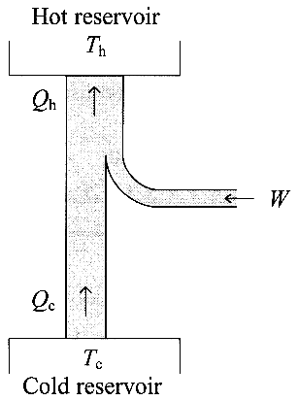
3. The diagram shows the principle of a heat pump as used, for example, in a domestic refrigerator.
(a) (i) List what each of the symbols T_{h}, Q_{h}, T_{c}, and Q_{c}, represents for a domestic refrigerator.
(ii) Using symbols from the diagram, write down an equation applying the principle of conservation
of energy to this heat pump. (iii) An electric motor provides the work W for the operation of the
heat pump. The motor runs from a 230 V supply and, during a period of operation of 3.5 minutes,
uses 42 kJ of energy. Calculate the current in the motor during this time. (7)

(b) Draw a diagram, similar to that above, showing the principle of a heat engine. (3)

(c) A heat pump designed to warm a house in winter uses a small lake as the cold reservoir. When
the water in the lake is at 0 °C the effect of using the heat pump is to freeze some of the water,
which has a specific latent heat of fusion l.
(i) After a day when the heat pump draws 26 MJ of energy from the lake, ice of mass 60 kg is
found around the cold reservoir of the heat pump. Calculate a value for l.
(ii) Looking up l in two data books, a student finds two different values, one of which he assumes is a misprint. Outline a method that he could use, given normal laboratory apparatus, to decide which value is correct. (6)

4. Eros, a stony asteroid, can be considered to be spherical and of radius 7800 m. Its gravitational field is so weak that a stone thrown vertically from its surface at more than 10ms⁻¹ ( = 22 m.p.h.) will never return. This speed is called the escape speed v_{e} from the asteroid.
(a) Sketch the gravitational field of Eros. (2)
(b) Suggest why any gas molecules diffusing to the surface of Eros from its core do not form an atmosphere. (2)

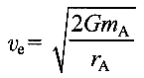
(c) The escape speed v_{e} from a spherical body such as this asteroid is related to the mass m_{A} and radius r_{A} of the asteroid by the equation

where G is the gravitational constant.
(i) Show that this equation is homogeneous with respect to units. (ii) Show that the mass of Eros is about 6 x 10¹⁵ kg and calculate its average density. (5)

(d) Whether a stone thrown from the surface of Eros escapes or returns can be likened to the indefinite expansion or final contraction of our Universe. (i) Sketch a graph to show how the size of our Universe varies with time since the Big Bang if it is to expand indefinitely. Label the axes of your graph. (ii) State what governs whether our Universe will expand indefinitely or come together in a Big Crunch. (4)

(e) At some future time, an asteroid of mass similar to that of Eros, i.e. of mass 6 x 10¹⁵ kg, may be found to be on a course which would result in it colliding with the Earth ten years later. In order to propel it off its course a rocket motor could be attached to the asteroid and fired to produce a force of 2 x 10⁶ N perpendicular to its path for 7000 s (about 2 hours). (i) Calculate the change in the asteroid's velocity which this rocket firing would produce.
(ii) Suggest with a reason whether such an attempt to alter the asteroid's course would be worthwhile. (4)

TOTAL FOR SECTION II: 49 MARKS TOTAL FOR PAPER: 80 MARKS

