1. Explain what, in physics, is meant by a field. (2)
State two differences between electric and magnetic fields. (2)

2. A current-carrying conductor is situated in a magnetic field. Describe how you could demonstrate that the magnitude of the force on the conductor is directly proportional to the magnitude of the current in it. You may wish to include a diagram in your answer. You may be awarded a mark for the clarity of your answer. (4)

An aluminium rod of mass 50 g is placed across two parallel horizontal copper tubes which are connected to a low voltage supply. The aluminium rod lies across the centre of and perpendicular to the uniform magnetic field of a permanent magnet as shown in the diagram. The magnetic field acts over a region measuring 6.0 cm x 5.0 cm.
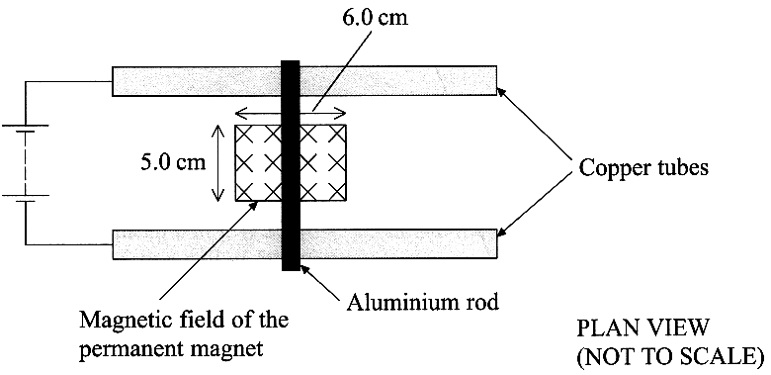

The magnetic flux density of the field between the poles is 0.20 T. Calculate the initial acceleration of the rod, assuming that it slides without rolling, when the current in the rod is 4.5 A. (4)

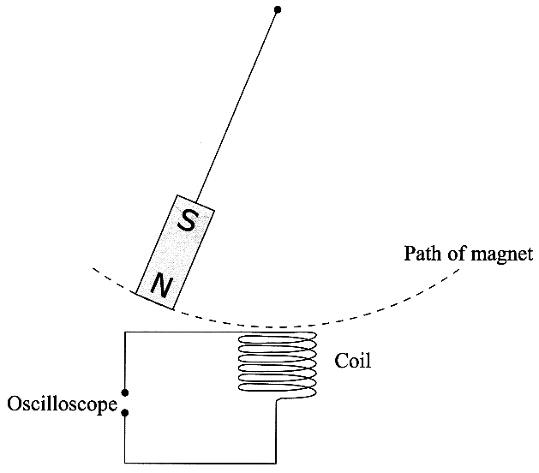
3. A bar magnet is suspended above a vertical coil of wire.
It is then displaced to one side and released such that it
oscillates above the coil as shown in the diagram.
The coil of wire has its ends connected to an oscilloscope.

Explain why an e.m.f. is induced across the
ends of the coil. (2)
By considering Lenz's law, label with an X on
a copy of the diagram each position of the
magnet at which the induced e.m.f.
changes polarity. (2)

The maximum induced e.m.f. is 3.0 mV.
Calculate the rate of change of flux needed
to induce this e.m.f. in a coil of 500 turns. (2)
State three changes that could be made to
the apparatus in order to increase the
maximum induced e.m.f. (3)

4. The diagram shows two parallel plates with a
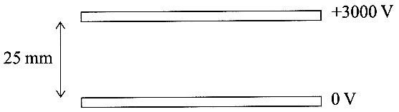
potential difference of 3000 V applied across them.
The plates are in a vacuum.

On a copy of the diagram sketch the electric
field pattern in the region between the plates. (2)
On the same diagram sketch and label two equipotential lines. (1)
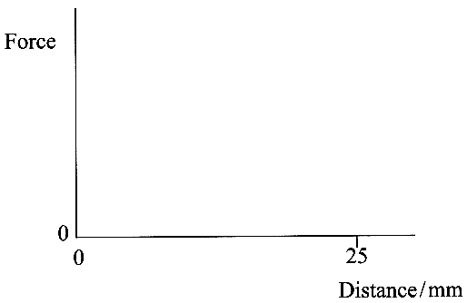
The plates are 25 mm apart.
Show that the force experienced by an
electron just above the bottom plate is
about 2 x l0 ⁻¹⁴ N (3)
Complete a copy of the graph to show how
the force on the electron varies with the
distance of the electron from the bottom plate. (2)

This force causes the electron to accelerate.
The electron is initially at rest in contact with
the bottom plate when the potential difference is applied.
Calculate its speed as it reaches the upper plate. (3)

5. A satellite of mass m_{s} moving at speed v_{s} is in a circular orbit around the Earth, mass M_{E}. The radius of the Earth is R_{E} and the satellite is at a height h above the Earth's surface. The gravitational constant is G.
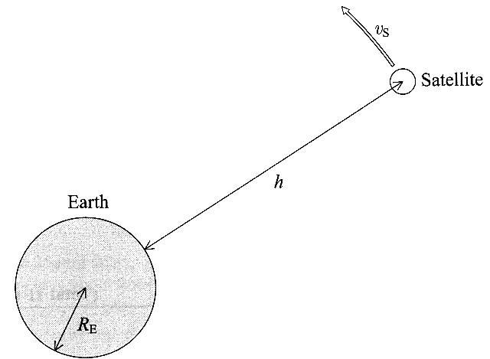
Using the symbols given, write down an expression for the magnitude of
(i) the centripetal force needed to maintain the satellite in this orbit,
(ii) the gravitational field strength in the region of the satellite. (3)

Show that the greater the height of the satellite above the Earth's surface, the smaller will be its orbital speed. (3)
A mechanic working outside an orbiting spacecraft accidentally releases his spanner.
Describe the subsequent motion of the spanner. (2)

TOTAL FOR PAPER: 40 MARKS

