Topic A – Astrophysics

1. (a) State the meaning of Tin the Stefan-Boltzmann law.
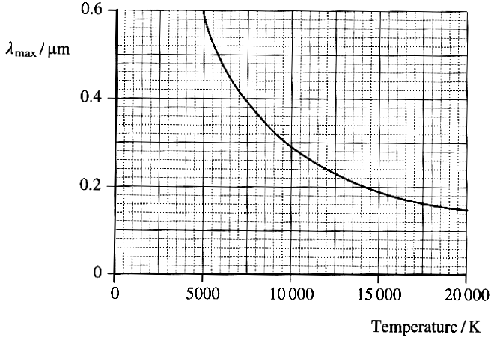
State the unit of luminosity. (3)

(b) The graph shows how λ_{max}
(the wavelength of the peak of
the radiation spectrum) for a range
of stars varies with the surface
temperatures of the stars.

Carry out appropriate calculations to
show that this graph is consistent
with Wien's law. (3)
Use the graph to estimate the surface
temperature of a star whose intensity
peaks at a wavelength of 0.4 μm. (1)
This star has a radius of 9.0 x 10⁷ m.
Calculate its luminosity. (4)
Calculate the rate in kg s⁻¹ at which matter is being consumed in this star. (3)

(c) Complete a copy of the sentence below by choosing the appropriate term within each pair of brackets.
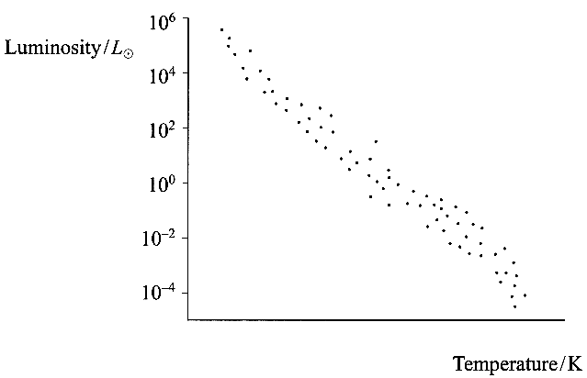
A red giant is a ( cool, hot ) star of ( high, low ) luminosity and large ( mass, surface area ) which has moved ( higher up the main sequence, lower down the main sequence, off the main sequence ). (4)

On a copy of the incomplete
Hertzsprung-Russell diagram opposite
(i) add a scale to the
temperature axis,
(ii) mark the approximate
position X_{s} of the Sun
(luminosity of the Sun = L_{Θ}),
(iii) shade in a region labelled W
where a white dwarf star might be found,
(iv) shade in a region labelled R
where the future red giant formed
from the Sun will be found. (5)

(d) Stars much more massive than the
Sun may become supemovae. How do astronomers recognise a supernova? (2)
How is a supernova formed? You may be awarded a mark for the clarity of your answer. (3)

(e) Astronomers announced in January 2000 that they had found our nearest black hole at a distance of 1600 light years from Earth. What is meant by a light year? (1)
Show that 1600 light years is equal to a distance of 1.5 x l0¹⁹ m. (2)
The black hole was detected because of its effect on a neighbouring star.
Why do astronomers have to rely on indirect evidence for locating black holes? (1)

(Total 32 marks)

