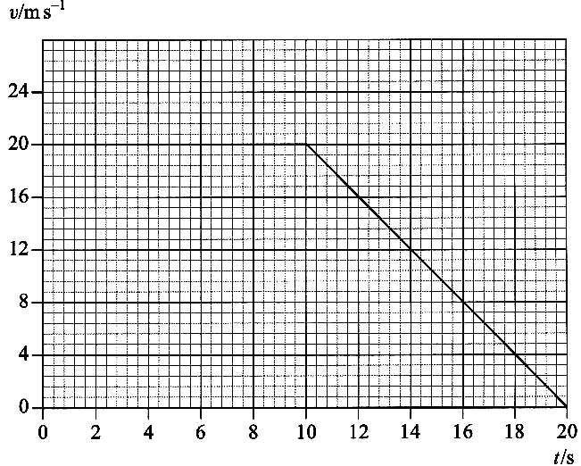
1. The graph opposite shows the variation of velocity with time for a
body moving in a straight line. Calculate:
(i) the total distance traveled,
(ii) the average speed over the 20 seconds. [4]

2. A lorry is travelling at 25 m s⁻¹ down a mountain road when the
driver discovers that the brakes have failed. She notices that an escape
lane covered with sand is ahead and stops her lorry by steering it on
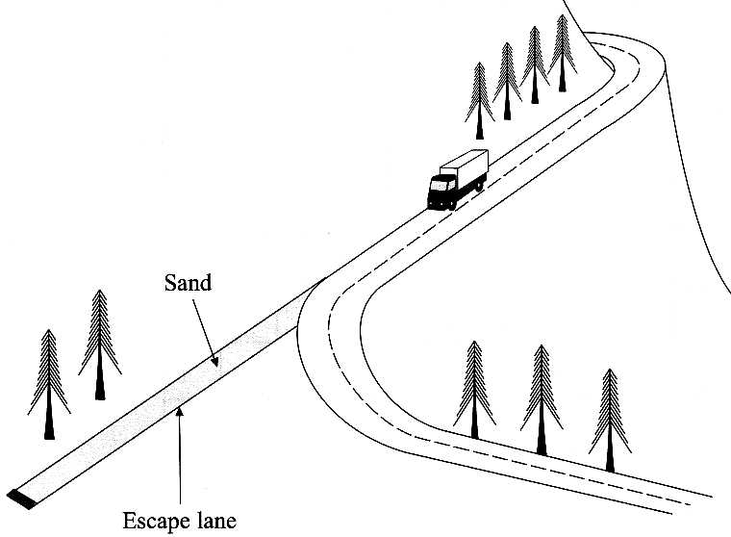
to the sand.

The lorry is brought to a halt in 40 m.
Calculate the average
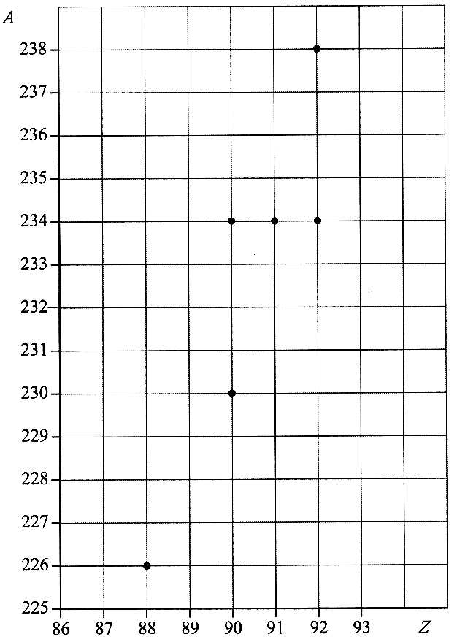
deceleration of the lorry. [3]
Suggest how the depth of
the sand affects the
stopping distance.
Justify your
answer. [1]

3. The nucleon number A and proton number Z for six different nuclides are
shown on the grid opposite.
Explain the term isotope. [1]
On a copy of the grid, circle two nuclides that are isotopes of the
same element. [1]
Draw an arrow labelled α showing one of the nuclides decaying by
alpha emission into one of the other nuclides.
Draw an arrow labelled β showing one of the nuclides decaying by
beta-minus decay into one of the other nuclides.
Use information from the grid to help you complete a nuclear equation,
in the form shown below, for this beta-minus emission.
Y → X + β
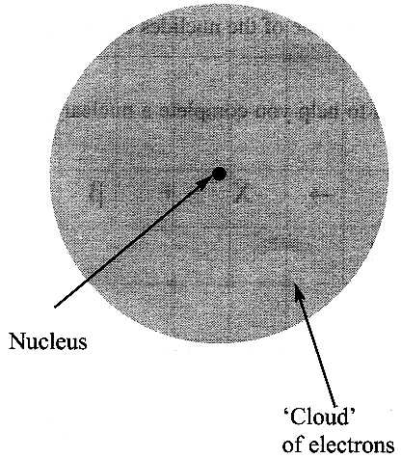
[Y and X represent the nuclei.] [5]

4. The nuclear atom may be represented as in the diagram.
Explain how the results of the alpha particle scattering experiment verify the nuclear
model of the atom. You may be awarded a mark for the clarity of your answer. [5]

5. Determine the resultant force on the object below. [1]
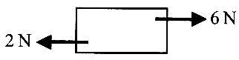

What can be deduced about the motion of an object:
(i) when the resultant force on it is zero,
(ii) when the resultant force on it is vertically upwards,
(iii) when the resultant force on it is in the opposite direction to its motion? [3]

Newton's third law of motion is sometimes stated in the form: "To every action there is an equal and opposite reaction".
A student argues that, in that case, the resultant force on an object must always be zero and so it can never be moved.
Explain what is wrong with the student's argument. [2]

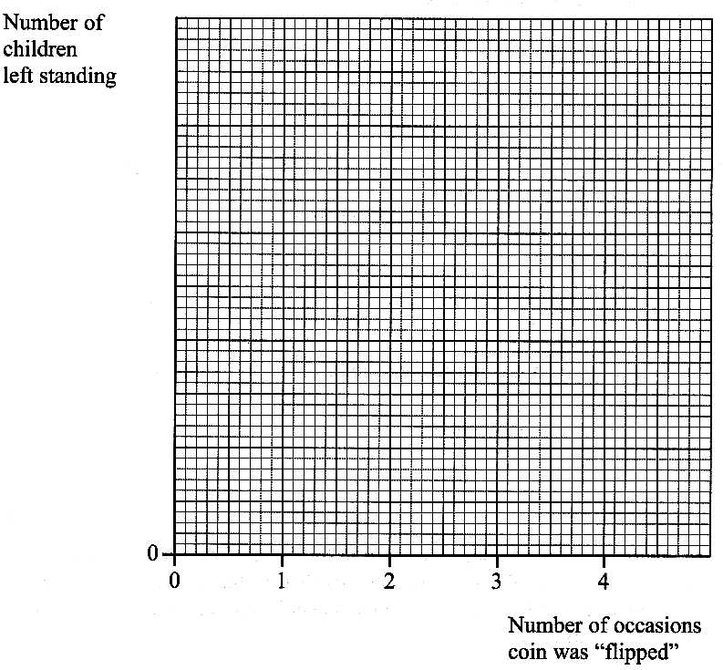
6. A physics student asked a large group of children to stand up and perform
a simple experiment to model radioactive decay.
Each child flipped a coin. Those who flipped a "head" sat down.
The children left standing again flipped a coin and those who flipped
a "head" sat down. This process was repeated twice more.
There were initially 192 children standing.
Plot on a copy of the axes opposite the expected graph of the results.
Add a scale to the y-axis. [3]
Radioactive decay is a random process. Explain what this means. [1]
In what way is the experiment a model of a random process? [1]
What is meant by the half-life of a radioisotope? [1]
Does the model illustrate half-life? Justify your answer. [1]

7. A wooden mallet is being used to hammer a tent peg into hard ground.
The head of the mallet is a cylinder of diameter 0.100m and length 0.196m.
The density of the wood is 750 kg m⁻³. Show that the mass of the head is approximately 1.2kg. [3]
The head strikes the tent peg as shown at a speed of 4.20ms ⁻¹ and rebounds at 0.58 m s ⁻¹.
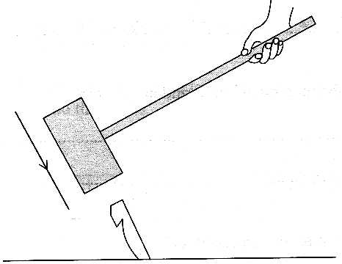
Calculate the magnitude of its momentum change in the collision. [3]
The head is in contact with the peg for 0.012 s.
Estimate the average force exerted on the peg by the head during this period. [2]
Give a reason why your value for the force will only be approximate. [1]
With reference to your calculations above, discuss whether a mallet with a rubber head
of the same mass would be more or less effective for hammering in tent pegs. [2]

8. The diagram opposite shows a small vehicle, which is free to
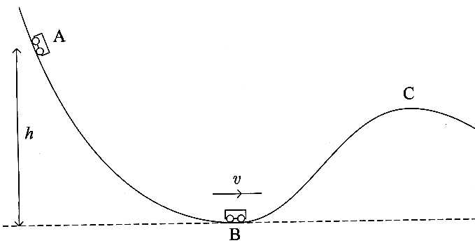
move in a vertical plane along a curved track.
The vehicle of mass m is released from rest from point A.
It runs down to point B, a distance h vertically below A.
Its speed at point B is v. Write down expressions for:
(i) the gravitational potential energy lost by the vehicle as it runs
from A to B, (ii) the kinetic energy of the vehicle at B. [1]
Hence derive an expression for the speed v. [2]
State one assumption you have made in your derivation. [1]
Would you expect the vehicle to pass point C?
Explain your answer. [2]

9. The diagram shows a painter standing on a uniform plank AE which rests on two moveable supports, B and D.
The weight of the plank is 220 N. The length of the plank is 2.5 m.
The free-body force diagram of the plank is also shown. (X is the push of the painter on the plank.)
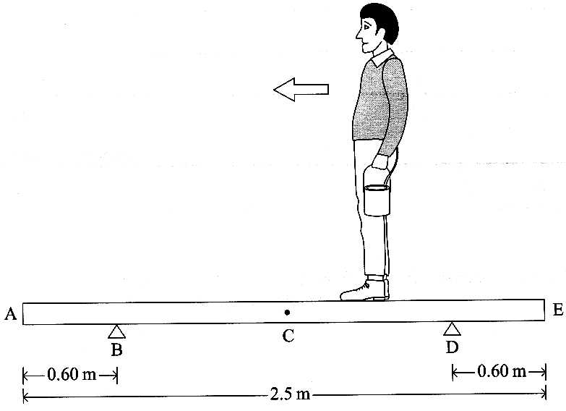

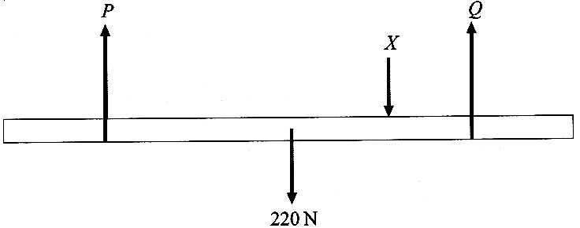

The total weight of the painter and paint tin is 760 N. Calculate the total mass of the painter and paint tin. [1]
The painter walks towards end A of the plank, still holding the paint tin.
(i) The magnitude of force Q decreases. Explain why. [2]
(ii) What happens to the plank and the painter if he passes the point where Q becomes zero?
Calculate the distance l of the painter from A when Q becomes zero. [4]
Explain how the value of l would change if the painter had a smaller mass.
How could the painter avoid force Q reaching zero, no matter where he stands? [3]

TOTAL FOR PAPER: 60 MARKS

