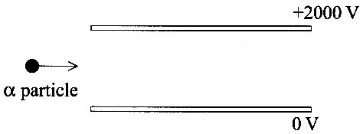
1. The diagram shows a high-speed alpha particle entering
the space between two charged plates in a vacuum.

Add to a copy of the diagram the subsequent path of the
alpha particle as it passes between the plates and well
beyond them. (3)

The gap between the plates is 10 mm.
Calculate the magnitude of the electric force on the alpha particle as it passes between the plates. (3)
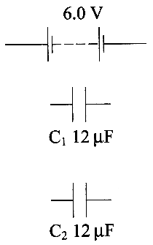
2. Complete copies the circuit opposite to show the two capacitors connected in
(a) parallel with the battery & (b) series with the battery. (2)

Use the values given to help you complete a copy of the table below. (6)
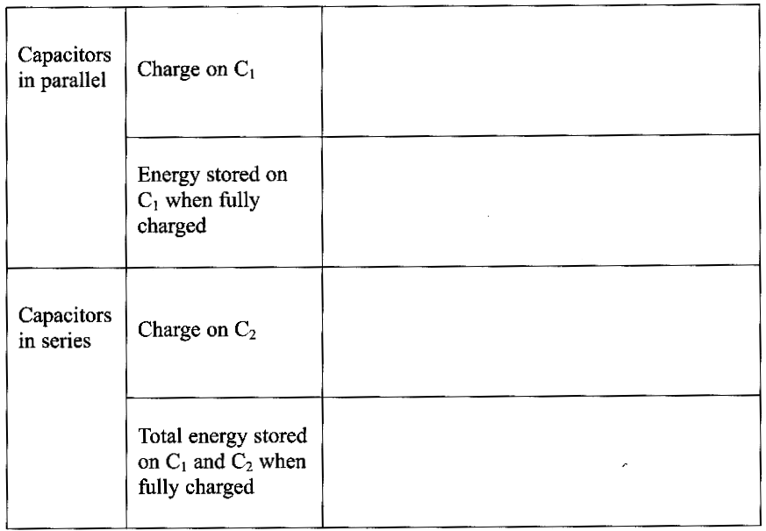

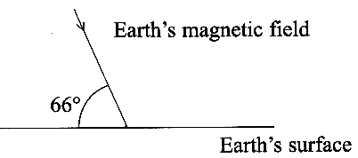
3. In London the Earth's magnetic field has a magnetic flux density
of 4.8 x 10⁻⁵ T at 66° to the horizontal as shown in the diagram.

Calculate the magnitude of the horizontal component of the Earth's
magnetic field in London. (2)

For a conductor of length l moving at a speed v perpendicular to a
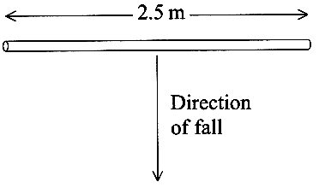
field of flux density B, the induced voltage V between the ends of the
conductor is given by: V = B l v
A metal scaffolding pole falls from rest off a high building.
The pole is aligned horizontally in an east-west direction.
The Earth's magnetic field lines at this point lie in a north-south direction.

Calculate the induced voltage across the pole 2.0 s after it started to fall. (3)

What would be the induced voltage after 2.0 s if the pole were aligned in
a north-south direction?
Explain your answer. (2)

4. The diagram shows two blades of aluminium. Blade A is complete. Blade B has been cut to form a comb.
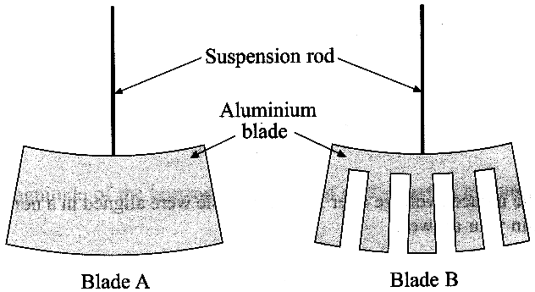
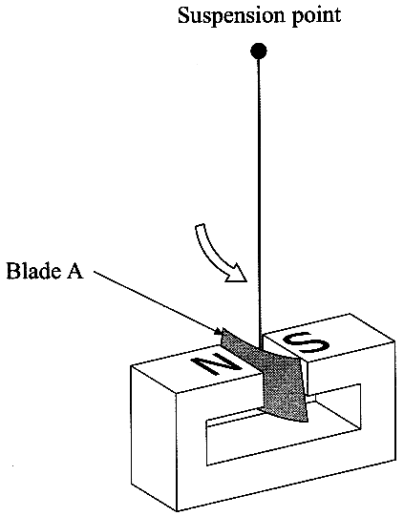

Which electrical property of the blade is increased by
cutting away the aluminium? (1)

Each blade is suspended in turn between the poles of a strong permanent magnet.
Electromagnetic induction produces current loops in blade A as it swings
between the poles.

Express Faraday's law of electromagnetic induction in words. (2)
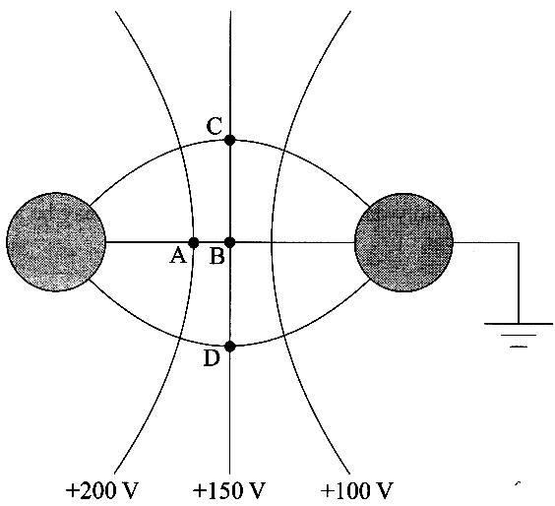
The oscillations of blade A are rapidly damped. Explain why.
You may be awarded a mark for the clarity of your answer. (4)

Suggest why the oscillations of blade B are only very
lightly damped when it replaces blade A as the blade
swinging between the poles. (1)

5. An isolated charged metallic sphere is brought close to an
identical earthed sphere that initially was uncharged.
Part of the resultant electric field and some of its equipotential
lines are shown.

On a copy of the diagram mark the sign of the charge on
each sphere. (2)
Draw an arrow on one of the field lines to indicate its direction. (1)
Expressing your answers in eV, state how much work is done
(i) against the field in taking an electron from C to D,
(ii) against the field in taking an electron from C to A. (3)

6. The diagram shows a body of mass w situated at a point which is a distance R from the centre of the Earth and r from the centre of the Moon.
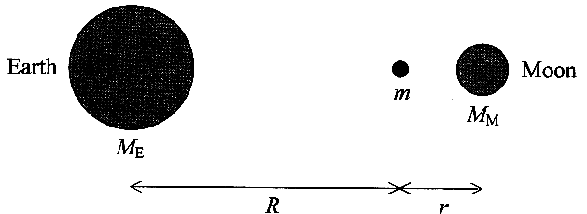
The masses of the Earth and Moon are M_{E} and M_{M}
respectively. The gravitational constant is G.
Using the symbols given, write down an expression for
(i) the gravitational force of attraction between the body
and the Earth,
(ii) the gravitational force of attraction between the body
and the Moon. (2)

The resultant gravitational force exerted upon the body at this point is zero.
Calculate the distance R of the body from the centre of the Earth given that r = 3.9 x 10⁷m and M_{E} = 81 M_{M}. (3)

TOTAL FOR PAPER: 40 MARKS

