Topic C - Nuclear and Particle Physics

3. (a) The diagram shows part of the range of unit prefixes.
Copy and complete the diagram below by filling in the empty boxes. (4)
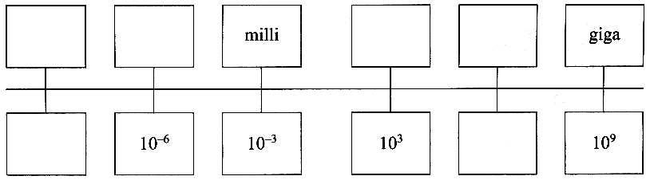
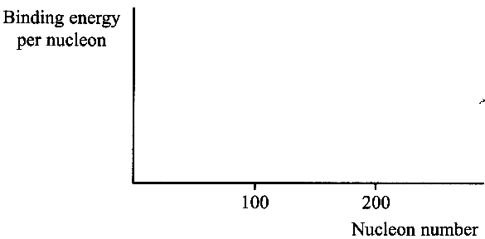
(b) What is meant by the term binding energy?
You may be awarded a mark for the clarity of your answer. (3)

On a copy of the axes opposite sketch a graph of binding energy
per nucleon against nucleon number. (2)

The binding energy of ¹⁶₈O is 123.45 MeV and the binding energy
of ¹⁷₈O is 126.43 MeV.
Which of these two isotopes of oxygen would you expect to be more stable?
Explain your answer. (3)
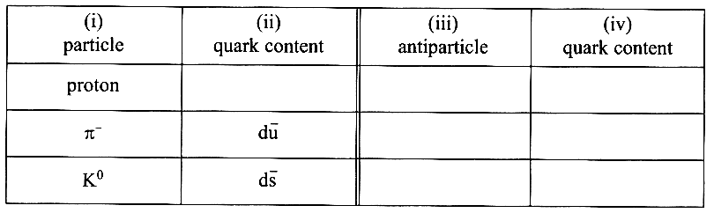
(c) Add the quark content of the proton to column (ii)
in a copy of of the table opposite.
Complete column (iii) to give the antiparticles of
the particles in column (i).
Complete column (iv) to show the quark content
of the antiparticles. (5)

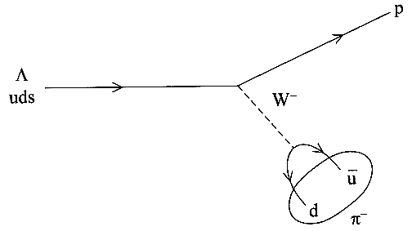
(d) The Feynman diagram opposite shows the decay of a neutral
lambda particle (Λ) to a proton and a negative pion (π⁻ ).
Show that the strange quark has a charge of - ¹/₃. (1)

Which of the following words which can be used to describe a π⁻ :
hadron, lepton, meson, baryon
What type of particle is the W ⁻ ? (3)

Write down an equation for the decay of the lambda particle. (1)
Show that both charge and baryon number are conserved in this decay. (2)
Explain why this cannot be a strong interaction. (1)

(e) A radioactive isotope of carbon, ¹⁴₆C, is continuously produced in the upper atmosphere when neutrons ejected from nuclei by cosmic rays collide with atmospheric nitrogen ¹⁴₇N.
Copy and complete the nuclear equation below to show the production of radioactive carbon in the upper atmosphere. Hence identify X, the other product of the reaction. (3)
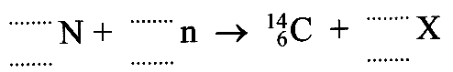

Living plants take up carbon dioxide from the atmosphere and have a normal activity
of 15.3 counts per minute per gram of carbon due to absorption of some carbon dioxide containing carbon-14.
On death, the plant no longer takes in carbon-14 and the amount already taken up decays with a half-life of 5730 years. Estimate the age of an archaeological specimen with an activity of 1.9 counts per minute per gram of carbon. (3)

Suggest one problem in measuring an activity as low as 1.9 counts per minute per gram of carbon. (1)

Total 32 marks

