Topic B - Solid Materials

2. (a) The diagram shows part of the range of unit prefixes.
Copy and complete the diagram below by filling in the empty boxes. (4)
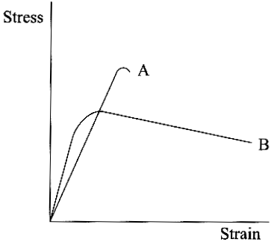
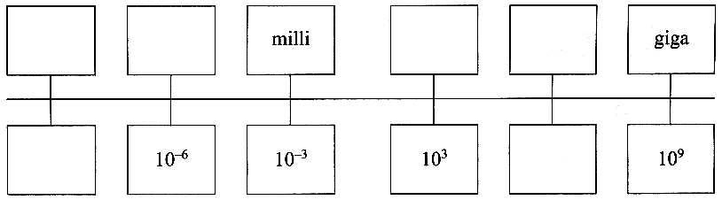

(b) The stress-strain curves for two materials A and B up to their breaking
points are shown opposite.
State, giving the reason for your choice in each case, which material is
(i) tougher; (ii) stiffer; (iii) more ductile (3)

Add a third line to a copy of this graph showing the behaviour of a
material C which has the following properties:

C has a smaller Young modulus than A or B,
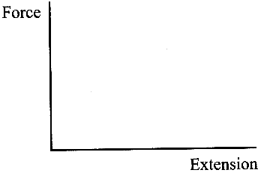
is stronger than A or B and is brittle. (3)

(c) On a copy of he axes opposite sketch a force-extension graph for natural rubber,
showing its behaviour for both increasing and decreasing force. (2)

Use your graph to explain what is meant by elastic hysteresis.
You may be awarded a mark for the clarity of your answer. (3)

(d) The diagram opposite shows an edge dislocation in a crystal lattice.
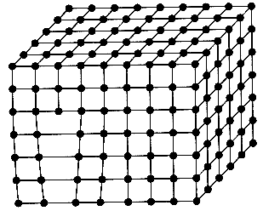
Label the slip plane on a rough copy of this diagram.
Explain how an edge dislocation makes it easier for layers of
atoms to slip over each other. (3)

How can a metal be work hardened?
Complete a copy of the sentence below by circling any word(s) in the
square brackets that describe(s) a metal after it has been work hardened.
After work hardening a metal is [ stronger, stiffer, more ductile, more brittle ]. (3)

Describe the process of annealing and explain in microscopic terms why it can return a work-hardened metal to its original softer state. (3)
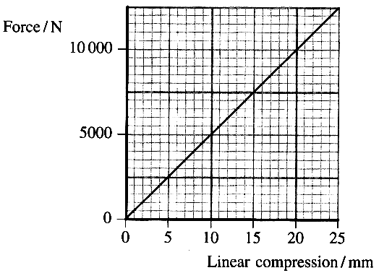
(e) Cycle helmets have a polystyrene foam lining. In the event of an
accident the foam lining is compressed (crushed) and provides a
stopping distance for the cyclist's head, reducing deceleration of the brain.
The graph shows the relationship between the force transmitted by a typical
foam liner and the amount of linear compression of the foam.
Use the graph to calculate the energy stored by this foam liner when it is
crushed by 18 mm. (4)

Calculate the deceleration of a head of mass 5.8kg when acted upon by a
force of 10000N. (2)

Helmets are designed to reduce head decelerations to no more than 200 g
{g = acceleration of free fall). Does this helmet fulfil the design requirements at this force?
Justify your answer. (1)
Suggest one reason why a cycle helmet should be replaced once it has suffered an impact. (1)

Total 32 marks

