Topic A – Astrophysics

1. (a) The diagram shows part of the range of unit prefixes.
Copy and complete the diagram below by filling in the empty boxes. (4)
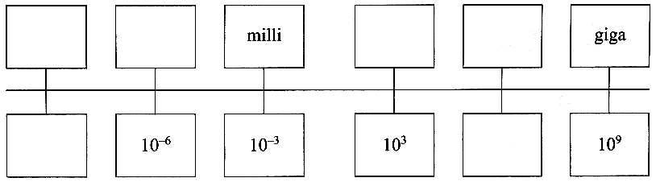

(b) When a star moves off the main sequence it initially becomes a red giant.
Describe the processes occurring which result in it becoming "giant-sized".
You may be awarded a mark for the clarity of your answer. (4)
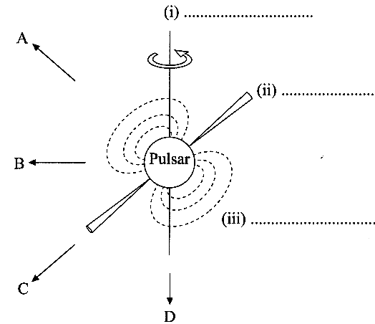
Use Wien's law to explain why these giant stars look red compared
with their appearance when they were on the main sequence. (2)

Use Stefan's law to explain why a red giant has greater luminosity
than when it was a main sequence star. (3)

(c) State the labels (i), (ii), (iii), required for the diagram of a
pulsar opposite. (3)

What type of star is a pulsar? (1)

In which possible directions, A, B, C, D, might the Earth be situated
and receive signals from this pulsar?
Explain your answer. (3)

(d) State two advantages of observing stars using radio telescopes. (2)

A radio telescope sensitive to certain frequencies in the GHz range detects a radio flux (intensity) of 1.6 x I0⁻¹⁵ Wm ⁻² from the Crab Nebula (one of the brightest radio sources in the sky).
What is the radio luminosity of the Crab Nebula in this frequency range?
(Distance of the Crab Nebula from Earth = 6.8 x l0¹⁹m.) (4)

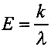
(e) Light can be regarded as a stream of tiny packets of energy called photons.
The energy of a photon (in joules) is related to the wavelength of the light (in metres) by the expression
where A: is a constant equal to 2.0 x 10⁻²⁵ kg m³ s⁻².

Show that a photon of red light (λ = 700 x 10⁻⁹ m) has an energy of about 3 x 10⁻¹⁰ J. (1)

Hence estimate the number of photons emitted per second by a red giant of luminosity 2.3 x 10³¹ Js⁻¹. (2)

Explain why your answer is only an approximation. (1)

State two advantages of CCDs compared with photographic film for recording images of distant stars. (2)

Total 32 marks

