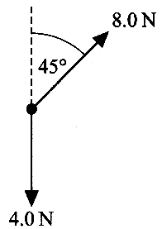
1. The diagram shows two forces acting on a body.
On a piece of graph paper draw a scale diagram to determine the resultant force
acting on the body. Use a scale of 1 cm to 1 N.

State the magnitude of the resultant force. (4)

What name is given to physical quantities which add by the same rule as forces?
Name two other examples of such physical quantities. (2)

2. A student performs an experiment to study the motion of a trolley on a horizontal
bench. The trolley is pulled by a horizontal string which runs over a pulley to
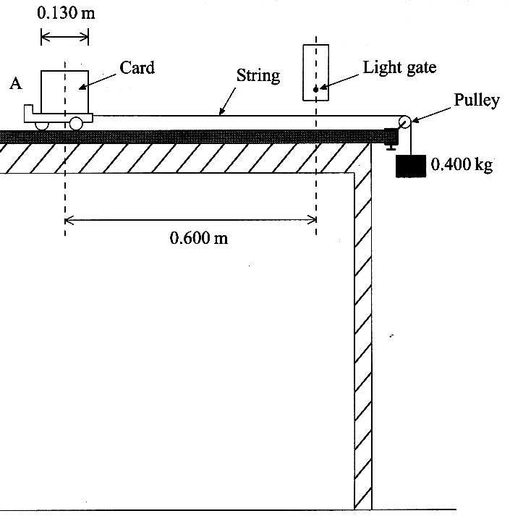
suspended mass.

Initially the trolley is held at rest at position A.
It is then released.

When it has moved some distance, but before
he suspended mass hits the floor, a card
attached to the trolley passes through a
light gate.

A clock controlled by the gate records how
long the card blocks the light beam.

The card, which is 0.130 m long, takes 0.070 s to pass through the beam.
Calculate the average velocity of the trolley as it passes through the light gate. (2)

The light gate is 0.600 m from the start. Show that the acceleration of the trolley is
approximately 3 m s ⁻² (3)

The mass of the trolley is 0.950 kg. Calculate the tension in the string pulling it,
stating any assumption which you make. (3)

The tension in the string must be less than the weight of the 0.400 kg mass suspended from it.
Explain why. (2)

3. The acceleration of free fall g can be measured by timing an
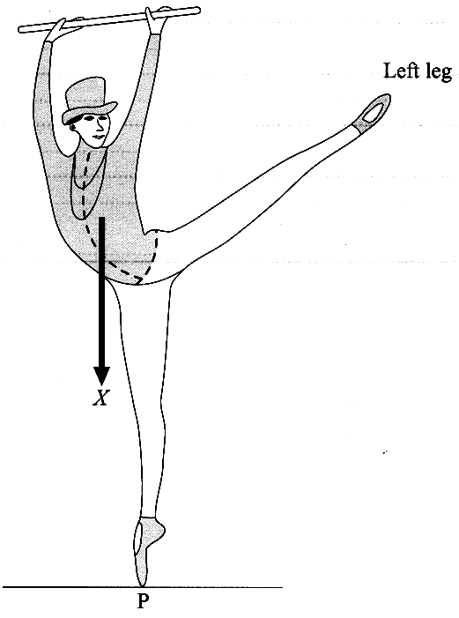
object falling from rest through a known distance. Explain one
advantage and one disadvantage of making thi as large as possible. (2)

In a typical laboratory measurement of g, a steel sphere is dropped
through a distance of the order of one metre. With the help of a
labelled diagram, describe and explain an experimental method
of measuring the time it takes the sphere to fall. (4)

At any given place, the weight of a body is proportional to its mass.
Explain how measurements of g support this statement. (2)

4. The diagram opposite shows a ballet dancer balancing on the point P
of her right foot, with her left leg extended. The arrow labelled X represents
the weight of the whole of her body apart from her legs.

To a rough copy of this diagram add a second arrow to represent the weight
of her extended left leg. Label this arrow Y.

Add a third arrow, labelled Z, to represent the weight other right leg. (2)

With reference to the relative sizes and positions of these forces, explain
how this situation illustrates the principle of moments.
You may be awarded a mark for the clarity of your answer. (5)
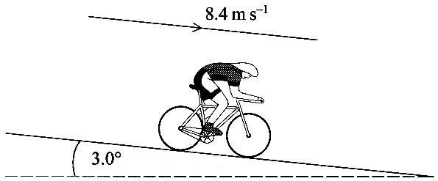
5. A cyclist is free-wheeling down a long slope which
is at 3.0° to the horizontal. He is travelling, without
pedalling, at a constant speed of 8.4 m s⁻¹.

The combined mass of the cyclist and bicycle is 90 kg.
Calculate the gravitational potential energy (g.p.e.)
lost per second. (3)

What happens to this lost g.p.e.? (1)

At the bottom of the slope the cyclist turns round and pedals back up at the same steady speed of 8.4 m s⁻¹.
Give an estimate of the rate at which the cyclist does work as he climbs the hill. (2)

6. Define momentum and state its unit. (2)
A stationary nucleus of thorium-226 decays by alpha particle emission into radium.
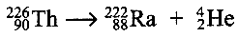
The equation for the decay is:

State the value of the momentum of the thorium nucleus before the decay. (1)
After the decay, both the alpha particle and the radium nucleus are moving.
Which has the greater speed? Justify your answer.
What can be said about the directions of travel of the two particles? (3)

7. Indium-115 (symbol In, proton number 49)
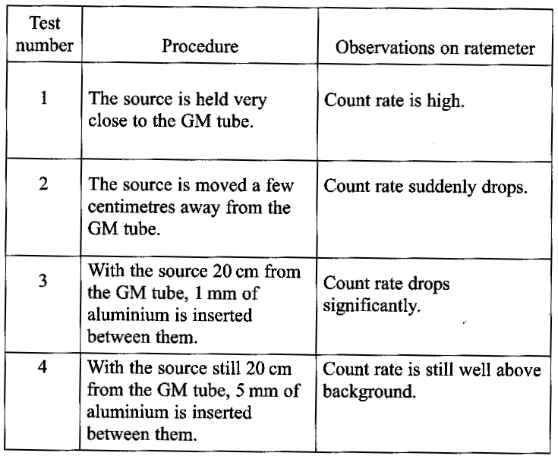
decays by beta-minus emission to tin (symbol Sn).
Write down a nuclear equation representing
this decay. (2)

Indium-115 has a half-life of 4.4 x 10¹⁴ years.
Calculate its decay constant. (2)
A radioactive source contains 2.3 x 10²¹ nuclei
of indium-115. Calculate the activity of this
source in becquerels.
State how this activity compares with a normal
background count rate. (3)

8. A Physics department has an old radium
source which is thought to emit alpha, beta
and gamma radiation. A student performs
some experimental tests to find out whether
this is correct. She uses a metre rule, a 1 mm
thick sheet of aluminium, a 5 mm thick sheet
of aluminium and a suitable Geiger-Muller
tube with a ratemeter. Her results are as
shown in the table opposite:

Which test(s) lead to the conclusion that each of alpha, beta and gamma radiation is emitted by the source?
Justify your answers. (4)

9. Alpha particles and electrons have each been used in scattering experiments to probe the structure of matter.
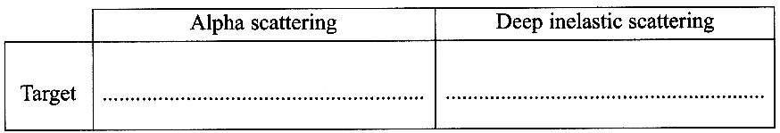
Copy out and complete the table. (2)

What conclusions can be drawn from
(i) alpha scattering experiments; (ii) deep inelastic scattering experiments? (4)

TOTAL FOR PAPER: 60 MARKS

