1. A 2.0 μF capacitor is charged to a potential difference (p.d.) of 50 V and a 3.0 μF capacitor is
charged to a p.d. of 100 V.
Calculate the charge on the plates of each capacitor and the energy stored by each. (4)

The capacitors are then joined together in parallel with their positive plates connected together.
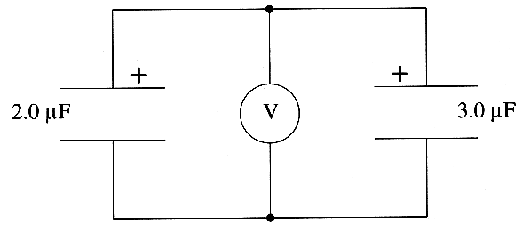
What is the equivalent capacitance of this combination? (1)
Hence calculate the total energy stored by the capacitors after connection. (3)
Suggest why there is a loss of stored energy when the capacitors are connected. (2)

2. The diagram is of a simplified cathode ray tube.
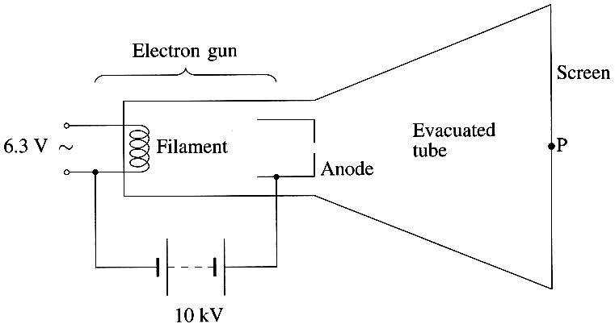
An electron beam is produced by the electron gun in the tube. A beam of electrons emerges from the hole in the anode and strikes the screen at point P.
Explain why electrons are emitted from the surface of the filament. (2)
Explain why the electrons move from the filament towards the anode. (1)

The potential difference between the filament and the anode is 10 kV.
Calculate the energy in joules of an electron emerging from the hole in the anode. (2)

The electron beam forms a current of 1.5 mA.
Show that the number of electrons passing through the hole in the anode is about 9 x 10¹⁵ per second. (2)
Hence calculate the rate at which energy is being delivered to the screen by the beam of electrons. (2)

3. Explain the action of the transformer shown below.
You may be awarded a mark for the clarity of your answer. (5)
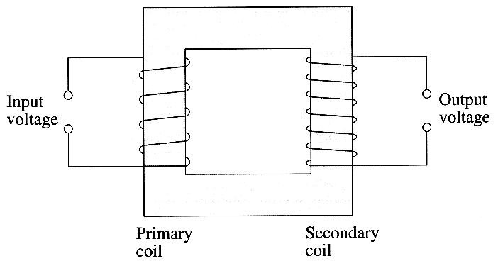
The following diagram shows an ideal step-down transformer.
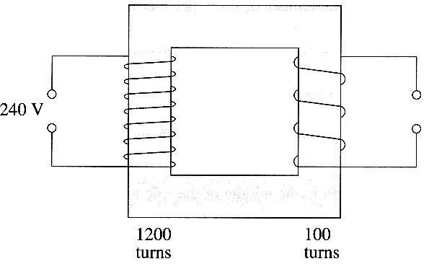
The input voltage is 240 V. Calculate the output voltage of the transformer. (2)

4. A metal "slinky" spring can be used as a long solenoid. It is stretched out so that each turn is 1.6 cm from its nearest neighbour. A current of 0.50 A is passed through the coils of the solenoid.
Calculate the number of turns per metre in the solenoid. (1)
Show that the magnetic field strength in the middle of the solenoid is about 4 x 10 ⁻⁵ T. (2)

A longitudinal compression pulse is sent along the solenoid. The resulting changes in the magnetic field strength are detected by a Hall probe fixed inside the solenoid. As the compression pulse passes the Hall probe, the reading changes as follows:

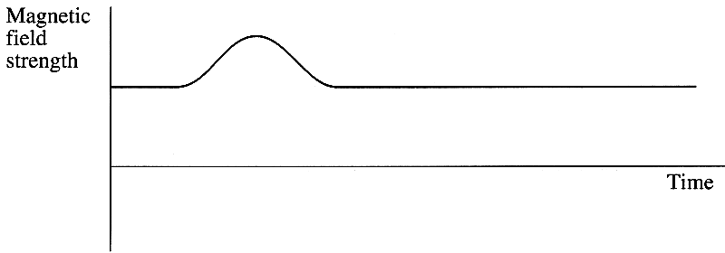
Explain the shape of the graph. (2)

The solenoid is replaced by a heavier one that has an identical number of turns per unit length. A rarefaction pulse is then sent along this heavier solenoid. This pulse travels at a slower speed than the pulse in the first solenoid.
Show on a copy of the axes opposite how the reading on the Hall probe will now vary. (2)

5. The Earth's gravitational field is radial.
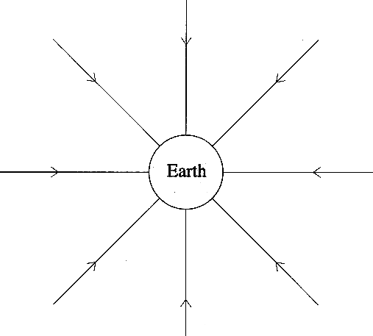
Explain how the diagram indicates that gravitational field strength is a vector quantity. (1)
Add to a copy of the diagram three successive equipotential lines. (3)

When a satellite is placed in a circular orbit around the Earth its change in gravitational potential is 2.2 x 10⁷ J kg⁻¹.
If the satellite has a mass of 5500 kg, calculate the work done in placing the satellite in this orbit. (2)
Explain why the gravitational potential energy of a satellite does not change as it orbits the Earth. (1)

TOTAL FOR PAPER: 40 MARKS

