Topic C - Nuclear and Particle Physics

3. (a) Use the data below to calculate the binding energy in MeV of a nucleus of oxygen, ¹⁶₈O.
Data: mass of proton = 1.007 276 u; mass of neutron = 1.008 665 u; mass of oxygen nucleus = 15.990 527 u (3)
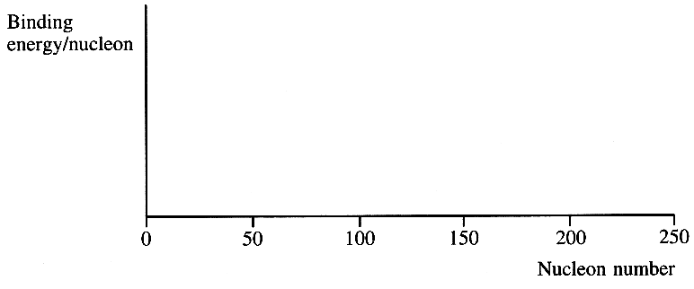
Calculate the binding energy per nucleon of ¹⁶₈O. (1)

On a copy of the axes opposite sketch a graph of
binding energy per nucleon against nucleon number. (2)
Show on the graph the approximate position of
(i) oxygen, labelling this point O,
(ii) iron, the most stable element, labelling this point Fe,
(iii) uranium, ²³⁸₉₂U, labelling this point U. (3)

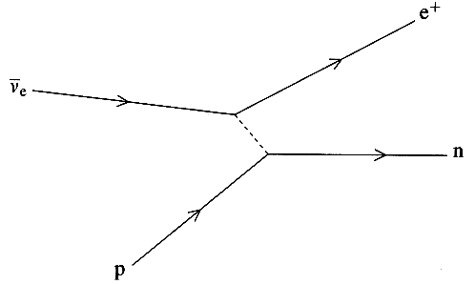
(b) The Feynman diagram opposite represents an interaction
between an antineutrino and a proton, known as inverse beta decay.
Write an equation for this interaction. (1)
Show that charge is conserved in this interaction. (1)
What type of interaction is responsible for inverse beta decay? (1)
Justify your answer. (1)
What exchange particle is involved? (2)
Suggest why the interaction is known as inverse beta decay. (2)

(c) State what is meant by a fundamental particle.
Which of the following are fundamental particles?
[ positron; neutron; muon; K° meson. ] (3)
Explain why it is not possible to have a meson with a charge of +2. You may be awarded a mark for the clarity of your answer. (3)

(d) Read the short passage below and answer the questions about it.

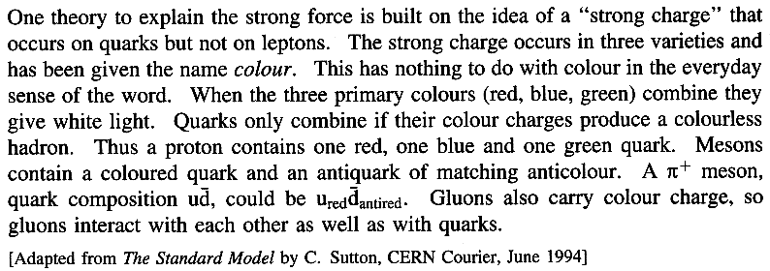

Give an example of a lepton. (1)

How do we know that leptons carry no colour charge? (1)

State one possible coloured quark combination for a proton. (2)

Three coloured quark combinations for a π ⁻ meson are listed below. For each example state whether it is a possible or an impossible combination and explain your answer. (4)
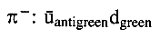
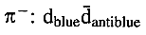
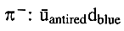

What type of particle is a gluon? (1)

(Total 32 marks)

