Topic A – Astrophysics

1. (a) The intensity of solar radiation at the top of the Earth's atmosphere is 1.4 kW m⁻². The Sun's average distance from the Earth is 1.5 x 10¹¹ m. Show that the luminosity of the Sun is approximately 4 x 10²⁶ W. (3)
Why is the intensity at the top of the Earth's atmosphere used in this calculation? (1)

The Sun's energy is produced when hydrogen 'burns' to form helium. Four protons are required to make each helium nucleus. Use the data below to estimate the energy released for each helium nucleus created.
(Your answer will be only approximate as it ignores the positrons which are also released in the process.)
Data: mass of proton = 1.67 x 10⁻²⁷ kg; mass of helium nucleus = 6.64 x 10⁻²⁷ kg (4)

Show that the number of helium nuclei created per second in the Sun is approximately 1 x 10³⁸. (1)
Hence estimate the mass of hydrogen burned per second in the Sun. (2)
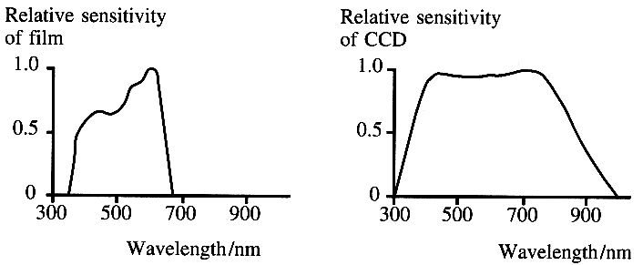
(b) The graphs show the sensitivity of a particular
brand of photographic film and that of a charge
coupled device, CCD, to different parts of the
electromagnetic spectrum.

The surface temperature of a star can be calculated
once the wavelength of the peak of its spectrum (λ_{max})
is known. Use the graphs to explain why photographic
film would be less suitable than CCDs for determining λ_{max} of a star which radiates mainly in the visible
region (400 nm - 700 nm) of the electromagnetic spectrum. (3)
State one other advantage of using CCDs suggested by these graphs. (1)

(c) State what happens to the hydrogen 'burning' process in a star as it moves off the main sequence to become a red giant. (2) Why is a red giant more luminous than the main sequence star from which it originated, even
though its temperature is lower? (1)

(d) Describe how observations of Cepheid variable stars are used to estimate the distance to nearby galaxies. You may be awarded a mark for the clarity of your answer. (5)

(e) Read the short passage below and answer the questions about it.
In a simple binary system two stars move in circular orbits of different radii about a common centre. The two stars take the same time T to complete one revolution. If the binary system is viewed more or less edge-on the stars periodically pass in fron of one another, reducing the amount of light that reaches us. Such a system is called an eclipsing binary and can be detected from its light curve, which is a plot showing how the observed light intensity varies with time. Once the orbital period T has been determined the total mass M of the binary system can be calculated from the relationship M = 4π² d³ / GT² where d is the sum of the radii and G is the gravitational constant.
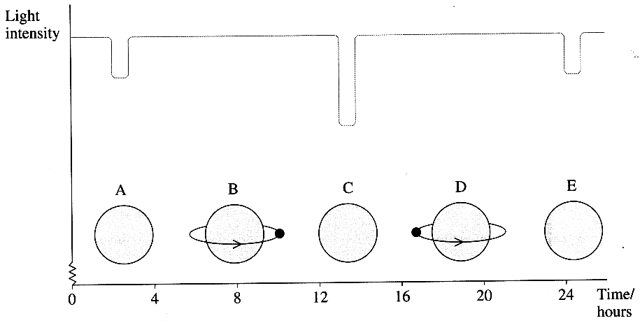
[Adapted from TRUMP Astrophysics Project]

Explain the meaning of the term binary system. (1)
The light curve for an eclipsing binary
consisting of a small very bright star and
a much larger star is shown below.
The system is being viewed edge-on.
Diagrams B and D (not to scale) show the
relative positions of the small and large
star at two times between the dips in the light curve.

On a copy, complete diagrams A, C and E to show
the positions of the small bright star at the times of
the dips in the light curve. (2)
Explain why the dip in the curve at A is smaller than the dip at C. (2)
Estimate the orbital period of this binary. (1)
Approximately how long does it take the small star to cross the disc of the larger one? (1)
On your copy of the light curve above show how the observed light intensity varies with time when this system is viewed perpendicular to the plane of the orbits. (2)

(Total 32 marks)

