Section I
1. Read the passage and then answer the questions at the end.

The ultimate speed
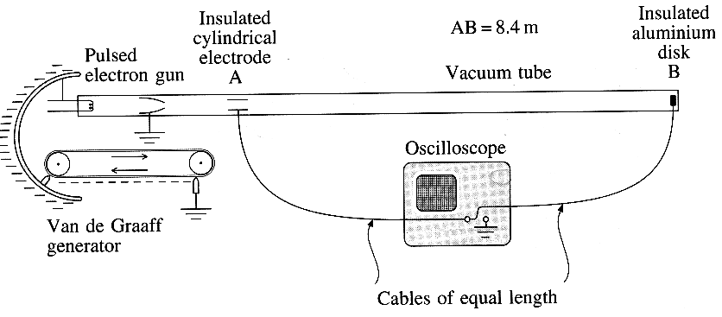
According to Newtonian mechanics, there is no upper limit to the speed that may be given to an object. Imagine, for example, that a body is acted on continually by a constant resultant force equal to its weight at the Earth's surface. After six months, starting from rest, its speed would be more than half the speed of light! For an electron, forces very much greater than its weight can be applied, and so it can easily be accelerated to speeds which Newton's laws predict to be greater than the speed of light. As little as 100V between two electrodes in a vacuum tube would accelerate an electron from rest to about 6 x lO⁶ ms⁻¹. Indeed, if the electrodes were only a few millimetres apart, the electrons' acceleration would be about 10¹⁵g. If the acceleration is through millions of volts, the need for a revised non-Newtonian dynamics becomes glaringly obvious.

An experiment was performed in 1962
by W. Bertozzi to measure the speeds
of electrons accelerated by a
Van de Graaff generator up to
measured energies of 1.5 MeV.
The experimental arrangement is
shown in the diagram.

The idea is to make direct
measurements of the time of flight of electrons
travelling in a vacuum over a distance AB of 8.4 m.
The electrons are released in short bursts of about 3 x 10⁻⁹ s duration from the electron gun system. The accelerating voltage is produced by the Van de Graaff generator. A cylindrical electrode at A and an aluminium disk at B pick up signals as a burst passes through A and arrives at B. These signals are carried to an oscilloscope with a calibrated time-base by cables of equal length, giving rise to the following results:
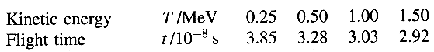

A direct calorimetric measurement of the kinetic energy of each electron burst is made by monitoring the rate of rise of temperature of the aluminium disk. The number of electrons arriving at B in each burst is found by measuring the rate of rise of the total charge on it. In this way, they were able to confirm that the kinetic energy acquired by an electron accelerated through a potential difference V is eV.
[The passage is adapted from Special Relativity, A. P. French, Nelson 1968.]

(a) Calculate the final speed of an object accelerated from rest at 9.81 ms⁻² for 182.5 days. (3)
(b) (i) Calculate the electric field strength between two flat electrodes placed 4.0mm apart when there is a potential difference of 100 V between them.
(ii) What is the force on an electron in this field?
(iii) What is the acceleration of an electron in this field? (6)
(c) Outline briefly how a Van de Graaff generator can accelerate electrons to very high energies. (3)
(d) The oscilloscope time-base was set at 10 ns div⁻¹, i.e. 10⁻⁸ s div⁻¹.
Draw carefully what is seen on the oscilloscope screen when a burst of 1.00 MeV electrons passes down
the vacuum tube. Show the time-base scale on the screen. (4)
(e) When N electrons hit the aluminium disk B, its temperature rises by Δθ, where N and Δθ are related
by the equation: mcΔθ = NeV.
(i) What do m and c represent in the product mcΔθ?
(ii) Explain what is meant by a potential difference of 1 volt.
Hence show that the unit of the product NeV is the joule. (4)
(f) (i) Calculate the speed v of the electrons for each value of the flight time given in the table.
(ii) Draw a graph of v² against T, the kinetic energy of the electrons in MeV.
(iii) Does your graph support the prediction of Newtonian mechanics that v² α T? Justify your answer.
(iv) What would you expect the best fit graph line to do as T rises to 10 MeV and beyond? (8)
(g) Explain why, in the Bertozzi experiment,
(i) the cables from A and B to the oscilloscope are of equal length,
(ii) a direct calorimetric measurement of the energy of each electron is made. (3)

TOTAL FOR SECTION I: 31 MARKS

Section II
(Answer ALL questions)

2. (a) The equations F = kx and V = Q / C are sometimes referred to as analogous mathematical models for a spring and a capacitor respectively.

(i) State what physical quantities are represented by F, x, V and Q in the equations above.

(ii) The energy stored in a capacitor is given by W_{c} = ¹/₂ QV and also by W_{c} = ¹/₂ CV².
Write down, by analogy, the two equivalent expressions for the energy W, stored in a spring.
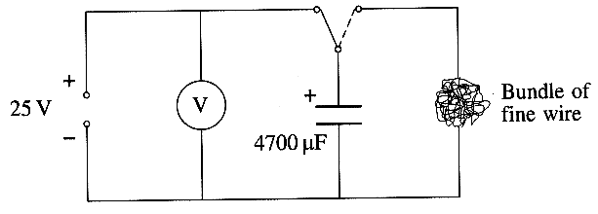
Show that W_{s} can also be expressed as ¹/₂ kx². (5)

(b) (i) A 4700 μF capacitor is charged to 25 V and
discharged through a tightly wound bundle of fine
nsulated wire.

Calculate the energy dissipated in the wire.

Explain why it would be difficult to use this
arrangement to demonstrate that W_{c} α V² for
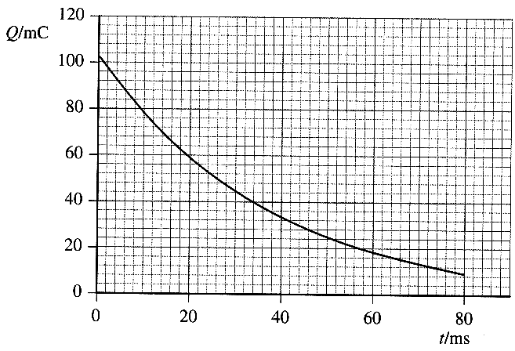
a range of potential differences up to about 50 V.
You may be awarded a mark for the clarity
of your answer. (6)

(ii) The graph shows how the charge on the
capacitor varies with time as it discharges.
State what name is given to this shape of graph
and name another physical phenomenon which
gives rise to graphs of this shape.

Showing your working, determine a value for
the resistance of the bundle of wire. (6)

(Total 17 marks)

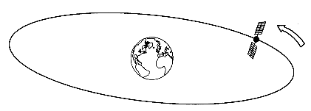
3. A communications satellite is in geosynchronous orbit around the Earth, i.e. it orbits the Earth once every 24 hours. The radius of the orbit is 4.2 x 10⁴ km.

(a) (i) Show that the acceleration of the
satellite is about 0.2 m s⁻².
In what direction is the acceleration? ;

(ii) This acceleration is equal to the gravitational field
strength g of the Earth at the satellite orbit.
Explain how a knowledge of g at 4.2 x 10⁴ km from the centre of the Earth enables the mass of the Earth to be calculated. (6)

(b) The satellite's electrical system is powered by an array of 18 000 photovoltaic cells, each of area 12cm².
(i) When fully illuminated in space by sunlight of intensity 1.4kWm², the array produces 4.5 kW of electrical power.
Calculate the efficiency of transfer of solar to electrical energy. (3)

(ii) In laboratory tests, the internal resistance of a single cell was found to be 40 Ω.
In the satellite the 18 000 cells are arranged in 300 rows of 60 by connecting 60 of them in series and joining 300 such rows in parallel.

Show that the combined resistance of the 18 000 cells in this arrangement is less than 10 Ω.

What e m f. will this arrangement produce if the e.m.f. of one cell is ε ? (4)
(iii) To measure the internal resistance r of one cell, a student
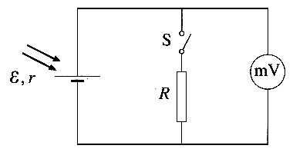
uses the circuit shown.

Explain how, by taking readings with the switch S first
open and then closed, the student can find the value of r.

Suggest a value for the fixed resistor R when r is 40 Ω. (4)

(Total 17 marks)

4. (a) The diagram below shows the main features of a rooftop TV aerial.
The supporting structure is omitted. The receiving section is the unshaded dipole.
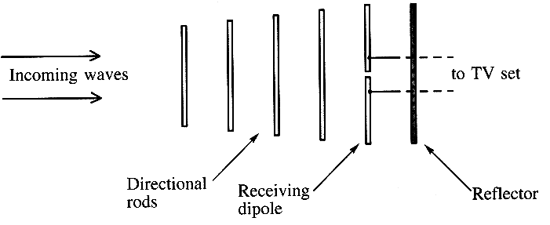

(i) The incoming signal is a plane polarised electromagnetic wave of frequency 1.07 GHz.
Calculate the wavelength of the incoming wave.

Outline how you could demonstrate experimentally, using the aerial and a TV set, that the incoming wave was plane polarised. (5)

(ii) Two waves, the incoming wave and its reflection from the reflector, are superposed at the receiving dipole.
Explain what is meant by the phrase 'two waves are superposed'.

Suggest, with a reason, how far the reflector should be placed from the receiving dipole to get the
strongest signal for the TV set. (4)

(b) A plane electromagnetic wave consists of oscillating electric and magnetic fields.
The intensity or energy flux I, measured in Wm⁻², can be expressed as:
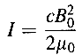

where B₀ is the maximum value of the magnetic flux density and the other symbols have their usual meaning.

(i) Show that the expression for I is homogeneous with respect to units.

(ii) Describe how a coil, together with any other apparatus you require, could be used to detect the presence of a steady magnetic field in the region of a bar magnet. (6)

(Total 15 marks)

TOTAL FOR SECTION II: 49 MARKS

TOTAL FOR PAPER: 80 MARKS

