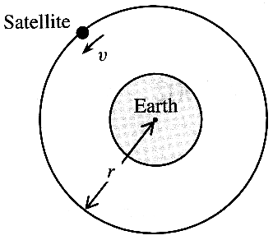
1. The value of G, the gravitational constant, is 6.67 x 10⁻¹¹ N m² kg⁻².
What are the base units of G ? (1)

A satellite orbits the Earth, mass M, in a circular path of radius r,
with speed v, as shown in the diagram.
It can be shown that the period of orbit T of the satellite is given by
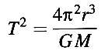
Show that this equation is homogeneous with respect to units. (2)

Personal navigation devices use the Global Positioning System (GPS). GPS satellites are in a non-equatorial orbit at a height of 20000 km above the Earth. The time to complete one orbit is 12 hours. Given that the radius of the Earth is 6400 km, use the above relationship to find the mass M of the Earth. (3)

2. State Faraday's law of electromagnetic induction. (2)

Microphones convert longitudinal sound waves into electrical signals, which can be amplified. One type of microphone consists of a flexible diaphragm connected to a coil of wire, which is near a cylindrical magnet.
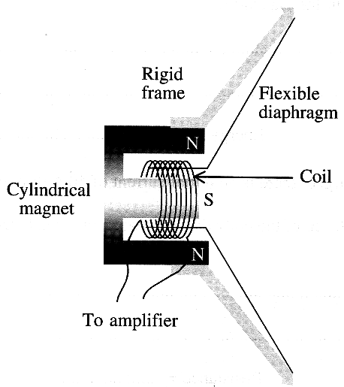
Describe how sound waves are converted into electrical signals.
You may be awarded a mark for the clarity of your answer. (4)

3. A defibrillator is a machine that is used to correct irregular heartbeats by passing a large current through the heart for a short time. The machine uses a 6000 V supply to charge a capacitor of capacitance 20 μF. The capacitor is then discharged through the metal electrodes (defibrillator paddles) which have been placed on the chest of the patient.

Calculate the charge on the capacitor plates when charged to 6000 V. (2)
Calculate the energy stored in the capacitor. (2)

When the capacitor is discharged, there is an initial current of 40 A through the patient.
Calculate the electrical resistance of the body tissue between the metal electrodes of the paddles. (1)

Assuming a constant discharge rate of 40 A, calculate how long it would take to discharge the capacitor. (2)
In practice the time for discharge is longer than this calculated time. Suggest a reason for this. (1)
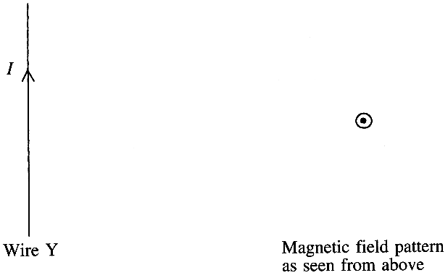
4. The diagram shows a straight wire Y carrying
a current I.

On a copy of this diagram draw the magnetic
field pattern close to the wire as seen when
looking from above. (3)

Calculate the current in this wire when the
field strength due to the wire alone at a point
12 cm from the centre of the wire
is 1.4 x 10⁻⁵ T. (2)
A second wire Z, carrying a current of 2I, is placed parallel and
12 cm from wire Y.
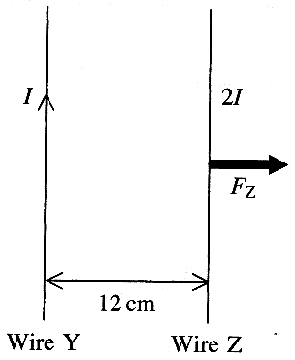
The diagram shows the direction of the force F_{z} exerted on the
second wire Z.

Add to a copy of the diagram an arrow showing the direction of the
current 2I in the second wire Z. (1)

A force F_{y} is also exerted on the first wire Y.
Add to the same diagram another arrow showing the direction of
this force. Label it F_{y}. (1)

What is the ratio F_{y} : F_{z} of the two forces? (1)

State two methods by which the magnitude of the force Fy could be
reduced. (2)

5. One practical arrangement for verifying Coulomb's law is to use a lightweight, negatively-charged, freely-suspended ball. It is repelled by the negative charge on a larger sphere that is held near it, on an insulated support. The small angle of deflection θ is then measured.
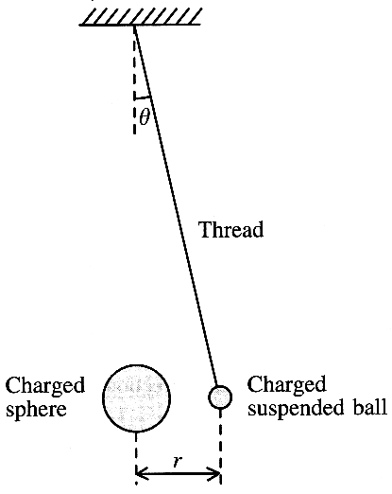
Draw a free-body force diagram for the suspended ball. (3)

The weight of the ball is W. Show that the force of repulsion F on the suspended ball is given by
F = W tan θ (2)

A student takes several sets of readings by moving the larger sphere towards the suspended ball in order to increase the mutual force of repulsion between them. He measures the angle of deflection θ and the separation distance r in each case. He then calculates the magnitude of the force F.
Here are some of his results.

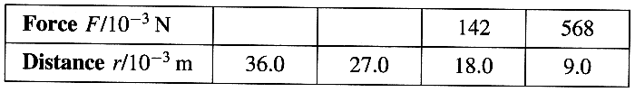

Calculate the values that you would expect the student to have obtained for the missing forces,
assuming that Coulomb's law was obeyed. (4)

Suggest why, in practice, it was necessary for the student to take measurements quickly using this arrangement. (1)

TOTAL FOR PAPER: 40 MARKS

