Topic D – Medical Physics

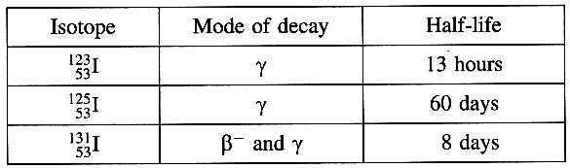
4. (a) A patient's thyroid function is to be investigated by
means of a radionuclide tracer.
Iodine accumulates in the thyroid.
Which of the three isotopes of iodine listed opposite
would be most suitable for such an investigation? (1)
Explain why the other two isotopes would not be
appropriate. (2)
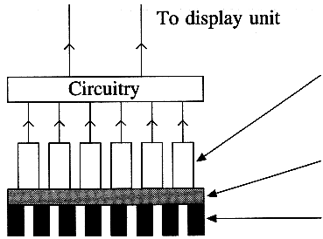
The diagram shows the main features of a gamma camera suitable for
monitoring the patient. On a copy of this diagram, identify the three
parts indicated by the arrows. (3)

(b) An X-ray tube operating at 65 kV has a tube current of 0.12 A.
It produces X-rays with an efficiency of 0.8 %.
Calculate the rate of production of heat at the anode. (3)
What feature of the X-ray tube helps dissipate this energy? (1)
Would the X-rays produced by this tube be more suitable for diagnosis
or therapy? Justify your answer. (3)

(c) State two advantages of using ultrasound for diagnosis compared with using X-rays for diagnosis. (2)
Explain why high frequency ultrasound is used for scanning an eye but a lower frequency is more suitable for abdominal scans. You may be awarded a mark for the clarity of your answer. (3)

Suggest an appropriate wavelength for the ultrasound to be used in an eye investigation. Hence calculate a suitable frequency for such an investigation. (Speed of sound in water = 1.5 x 10³ m s ⁻¹.) (3)

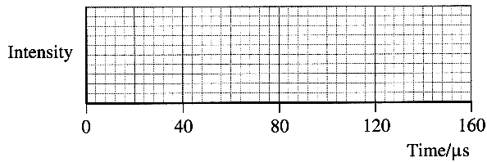
During an ultrasound scan single pulses of ultrasound are
transmitted at regular intervals. Typically pulses of
duration 10 μs are transmitted at 120 μs intervals.
On a copy of the grid below draw a scale diagram
showing two consecutive pulses. (2)
Why is it important that the pulses are well separated? (1)

(d) Read the short passage below and answer the questions about it.

Most of the X-rays falling on a photographic film pass straight through without any interaction. Light, however, is readily absorbed by photographic film. In a simple intensifying system two fluorescent screens are placed either side of a double-sided photographic film. X-rays from the patient penetrate the film and the two fluorescent screens. The fluorescent screens absorb the X-radiation and re-emit visible radiation in a pattern duplicating that of the original X-ray beam. The main film blackening results from the light emitted in the fluorescent screens. Modern intensifying systems can give intensification factors of up to 250. However, some detail is lost due to the diffusion of light from the fluorescent screens.
[Adapted from Medical Physics Imaging by J. Pope]
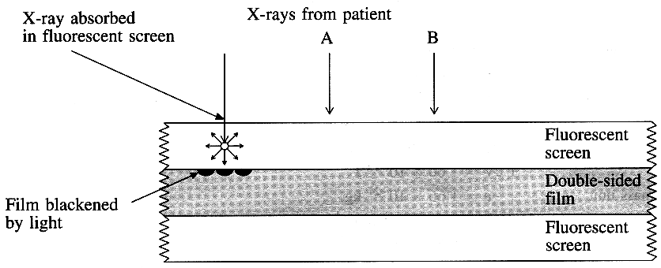
Why is photographic film alone not a very
sensitive way of detecting X-rays? (1)
The diagram opposite shows how an intensifying
system operates.
Complete a copy of the diagram for
(i) X-ray A, which produces direct blackening of
the photographic film. (1)
(ii) X-ray B, which produces blackening of the
film after absorption in the lower fluorescent screen. (2)

State the meaning of the term fluorescent. (1)
Explain the benefit to the patient of using an intensifying system. (2)
What is the disadvantage of using an intensifying system? (1)

(Total 32 marks)

