Topic C - Nuclear and Particle Physics

3. (a) A stationary neutron can decay to a proton and an electron. Use the data below to predict the maximum total kinetic energy of the electron and the proton in MeV.
Data: mass of neutron = 1.008 665u; mass of proton = 1.007 276u;
mass of electron = 0.000 549u; lu = 930 MeV (3)

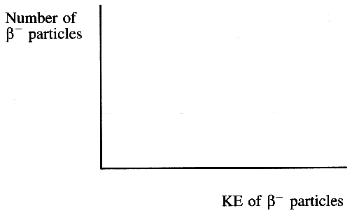
Explain why the principle of conservation of linear momentum tells
you that almost all this kinetic energy is given to the electron. (2)

On the axes opposite sketch a graph showing the energy spectrum
for the β ⁻ particles produced during beta decay.
Add a scale to the horizontal axis. (3)
Explain why the shape of this graph led to the prediction of the existence
of neutrinos. You may be awarded a mark for the clarity of your answer. (3)

(b) State one similarity and one difference between a proton and an antiproton. (2)
Write down two particle-antiparticle pairs of leptons. (2)
What happens when a particle and its antiparticle collide? (1)

(c) Use the laws of conservation of charge and baryon number to decide whether the following interactions are possible or not. In each case show how you applied the laws. (4)
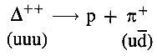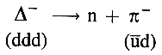
These two decays are examples of strong interactions. What exchange particle is responsible for the decays? (1)

Delta particles are baryons consisting of u and d quarks only. Two more members of the delta particle family are the Δ⁺ and the Δ°. These are excited states of the proton and the neutron. State the quark composition of the Δ⁺ and the Δ°. (2)

(d) Read the short passage below and answer the questions about it.

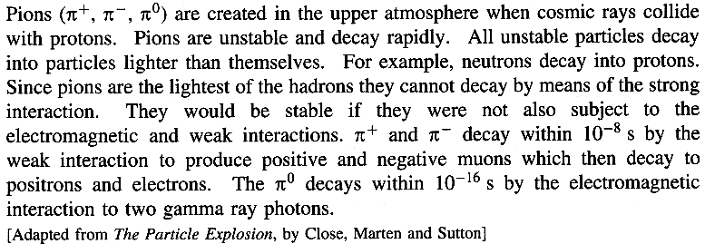

What is a hadron? (1)
List all the leptons mentioned in the passage. (1)
Why are pions unable to decay by means of the strong interaction? (1)

Copy and complete the following sentence by circling the appropriate word inside the brackets.
Pions which decay by the weak interaction have a {shorter / similar / longer} lifetime than those which decay by the electromagnetic interaction. (1)
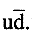
A positive pion π⁺ has a quark composition
State one possible quark composition of a neutral pion π°.

Draw a Feynman diagram showing the decay of a neutron to a proton,
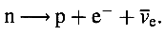 (2)
Why must this be a weak interaction? (1)
Label the exchange particle on your Feynman diagram. (1)

(Total 32 marks)

