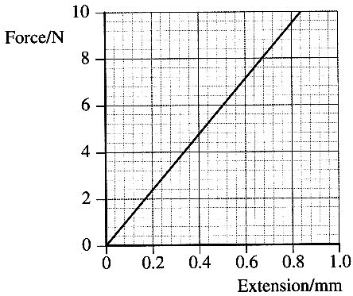
Topic B - Solid Materials

2. (a) Calculate the stress in a steel wire of length 2.6 m and
cross-sectional area 1.5 x 10 ⁻⁷ m² when it is subjected to a tensile
force of 8.0 N. (2)

Part of a force-extension graph for such a steel wire is shown opposite.
Use the graph to find the extension of the wire for an applied force of 8.0 N.
Show that the corresponding strain in the wire is approximately 3 x 10 ⁻⁴.
Hence determine the Young modulus for steel. (4)
Calculate the work done in stretching the wire by 0.4 mm. (3)

A second wire is made of the same steel. It has the same cross-sectional area but twice
the length. On a copy of the graph draw the force-extension graph for this wire. (2)

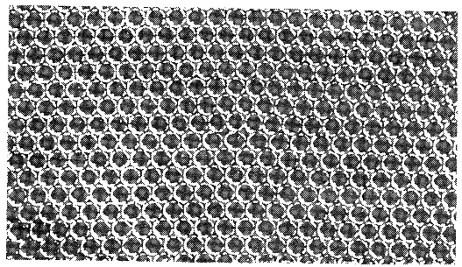
(b) A horizontal concrete beam rests on two pillars, one at each end, forming a bridge. It supports a large load at its centre. Draw the concrete beam and show the regions of the beam which are in tension and the regions which are in compression. (2)
Explain why microscopic cracks in the lower surface of the beam are more
dangerous than any which form in the upper surface of the beam.
You may be awarded a mark for the clarity of your answer. (3)

(c) The photograph is of a bubble raft model of an edge dislocation.
What do the bubbles represent? (1)
Indicate on a rough copy of the photograph where the
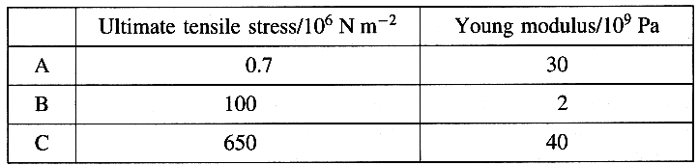
"dislocation" in the bubble raft occurs. (1)

(d) The table gives the properties of three
different materials.
Use this data to describe each material as either
strong or weak and either stiff or flexible. (3)
The materials are CFRP (carbon fibre reinforced polymer), nylon and polythene. Identify A, B and C. (2)
State which of these materials is/are a composite material(s). (1)

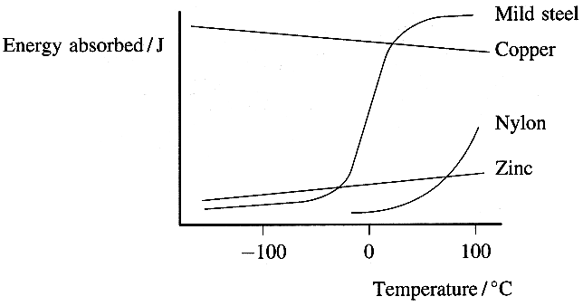
(e) Read the short passage below and answer the questions about it.
The toughness of a material can be measured by the
energy it absorbs during fracture.
Toughness can change with temperature. Materials which are considered
to be tough and exhibit ductile failure at room temperature may be brittle
at low temperatures. Brittle failure can occur without warning. It has been
suggested that temperatures in the North Atlantic at the time of the
sinking of the Titanic were such that the steel of the ship's hull was brittle.
Ductile-brittle transition curves for some materials are shown opposite.
Different steels have different transition temperatures so provided the correct
steel is selected there are no problems in, for example, laying oil pipelines across
Alaska (where winter temperatures can be as low as - 30°C).
[Adapted from Institute of Materials Teacher Pack by Claire Davis]

Explain the meaning of the terms: (i) ductile; (ii) transition temperature (2)
Suggest the temperature below which a component made from mild steel risks brittle failure. (1)
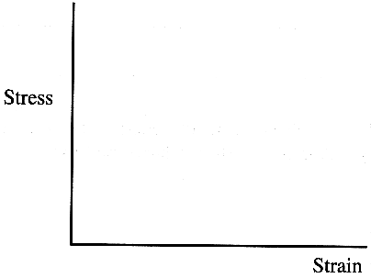
Which of the materials on the graph would not be at risk of brittle failure at low
temperatures? Explain your answer. (2)
Add to a copy of the graph the transition curve of a steel suitable for making
pipelines which would be laid in Alaska. (1)

On a copy of the axes opposite sketch a stress-strain graph to breaking point for mild
steel above its ductile-brittle transition temperature. (2)

(Total 32 marks)

