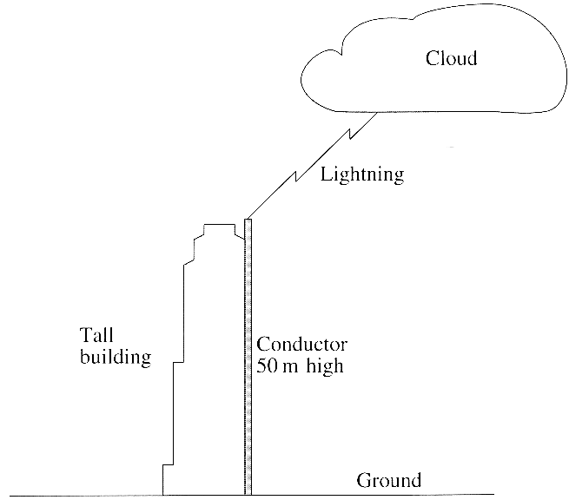
1. The table gives four word equations.
Copy and complete the table with the quantity defined by each word equation. [4]
Word Equation | Quantity Defined
Voltage ÷ Current
Voltage x Current
Charge ÷ Time
Work Done ÷ Charge

2. A lightning stroke passes between a cloud and a
lightning conductor attached to a tall building.
A very large current of 20 000 A passes for 4.0 x l0⁻⁴s.
Calculate the charge flowing to the ground in this time. [2]
The lightning conductor is 50m high and has a cross-sectional
area of 1.0 x 10⁻³ m². It is made from copper which has a
resistivity of 1.7 x 10⁻⁸ Ωm. Calculate the resistance of the
lightning conductor [3]
Hence calculate the potential difference between the top
and bottom of the current-carrying lightning conductor. [2]
If lightning strikes a tree such that there is the same current through it as there was through the conductor, then a much larger potential difference exists between the top and bottom of the tree. Explain why this is so. [1]

3. A car of weight 12000N is stationary on a horizontal road. The four wheels of the car are fitted with air-filled (pneumatic) tyres. The pressure of the air in each tyre is 3.0 x l0⁻⁵ Nm⁻². Estimate the area of contact between each tyre and the road surface. [2]
The rubber in the tyres is repeatedly stretched and relaxed when the car is in motion but the overall volume of the tyres remains constant. During a journey the temperature of the air in the tyres rises from 10ºC to 30ºC. Calculate the pressure of the air at 30ºC. [3]
Sketch a graph to show how the area of contact between a tyre and the road varies with the pressure of the air. [3]

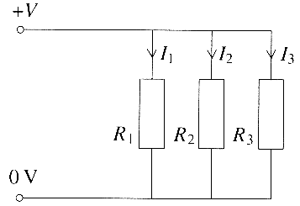
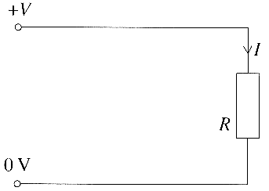
4. Three resistors R₁ R₂ and R₃ are connected in parallel with each other. They could be replaced by a single resistor of resistance R.

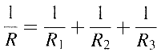
Show that the resistance, R, of the equivalent resistor can be calculated from: [3]
A student has four identical resistors each of resistance 10 Ω.
She connects them to form the different networks shown below.
Calculate the equivalent total resistance of each network. [3]
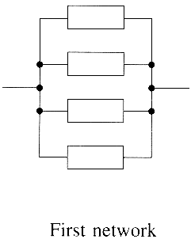
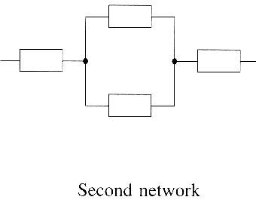
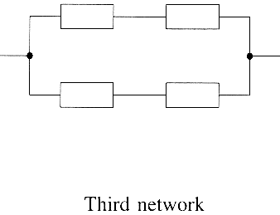

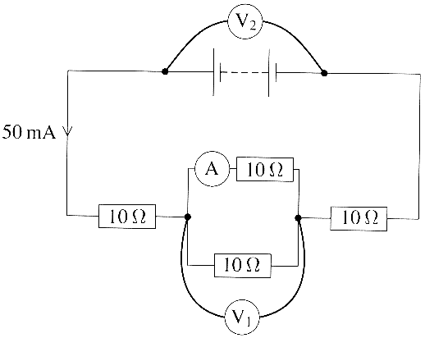

She then connects a battery across the second network and adds
meters to make the circuit shown opposite. A current of 50 mA is
drawn from the battery.
Determine the reading on each of the three meters. [5]

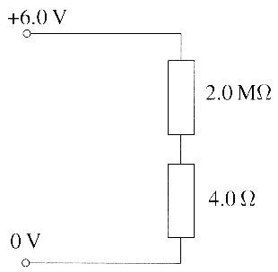
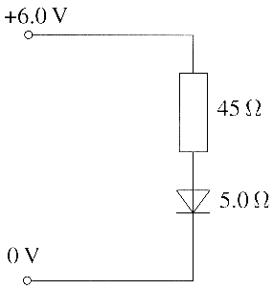
5. Two resistors of resistance 2.0 MΩ and 4.0 Ω are connected in series
across a supply voltage of 6.0V. Together they form a simple potential
divider circuit. State the potential difference across each resistor. [2]
A second potential divider circuit uses a resistor and a diode connected
in series with the same supply. Calculate the potential difference across
each component when the resistance of the resistor and diode are
45 Ω and 5.0 Ω respectively. [2]
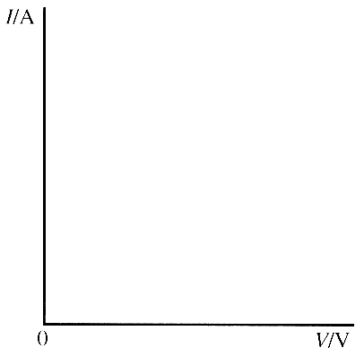
In this circuit the diode is in forward bias. Make a copy of the axes
opposite and sketch a graph of current I against potential difference V
for a diode in forward bias. [1]

6. Water in a plastic kettle is heated by an electric element near the bottom of the kettle.
The temperature of the water near its surface can be recorded on a thermometer.
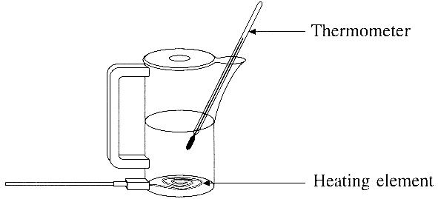

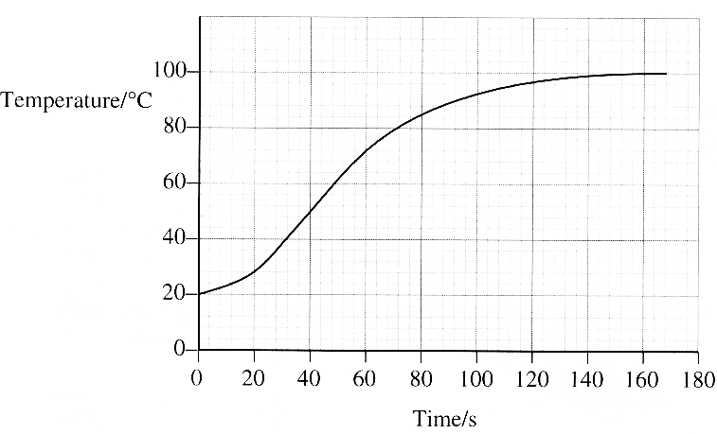

A kettle contains 0.70 kg of water at an initial temperature of 20 °C.
It is calculated that about 250 kJ of thermal energy is needed to
heat the water from 20 ºC to 100 ºC.. Show how this value is
calculated. (The specific heat capacity of water is 4200 J kg⁻¹ K⁻¹ ) [2]
Calculate the time it should take for an element rated at 2.2 kW
to supply this energy. [3] To check this calculation, the kettle is
switched on at t = 0 s and temperature readings are taken as the
water is heated. The graph opposite shows how the temperature
varies with time.Use the graph to fully describe qualitatively how the temperature of
the water changes during the first 160s. [3]
Estimate the efficiency of the electric heating element in bringing the water to the boil. [2]
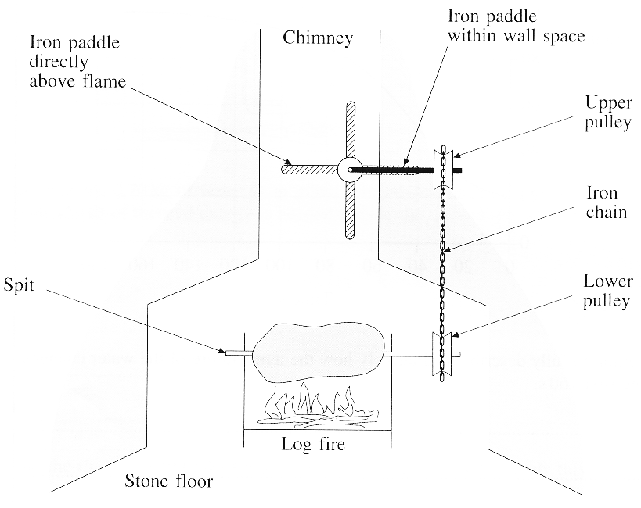
7. A Smoke Jack is an example of an 18th century heat engine that was
found in the large kitchens of manor houses and stately homes.
It consists of four rotating paddles, which are in the chimney,
directly above the open log fire. The paddles are connected to the spit
by gears and pulleys. Food on the spit is slowly cooked as the spit rotates.
A diagram of a simple Smoke Jack is shown opposite.
Define the term heat engine. [3]
During a cold winter, the temperature of the air at the topof the
chimney is -5 °C and that of the hot air just above theflames is at 350 °C.
Calculate the maximum thermal efficiency
of this Smoke Jack. [3]
In practice, the Smoke Jack's thermal efficiency is much less than this.
With reference to the diagram state two different ways by which the
thermal energy from the logs would be wasted. [2]
The molecules of the gases in the air are in constant random motion and so possess random kinetic energy. It can be assumed that these gases behave as ideal gases. Hence calculate the ratio of the average kinetic energy of the molecules just above the flames to that of the molecules at the top of the chimney. [2]

8. The kinetic theory of gases is based on a number of assumptions. Two of these are stated below.
- First assumption: The molecules are in continuous, random motion.
- Second assumption: The average distance between the molecules is much larger than the molecular diameter.
For each assumption, state and explain one observation which supports the assumption. [4]

