Topic D – Medical Physics

4. (a) State one similarity and two differences between alpha and beta radiation. (3)

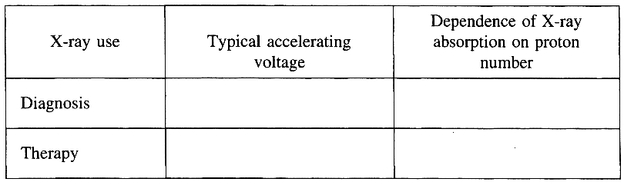
(b) Complete a copy of the table
oppositebelow. (4)
When using X-rays for therapy
it is important that healthy tissue
receives as low a dose as possible.
State and explain one way in
which these low doses are
achieved. (3)

(c) The specific acoustic impedance Z of a material is calculated by multiplying its density by the speed of sound in the material. Show that Z has the units kg m⁻² s⁻¹. (2)
Data: Zair =400 kg m⁻² s⁻¹ Zsoft tissue = 1.6 x 10⁶ kg m⁻² s⁻¹
Use this information to help you explain why it is impossible to use ultrasound to investigate any part of the body which is behind the lungs. You may be awarded a mark for the clarity of your answer. (5)
Give a reason why ultrasound is preferred to X-rays for examining unborn babies. (1)
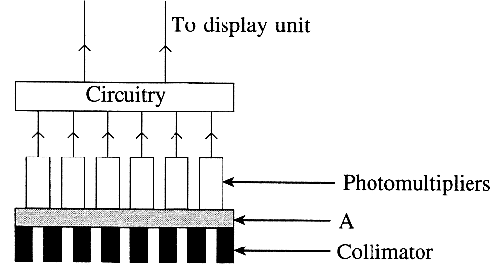
(d) The diagram opposite shows the essentialfeatures of a
simple gamma camera.
Name the part marked with the label A. (1)
What is the purpose of the collimator and from what
material is it made? (2)
Describe one physical process that takes place in
a photomultiplier. (2)

(e) Read the short passage below and answer the questions about it.
^{99m}₄₃Tc is a γ emitting radionuclide of half-life 6 hours used in tracer studies. It is produced when the radionuclide ⁹⁹₄₂Mo decays by β emission. This decay has a half-life of 67 hours. Because of its short half-life ^{99m}₄₃Tc must be produced in portable generators. These contain the parent isotope ⁹⁹₄₂Mo. When required the ^{99m}₄₃Tc is obtained by flushing salt solution through the generator, a process known as elution. The molybdenum is not removed by this process and after approximately 1 day enough new daughter isotope will have been produced for another elution to take place. The generator needs replacing approximately weekly since the ⁹⁹₄₂Mo activity falls to an inadequate level after this time.
[Adapted from Medical Physics Imaging by J Pope]

Explain what is meant by elution. (1)
Write a nuclear equation for the decay of molybdenum. (2)
Why must ^{99m}₄₃Tc be produced in portable generators? (1)
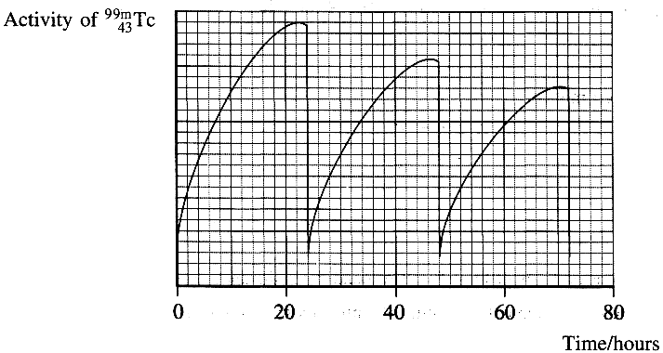
Show that after 1 week the activity of the ⁹⁹₄₂Mo in a portable generator would have fallen to less than ¹/₂ of its original value. (2)

The sketch graph opposite shows
how the activity of the ^{99m}₄₃Tc in a
generator varies with time.
On a copy of thiis graph indicate the time at
which the second elution takes place. (1)
Explain why successive Tc activity peaks
are smaller. (1)
Why is it advisable to leave a period of
approximately 1 day between elutions? (1)

( Total 32 marks)

