Topic B - Solid Materials

2. (a) A bridge is formed from a uniform concrete beam of weight W supported at each end by a brick pillar. A vehicle of weight P is stationary ¹/₄ way along the bridge. On a copy of the diagram below draw arrows to show the forces acting on the beam. Label each force and state the origin of the upward forces. (3)
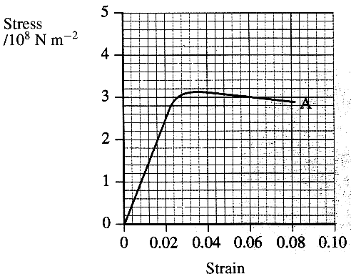
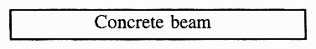
(b) Some properties of two materials A and B are given
opposite and below, material A on the graph, material
B in the table.
Use the graph to complete a copy of the table for
material A. (2)
Use the table to draw a copy of the graph on the grid
showing the behaviour of material B. (3)
Show on your graph the region in which material A obeys
Hooke's law. (1)
Material A is in the form of a wire of cross-sectional
area 8.8 x 10⁻⁷ m² and length 2.5 m.
Calculate the energy stored in the wire when it experiences
a strain of 0.020. (4)
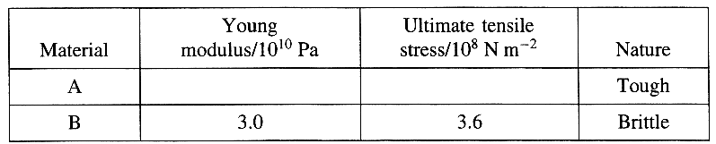

(c) Describe the difference between a fibre composite and a laminate. (2)
Explain how the risk of failure by cracking is reduced in either a fibre composite or a laminate.
You may be awarded a mark for the clarity of your answer. (3)

(d) Perspex is an amorphous polymer. Draw a labelled diagram showing the molecular structure of Perspex. (2)
Describe the difference in behaviour of a thermoplastic polymer and a thermosetting when heated. (2)
Is Perspex a thermoplastic polymer or a thermosetting polymer? (1)

(e) Read the short passage below and answer the questions about it.
Elastic materials under stress store strain energy. In a car with no springs there would be violent interchanges of gravitational potential energy and kinetic energy every time a wheel passed over a bump. The springs of the car enable changes of potential energy to be stored temporarily as strain energy, resulting in a smoother ride. Most ski runs are more bumpy than a normal road. The tendons in the legs of a fast moving skier must be able to store and give up again very large amounts of energy. Light aircraft which may have to land on rough ground often have their undercarriages sprung by means of rubber cords. [Adapted from Structures by J E Gordon]

Explain what is meant by the term strain energy. (1)
Why is it important that the springs, tendons and rubber cords mentioned in the passage are not stressed beyond their elastic limits? (1)

Useful data: Energy stored per unit mass/J kg⁻¹
Modem spring steel 130
Tendon in leg 2500
Rubber cord 8000

Show that a car of mass 1200kg would need steel springs of total mass approximately equal to 3 kg to store energy when it encounters pot-holes of depth 3 cm. (3)
The sum of the mass of leg tendons of a skier might be of the order of 0.4 kg. Estimate the size of 'bump' that a skier of mass 75 kg could theoretically negotiate. (2)
Sketch a hysteresis curve to show the behaviour under stress of a rubber suitable for springing light aircraft undercarriages. (2)

(Total 32 marks)

