Topic A – Astrophysics

1. (a) State two similarities and one difference between light and radio waves. (3)

(b) Stars β Ori and α Cet have temperatures of approximately 11 000K and 3600 K respectively.
Calculate the wavelength at which the intensity of radiation from each star is a maximum. Give your answers in nanometres. (3)
Use the Stefan-Boltzmann law to calculate the power emitted per square metre of surface,
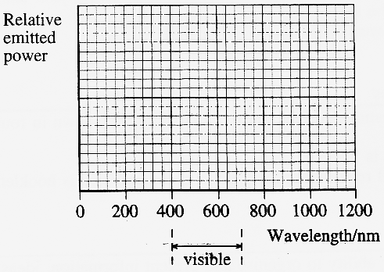
measured in W m⁻², for β Ori. (2)
The power emitted per square metre of
surface for α Cet = 1.0 x lO⁷m⁻².
Copy out and sketch two graphs on the axes
opposite, showing how this emitted power is
distributed over different wavelengths for each star.
Label your graphs Ori and Cet.
The visible spectrum extends from approximately
400 nm to 700 nm.
Use your graphs to explain why β Ori is a bluish star,
while α Cet is reddish. (2)

(c) Draw a labelled diagram to illustrate the principle of
how the distance to a nearby star can be measured using
the annual parallax method. (4)
Why is this method only suitable for nearby stars? (1)

(d) Stars of more than eight solar masses may undergo a spectacular supernova explosion. Outline the processes that take place in the star that result in such an event. You may be awarded a mark for the clarity of your answer. (4)
What may happen to the core remnant from such an event? (1)

(e) Read the short passage below and answer the questions about it.
The Sun is a typical main sequence star. The conversion of hydrogen to helium in its core where the temperature is approximately 15 x 10⁶ K releases energy. This energy is chiefly in the form of X-rays of wavelength 0.2 nm - 1 nm and is transported to the Sun's surface by radiation and convection. It takes about 2 x 10⁵ years for the energy to reach the Sun's surface. The radiative zone extends from the centre to ³/₄ of the solar radius. In this zone X-rays are repeatedly absorbed and re-emitted by gas atoms. This happens at approximately 1mm intervals. The convective zone ranges from ³/₄ solar radius outwards. In this zone the gas is cooler and even more opaque to X-rays so energy is transported by large-scale movement of the gas itself. [Adapted from Life and Death of Stars by Dr L J Smith]
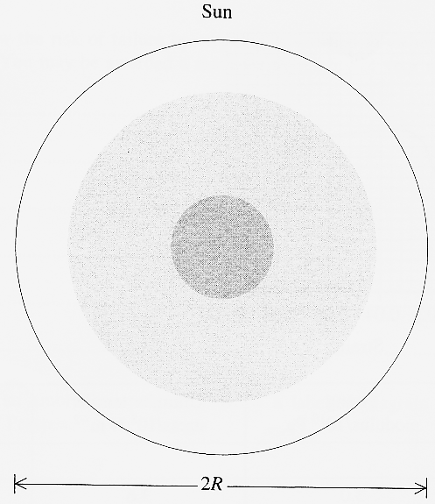
Sketch a Hertzsprung-Russell diagram to show what is
meant by the term main sequence. (3)

The radius of the Sun is 7 x 10⁸ m.
Calculate the time it would take for X-rays to reach the
surface of the Sun if they travelled there directly
at a speed of 3 x 10⁸ m s⁻¹. (2)

Why is convection the main method of energy transfer
in the outer region of the Sun? (1)

Copy out and label the diagram opposite to
summarise the transport of energy to the Sun's surface. (3)

(Total 32 marks)

