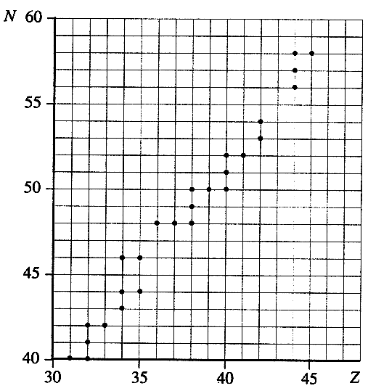
Topic C - Nuclear and Particle Physics

3. (a) Define density. (1)
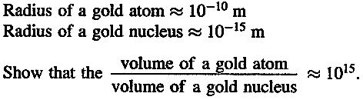
The density of gold is 19 000 kg m³.
Estimate the density of a gold nucleus.
What assumption have you made in obtaining your answer? (3)
(b) On a copy of the axes below sketch graphs showing
the energy spectra for (i) a typical α particle decay.
(ii) a typical β⁻ decay. (3)
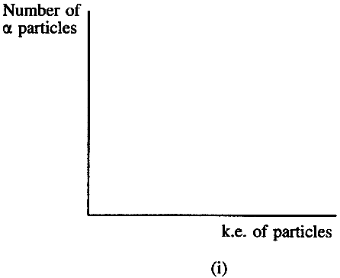
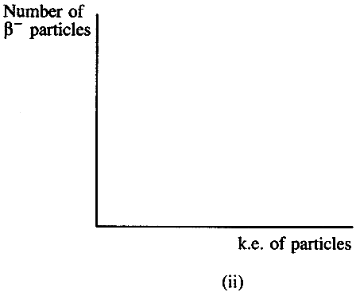

Copy and complete the equation opposite showing the decay of a neutron to a proton. n → p+ (2)
State the quark compositions of the neutron and the proton.
Use these to explain why only the weak interaction can be responsible for this decay.
You may be awarded a mark for the clarity of your answer. (3)

(c) The grid above on the left shows the relationship between number of neutrons N and number of protons Z for some of the stable nuclides in the region Z = 31 to Z = 45.
Strontium-90, ⁹⁰₃₈Sr, is an unstable nuclide. It decays by β⁻ emission to an unstable isotope of yttrium. On a copy of this graph mark the position of ⁹⁰₃₈Sr and this isotope of yttrium. (2)
⁸²₃₇Rb is another unstable nuclide. Mark the position of ⁸²₃₇Rb on the graph.
By what means would you expect ⁸²₃₇Rb to decay? (2)

(d) The following strong interaction has been observed. K⁻ + p → n + X
The K⁻ is a strange meson of quark composition us. The u quark has a charge of + 2/3.
The d quark has a charge of - 1/3. Deduce the charge of the strange quark. (1)
Use the appropriate conservation law to decide whether particle X is positive, negative or neutral. (2)
Is particle X a baryon or a meson? Show how you obtained your answer. (2)
State the quark composition of X. Justify your answer. (3)
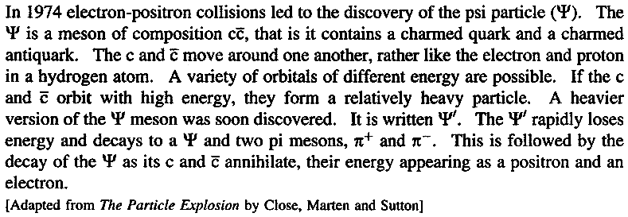
(e) Read the short passage opposite
and answer the questions about it.

List all the antiparticles
mentioned in the passage. (2)
Although the Ψ contains charmed
quarks, it has zero charm itself.
Explain how this can be so. (1)
Describe how a charmed quark
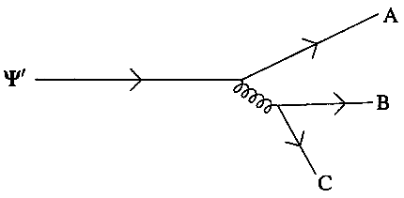
and a charmed antiquark can create a heavier version of the Ψ. (1)
The Feynman diagram opposite shows the decay of the Ψ'.
Complete a copy of this diagram by identifying the
particles A, B and C. (2)
What fundamental interaction is responsible for this decay? (1)
Identify the exchange particle involved. (1)
(Total 32 marks)

