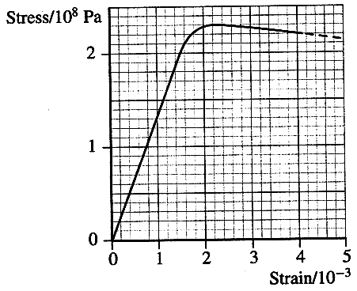
Topic B - Solid Materials

2. (a) Define work. (1)
State an appropriate unit for work. (1)
Express this unit in terms of base units. (2)

(b) State Hooke's law. (2)
The graph shows the stress-strain relationship for a copper wire
under tension.
Use the graph to determine:
(i) the ultimate tensile stress for copper
(ii) the Young modulus of copper (3)

A copper wire of cross-sectional area 1.7 x 10⁻⁶ m² and length 3.0 m
is stretched by a force of 250 N.
Will the behaviour of the wire at this point be elastic or plastic? Justify your answer. (2)

Show this point on a copy of this stress-strain graph on the previous page. Label it P. (1)

Calculate the extension of the wire. (2)

(c) Explain with the aid of a diagram what is meant by an edge dislocation. (2)

Describe how the presence of dislocations can reduce the risk of metals failing by cracking.
You may be awarded a mark for the clarity of your answer. (3)

(d) Sketch a force-extension graph for natural rubber showing its behaviour for both increasing
and decreasing force. (2)

Use your graph to explain why a rubber band which is repeatedly stretched and relaxed becomes noticeably warmer. (2)

(e) Read the short passage below and answer the questions about it.

The outer layer of a human tooth is made of enamel and is the hardest tissue in the body. It is a typical ceramic with a high compressive strength, low tensile strength and a high Young modulus. It is brittle and consists of long crystals of calcium phosphate set vertically on the surface of the underlying dentine. Dentine is the main structural material of a tooth. It is a composite material consisting of needle shaped crystals in a collagen fibre matrix. Dentine has a much lower Young modulus than enamel and is tough. False teeth (dentures) are made from PMMA
(polymethyl methacrylate), an amorphous polymer with a glass transition temperature of 110 °C.

What is meant by the following term used in the passage? 'composite material' ? (2)

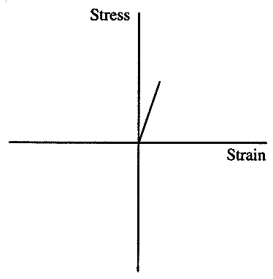
Draw labelled diagrams to show the difference in molecular structure of a crystalline material and an amorphous polymer. (3)

The graph shows the behaviour of enamel under tension.
Add to a copy of this graph:
(i) a line labelled E to show the behaviour of enamel
under compression,
(ii) a line labelled D to show the behaviour of dentine
under tension. (4)

(Total 32 marks)

