Topic A – Astrophysics
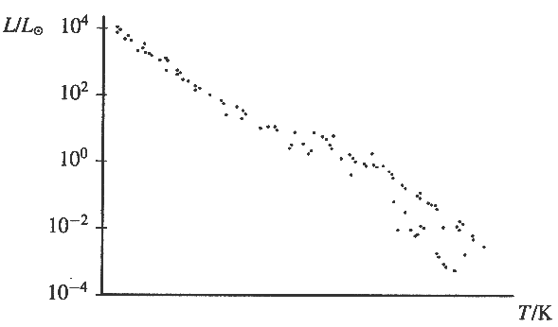
1. (a) Define power. (1)
State an appropriate unit for power. (1)
Express this unit in terms of base units. (2)

(b) A Hertzspmng-Russell diagram showing the main
sequence is drawn opposite.
Luminosity of the Sun

On a copy of this diagram, draw a circle on the diagram
showing the region where the Sun is located.
Label this circle S.
Draw another circle showing the region where the most
massive main sequence stars are located. Label this circle M. (2)
Indicate on the temperature axis the approximate temperatures of the coolest and of the hottest stars. (2)
Explain why large mass stars spend less time than the Sun on the main sequence. (2)
The luminosity of the Sun is 3.9 x 10²⁶ W.
Calculate the rate at which mass is being converted to energy in the Sun. (3)

(c) Charge coupled devices can have an efficiency as great as 70% compared with photographic film which has an efficiency of less than 5%. State two advantages of this greater efficiency. (2)
Explain why astronomical telescopes are sometimes launched into space. (2)

(d) Observations with a radio telescope in 1967 detected signals from a mysterious source which was called a pulsar.
What type of star is a pulsar? (1)
What was unusual about the signals? (2)
Pulsars emit radio waves continuously. Explain why the signals detected on Earth are not continuous. You may be awarded a mark for the clarity of your answer. (3)

(e) Read the short passage below and answer the questions about it.
Cepheid variables are faint red giants whose brightness changes periodically. Their periodic changes in luminosity are the result of periodic pulsations of their giant bodies. A simple relationship exists between the periods of these pulsations and the luminosities of the stars. The greater the luminosity, the longer the period of pulsation. This relationship has proved very useful for measuring the distances of stars which are too far away to show a parallax displacement. By measuring the pulsation period of a star its luminosity can be determined. This, combined with a measurement of the intensity at the Earth's surface, enables the distance to the star to be calculated.
[Adapted from The Creation of the Universe by George Gamow]

What is meant by the following terms used in the passage?
(i) Red giants; (ii) Parallax displacement (3)
The curves below are plots of intensity against time for two Cepheid variable stars, A and B. These are known as light curves.
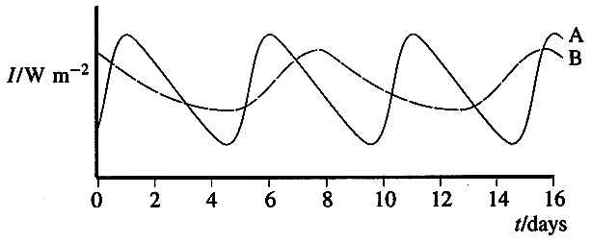
Estimate the period of the pulsations of star A. (1)
What can be deduced about the luminosity of star B? (1)
Since the average intensities of stars A and B are similar, what can be deduced about the distances of the two stars from the Earth? Give the reasoning which led to your answer.(2)
Name the two forces, one which causes a star to contract and one which causes it to expand, which must be repeatedly out of balance in a Cepheid variable. (2)

(Total 32 marks)

