Synthesis material

Introduction

The content of this section draws together material from different areas of the physics that you have studied in the previous Units. The first question in Section 2 of the synoptic test will examine this synthesis material. As you study the synthesis material, you may find that a number of different areas of physics have similarities in the way in which they behave. You compare the stretching of a spring with the charging of a capacitor, radial electric fields with radial gravitational fields, and the discharge of a capacitor with the decay of a radioisotope. You also study how an area of modern physics, the principles of particle accelerators, involves many different areas of physics, such as electric and magnetic fields, circular motion and momentum.

Things to understand

Comparing springs and capacitance

- the force F needed to stretch a string an extension x is given by F = kx where k is the force constant
- the potential difference V needed to displace a charge Q on a capacitor is given V = (1 / C) x Q where C is the capacitance
- a graph of F against x is a straight line through the origin of slope k
- a graph of V against Q is a straight line through the origin of slope 1 / C
- a spring with a large force constant requires a larger force for a given extension
- a capacitor with a large capacitance requires a smaller potential difference for a given displacement of charge
- a large capacitance, large Q for given V, is analogous to a weak spring, large x for given F
- energy stored in a charged capacitor is the area under a potential difference – displaced charge graph = ½VQ

Comparing electric and gravitational fields

- electric fields affect all charges
- gravitational fields affect all masses
- electric field strength E is the force per unit charge measured in NC⁻¹
- gravitational field g is the force per unit mass measured in Nkg⁻¹
- a point / spherical charge produces a radial electric field
- a point / spherical mass produces a radial gravitational field
- the electric field strength of a point / spherical charge obeys an inverse square law, g = GM / r²
- the constant k >> the constant G
- electric fields have both attractive and repulsive forces while gravitational fields are always attractive
- an earthed metal container can be used to shield the effects of external electric fields while there is no way of shielding the effects of external gravitational fields

Comparing capacitor discharge and radioactive decay

- the charge displaced on a discharging capacitor decreases exponentially with time, Q = Q₀e^{-t/RC}
- the number of undecayed atoms of a radioactive source decrease exponentially with time, N = N₀e^{-λt}
- discharge current decreases exponentially with time, I = I₀e^{-t/RC}
- activity decreases exponentially with time, A = A₀e^{-λt}
- the discharge current depends on the amount of charge displaced, I = Q / RC
- the activity depends on the number of undecayed atoms remaining A = λN
- time constant, RC, is the time taken for the current to decrease to 1 / e of its original value

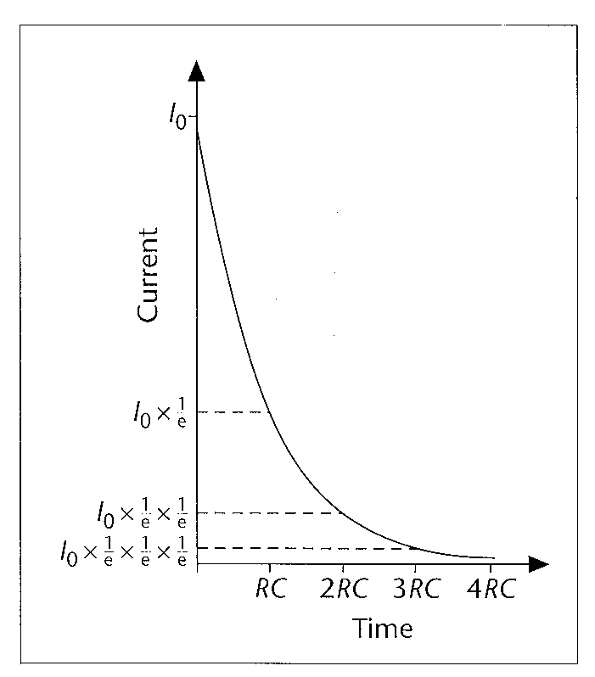

- the time taken for the current value to half is the half life, ln2 x RC
- the average time taken for the number of undecayed atoms to halve is the half life, t_{½} = ln2 x 1 / λ
- the time taken for the number of undecayed atoms to fall to 1 / e of its original value is the time constant, 1 / λ
- plotting ln(current) against time gives a straight line of slope –1 / RC
- plotting ln(number of undecayed atoms) against time gives a straight line of slope –λ

Mass and energy

- energy has mass, so when a body gains energy it gains mass as well
- increase in mass for an energy gain ∆E is given by ∆E / c² where c is the speed of light
- accurate measurements of atomic mass are based on an atom of carbon-12
- the unified mass unit, one twelfth of the mass of a carbon-12 atom, is a convenient unit for calculating mass changes involving sub-atomic particles
- a decrease in mass during a reaction indicates that energy with this amount of mass is released
- splitting up large nuclei into much smaller nuclei releases energy – a process called fission
- a fission reaction is started by the absorption of a neutron and then releases further neutrons, each of which can go on to start another reaction so that a chain reaction can build up

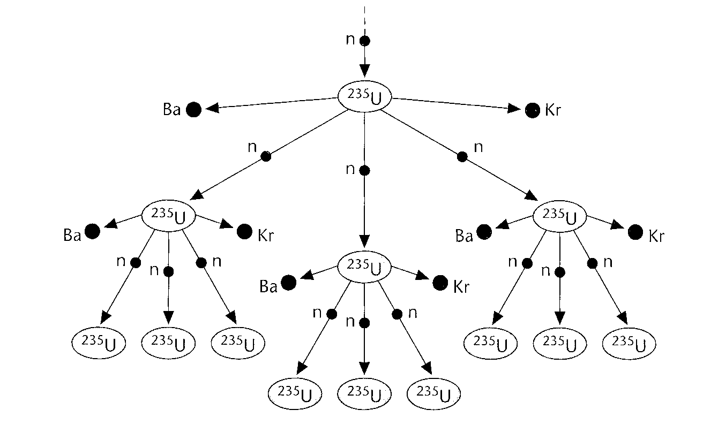

- joining together of very light nuclei also releases energy – a process called fusion

Linear accelerators

- electric fields are used to accelerate charged particles
- work done qV is transferred to kinetic energy ½mv² of accelerated particles
- a Van de Graaff generator is a device that produces a very large voltage used to accelerate charged particles to energies in the MeV range, 10⁻¹³J
- particles with higher energies than this are needed to smash atoms and sub-atomic particles
- a linac uses a series of charged plates to continually accelerate charged particles in the GeV range, 10⁻¹⁰J

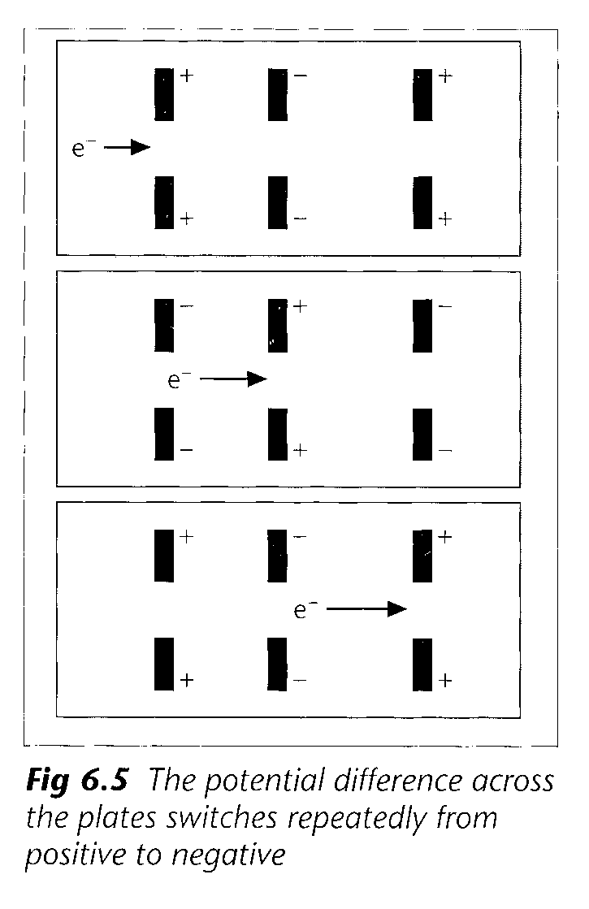

- the plate separation increases along a linac to allow for the increasing speed of the charged particles
- no matter how much energy a particle gains, its speed can never reach that of light
- the accelerated charged particles are used to bombard other particles in a fixed target

Ring accelerators

- when a charged particle moves at 90º to a magnetic field, a force BQv acts on it perpendicular to both its direction of motion and the magnetic field
- force direction can be found using Fleming’s Left hand rule where a current direction (second finger) is the same as that of positive charges but opposite to that of negative charges
- since force is perpendicular to velocity, no work is done so speed remains the same but direction changes
- charged particles follow a circular path with force BQv providing the centripetal force, mv² / r
- by using magnetic fields, the very long linear path of a linac can be turned into a spiral in a cyclotron or a circle in a synchrotron
- a cyclotron uses an alternating electric field to accelerate charged particles and a magnetic field to make them follow circular paths

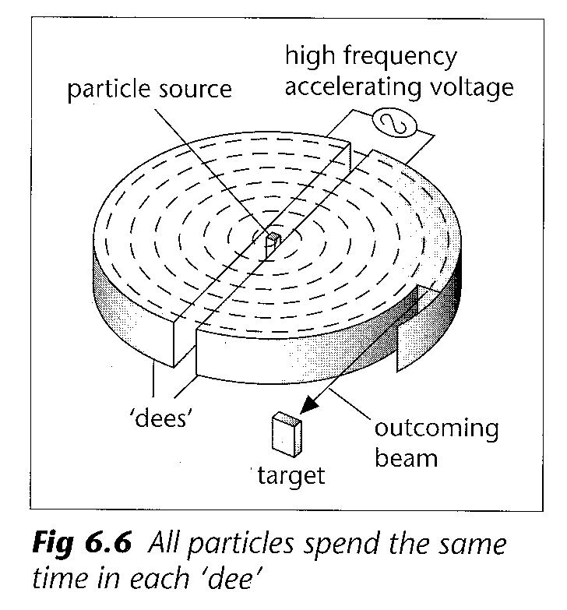

- as the charged particles are accelerated every half turn, their paths radius in the magnetic field increases
- for speeds up to about 90% of the speed of light, the faster charged particles, despite travelling further, spend the same length of time in each ‘dee’ as the slower particles
- for such charged particles, the accelerating electric field can have a constant frequency, f = BQ / 2πm
- rather than hitting a fixed target, beams of particles in a synchrotron are sometimes made to collide together from opposite directions
- total momentum of these colliding beams is zero (equal and opposite) so no energy needed for kinetic energy after the collision and thus energy available to create new particles is greater

Detecting particles

- charged particles ionise the atoms of the material through which they pass
- number of ions produced per mm of track depends on charge and speed
- a bubble chamber contains liquid hydrogen: small bubbles form around the trails of ions left by the passage of charged particles
- in a cloud chamber, alcohol droplets from a saturated vapour condense on the trail of ions
- to allow full analysis of the trails (tracks), photographs are taken from a number of different angles
- spark and drift chambers contain plates or wires at different high potentials
- currents flow where trails of ions from, and computers use the positions of these currents to construct the paths of the charged particles
- slower particles are involved in more ionising collisions per millimetre of path than fast particles so produce thicker tracks
- applying a magnetic field across the paths of the charged particles deflects them along circular paths
- the greater a particle’s momentum, the less it is deflected while positive and negative charges are deflected in opposite directions

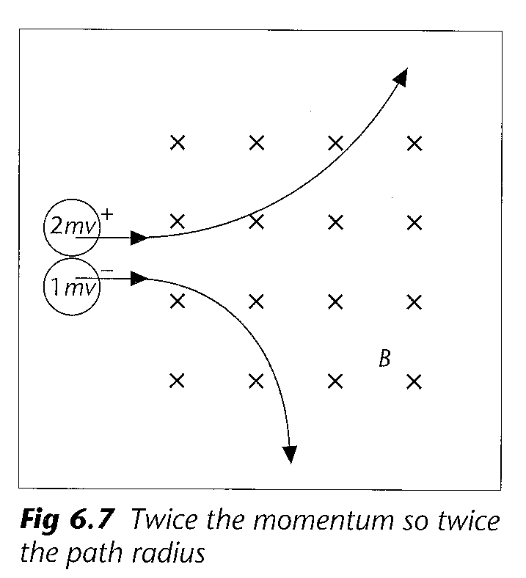
- as a particle loses kinetic energy through ionising collisions, its momentum and path radius decrease and the particle follows an inward spiral

Things to learn

With regards to the amount of learning involved, this part of the specification is somewhat different to other Units. It is more important that you are familiar with the principles that the synthesis material draws together from different areas of physics. The question set will test your understanding and application of these principles rather than expecting you to recall detailed knowledge about them as your other Unit Tests will already have done this. Therefore you should concentrate on your understanding rather than spending time learning detailed knowledge.

Checklist

Before attempting the following questions on the synthesis material, check that you:

- have compared the stretching of a spring with the charging of a capacitor
- appreciate the mathematical similarities of the two processes
- understand that the force constant k of a spring can be compared to the inverse of inverse 1 / C
- know that the product of force and displacement and also that of potential difference and charge have units of energy
- have compared electric and gravitational fields
- appreciate that all radial fields obey an inverse square law
- know a number of ways in which radial electric and gravitational fields are similar and some of the ways in which they differ
- have compared capacitor discharge with radioactive decay
- appreciate the mathematical similarities of the two processes
- understand why a quantity whose rate of decrease depends on how much of it is there decreases exponentially with time
- appreciate the constant ratio property of the exponential decay curve and understand how this relates to the concepts of time constant and half-life
- understand that the decay constant λ can be compared to the inverse of the time constant 1 / RC
- know how to find the mass difference of a nuclear reaction
- can calculate the amount of energy released from any mass difference
- understand how the processes of fission and fusion both release energy
- appreciate the role played by a uniform electric field in accelerating charge particles
- know that, for a single pair of electrodes, the energy gained by the charged particles is limited by the maximum accelerating voltage available
- understand how a linear accelerator uses a series of accelerating voltages to produce beams of very high energy particles
- appreciate that all particles have the same upper limit to their sped, that of the speed of light
- know that the main disadvantage of a linac is the extremely long length involved
- understand how a magnetic field is used to force charged particles into circular paths
- can use Fleming’s left-hand rule to predict the direction in which beams of both positive and negative particles will deflect
- understand the operating principle of a cyclotron
- can derive the equation for the frequency of an alternating accelerating voltage, f = BQ / 2πm
- appreciate that this frequency is constant for all particles with the same charge and mass
- understand why more energy is available for particle creation when two beams collide head-on than when a single beam collides with a stationary target
- appreciate that all particle detectors rely on the ionisation produces by charged particles moving through them
- understand the principles of a bubble, cloud, spark and drift chambers
- can interpret particle tracks in terms of the charge and momentum of the particles producing them

