Fields and forces and the A2 practical test

Fields and Forces

Introduction

Fields are used to interpret interactions between particles, a field being a region within which a force can be experienced. Gravitational, electric and magnetic fields all have fields associated with them. As you study fields and forces, you learn about the uniform and radial fields and the similarities and differences between gravitational and electric fields. You find that radial gravitational forces are responsible for the orbit of the planets around the Sun and learn how to calculate the period of an artificial satellite in orbit around the Earth. You find that uniform electric forces accelerate electrons’ speed. You discover that a pulse of current flows in a circuit in which there is a capacitor, a component containing an insulator, and find that capacitors can store energy. You investigate the magnetic fields resulting from permanent magnets and from current flowing in wires, and discover how, when these are combined, they produce a force. You learn that whenever there is a relative movement between a conductor and a magnetic field, an electromotive force is produced and how this is used to generate electricity.

Things to understand

Gravitational fields

- mass is the amount of matter in a body and, for a given body, remains the same everywhere
- all masses attract, exerting equal and opposite gravitational forces on each other
- gravitational forces are very small unless at least one of the masses involved is extremely large
- the region surrounding a mass in which another mass experiences a gravitational force of attraction is known as a gravitational field
- field lines are used to show the shape and direction of a gravitational field

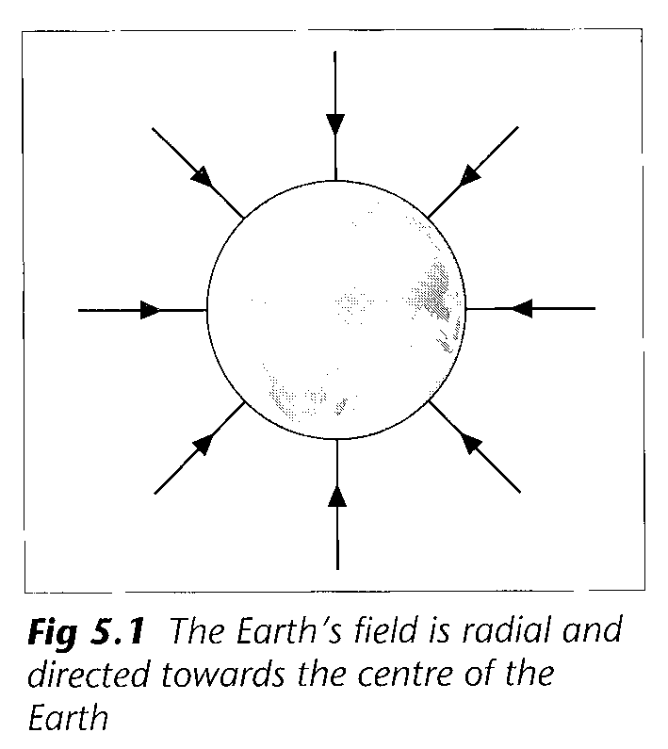

- the strength of a radial gravitational field weakens with increasing distance from the mass, indicated by the field lines spreading out
- for a radial field, gravitational field strength obeys an inverse square law

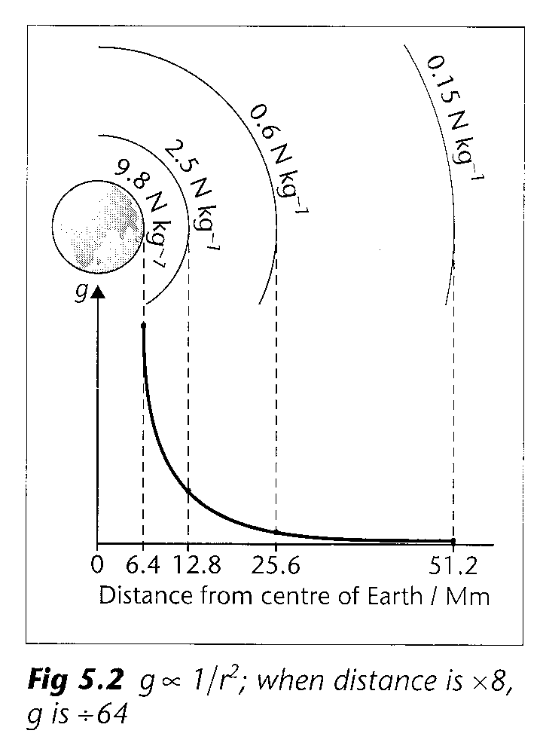

- across a relatively small region, the Earth’s gravitational field is effectively uniform
- the strength of a uniform gravitational field is the same everywhere
- gravitational field strength is the gravitational force that would be exerted on a mass of 1kg placed at that point
- gravitational field strength, a vector quantity, is numerically the same as the free fall acceleration at that point, Nkg⁻¹ = ms⁻²
- orbiting satellites have only the force of gravity acting on them
- their orbital speed is such that the gravitational force provided the exact amount of centripetal force required for their circular motion
- work is done moving masses apart resulting in an increase in their potential energy
- an orbiting satellite has constant potential energy and follows a line along a spherical equipotential surface

Electric fields

- rubbing a polythene strip with a duster charges the strip negatively and the duster positively
- electrons are dragged from the duster onto the strip leaving the strip with an excess of electrons (negative) and the duster with excess protons (positive)
- both the strip and the duster are insulators and so maintain their charges – a metal rod would immediately conduct away any charge transferred to it
- electric charges either attract when the signs are opposite or repel when the signs are the same
- the region surrounding a charge in which another charge experiences an electric force is known as an electric field
- field lines are used to show the shape and direction of an electric field
- the electric field of a point charge is radial and directed towards a negative charge and away from a positive charge

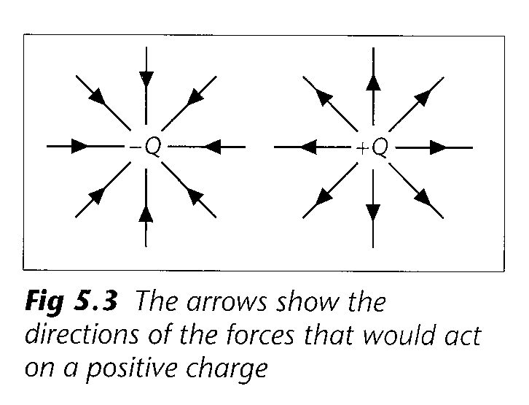

- in the central region between two parallel, oppositely charges plates, the electric filed is uniform and directed towards the negative plate
- the strength of a radial electric field weakens with increasing distance from the charge whereas that of a uniform electric field is the same everywhere
- electric field strength, a vector quantity, is the electric force that would be exerted on a charge of 1C placed at that point, measured in NC⁻¹
- for a radial field, electric field strength obeys an inverse square law
- the electric field strength of a uniform field can be found by dividing the potential difference across the plates by the separation, NC⁻¹ = Vm⁻¹
- uniform electric fields are used to accelerate electron beams
- work done, eΔV, on the electron appears as kinetic energy of the electron

Capacitors

- a capacitor consists of two metal plates separated from each other by an insulating material
- current cannot flow in the insulator but a battery can take electrons from one plate and add electrons to the other
- one plate of a charged capacitor is positive (electrons removed) and the other is negative (electrons added)
- the amount of charge displaced depends on the potential difference across the capacitor’s plates, Q = CV
- as a capacitor charges, the current charging it decreases
- the area under a current-time graph represents the charge displaced
- the initial current is determined by the supply voltage and the total circuit resistance
- decreasing resistance increases the charging current and the capacitor takes less time to charge

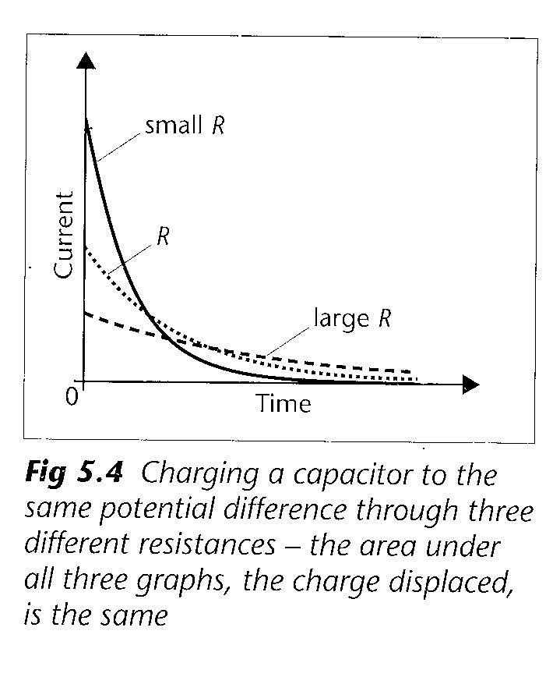

- connecting capacitors in parallel increases the total capacitance
- the total capacitance of capacitors in series is always less than any of the individual capacitances
- a charged capacitor stores energy
- the area under a potential difference – charge graph represents the energy stored

Magnetic fields

- two permanent magnets either attract when poles are opposite or repel when poles are the same
- a magnetic field is any region within which magnetic forces act
- field lines are used to show the shape and direction of a magnetic field
- all magnetic field lines are continuous
- the arrows show the direction in which the north end of the needle of a plotting compass would point
- neutral points are formed where magnetic fields overlap and completely cancel
- a current flowing in a wire produces a circular magnetic field around the wire
- the magnetic field outside a current-carrying solenoid resembles that of a bar magnet, whereas that inside it is uniform
- a force acts when a current flows at an angle to a magnetic field, the force being greatest when the current and the magnetic field are perpendicular
- the force is perpendicular to the current and the magnetic field

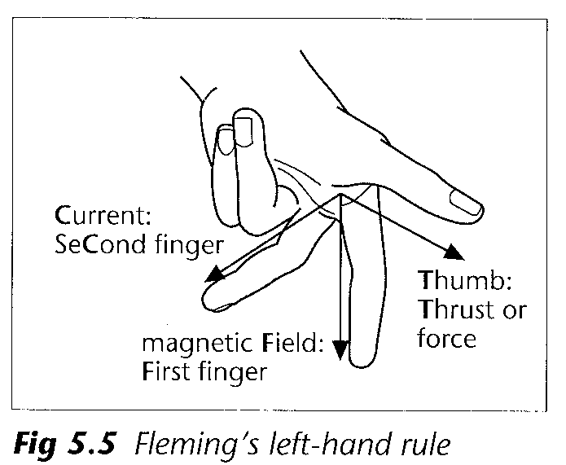

- the strength of a magnetic field is called its magnetic flux density
- magnetic flux density is a vector quantity that can be measured using a pre-calibrated Hall probe

Electromagnetic induction

- magnetic flux is the product of the magnetic flux density and the area through which it is passing
- the magnetic flux linkage through a coil depends on the number of turns in the coil
- an e.m.f. is induced in a coil whenever there is a change in magnetic flux linkage
- the faster the rate of change in magnetic flux linkage, the larger the induced e.m.f., ε = rate of change of magnetic flux linkage
- if there is a complete circuit then an induced current flows
- induced currents flow in such a way that their interaction with the magnetic field produces an effect that opposes whatever caused them
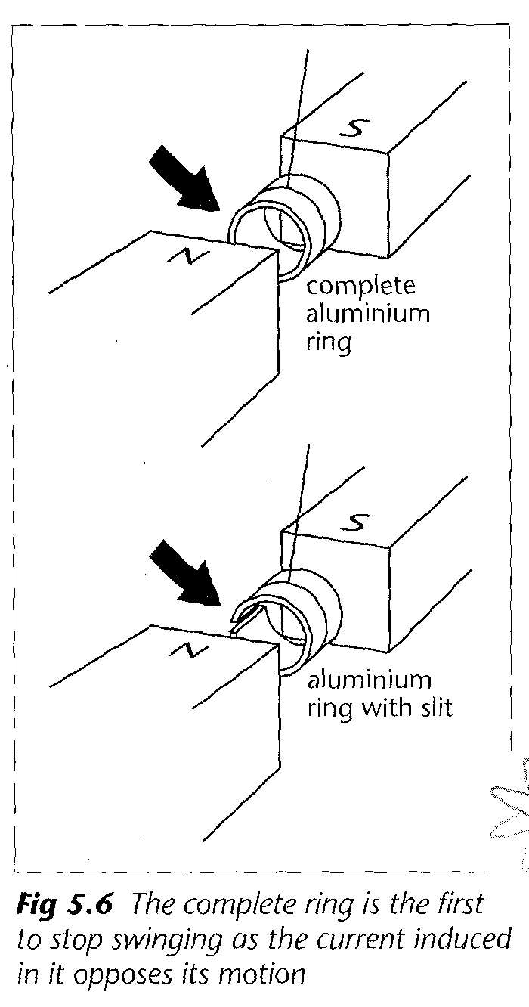

- a transformer uses electromagnetic induction to change the size of an alternating voltage
- alternating current in the primary coil produces an alternating magnetic field in the transformer’s coil
- the alternating magnetic flux through the secondary coil leads to an induced e.m.f. across its terminals
- a step-down transformer has fewer secondary than primary turns so its output voltage is less than the input
- an ideal transformer would be 100% efficient and its output power would equal its input power

Things to learn

You should learn the following for your Unit PHY5 Test. Remember that it may also test your understanding of the ‘general requirements’. (See Appendix 1)

Equations that will not be given to you in the test

- weight = mass x gravitational field strength weight = mg

- the inverse square law for force between two point masses F = Gm₁m₂ / r²

- centripetal force = mass x speed² / r F = mv² / r

- the inverse square law for force between two point charges F = kQ₁Q₂ / r²

- capacitance = charge displaced / potential difference C = Q / V

- the relationship between the potential difference across the coils of a transformer and the number of turns in them

V₁ / V₂ = N₁ / N₂

Laws

- Newton’s law of gravitation: the gravitational force between two bodies is directly proportional to the product of their masses and inversely proportional to the square of their separation
- Coulomb’s law: the electric force between two charges is directly proportional to the product of their charges and inversely proportional to the square of their separation
- Faraday’s law: the magnitude of the e.m.f. induced across a circuit is equal to the rate of magnetic flux linkage through that circuit
- Lenz’s law: any current driven by an induced e.m.f. opposes the change causing it

General definitions

- gravitational field: region in which a gravitational force acts on a mass
- gravitational field strength: force exerted per unit mass by a gravitational field
- geostationary satellite: orbits above equator, in same direction as Earth rotates, with a period of 24h and so maintains the same position above the Earth’s surface
- inverse square law: when a quantity decreases in proportion to the square of the distance
- electric field: region in which an electric force acts on a charge
- electric field strength: force exerted per unit charge by an electric field
- equipotential surface: surface over which potential is equal at all points
- magnetic field: region in which a magnetic force acts
- neutral point: position within overlapping magnetic fields where the resultant force is zero
- tesla: the unit of magnetic flux density; the magnetic flux density that produces a force of 1N on each metre length of wire carrying current of 1A perpendicular to the magnetic field

Word equation definitions

- capacitance = charge displaced / potential difference so 1F = 1CV⁻¹
- magnetic flux density = force/(current x length of wire)
- magnetic flux = magnetic flux density x area
- magnetic flux linkage = magnetic flux x number of turns

Experiments

- 1. Current in a capacitor circuit

Set up the circuit as shown below
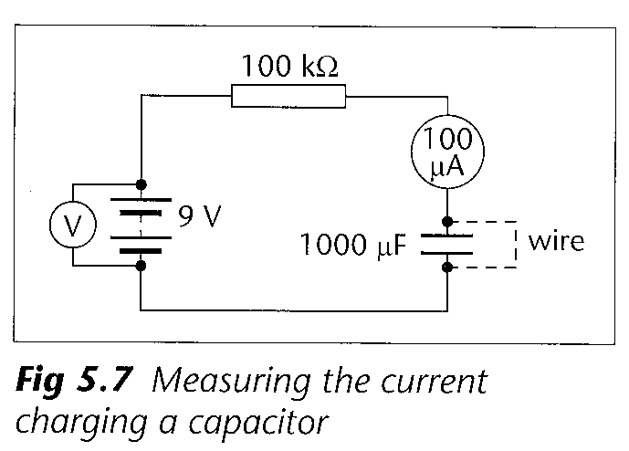

With the capacitor shorted out, record the current from the microammeter.
Remove the shorting lead and start timing.
Record the current every 5s until it has fallen to 5% of its starting value.
Plot a graph of current against time.
Repeat using resistances of 50 and 200kΩ.
Find the area under each curve either by counting squares or by approximating it to a suitable triangle.
Divide the area (charge) by the voltmeter reading to obtain a value for the capacitance.

- 2. Charging a capacitor at a constant rate

This experiment overcomes the problem of finding the area under a curve by keeping the charging current constant and so changes the curve in to a straight line.
With the variable resistor at its maximum value, set up the circuit shown below.

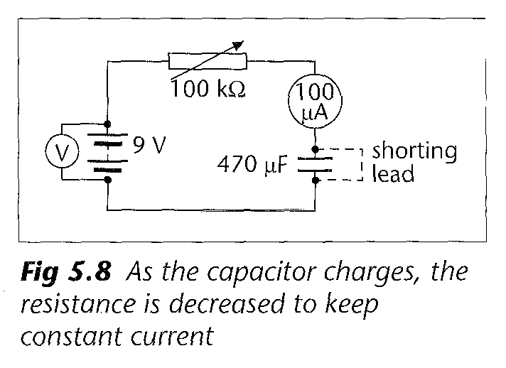
Short out the capacitor and adjust the variable resistor so the ammeter reads a convenient value, e.g. 80μA
Remove the shorting lead and start timing.
Keep adjusting the variable resistor to maintain a constant current.
Stop timing when the variable resistor reaches its minimum value.
Repeat and obtain an average charging time.
Calculate charge = current x time.
Divide the charge by the voltmeter reading to obtain a value for the capacitance.
Repeat for different values of constant current.

- 3. Energy stored in a charged capacitor

Charge a capacitor to a potential difference of 3V and discharge it through a single lamp as shown in (a) below.

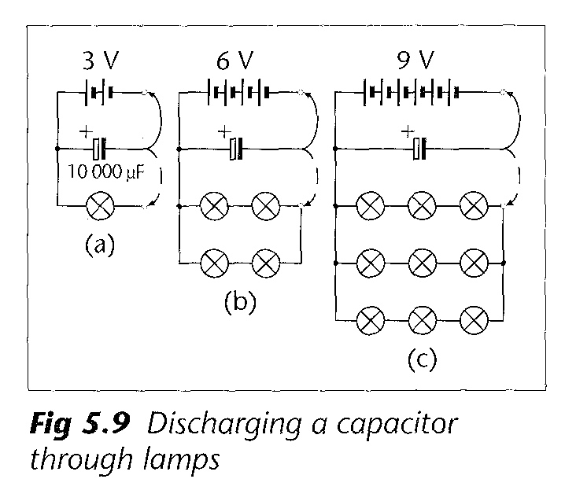
Note the brightness and length of flash.
Charge the capacitor to 6V and discharge it through different lamp combinations
Brightness and length of flash is the same when using four lamps connected as shown in (b) above.
When voltage doubles, flash energy quadruples.
Charge the capacitor to 9V and discharge it through different lamp combinations.
Brightness and length of flash is the same when using nine connected as shown in (c) above.
When voltage trebles, flash energy is nine times greater.
So energy stored in charged capacitor α V².

- 4. Force on a current in a magnetic field

Set up the apparatus as shown below with the aluminium rod clamped firmly in place.

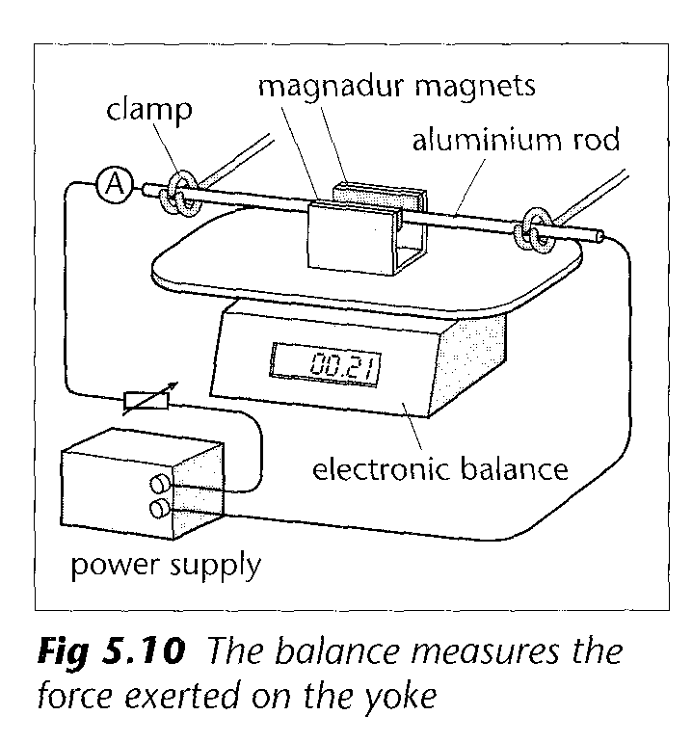

Zero the balance, set to read force, to allow for the weight of the magnets and the yoke.
Switch on the supply and adjust for a current of 1A.
Record the force from the balance.
Vary the current to obtain a series of corresponding values of force and current.
Plot a graph of force against current.
Repeat for different lengths of rod in the magnetic field by adding further pairs of magnadur magnets. Grpahs obtained shown on the next page.

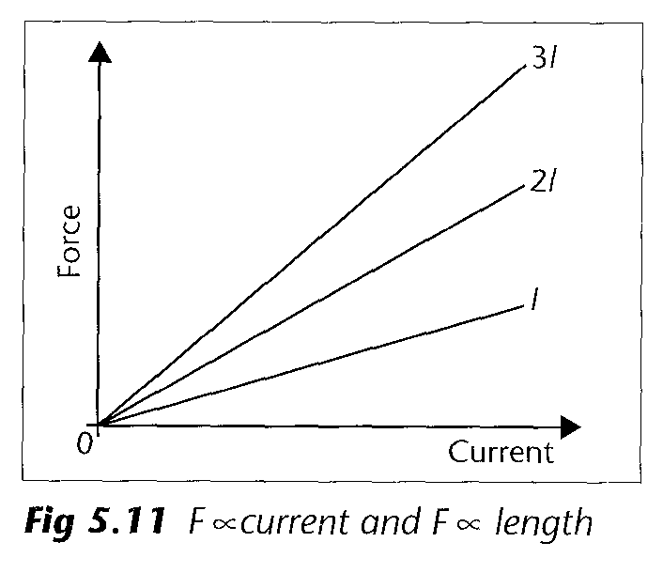

Increase the magnetic field strength by holding the magnadur magnets closer together and observe that the force increases.

- 5. Investigating the magnetic field strength near a straight wire.

Place a pre-calibrated Hall probe 1cm from a straight wire carrying a current of 2A as shown below

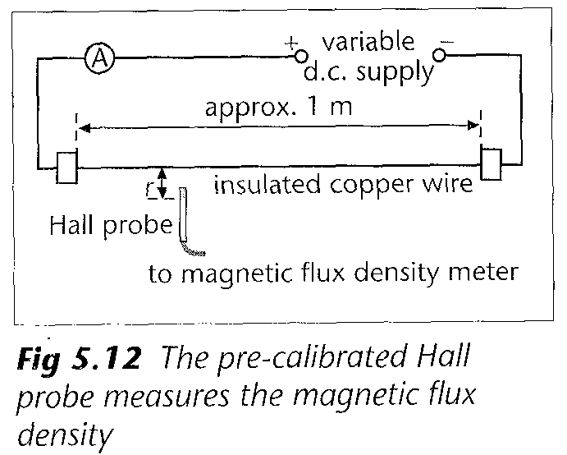

Observe the reading on the flux density meter as the probe is slowly rotated.
Record the maximum reading; probe is then at 90˚ to the filed lines.
Repeat for currents increasing in steps of 2A, up to a maximum of 10A.
Plot a graph of magnetic flux density against current.
Straight line through the origin shows that B α I.
Using a current of 10A, record the magnetic flux density at different distances from the wire.
Plot a graph of magnetic flux density against 1 / distance.
Straight line through the origin shows that B α 1 / r.

Checklist

Before attempting the following questions on fields and forces, check that you:

- appreciate that all masses attract

- understand the concept of a field and how this applies to masses, charges and magnets/currents

- can sketch the shape and show the direction of the radial gravitational field of a mass

- have learnt a statement of Newton’s law of gravitation

- appreciate what is meant by an inverse square law

- know why the gravitational field strength is numerically the same as the free fall acceleration

- know that gravitational forces are responsible for the circular motion of planets and satellites

- appreciate the usefulness of geostationary satellites

- understand that the potential energy of a satellite remains constant

- realise that equipotential lines are always at 90˚ to field lines

- know that under certain conditions the Earth’s gravitational field can be considered as uniform

- understand the process whereby an object is charged by frictional contact

- know that there are two signs of charge and that the electronic charge is the smallest possible amount of charge

- appreciate that opposite charges attract and like charges repel

- can sketch the radial electric field of both positive and negative charges

- have learnt a statement of Coulomb’s law

- can sketch the electric field between two, oppositely charged parallel plates and can add a number of equipotentials to it

- know how a uniform electric field is used to accelerate charged particles

- can calculate the speed of an electron fired form an electron gun

- know the structure of a capacitor and why it cannot conduct electricity

- understand what is happening when a capacitor is charging

- have learnt a description of an experiment to show how the current charging a capacitor varies with time and know how a variable resistor can be used to maintain the charging current

- know that the area under a current-time graph represents the charge

- have learnt the definition of capacitance and know its unit

- understand the effect of combining resistors in series and in parallel

- know that a charged capacitor stores energy

- have learnt a description of an experiment to show how the energy stored in a charged capacitor depends on the potential difference across it

- can sketch the magnetic field produced by a single bar magnet, between two attracting bar magnets and between two repelling bar magnets

- understand the concept of a neutral point

- can sketch the magnetic field produced by a current in a wire and in a solenoid

- know that a force acts on a current flowing at an angle to a magnetic field

- can use Fleming’s left hand rule to find the direction of this force

- have learnt a description of an experiment to investigate the force exerted on a current in a magnetic field

- have learnt the definition of magnetic flux density and its unit, the tesla

- appreciate that magnetic flux density can be measured using a Hall probe

- have learnt a description of an experiment to investigate the magnetic field near a straight wire and know how a similar method can be used for a solenoid

- can distinguish between magnetic flux density, magnetic flux and magnetic flux linkage

- know that any change in magnetic flux through a coil induces and e.m.f.

- have learnt a statement of Faraday’s law

- have learnt a statement of Lenz’s law

- understand the principle of operation of a transformer

- know that a transformer will not work using direct current

- can calculate the output voltage from a known transformer

- are familiar with the ‘general requirements’ in Appendix 1 and how they apply to the topics of fields and forces

The A2 practical test

Introduction

This test builds on the laboratory skills examined in the Unit PHY3 Practical test and expects you to demonstrate more advanced skills than in AS. It is based on material from any part of the basic specification. The test consists of three questions each one lasting 25 minutes, although the apparatus may only be used for the first 20 minutes of these. There is a further 15 minutes writing up time at the end giving a total test length of 90 minutes. Each question is worth 16 marks. Question 1 usually contains two exercises of approximately equal length that focus on setting up and using apparatus and recording observations. Question 2 concentrates on using apparatus and evaluating results, with some planning being required. Question 3 concentrates on planning with aspects of analysis and evaluation. At least one question involves drawing a graph, which may involve the use of logarithms. None of the questions will require the use of data logging apparatus although you may be asked to explain how to set up and use such a device. All advice given in ‘AS and A level introduction’ concerning the AS practical test also applies to that for A2. The following section adds to this advice and gives a sample question of each type. Where possible, you should also practise these questions using the apparatus, which is listed in the questions.

Advice on tackling the A2 practical test

- read carefully through all the advice given on tackling the AS practical test given in ‘AS and A level introduction’
- make sure that you know how to use all standard apparatus met with while studying Units 4 and 5 such as signal generators and oscilloscopes
- practise using your calculator to find the logarithm, both natural and base 10, of a number
- practise using your calculator to find the number from a logarithm, both natural and base 10
- remember that taking logarithms of y = ax^{n} gives log y = n log x + log a, which is similar to y = mx+c so the power n is the gradient of the straight line obtained when log y is plotted against log x
- also, if one quantity decreases exponentially with another, y = ae^{-kx}, plotting ln y against x gives a straight line with a gradient of –k, since ln y = -kx + ln a which is again similar to y = mx + c

Sample A2 practical questions

1. (a) You are to determine the time taken for the charging current in an RC circuit to halve.

Apparatus needed : 4.5V d.c. power supply, 470μF capacitor with positive terminal clearly marked, 47kΩ resistor in holder, 100μA ammeter, five connecting leads

Draw a circuit diagram of the circuit you would use to monitor the current during the charging of a capacitor in series with a resistor from a d.c. power supply. Explain why it is necessary to connect the capacitor into the circuit with the correct polarity. How would you discharge the capacitor while it is still connected to the circuit? (4)

correct series arrangement showing all four components (1)
with correct polarity of capacitor marked (1)
to maintain the dielectric/insulator (1)
short out the capacitor by connecting the spare leads across it (1)

Set up the circuit and determine the time taken for the current to halve. Show all your readings below and explain the precautions you took to make your readings as accurate as possible. You are not expected to draw a graph. (4)

correct time measured (1)
and repeated (1)
for different starting currents (1)
value between 10 and 20s (RC ln 2 =15s) with unit, to 2/3 s.f. (1)

(b) This experiment is concerned with the use of a diffraction grating to observe spectra.

Apparatus needed : 12V, 24W lamp connected to supply and clamped 75cm above bench with filament horizontal, 300 line mm⁻¹ diffraction grating clamped a few cms below the lamp with rulings parallel to filament, A4 sheet of white paper on bench with shorter sides parallel to filament, 10cm focal length converging lens, tripod supporting a Petri dish containing a very dilute potassium permangenate solution, metre rule, dim lights.

Place the converging lens on top of the diffraction grating and adjust the height of the grating so that a sharp image of the filament lamp is focused on the paper on the bench. Record the distance D from the diffraction grating to the bench. Mark on the piece of paper the limits of the first order visible spectrum on either side of the image of the filament. Sketch the spectra and mark the distance x_{R} between the two red limits and the distance x_{V} between the two violet limits. (3)

D, x_{R} and x_{V} to the nearest mm (1)
neatly drawn diagram showing filament and spectra (1)
spectra labelled correctly e.g. violet nearest filament (1)

Calculate the angle θ_{R} between the first order red limit of the spectrum and the image of the filament using tan θ_{R} = x_{R} / 2D and hence find sin θ_{R}. (2)

correct calculation of tan θ_{R} (1)
sin θ_{R} found and in range 0.18 to 0.21 (1)

Carefully insert the tripod and dish containing the purple solution so that the light to one of the first order spectra passes through the solution. Describe any changes in the appearance of the spectrum. Explain briefly why the spectrum changes. (3)

black band described or drawn between red and violet (1)
detail – broad band with narrow red and violet bands (1)
photons having certain energies are absorbed by solution (1)

2. You are to investigate how the periodic time of a vibrating cantilever is dependent on the length of the cantilever.

Apparatus needed : wooden metre rule labelled A, two 100g slotted masses, rubber band to secure the masses to the rule, G-clamp, small block of wood, second metre rule, Vernier callipers, digital stopwatch, stand, clamp and boss.

(a) Set up the apparatus as shown below using the metre rule labelled A. The length l should be set to 0.900m.

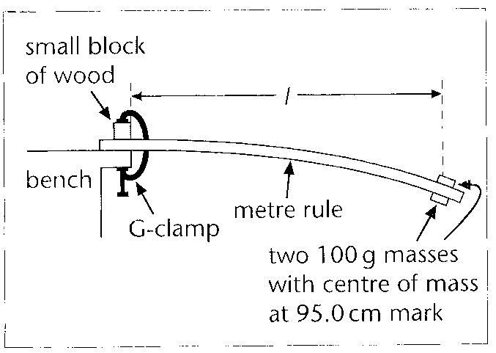

Explain carefully how you ensured that the length l was set to 0.900m. You may add to the diagram if you wish. (2)

use of horizontal second rule (1)
good description of how l was set (words or diagrams) (1)

(b) Displace the end of the rule vertically and determine the period T of the vertical oscillations. (3)

T with unit and averaged from repeated readings (1)
at least 20 oscillations measured in total (1)
T within ± 0.02s of supervisor’s value (1)

(c) Measure the width b and the thickness d of the clamped rule. Estimate the percentage uncertainty in each of these quantities. (5)

b with unit and within ± 0.05cm of supervisor’s value (1)
d with unit and within ± 0.05cm of supervisor’s value (1)
both b and d repeated (1)
correct uncertainties (either half-range or ± 0.01cm) (1)
correct calculations of percentage uncertainties (1)

(d) The Young modulus E of the rule is given by E = 16π2Ml³ / bd³T², where M = total mass attached to rule. Use your results to calculate a value for E. (2)

substitution of SI values into expression for E (1)
correct calculation of E with unit (1)

(e) Explain why d would contribute far more than b to the uncertainty in your value for E. (2)

percentage uncertainty in d is larger than it is in b (1)
and is multiplied by 3 (since d³ in expression) (1)

(f) What additional apparatus would you use to improve the precision in your measurement of d? Estimate the factor by which this would reduce your percentage uncertainty in d. (2)

use a micrometer to measure d (1)
percentage uncertainty in d reduced by a factor of 10 (1)

3. You are to plan an investigation of how the diameter of a crater formed in soft sand by a polystyrene sphere is dependent on the impact velocity of the sphere. You are then to analyse a set of data from such an experiment. You may use the sphere and the sand provided to observe the crater formation, but you are not required to take any measurements. In addition to the apparatus provided, you may assume that a metre rule, a pair of dividers, a set square and a stand and clamp would be available.

Apparatus needed : 250ml beaker containing dry sand to within 1cm of top, table tennis ball

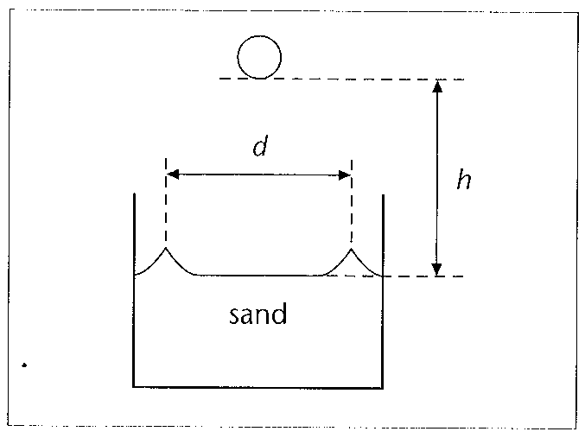

(a) (i) Which quantity would you vary in order to vary the impact velocity of the sphere? Draw a diagram of your experimental arrangement. Indicate on the diagram any measurements to be taken. Explain how the impact velocity could be found from your measurements. (4)

vary height above sand from which the sphere is released (1)
diagram, as above, showing height of bottom of sphere above sand and d (1)
kinetic energy gained = potential lost (1)
½mv² = mgh (1)
v = √(2gh) (1)

(ii) State an assumption which you have to make to determine the impact velocity. How might this assumption affect the velocities which you use? (2)

assume that air resistance is negligible (1)
need to use small heights / velocities to minimise air resistance so limits range used (1)

(iii) The diameter d of the crater is expected to be related to the impact velocity v by an equation of the form d = kv^{n} where k and n are constants. Describe briefly how you would investigate this relationship experimentally and include an indication of the graph you would plot to investigate the equation. (3)

vary v (by varying h) and measure corresponding d (1)
plot log (d / m) against log (v / ms⁻¹) (1)
taking logarithms of d = kv^{n} gives log d = n log v + log k should get a straight line with a gradient n and intercept log (k / m) (1)

(b) The following data was obtained from such an investigation.

v / ms⁻¹ | d / m
0.44 | 0.0118
0.77 | 0.0168
1.17 | 0.0218
1.47 | 0.0234
1.72 | 0.0275
2.12 | 0.0308

Use the columns provided for your processed data, and then plot a suitable graph to test the equation. (5)

log (v / ms⁻¹) | log (d / m)
-0.357 | -1.93
-0.114 | -1.77
0.068 | -1.66
0.167 | -1.63
0.236 | -1.56
0.326 | -1.51

plot a graph of log (v / ms⁻¹) against log (d / m) – see graph below

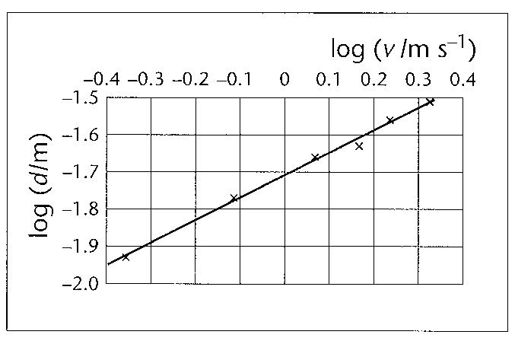

correct log values (1)
suitable scale for graph (1)
axes labelled with units correctly shown in either table or graph (1)
correct plotting (1)
good best-fit straight line (1)

(c) Use your graph to determine a value for n. (2)

n = gradient = -1.50 – (-1.95) / (0.34 – (-0.40)) = 0.45 / 0.74 = 0.61
large triangle used for gradient (1)
correct calculation giving n to 2 or 3 s.f. and with no unit (1)

