Electricity and Thermal physics

Introduction

Electricity is that invisible method of working that has transformed the way that we live. Modern civilisation relies heavily on electricity. Electricity drives modern life like few other discoveries of the 19th century. Electricity is convenient and easy to control. As you go through this unit you learn how the very slow movement of a large number of electrons within an electric circuit results in a current. You find how the size of the current depends on the potential difference driving the current and the resistance to their movement. This allows you to calculate the current in and the power dissipated by different parts of a circuit, even when the power supply has its own internal resistance. You discover how the resistance of a wire depends on its length and cross-sectional area, how the resistance of an LDR depends on its illumination and how the resistance of a thermistor depends on its temperature.

Things to understand

Charge and Current

- charge Q is either positive or negative and is measured in coulombs (C)
- an electric current I consists of a flow of charged particles: these might be positive ( a beam of alpha particles), negative (electrons moving through a wire) or a mixture of both positive and negative (ions moving through an electrolyte solution)
- the direction of a current is always that in which a positive charge would move irrespective of the sign of the actual charge carriers

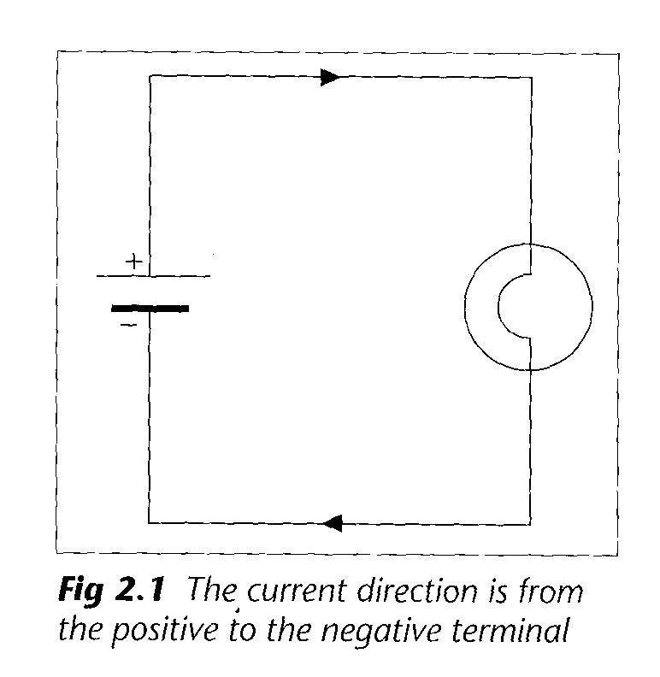

- current is the rate of flow of charge
- current is measured in coulombs per second (Cs⁻¹), a unit more commonly known as the ampere (A)
- the current flowing at a point in a circuit is measured by inserting an ammeter into the circuit at that point

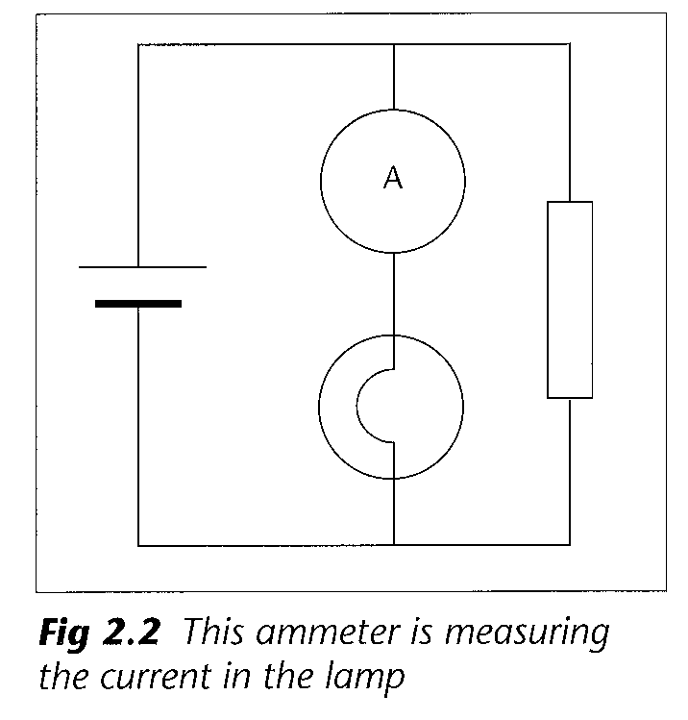
- an ammeter should have as low a resistance as possible
- charge is always conserved
- current is the same at all points around a series circuit
- the total current entering a junction equals the total current leaving it

Drift velocity

- the electrical behaviour of metals, semiconductors and insulators is related to the number of charged particles that are free to move between them
- all electrons in a perfect insulator are fixed to their atoms so that none are free to move
- most electrons in a metal are fixed to their atoms but one or two per atom are free to move and carry charge
- the number of atoms and, hence, the number of conduction electrons in a metal wire is extremely large
- the current in a metal wire consists of a very large number of electrons moving at a very slow drift velocity, typically 0.1mms⁻¹
- the equation I = nAqv, where

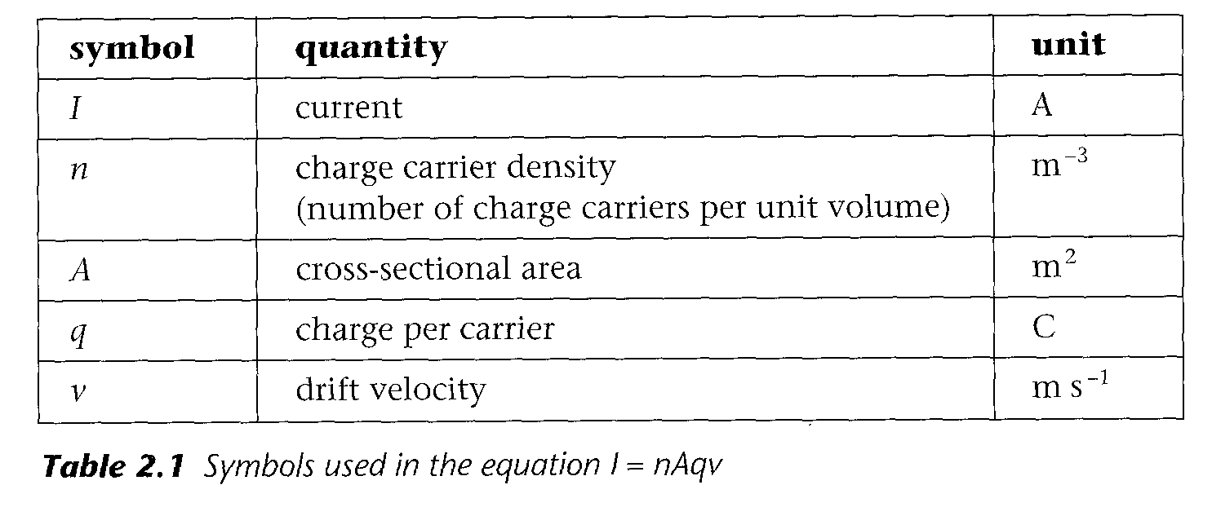

- when a circuit is turned on, all the conduction electrons throughout the circuit start to slowly drift almost instantaneously

Potential difference

- in a circuit, the power supply forces the charge carriers to move around a circuit from a high to a low potential
- components oppose the motion of these changes
- the moving charges do work on the components and transfer energy to them
- components in which there is a current must have a potential difference across them
- the potential difference across a component is the energy transferred by each coulomb of charge passing through it
- potential difference is measured in joules per coulomb (JC⁻¹), a unit commonly known as volt (V)
- the potential difference across a component is measured by connecting a voltmeter in parallel with that component

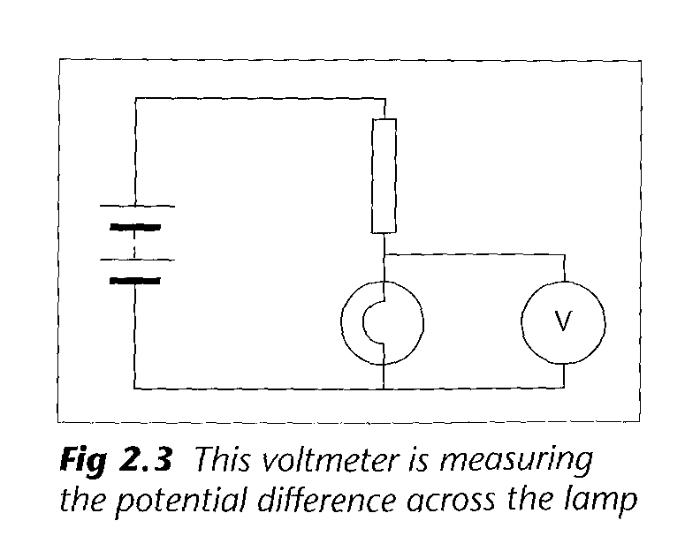
- a voltmeter should have as high a resistance as possible
- components connected in parallel must have the same potential difference across them
- the total potential difference across components connected in series is the sum of the potential differences across each one

Resistance

- resistance is a measure of a component’s opposition to a flow of charge
- when resistance is high, a large potential difference is needed for a given current
- resistance is the ratio of the potential differences across the component to the current in it.

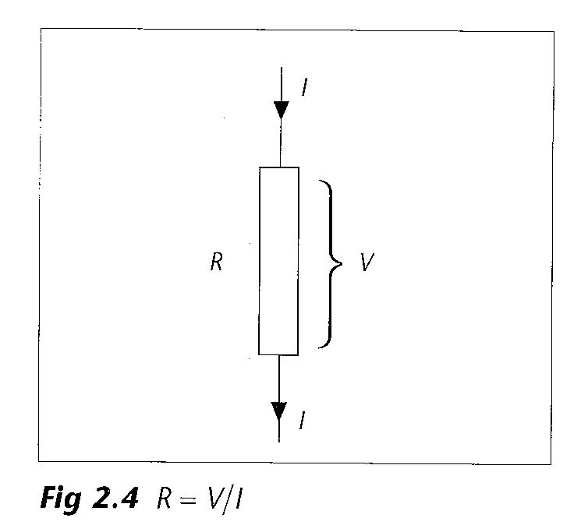

- the resistance of a component indicates the potential needed for 1A of current
- an ohmmeter can be used to measure directly the resistance of a small component, although if the component’s resistance is small then the resistance of the connecting leads must be taken into account
- connecting components in series increases the total resistance
- the total resistance of components in parallel is always less than any of the individual resistances
- the resistance of a metal wire increases with temperature since the increased lattice vibrations obstruct the movement of the charge carriers so reduce the drift velocity
- the resistance of a negative temperature coefficient (NTC) thermistor decreases as temperature increases since the increased lattice vibrations release more charge carriers so increasing the charge carrier density
- LDR resistance decreases as illumination increases

Resistivity

- resistivity is a measure of a material’s opposition to a flow of charge
- the resistance of a wire depends on its length, cross-sectional area and the resistivity of the material from which it is made
- a long wire has a greater resistance than a short wire of the same material and area
- a thick wire has a smaller resistance than a thin wire of the same material and length

Potential divider

- a potential divider consists of a chain of resistors connected in series across a supply voltage
- a potential divider divides the total potential difference across it in the ratio of its resistances so the potential difference across each resistor depends on the values of the resistances used
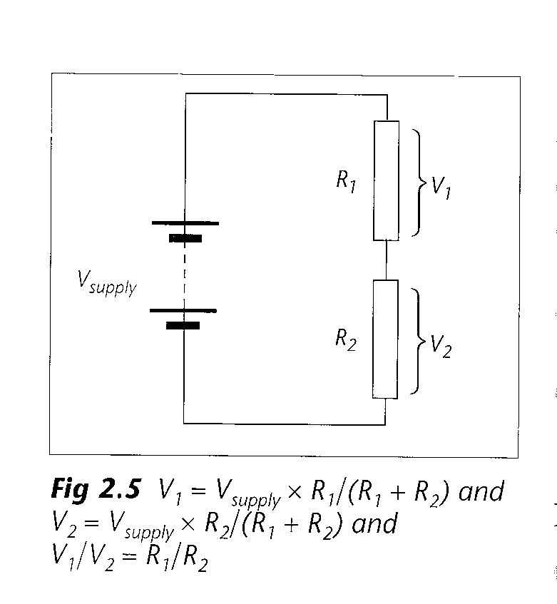
- a temperature-sensitive potential divider uses an Thermistor as one of its series resistors
- a light-sensitive potential divider uses an LDR as one of its series resistors
- a potentiometer is a variable potential divider

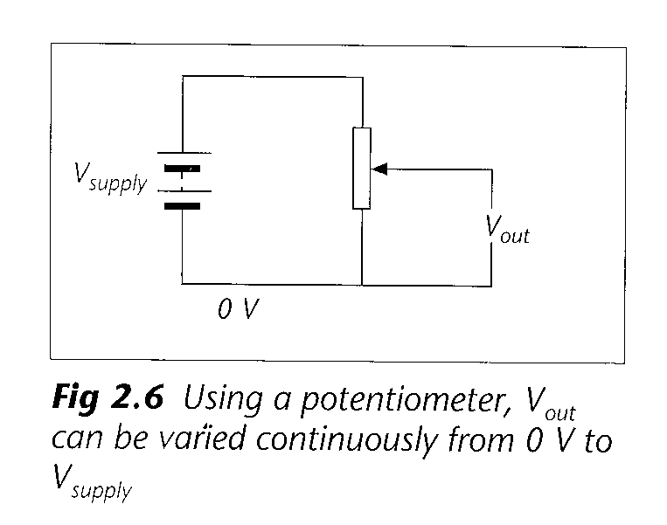

Current-potential difference characteristics

- the way in which the current changes with potential difference varies from component to component

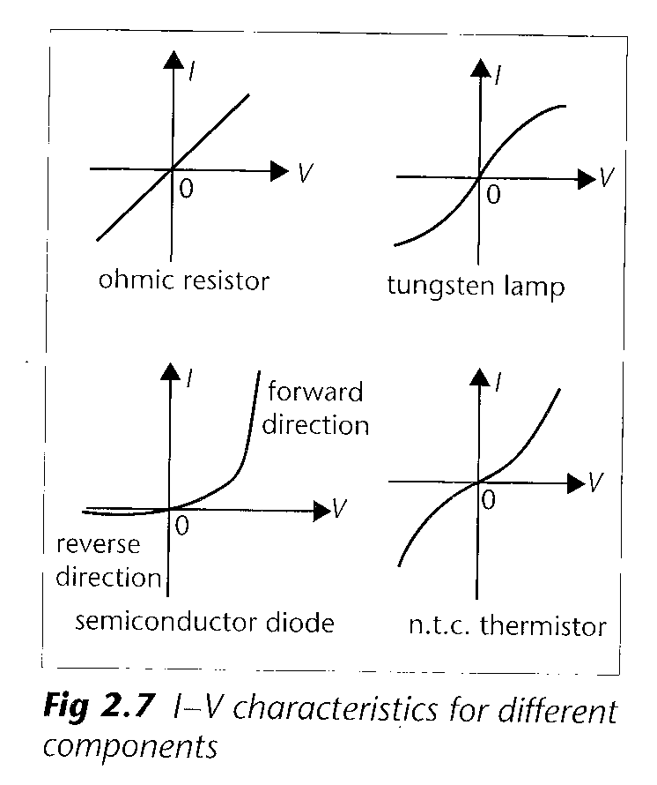

- current is proportional to potential difference for an ohmic component; the graph is a straight line through the origin and the resistance is constant
- the graph for a tungsten filament lamp shows that the resistance of its filament increases as it gets hotter
- the graph for a NTC thermistor shows that its resistance decreases as it gets hotter
- a semiconductor diode only conducts well in the forward direction while very little current flows in the reverse direction

E.m.f and internal resistance

- a power supply does work on the charge carriers as it forces them to move around a circuit and so gives energy to the circuit
- the e.m.f. of a power supply is the energy given to each coulomb of charge passing through it
- e.m.f. is measured in (JC⁻¹) or volts (V)
- not all the energy given to the charge carriers reaches the external circuit as some of it is transferred within the power supply as the charges do work on the internal resistance
- internal resistance is the effective opposition of the power supply to the flow of current through it
- the potential difference across the internal resistance is often referred to as the ‘lost volts’
- the potential difference across the terminals of a power supply only equals its e.m.f. when it is supplying no current
- the terminal potential difference is less than the e.m.f. when there is a current; the larger the current, the more the ‘lost volts’ and the smaller the terminal potential difference
- a car battery has a very small internal resistance as it has to supply large currents to the starter motor
- an e.h.t. power supply has a very large internal resistance to limit the current it supplies to a safe level

Circuit calculations

- total circuit resistance must include the internal resistance of the power supply
- current supplied = e.m.f. / total circuit resistance
- potential difference across a part of a circuit = current in that part x resistance of that part

Things to learn

You should learn the following for your Unit PHY2 Test. Remember that it may also test your understanding of the ‘general requirements’

Equations that will not be given to you in the test

- charge = current x time Q = It
- potential difference = energy transferred / charge V = W / Q
- potential difference = current x resistance V = I x R
- electrical power = potential difference x current P = VI
- energy transferred electrically = potential difference x current x time W = VIt
- resistance = resistivity x length / cross-sectional area R = ρl / A

Laws

- the sum of the currents entering a point is equal to the sum of the currents leaving that point (known as Kirchoff’s first law; this law is a consequence of the conservation of charge)
- around any closed loop, the sum of the e.m.f.s is equal to the sum of the potential differences (known as Kirchoff’s second law; this law is a consequence of the conservation of energy)
- Ohm’s law: the current in a conductor is directly proportional to the potential difference across it provided the temperature remains constant

General definitions

- current: the rate of flow of charge
- series: components connected such as the same current goes through each in turn
- parallel: components connected across each other such that they each have the same potential difference and the current has a choice of routes
- drift velocity: the average velocity of the charge carriers through a circuit
- charge carrier density: the number of charged particles per metre cubed that are free to move and carry current
- potential difference: a voltage across a component that takes energy away from a charge; the energy transferred by each coulomb of charge passing through the component
- resistor: a component that opposes the flow of current
- NTC thermistor: a component whose resistance decreases as the temperature increases
- LDR: a component whose resistance decreases as the level of illumination increases
- diode: a component that conducts easily in one direction but not in the other
- potential divider: a chain of resistors that divides up the voltage from a source in proportion to the resistance values
- e.m.f. (electromotive force): a voltage that does work on, and gives energy to, a charge; the energy given to each coulomb of charge
- internal resistance: opposition to the flow of current within the power supply

Word equation definitions

- pressure = force / area
- specific heat capacity = energy supplied / (mass x temperature rise)
- specific latent heat = energy supplied / mass of substance that has changed state
- efficiency = useful energy output / total energy input

Experiments

- 1. Conduction by coloured ions

Wet some filter paper on a glass slide with ammonium solution. Put a single crystal of copper sulphate and one of potassium permanganate onto the filter paper. Using pins as electrodes, connect a potential difference across the slide.

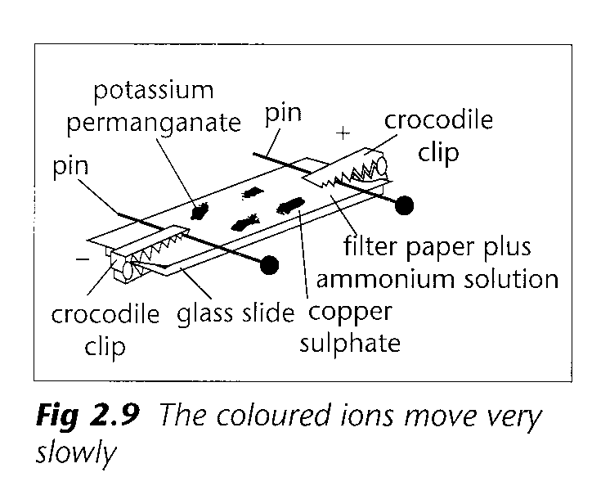

The positive blue copper ion moves slowly towards the negative electrode. The negative purple permanganate ion moves slowly towards the positive electrode.

2. The resistance of a wire

Join the terminals of a digital ohmmeter and record the resistance of its connecting leads. Plot a graph of resistance against length. (Graph a)
Use the ohmmeter to measure the resistance of equal lengths of different resistances of nichrome wire. Use a micrometer (having checked for zero error) to measure the diameters. Plot a graph of resistance against 1/crossectional-area. (Graph b)

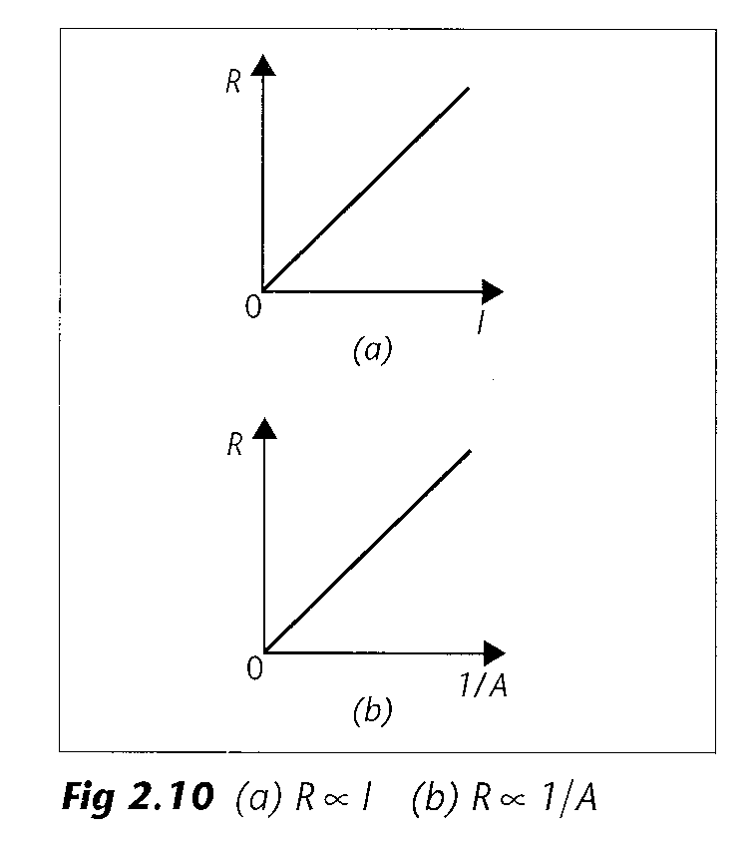

The results show that R ∝ l / A.
The constant of proportionality is ρ, the resistivity of nichrome, so R = ρ l / A. Use R = ρ l / A to calculate the resistivity of nichrome.

- 3. Measuring how current varies with potential difference

Use a range of components: ohmic resistor, lamp, thermistor and diode. Use a variable power supply to vary the potential difference across the component.

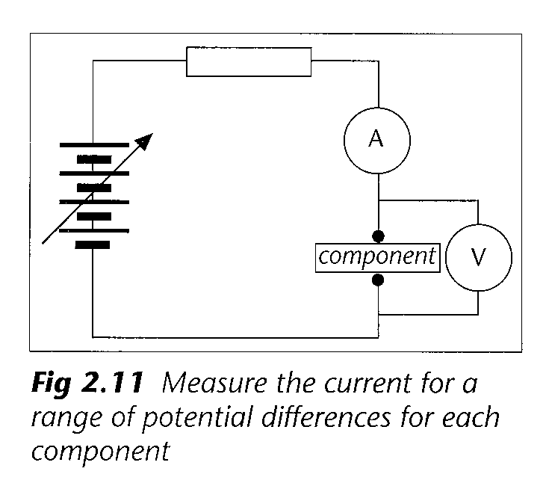

Series resistor is needed to prevent damage to the diode when in forward direction. Record a range of corresponding of current I and potential difference V. Reverse the component and repeat. Plot a graph of I against V. (See page 4). Calculate the resistance (V/I) for each pair of values and compare.

- 4. Measuring e.m.f and internal resistance

Set up the circuit shown in the diagram below.

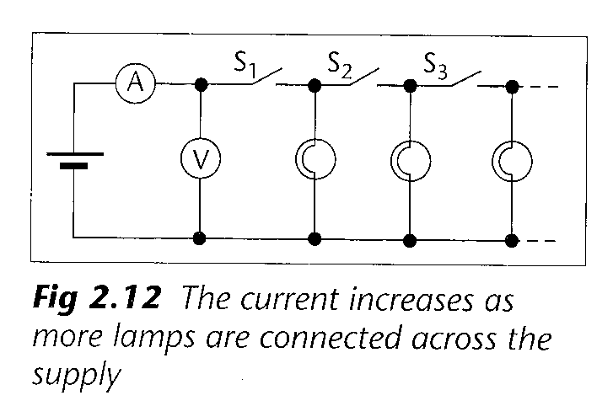

Open all the switches and record the reading of the digital voltmeter. This is the e.m.f. Close switch S₁ and record the reading of the ammeter and the voltmeter. Continue until all the switches are closed. Plot a graph of potential difference against current.

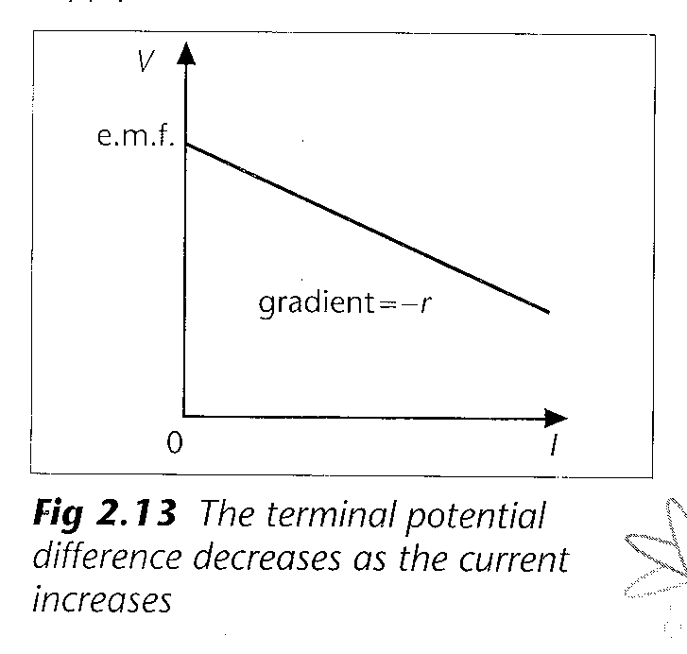

Terminal potential difference = e.m.f. – potential difference across internal resistance
= e.m.f. – Ir = -rI + e.m.f.
Comparing this equation with y = mx + c, gradient of graph = -r, so internal resistance = - gradient,
intercept = e.m.f.

Checklist

Before attempting the questions on electricity, check that you:

- know that the charge on an electron is negative and very small

- appreciate that a very large number of electrons are needed to give one coulomb of charge

- realise that any flow of charge (positive, negative or even a mixture of both in opposite directions) is a current

- know that the size of a current gives the rate of flow of charge and that 1A = 1Cs⁻¹

- understand why an ammeter has a very low resistance and how it is connected to measure a current

- know that the current is the same at all points in a series circuit and that the sum of the currents entering and leaving a junction is the same

- know the meaning and unit of each symbol in the equation I = nAqv

- can relate the electrical behaviour of conductors, semiconductors and insulators to the value if ‘n’

- know that the drift velocity v of an electron in a metal is very slow (typically 0.1mms⁻¹)

- have learnt the definition of potential difference and know that 1V = 1JC⁻¹

- understand why a voltmeter has a very high resistance and how it is connected in a circuit to measure potential difference

- know that components in parallel have the same potential difference across them

- know that the potential differences add up for components in series

- can confidently solve problems relating to series and parallel circuits

- appreciate the effects that non-ideal ammeters have on a circuit

- can calculate, given its resistance, the reading of a non-ideal meter placed anywhere in a circuit

- know the effect of resistance on current flow

- have learnt the definition of resistance and know its unit

- can calculate the effective resistance of series and parallel combinations of resistors

- appreciate how an increase in temperature increases a metal’s resistance by reducing the charge carrier’s drift velocity

- appreciate how an increase in temperature reduces a NTC thermistor’s resistance by increasing the charge carrier density

- know that an increase in light level decreases the resistance of a LDR

- have measured the resistance of various wires and know how its value depends on the wire’s dimensions

- have learnt the definition of resistivity and know its unit

- can calculate the potential difference across each of the resistors in a potential divider

- appreciate that thermistors and LDRs can be used in potential divider circuits to produce temperature and light sensors

- know the structure of a modern potentiometer and how it can be used either as a variable resistor to control current or as a potential divider to control voltage

- have learnt a description of an experiment to measure the current-potential difference characteristics of a component

- can sketch I-V graphs for:

an ohmic conductor
a tungsten (metal) filament lamp
an NTC thermistor (or carbon filament lamp)
a semiconductor diode

- have learnt the statement for Ohm’s law

- have learnt the definition of e.m.f. and appreciate how (and why) it differs from potential difference

- know that the sum of the e.m.f.s is equal to the sum of the potential differences around any closed circuit loop and appreciate that this is a consequence of conservation of energy

- appreciate that all sources of e.m.f. will have some internal resistance

- realise that the terminal potential difference only equals the e.m.f. when no current flows

- appreciate the need for an infinite resistance voltmeter to measure e.m.f.

- understand why the terminal potential difference falls as more current is supplied by the power supply

- have learnt a description of an experiment to find the e.m.f. and internal resistance of a power supply

- appreciate the need for a car battery to have a very small internal resistance and an e.h.t supply to have a very large internal resistance

- can confidently solve circuit problems involving internal resistance

- are familiar with the ‘general requirements’ (see Appendix 1) and how they apply to the topic of electricity

Thermal Physics

Introduction

Thermal physics involves the transfer of energy, either by heating or by working, together with an understanding of the effects that this produces. As you study thermal physics, you learn how the motion of the molecules of a gas is responsible for the pressure it exerts. You find that the speed of the molecules increases with temperature and produces an increase in pressure. The resulting relationship allows you to predict the temperature at which the pressure of the gas would become zero. You also discover how the pressure and volume of a gas relate when at a constant temperature.

You find that transferring energy to a solid either increases its temperature or changes it into a liquid and so appreciate the difference between specific heat capacity and specific latent heat. You learn about internal energy and how conservation of energy leads to the first law of thermodynamics, and discover the differences between heating, electrical working and mechanical working. You find that energy flowing naturally from hot to cold can do work while work must be done to force energy to flow the other way and learn how to improve the maximum efficiency of such systems.

Things to understand

Pressure and temperature

- solids are rigid and can be used to transmit forces (diagram a)
- fluids (gases and liquids) flow to fit the shape of the container and can be used to transmit pressure

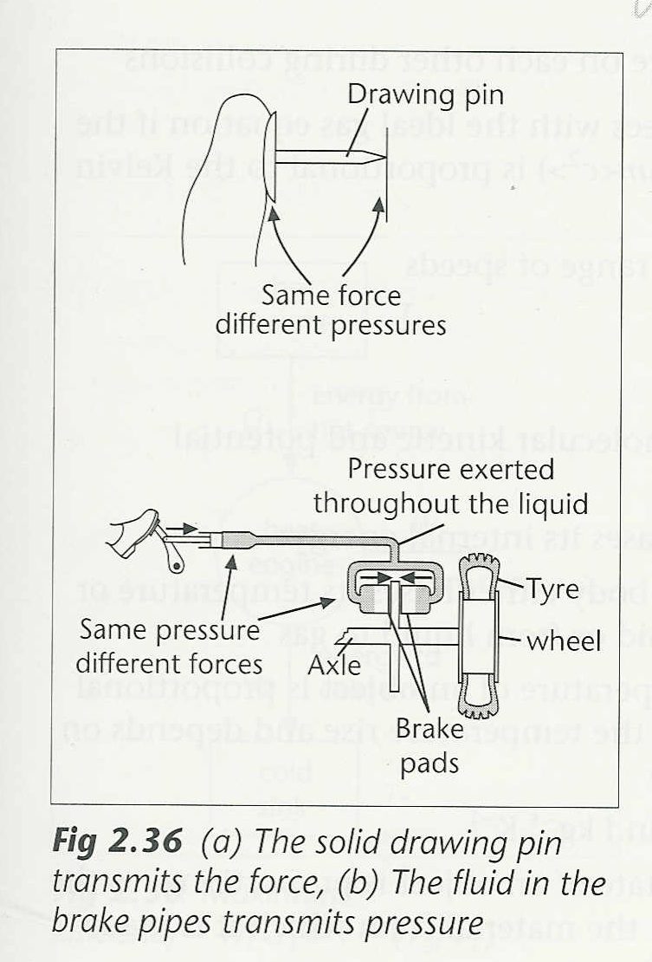

- pressure acts at 90˚ to any surface and is the force exerted per unit area
- the unit of pressure is the pascal (Pa)
- a calibrated thermometer is used to measure temperature
- the pressure of a fixed amount of gas in a given volume increases with temperature
- reducing temperature, reduces the pressure and experimental work predicts that all gases have the same temperature (absolute zero) at which their pressures would be zero
- pressure is directly proportional to Kelvin temperature, p ∝ T
- the Kelvin and Celsius temperature scales are related by T /K = θ /ºC + 273

The ideal gas equation

- the pressure of a fixed amount of gas at constant temperature increases as its volume decreases
- experimental work shows that pressure and volume are inversely proportional, p ∝ 1 / V, if T is constant
- if all three of the macroscopic properties change, p ∝ T / V so that pV / T = constant that depends only on the number of moles of gas present
- for one mole, pV / T = R, the molar gas constant
- for n moles, pV = nRT

Kinetic model of a gas

- Brownian motion gives evidence for the random motion of air particles
- high compressibility of gases gives evidence for the large spacing of air molecules
- the particles of all gases are mobbing around continually at high speed
- pressure results from collisions of the gas particles with the container walls
- the speed of gas particles increases with temperature
- pressure increases with temperature as the collisions with the walls of the container are both harder and more frequent
- a decrease in the volume results in an increase in the packing density of the particles so there are more collisions per unit area in the same time and pressure therefore rises
- the behaviour of a gas can be modelled using a mechanical model

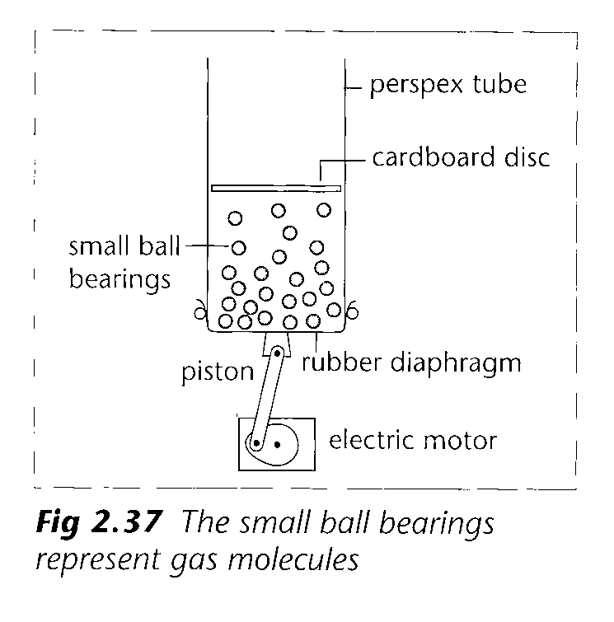

- a theoretical model relies on a number of assumptions
gases consist of identical molecules in continuous random motion
molecular collisions are, on average, elastic
the volume of the actual molecules is negligible compared to the volume of the container
the molecules only exert a force on each other during collisions with each other
- the theoretical prediction only agrees with the ideal gas equation if the average molecular kinetic energy (½m<c²>) is proportional to the Kelvin temperature
- the molecules of a gas have a wider range of speeds

Heating solids and liquids

- internal energy is the sum of molecular kinetic and potential energies
- adding energy to a substance increases its internal energy
- increasing the internal energy of a body either raises its temperature or changes its state, from solid to liquid or from liquid to gas
- the energy needed to raise the temperature of an object is proportional to both the mass of the object and the temperature rise and depends on the material from which it is made
- specific heat capacity is measured in Jkg⁻¹K⁻¹
- the energy needed to change the state of an object is proportional to the mass of the object and depends on the material from which it is made
- specific latent heat is measured in JK⁻¹
- more energy is needed to change the state of an object than is needed to increase its temperature by 1K
- changing from a liquid to a gas requires much more energy than changing from a solid to a liquid as the molecules need to be pulled apart against intermolecular forces and the substance has to do more work pushing back the surroundings as it expands

Heating and working

- a hot object has a greater concentration of energy than a cold object
- when two bodies are in thermal contact there is a random exchange of energies between them
- this random exchange of energies always results in an energy flow (ΔQ) from hot to cold places
- the process where energy flows through a temperature difference from hot to cold is called heating
- energy transfer can occur through conduction, convection, radiation and evaporation
- working is the process where a force causes motion
mechanical working is where a mechanical force causes the motion of a mass, ΔW = FΔx
electrical working is where an electrical force causes motion of a charge,
ΔW = VΔQ
- working can transfer energy ΔW to any object, hot or cold, while heating can only transfer energy from a hot object to one that is cooler
- since energy is conserved, change in internal energy of a body equals the sum of the energy transferred by heating and by working
- heating and working are positive where the process adds energy to the body and negative where the process transfers energy away from the body
- energy transferred by heating is zero in either an isolated system or where there is no temperature difference, ΔQ = 0
- there is no change in internal energy, ΔU = 0, of a body if its temperature is constant and it is not changing state

Heat engines and pumps

- a heat engine takes energy from a hot source and uses some of it to do work
- the rest of the energy is transferred by heating to a cold sink
- efficiency is the ratio of the useful work output to the total energy taken from the hot source
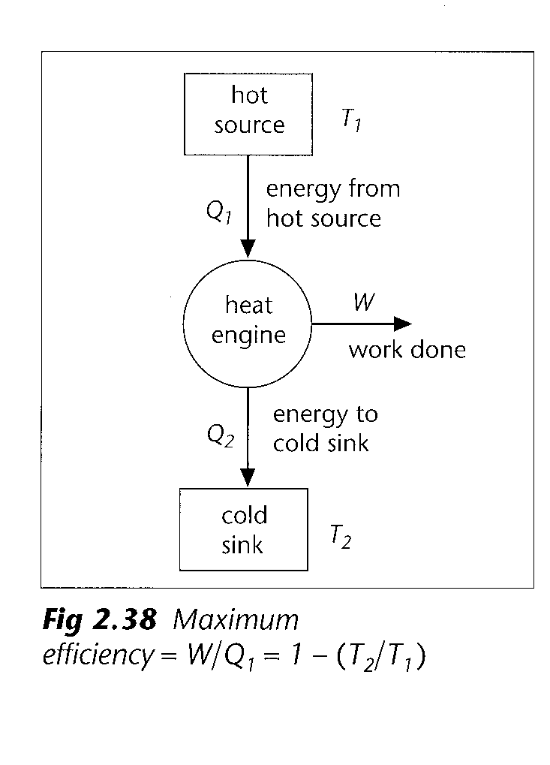

maximum thermal efficiency depends on the Kelvin temperature T₁ of the hot source and T₂ of the cold sink
- efficiency is increased either by increasing the temperature of the hot source or by reducing the temperature of the cold sink
- although energy flows naturally from hot to cold, a heat pump does work to move energy from cold to hot
- refrigerators, freezers and air conditioners all use heat pumps
- the energy expelled to the hot surroundings is the sum of the energy removed from the cold body and the work needed to remove it
- to maintain a cold body at a constant temperature, a heat pump has to remove energy from the body at the same rate as energy is entering it

Things to learn

You should learn the following for your Unit PHY2 Test. Remember that it may also test your understanding of the ‘general requirements’

Equations that will not be given to you in the test

- pressure = force / area p = F / A
- pressure x volume = number of moles x molar gas constant x absolute temperature pV = nRT
- pressure x volume / temperature = constant p₁V₁ / T₁ = p₂V₂ / T₂

Laws

- pressure law: for a fixed mass of gas at constant volume, the pressure is directly proportional to the Kelvin temperature
- Boyle’s law: for a fixed mass of gas at constant temperature, pressure x volume is constant
- First law of thermodynamics: increase in internal energy (ΔU) = energy transferred by heating (ΔQ) + energy transferred by working (ΔW)

General definitions

- absolute zero: temperature at which the pressures of all gases would be zero Kelvin (since kinetic energy of molecules = 0); the lowest temperature theoretically possible
- Brownian motion: random motion of visible particles caused by random impacts from invisible molecules
- mean square speed <c²>: the sum of the squares of the individual molecules divided by the total number of molecules
- r.m.s. (root mean square) speed: square root of the mean square speed
- internal energy: sum of the random kinetic and potential energies of the molecules of a body
- specific heat capacity: energy needed to raise the temperature of 1kg of the substance by 1K without a change of state
- specific latent heat of fusion: energy needed to change 1kg of solid into liquid at its melting point
- specific latent heat of vaporisation: energy needed to change 1kg of liquid into vapour at its boiling point
- heating: process in which energy transfer is driven by a temperature difference with the energy flowing from hot to cold
- mechanical working: process in which energy transfer occurs when a force moves through a distance
- electrical working: process in which energy transfer occurs when a force moves a charge
- heat engine: a device that takes energy from a hot source, uses some of this to do mechanical work, and gives the rest to a cold sink
- heat pump: a device that does work to move internal energy from a cold body to a hot body

Word equation definitions

- pressure = force / area
- specific heat capacity = energy supplied / (mass x temperature rise)
- specific latent heat = energy supplied / mass of substance that has changed state
- efficiency = useful energy output / total energy input

Experiments

- 1. The pressure law

Submerge as much of the flask as possible in the water.

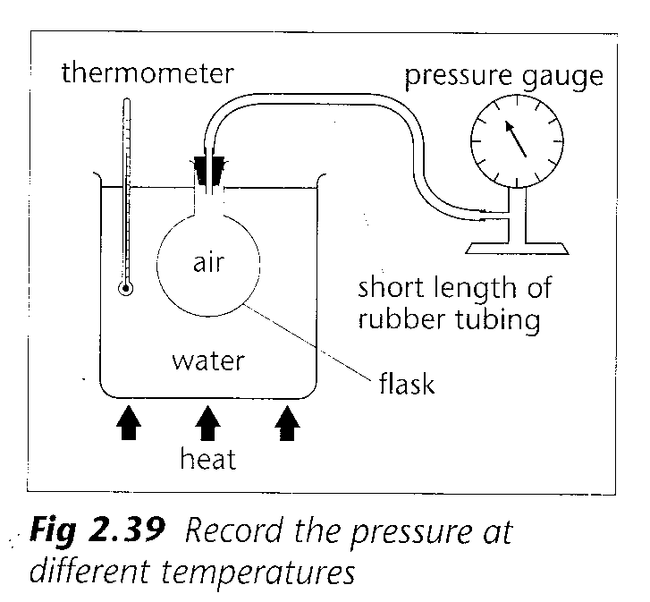

Use a short length of tubing to connect to pressure gauge since the air in it will not get fully heated.
Record a series of corresponding readings of pressure and temperature for temperatures form 0°C to 100°C.
Allow time for the air in the flask to reach the same temperature as the water.

Plot a graph of pressure against temperature and use it to predict the temperature at which the pressure would become zero.
Using absolute zero as the origin, the graph shows that pressure is directly proportional to the Kelvin temperature.

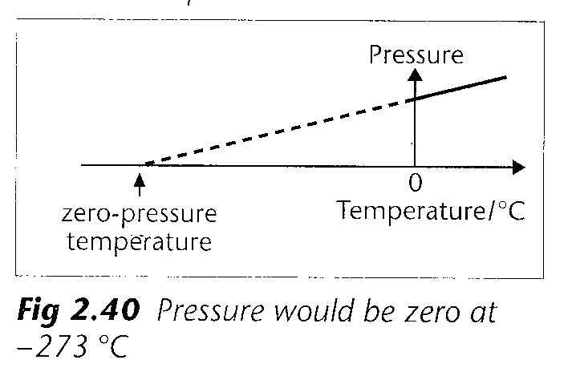

- 2. Boyle’s law

Measure the pressure and the volume of the trapped air.

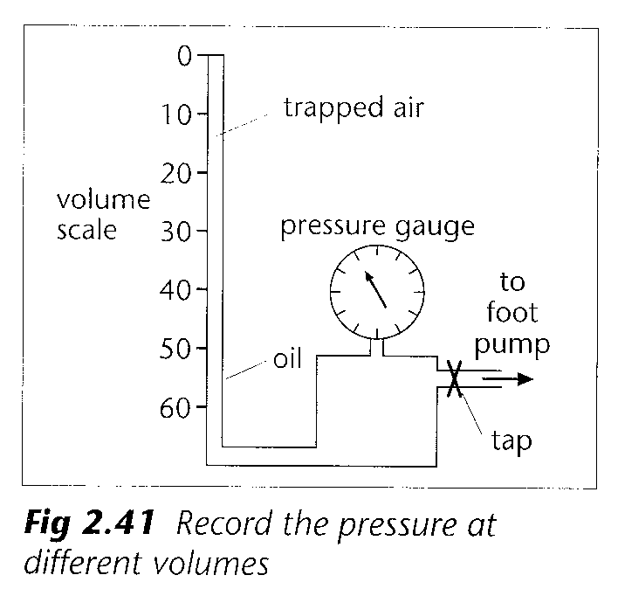

Use a foot pump to increase the pressure.
Record a series of corresponding readings of pressure and volume.
Allow time between readings for the compressed air to reach room temperature.
Multiply each pressure by its corresponding volume.
Results show that ‘pressure x volume = constant’.
Alternatively, plot a graph of pressure against 1 / volume.
Straight-line graph through the origin shows that the pressure is inversely proportional to the volume.

- 3. Brownian motion

Use a cover slip to trap smoke from a burning straw in the smoke cell.

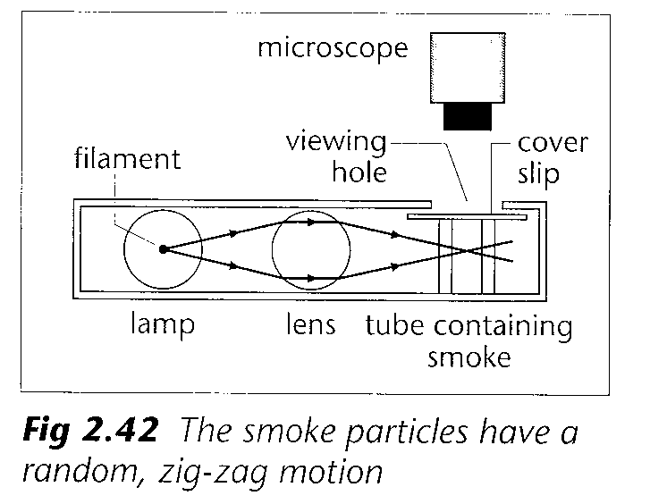

The lens focuses light from the lamp onto the smoke particles.
Light reflects into the microscope from the smoke particles that appear as very small bright dots.
Smoke particles dance about randomly, moving first one way then immediately another.
The much smaller air molecules are knocking the smoke particles about.
Due to the small size of air molecules, there is an imbalance in the distribution of the air molecules hitting the smoke particle at any instant.

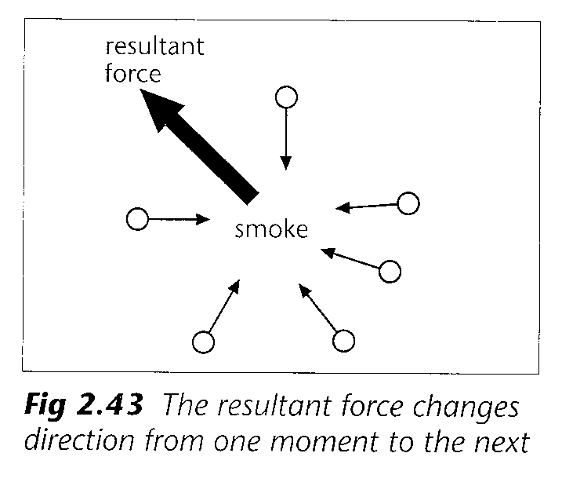

The constantly changing resultant force moves the smoke particle first one way and then another.
Air molecules must be moving very fast to have sufficient momentum to cause the heavier smoke particles to move in this way.

- 4. Measuring specific heat capacity

A suitable apparatus for measuring the specific heat capacity of a solid is shown below.

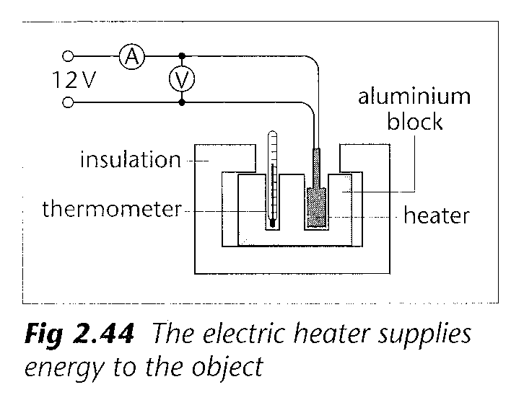

Measure the mass, m, of the object and its initial temperature θ₁.
Switch on the electric heater for a measured amount of time, t, e.g. 5 min.
Measure the potential difference V and the current I.
The electrical work done on the heater is calculated using VIt. Since the object is well lagged, it is assumed that all this energy is transferred to the object.
Measure the highest temperature θ₂ reached after the heater is switched off.
Since energy supplied = mass x specific heat capacity x temperature rise
Specific heat capacity = VIt / (m x (θ₂- θ₁)

- 5. Measuring specific latent heat

A suitable apparatus for measuring the latent heat of fusion of water is shown below.

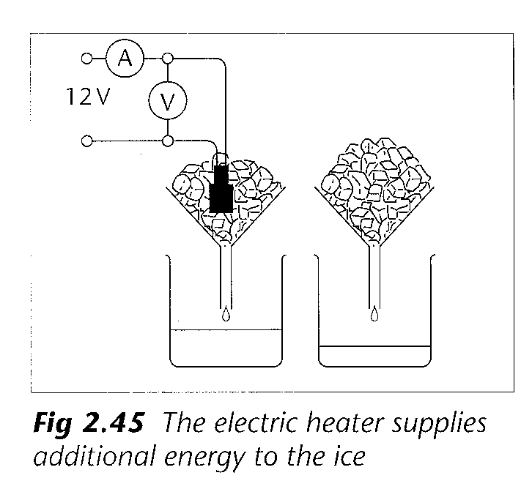

Switch on the electric heater and measure the potential difference V and the current I.
Measure the mass of two empty beakers.
Use the beakers to collect water from each funnel for a measured time t, e.g. 5 min.
Calculate the mass of the water in each beaker and so find the additional mass m of ice melted by the heater.
The electrical work done on the heater is calculated using VIt.
Assuming all energy from the heater is used to melt the ice and since,
energy supplied = mass x specific latent heat
specific latent heat = VIt / m.

Checklist

Before attempting the questions on thermal physics, check that you:

- appreciate that solids transmit forces and fluids transmit pressures

- know that pressure is the force per unit area and is measured in pascals (Pa) where 1 Pa = 1 Nm⁻²

- have learnt a description of an experiment showing how the pressure of a gas varies with temperature

- can sketch a graph showing the variation of pressure with temperature

- have learnt the statement of the pressure law

- understand the concept of absolute zero

- know how to convert between the Kelvin and Celsius temperature scales

- have learnt a description of an experiment showing how the pressure of a gas varies with volume

- can sketch a graph showing the variation of pressure with volume of a gas at constant temperature

- have learnt the statement of Boyle’s law

- can solve problems using the ideal gas equation, pV = nRT

- have learnt a description of an experiment to demonstrate the Brownian motion of smoke particles in air

- can explain how Brownian motion gives evidence that gases consist of atoms or molecules moving randomly at high speeds

- know that molecular speed increases with temperature

- appreciate that pressure results from collisions of the gas particles with the walls of the container

- can explain in molecular terms why the pressure of a gas increases with increasing temperature and with decreasing volume

- have learnt the assumptions on which the theoretical model of a gas is founded

- are familiar with the steps involved in using the theoretical model to describe the equation
p = ⅓ρ<c²>

- can use this equation to calculate the root mean square speed of gas molecules

- understand the difference between mean speed and r.m.s. speed

- know that the theoretical equation agrees with the ideal gas equation provided that the average molecular kinetic energy is directly proportional to the Kelvin temperature

- appreciate that internal energy is the sum of the molecular kinetic and potential energies

- know that either a rise in temperature or a change in state increases internal energy

- have learnt the definition of specific heat capacity

- have learnt a description of an experiment using an electric heater to measure the specific heat capacity of a solid and can adapt this to measure that of a liquid

- can identify sources of experimental error in such heating experiments and know some ways of reducing these

- can calculate the amount of energy transferred when a body either warms up or cools down

- have learnt the definition of specific latent heat

- have learnt the description of an experiment using an electric heater to measure the specific latent heat of fusion of water and can adapt this to measure its latent heat of vaporisation

- can calculate the amount of energy transferred when a body changes state

- appreciate why, for the same substance, the latent heat of vaporisation is much greater than the latent heat of fusion

- know that the random exchange of energy between a hot and a cold body results in a net energy flow from hot to cold, a process known as heating

- can explain how energy transfer occurs by conduction, convection, radiation and evaporation

- appreciate that working involves a force causing motion and that working can be either mechanical or electrical

- understand the difference between heating and working

- have learnt the statement of the first law of thermodynamics

- appreciate that this law is simply an application of the principle of conservation of energy

- can apply this law in the form ΔU = ΔQ + ΔW to any given system

- appreciate the conditions under which ΔU and ΔQ are zero and the significance of positive and negative values of the quantities involved

- understand that to maintain a constant temperature, a heat pump must remove energy from a system at the same rate as it is entering

- are familiar with the ‘general requirements’ (see appendix 1) and how they apply to the topic of thermal physics

