Appendix 1 – General Requirements

Introduction

The general requirements consist of material common to the whole of the AS and A level syllabus. The part of the specification containing it is easily overlooked, as it comes before the start of Unit 1. However, it is very important as most its content may be tested in any of the assessment tests, although a small amount only applies to tests PHY4, 5/01, 5/02 and 6.

Things to learn and understand for all assessment tests

Physical quantities

- A physical quantity is any measurable physical property and is written as the product of a number and a unit
- All measurements must be made using an internationally agreed unit to allow comparisons between measurements from different sources… the International System of Units (SI)
- The prefixes that are used with units to show larger or smaller multiples:

Prefix | Symbol | Multiplier
giga | G | 10⁹
mega | M | 10⁶
kilo | k | 10³
milli | m | 10⁻³
micro | μ | 10⁻⁶
nano | n | 10⁻⁹
pico | p | 10⁻¹²

- The approximate sizes of common physical quantities e.g. mass of an adult ~ 70kg and a diameter of an atom ~ 10⁻¹⁰m
- There has to be a starting set of base physical quantities, together with a corresponding set of base units
- Length, mass, time, current, temperature interval and amount of substance are all base SI physical quantities
- All other physical quantities can be produced by combining base physical quantities and are called derived physical quantities
- The metre, the kilogram, the second, the ampere, the Kelvin and the mole are all base units
- A word equation is simply an equation written using words instead of symbols that can be used to define either a derived physical quantity or its derived unit e.g. charge = current x time and coulomb = ampere x second
- All equations must be homogeneous is that they must equate, add together or subtract the same type of physical quantity
- Homogeneous equations can still be wrong as they may contain incorrect numbers

Scalars and vectors

- All physical quantities are either scalars or vectors, where a scalar quantity has only size whereas a vector quantity has both size and direction
- A single vector can be split up into any number of components although it is usual to choose two components that are at right angles to each other, a process called resolution of the vector
- Any number of vectors can be added together to find the single resultant vector that could be used to replace them by use of either a scale drawing or a suitable calculation

Graphs

- The plotting of clear and accurate graphs is an essential skill in physics; make sure you practice selecting suitable, sensible scales and plotting accurate data points. YOU WILL DEFINITELY HAVE TO PLOT GRAPHS IN TEST PHY3/02, 5/02 AND 6
- A graph can replace a data table; you should be able to extract data from either of these formats
- A straight line graph represents a linear relationship and has an equation of the form y = mx + c where m is the slope and c is the intercept
- The slope of a graph gives the rate at which one quantity is changing with the other; for a straight line this will be the same all the way along it, while it varies from place to place along a curve
- Drawing a tangent to a curve and finding its slope gives the instantaneous rate of change at that point
- The area enclosed by the line and the x-axis may represent a physical quantity, e.g. work done = area enclosed by a force-displacement graph
- Sketch graphs are an excellent way of showing how one physical quantity varies with another; a single sketch graph can replace many words and often result in a better answer

Check for all tests

Before attempting any of the questions in Units PHY1 to PHY6, check that you:

- know that a physical quantity is any measurable physical property and is written as the product of a number and an internationally agreed unit
- know the unit of every physical quantity that you can encounter and remember to add the correct unit to all your calculated answers
- have learnt the prefixes used with units to show larger or smaller multiples
- understand the system of base and derived physical quantities used in physics
- can use word equations to define derived physical quantities and their derived units
- know how to express a derived unit as a combination of only base units
- know how to use homogeneity to check the possible correctness of an equation while appreciating why a homogeneous equation may still be wrong
- can explain the difference between a scalar and a vector quantity
- know how to resolve a vector into two components that are at right angles to each other
- can find the resultant of several vectors using a scale drawing and of two perpendicular vectors by calculation
- have practised selecting suitable scales and plotting data points
- can read numerical data from a graph
- know the equation y = mx + c and its relationship to a straight line graph
- can find the slope m and the intercept c of a straight line graph and appreciate that both these quantities are likely to have units
- can find an accurate value for the instantaneous rate of change of one quantity with another in situations where they vary both linearly and non-linearly
- are familiar with the concept of rate of change with time, as found in the definitions of velocity, acceleration, force, activity, etc.
- can find the area enclosed by the line and the x-axis by an appropriate method e.g. by direct calculation for a straight line and by counting squares for a curve
- will remember to use a sketch graph whenever it helps me produce a better answer

Additional things to learn and understand for tests PHY4, 5/01, 5/02 and 6

Graphs

- Know the shapes of graphs of simple functions so that you can quickly sketch the different relationships between the physical quantities that you meet in your studies

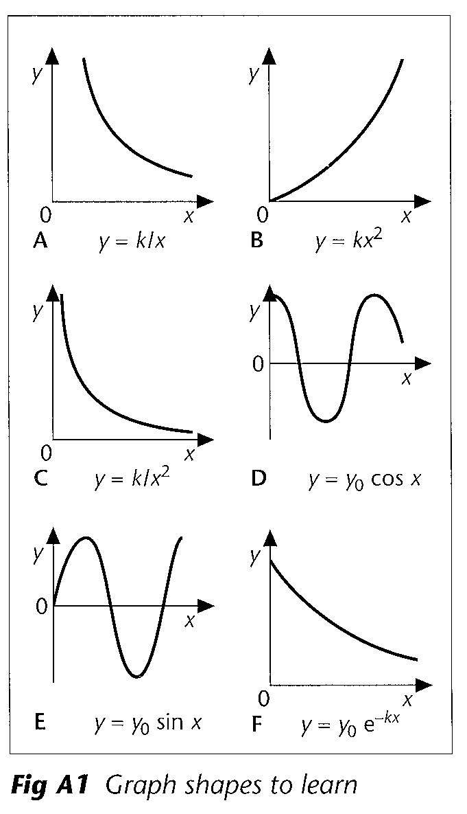

Graph A does not touch either axis…it might represent how the pressure of a fixed mass of gas varies with its volume at constant temperature
Graph B rises from the origin with an increasing slope…it might represent how the displacement of a uniformly accelerating body varies with time
Graph C is similar to graph A but is less shallow…it might represent how the intensity varies with distance from a point source of light
Graph D is a co-sinusoidal curve about a zero position…it might represent how a the displacement of a heavy oscillating pendulum varies with time
Graph E is a sinusoidal curve about a zero position…it might represent how an alternating voltage varies with time
Graph F is an exponential decay curve; it falls from a positive intercept with a decreasing slope, never quite reaching the x-axis…it might represent how the voltage across a discharging capacitor varies with time

- Know how to use your calculator to find logarithms
- Know that a logarithmic plot can be used to find the power of a relationship, e.g. a logarithmic plot of the data of graph A from above would produce a linear graph with a slope of –1 (since k / x = kx⁻¹ i.e. x is raised to the power of –1), whereas a slope of +2, shown below, would be produced from the data of graph B above (kx² i.e. x is raised to the power of 2)

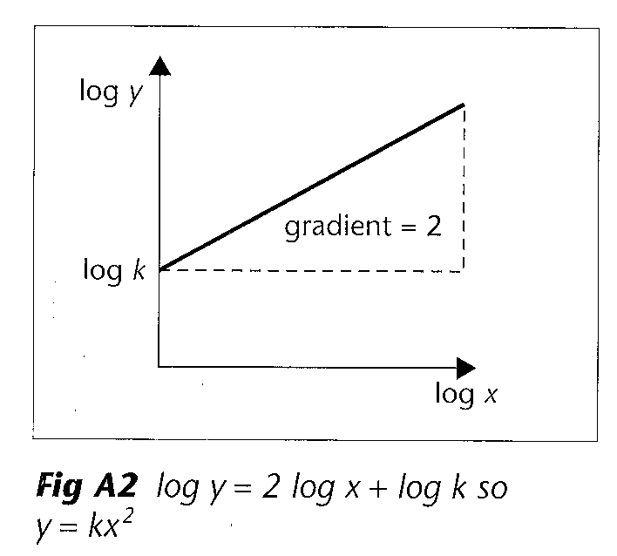
- Know that if the natural logarithm of the data represented by the y-axis in graph F is plotted against the x-axis data, a straight line graph is produced proving that the original curve is exponential

