Paper 3 (2001)
Time 2 hours 30 minutes

Section A

Answer four questions from this section.

1 (a) Define linear momentum. [1]

(b) Two spheres of masses m₁ and m₂ are moving towards one another along the same straight line.

The spheres have velocities u₁ and u₂, as illustrated in Fig. 1.1.

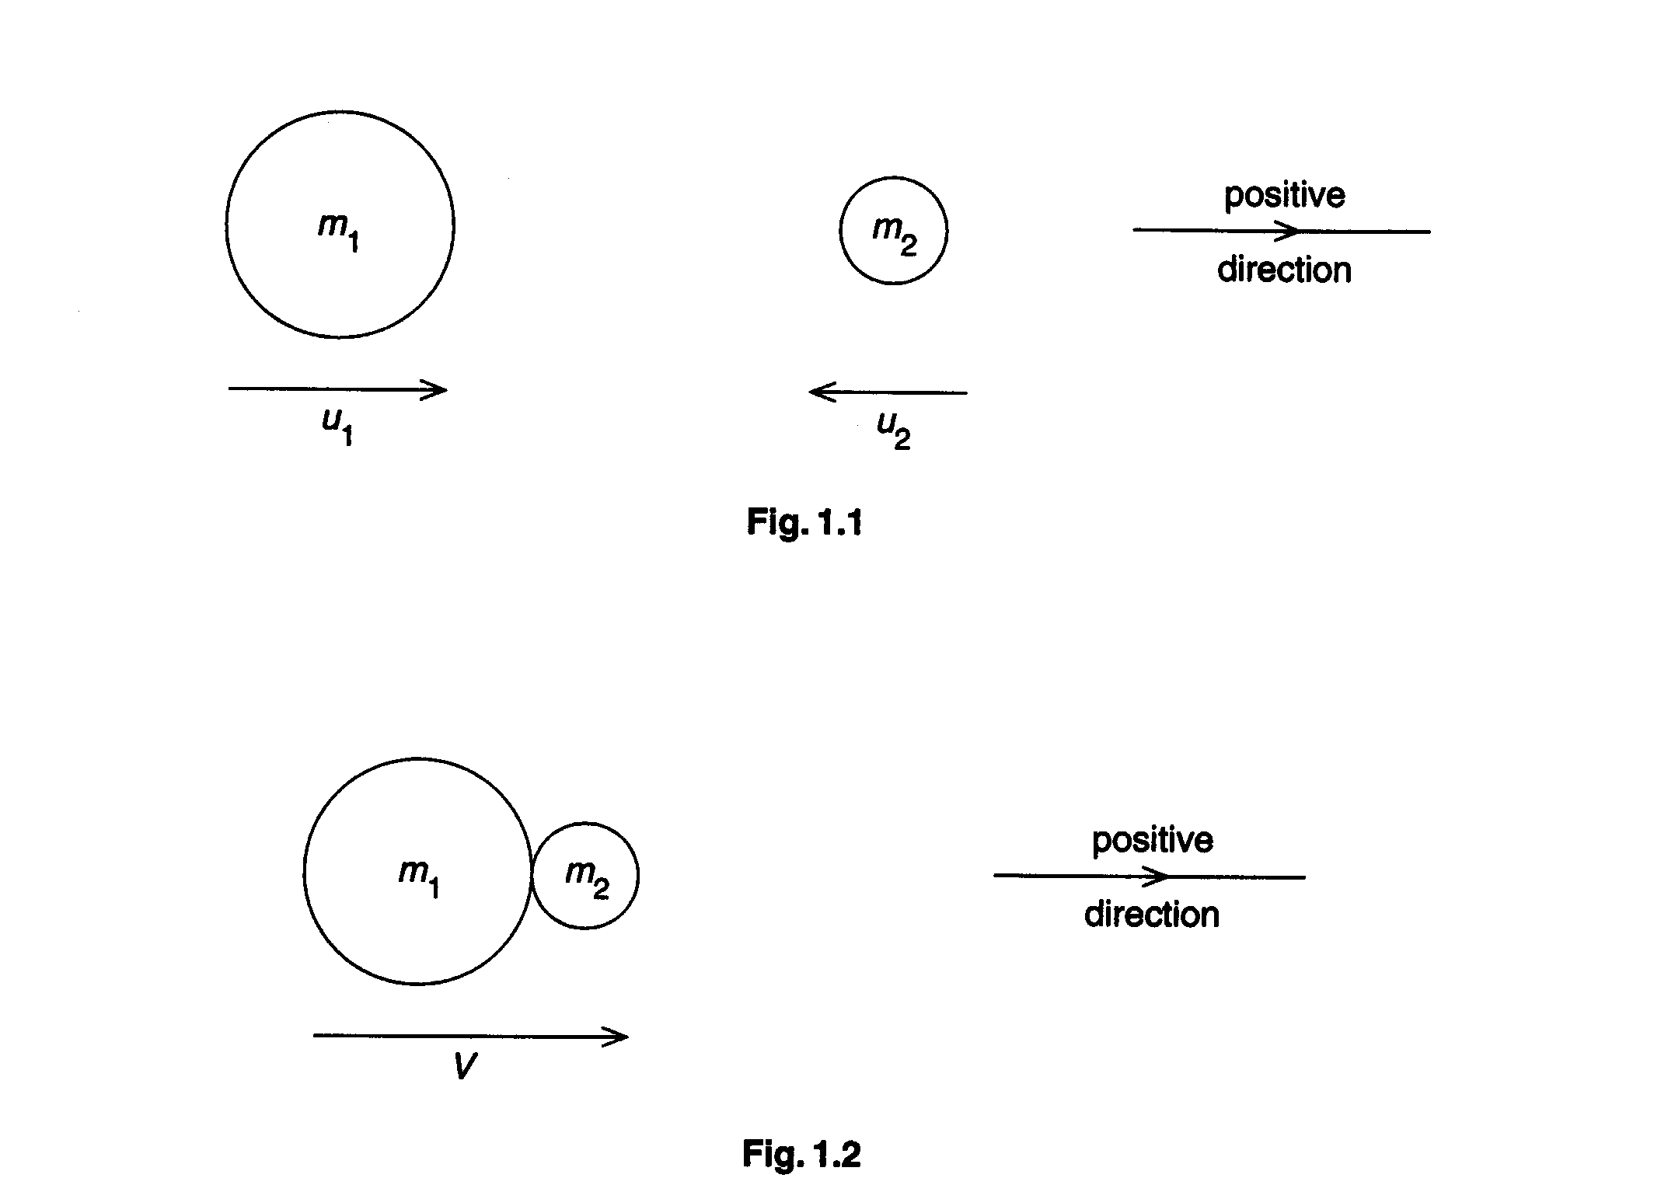

During impact, the spheres stick together and then move off with velocity V, as illustrated in Fig.1.2.

(i) State and explain whether the collision is elastic or inelastic.
(ii) Taking the direction of the final velocity V as being positive, write down equations, in terms of m₁, m₂, u₁, u₂ and V, to represent the change in momentum of
1. the sphere of mass m₁,
2. the sphere of mass m₂.

(iii) Using your answers to (ii), write down, for this collision, an equation to represent conservation of linear momentum. [6]

(c) An ideal gas is enclosed in an insulated cylinder by means of a piston, as illustrated in Fig. 1.3.

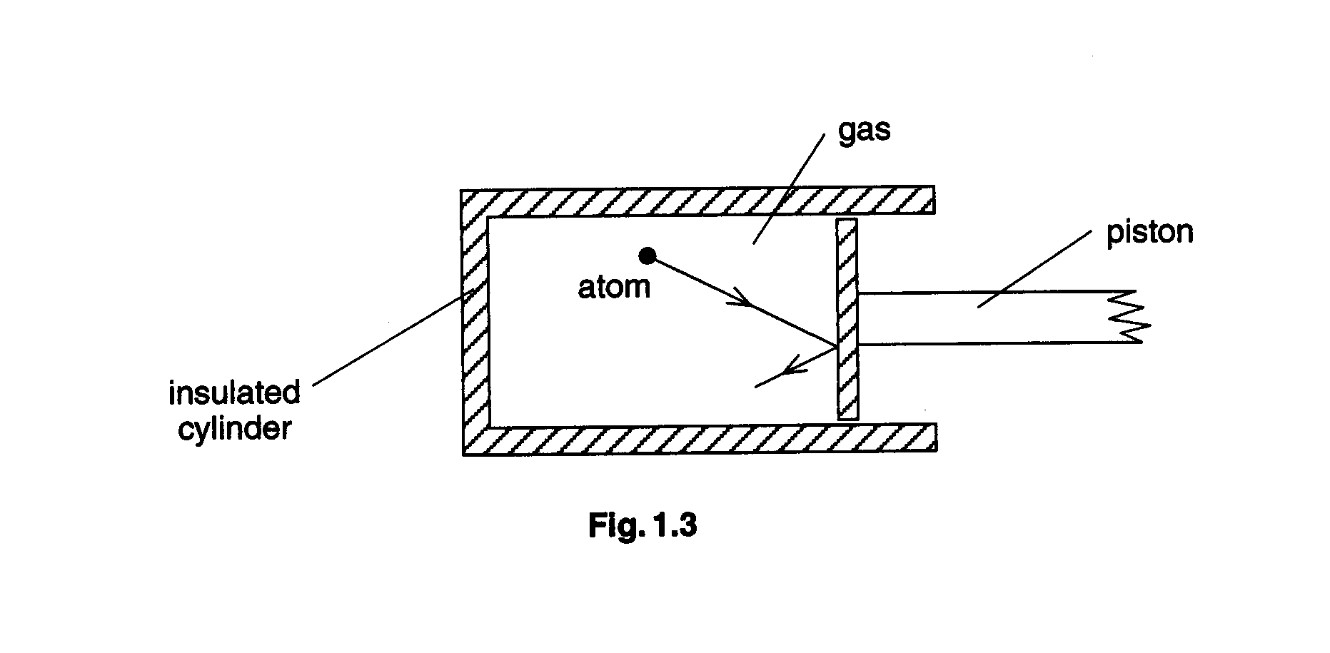

An atom of the gas collides with the stationary piston.

(i) 1. State the assumption made in the kinetic theory of gases about the nature of the collisions between gas atoms and the walls of the container.

2. State, with a reason, whether the momentum of the atom is conserved in the. collision between the atom and the piston.

(ii) The piston is now moved outwards rapidly so that the gas expands.

1. Suggest what happens to the speed of the atom as a result of a collision with this moving piston.

2. State and explain, in terms of kinetic theory, the change, if any, that your suggestion makes to the temperature of the gas. [7]

(d) (i) Write down an equation to represent the first law of thermodynamics. Explain carefully the symbols used.

(ii) Use the first law of thermodynamics to explain your conclusion in (c)(ii) 2. [6]

2 (a) (i) Define
1. electric field strength,
2. electric potential.

(ii) State how electric field strength at a point may be determined from a graph of the variation of electric potential with distance from the point. [6]

(b) The moon Charon (discovered in 1978) orbits the planet Pluto. Fig. 2.1 shows the variation of the gravitational potential Φ with distance d above the surface of Pluto along a line joining the centres of Pluto and Charon.

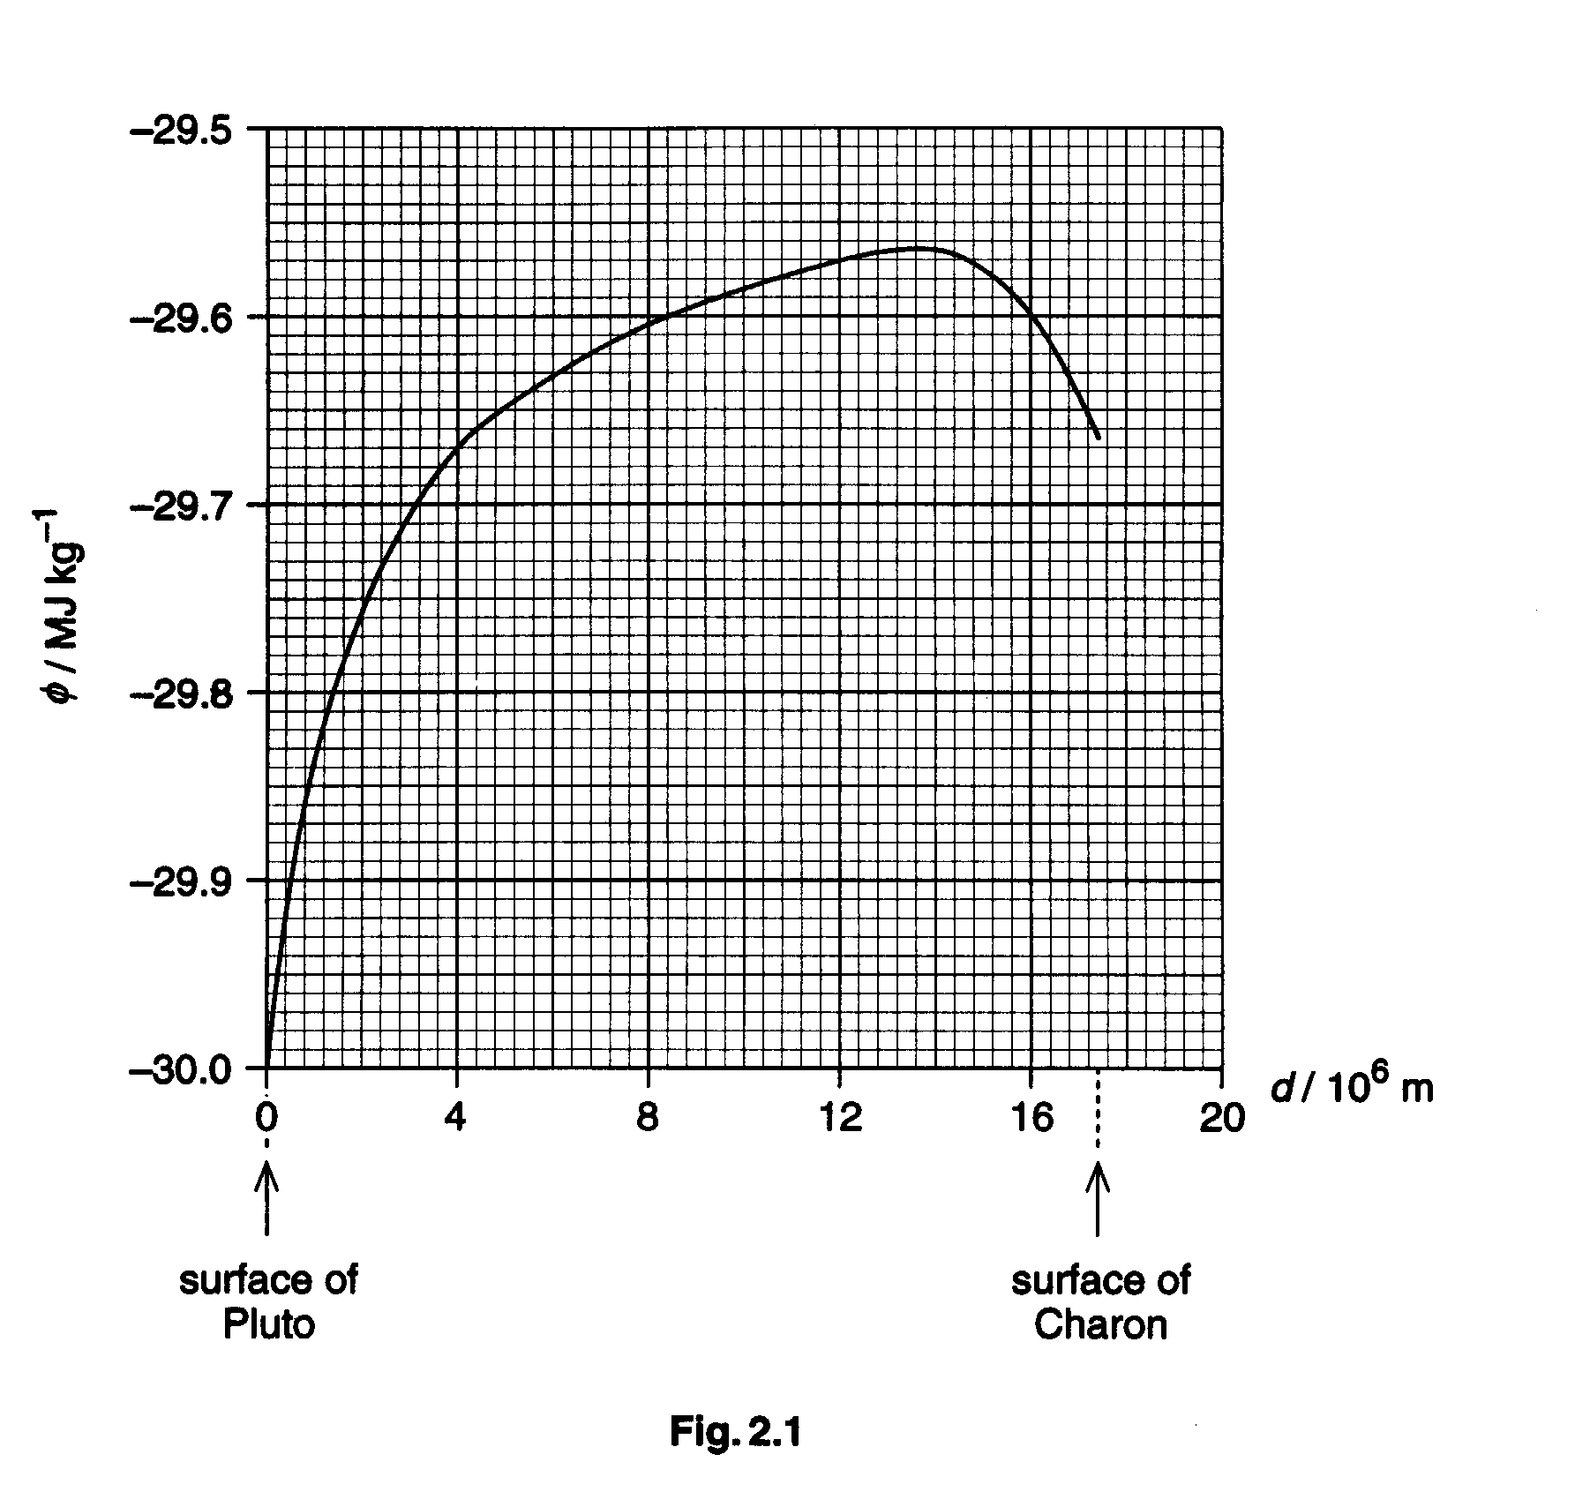
The gravitational potential is taken as being zero at infinity.
(i) Suggest why all values of gravitational potential are negative. [2]
(ii) By reference to your answer to (a)(ii), suggest why the gradient at a point on the graph of Fig. 2.1 gives the magnitude of the acceleration of free fall at that point. [2]
(iii) Use Fig. 2.1 to determine, giving an explanation of your working,
1. the distance from the surface of Pluto at which the acceleration of free fall is zero,
2. the acceleration of free tall on the surface of Charon. [5]

(c) A lump of rock of mass 2.5 kg is ejected from the surface of Charon such that it travels towards Pluto.

(i) Using data from Fig. 2.1, determine the minimum speed with which the rock hits the surface of Pluto.

(ii) Suggest why, if the rock travels from Pluto to Charon, the minimum speed on reaching Charon is different from that calculated in (i). [5]

3 (a) (i) Describe the motion of one particle in a transverse progressive wave. [2]

(ii) Sketch suitable graphs, with labelled axes, for a sinusoidal wave to illustrate what is meant by
1. amplitude A,
2. wavelength λ,
3. period T. [4]

(iii) Show that the speed v of a wave is related to its frequency f and wavelength λ, by the expression
v = f λ. [3]

(b) Explain the principle of superposition of two waves. [2]

(c) Two small sound sources S₁ and S₂ have frequencies 500 Hz and 504 Hz respectively.
Sound from the two sources is detected at point X, as illustrated in Fig. 3.1.

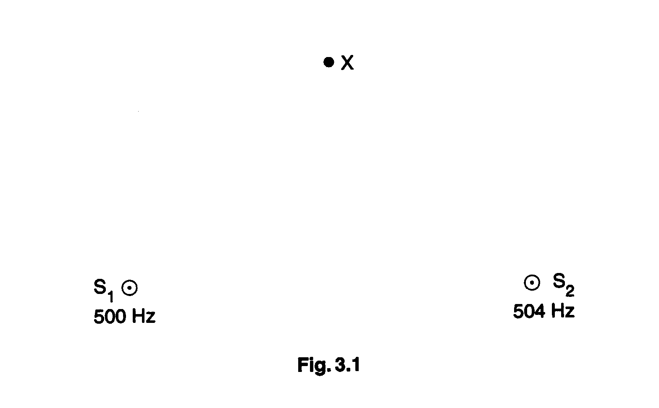

The sound waves from S₁ and S₂ have equal amplitudes A at X.

(i) At time t = 0, a wave crest from S₁ meets, at X, a wave crest from S₂. By reference to your answer to (b), state the resultant amplitude at X.

(ii) A short time later, a crest from S₁ meets, at X, with a trough from S₂.

1. Show that crest meets trough at X at time t = 0.125 s.
2. State the resultant amplitude at X at t = 0.125s.
3. Suggest what would be heard at X during the time interval between t = 0 and t = l.0 s. [6]

(d) (i) Explain the meaning of coherence in relation to the superposition of two waves.
(ii) Suggest why a variation of resultant amplitude is heard in (c) although the two sources are not coherent. [3]

4 (a) Define
(i) the capacitance of a capacitor,
(ii) the resistance of a resistor. [2]
(b) A battery of e.m.f. 6.0 V and negligible internal resistance is connected in series with a capacitor, a resistor and a switch, as shown in Fig. 4.1.

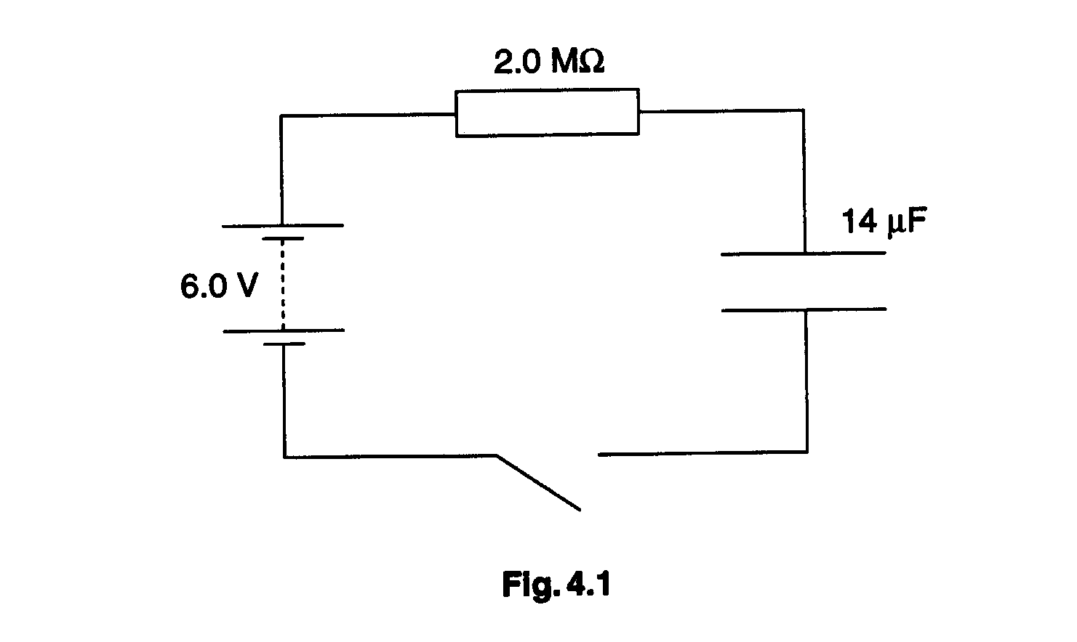

The capacitor has capacitance 14 μF and is uncharged initially. The resistor has resistance 2.0 MΩ.

(i) The capacitor has infinite resistance to direct current. Explain why, when the switch is closed, there is a current in the resistor.

(ii) At time t after the switch is closed, the potential differences across the capacitor and across the resistor are V_{C} and V_{R} respectively.
1. Use Kirchhoff's laws to write down an equation relating V_{C}, V_{R} and the e.m.f. of the battery.
2. Suggest why, as t increases, the p.d. V_{C} across the capacitor increases, and the current in the circuit changes. [6]

(c) At one time t, the current in the resistor is 1.8 x 10⁻⁶ A.
(i) Calculate the p.d. V_{R} across the resistor.
(ii) Show that the p.d. V_{C} across the capacitor is 2.4 V.
(iii) Calculate the charge q on one plate of the capacitor.
(iv) Calculate the energy E_{C} stored in the capacitor. [6]

(d) When the capacitor is fully charged, it is isolated and removed from the circuit. The capacitance of the capacitor is then reduced from 14 μF to 5.0 μF
(i) Calculate
1. the new p.d. across the capacitor,
2. the energy now stored in the capacitor.
(ii) The energy stored in the capacitor increases when the capacitance is reduced. Suggest an explanation for this energy increase, making reference to conservation of energy. [6]

5 (a) A wire of unextended length l and cross-sectional area A extends elastically by an amount Δl when the tension in the wire is increased by an amount F.
Write down expressions in terms of l, Δl, A and F for
(i) the spring constant k of the wire,
(ii) the Young modulus E of the material of the wire. [2]
(b) In order to determine the Young modulus of the metal of a wire, a student set up the apparatus illustrated in Fig. 5.1.

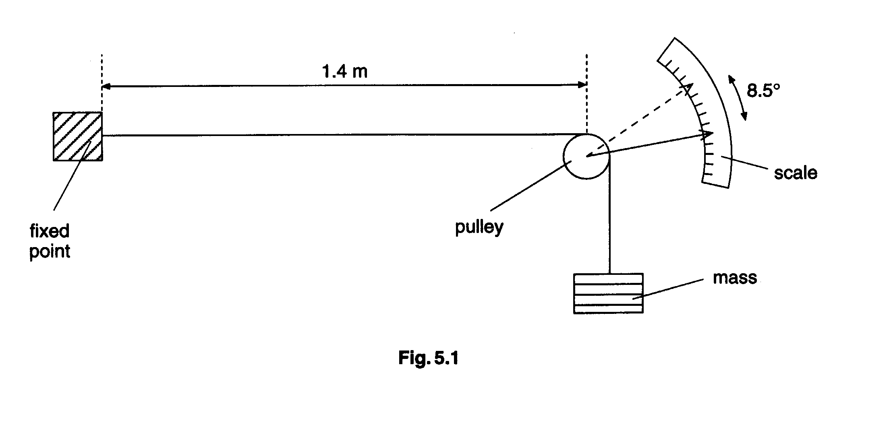

The length of wire between the fixed end and the pulley is 1.4 m and the area of cross-section of the wire is 6.2 x 10⁻⁷ m². The wire passes over the pulley and is held taut by a mass attached to its free end.

When the mass attached to the end of the wire is increased by 7.0 kg, a pointer attached to the pulley rotates through an angle of 8.5º.

(i) The pulley has diameter 1.6cm. The wire does not slip over the pulley as the pulley turns. Show that the extension of the wire resulting from the increased mass on its end is 1.2mm.
(ii) Calculate
1. the increase in the stress in the wire,
2. the increase in the strain of the wire,
3. the Young modulus of the material of the wire. [7]

(c) (i) Sketch a graph to show the variation with load F on the wire of its extension Δl. Assume that the elastic limit is not exceeded.
(ii) Use your graph to show that the strain energy E_{S} stored in the wire is given by the expression
$E_{S}=\frac{1}{2}k{\left(Δl\right)}^{2}$,
where k is the spring constant of the wire.

(iii) For a total mass of 8.0 kg attached to the wire, the wire extends by 1.37 mm. Calculate the strain energy stored in the wire for this extension. [6]

(d) (i) The specific heat capacity of the material of the wire in (b) is 420 J kg⁻¹ K⁻¹ and the mass of the wire is 6.2 x 10⁻³ kg. Calculate the change in temperature of the wire when the total mass of 8.0 kg is removed, assuming all the strain energy is converted into thermal energy in the wire.

(ii) Hence suggest why the steel head of a hammer can become warm when it is used repeatedly to hit nails into wood. [5]

6 (a) (i) Distinguish between proton (atomic) number and nucleon (mass) number of a nucleus.

(ii) Write down the nuclear notation of a nuclide with particular reference to a lithium (Li) nucleus containing 3 protons and 4 neutrons. State the meaning of any number that you write down. [4]

(b) Free neutrons (neutrons not contained within a nucleus) are unstable and decay by β-emission with a half-life of 770s.

(i) Explain what is meant by

1. the neutrons are unstable,
2. half4ife. [4]

(ii) Write down a possible nuclear equation for the decay of a free neutron. [1]

(iii) Using your relationship in (ii) and the following data, calculate the energy released in the decay of a free neutron.

rest mass of neutron = 1.008665 u

rest mass of proton = 1.007276 u

rest mass of electron =0.000549 u [3]

(c) (i) Sketch a graph to show the variation with nucleon number of the binding energy per nucleon of nuclei.

(ii) By reference to your graph, explain how the process of nuclear fusion may result in the release of energy. [4]

(d) A ‘superheavy’ nucleus with 118 protons and 175 neutrons has been discovered. This was achieved by firing very high energy Krypton-86 (${}_{\text{36}}^{\text{86}}{}\text{Kr}$) nuclei at a Lead-208 (${}_{\text{82}}^{\text{208}}{}\text{Pb}$) target.

(i) Write down the nuclear equation for this fusion reaction.

(ii) The ‘superheavy’ nucleus was identified by the emission of a series of six high-energy α-particles within a short period of time.

Suggest

1. why the ‘superheavy’ nucleus decays soon after production,

2. the nuclear composition (the numbers of protons and of neutrons) of the nucleus into which the ‘superheavy’ nucleus decays. [4]

Section B

Answer two questions from this section.

One question is set on each of the seven optional topics, namely

Question 7 Option A Astrophysics and Cosmology,
Question 8 Option C The Physics of Materials,
Question 9 Option E Electronics,
Question 10 Option F The Physics of Fluids,
Question 11 Option M Medical Physics,
Question 12 Option P Environmental Physics,
Question 13 Option T Telecommunications.

You may choose any two questions.

Option A

Astrophysics and Cosmology

7 (a) Fig. 7.1 gives distances from Earth, or diameters, of objects in the Universe.

distance (or diameter) | identity
4 x 10⁵ km  8 light-minutes  6 x 10⁴ light-years  1 x 10⁷ light-years | distance between Earth and Sun

Copy Fig. 7.1 and complete it by suggesting, in each case, what the distance or diameter might be. [3]

(b) (i) State, in chronological order, the main processes that are thought to have occurred between 0.01s after the big bang and the formation of atoms. [5]

(ii) Outline one difficulty involved in projecting the evolution of the Universe back before about 0.01 s. [3]

(c) Fig. 7.2 shows the relative transparency of the Earth's atmosphere to electromagnetic radiation of various wavelengths.

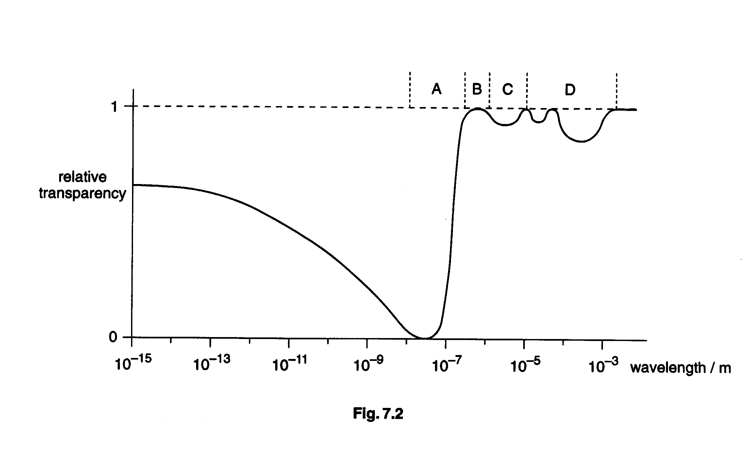

(i) Identify the region, A, B, C or D, corresponding to visible light.

(ii) Some astronomical observations are made using electromagnetic radiation of wavelength about 50 nm. By reference to Fig. 7.2, suggest why such observations are made from satellites or space probes.

(iii) Give two reasons why astronomical telescopes detecting visible light are sometimes sited on isolated mountain-tops. [4]

Option C

The Physics of Materials

8 (a) (i) Draw a diagram to illustrate the lattice structure of a hexagonal crystal.

(ii) Explain the concept of the Bravais lattice, illustrating your answer by reference to a hexagonal lattice structure. [6]

(b) (i) Outline an experiment to demonstrate the processes of quenching and tempering of steel.

(ii) Describe the properties of steel when it has been
1. quenched,
2. tempered. [5]

(c) In early designs of steam boilers, some catastrophic accidents happened as a result of creep. Outline the process of creep, and the conditions under which it is likely to occur. [4]

Option E

Electronics

9 (a) A student designs a thermometer using a thermistor T. He connects the thermistor in the circuit of Fig. 9.1.
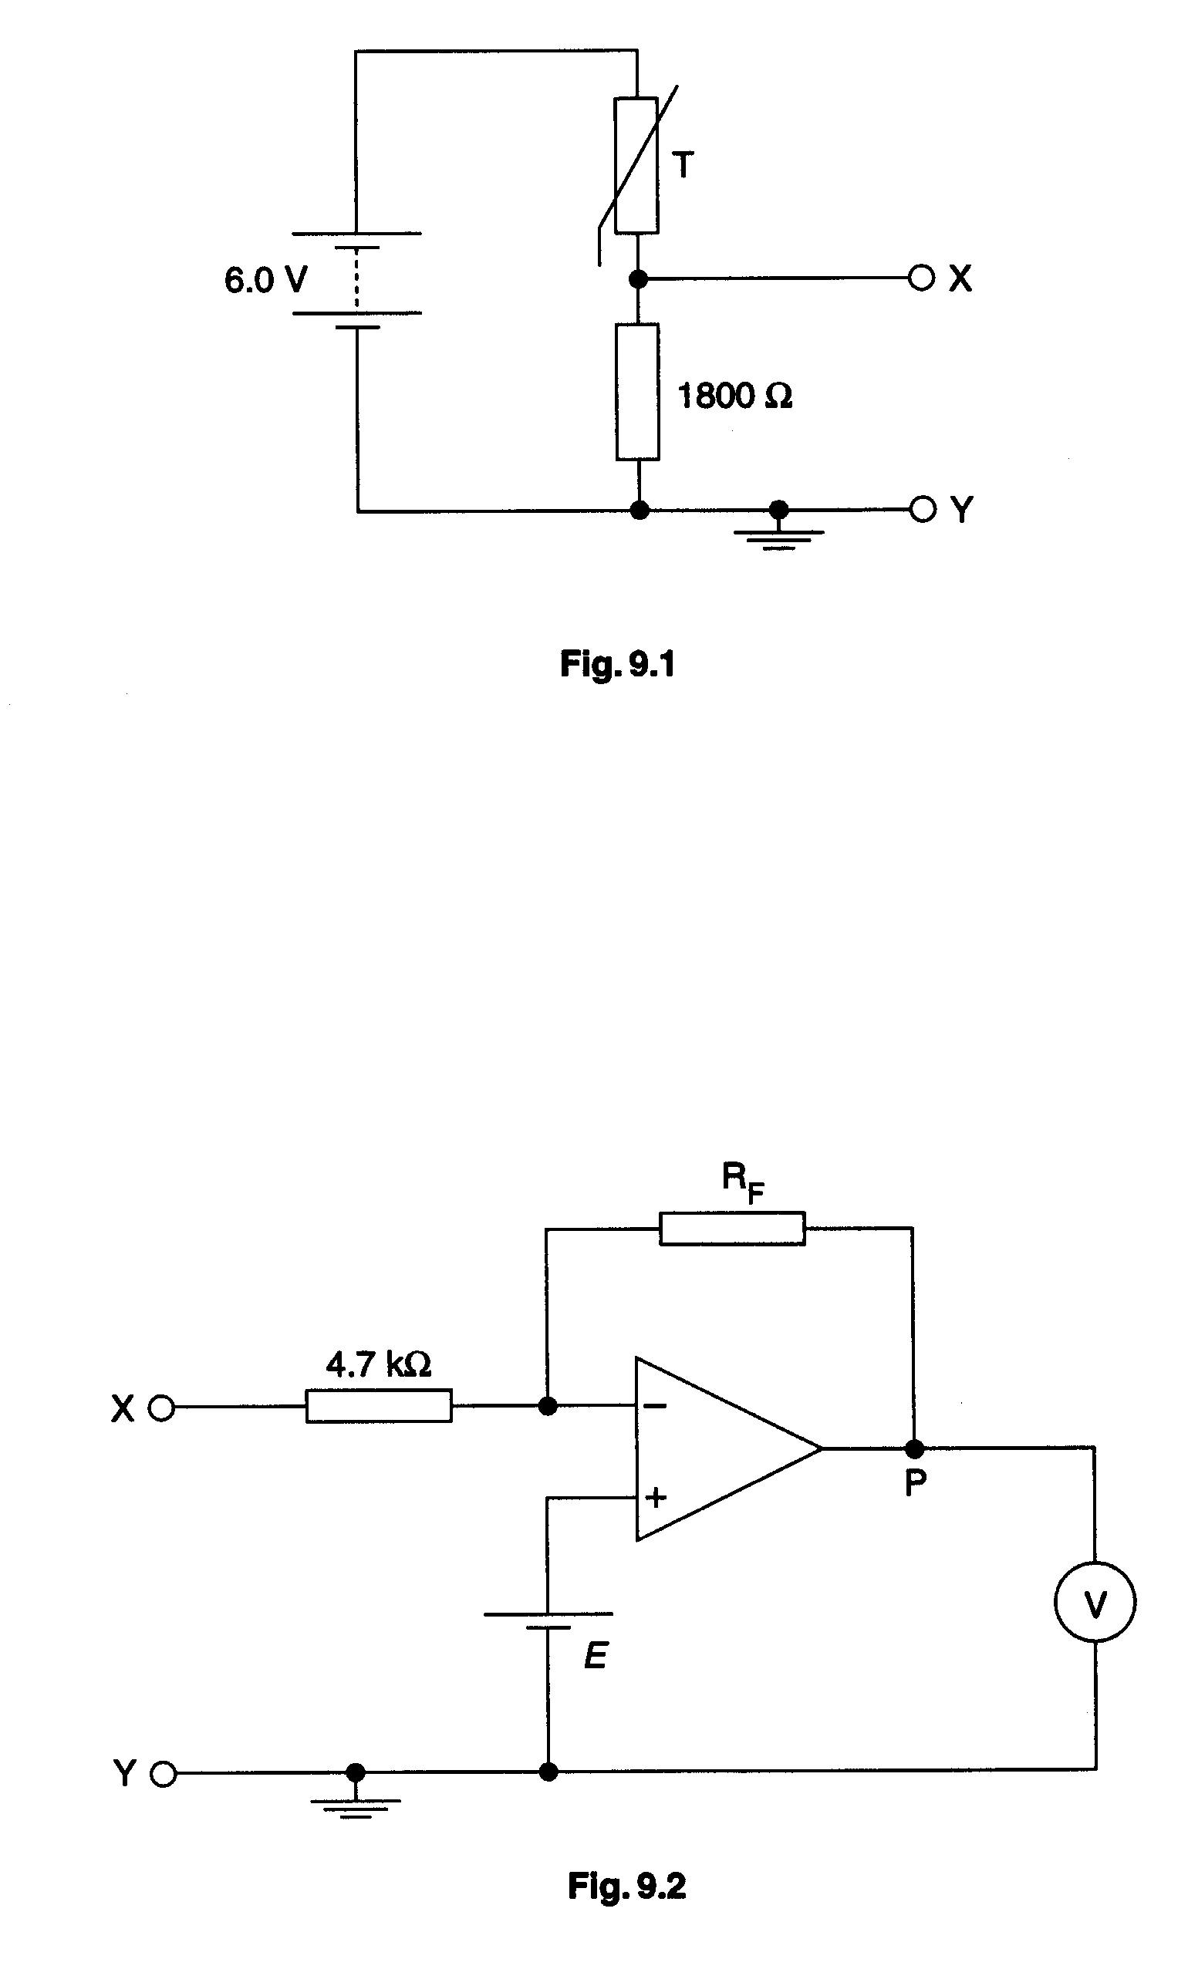
The battery has e.m.f. 6.0 V and negligible internal resistance. The resistance of the thermistor is 1800 Ω at 20ºC and 1500 Ω at 25 ºC. Calculate the potential difference across the fixed resistor of resistance 1800 Ω for thermistor temperatures of

(i) 20 ºC,
(ii) 25 ºC.
[3]
(b) The student decides to use the circuit of Fig. 9.2 to amplify the change in p.d. due to the change in temperature of the thermistor.
(i) State which terminal of the voltmeter, the positive or the negative, must be connected to point P so that positive values of voltage are shown on the voltmeter.

(ii) Deduce, with an explanation, the e.m.f. E of the battery connected between earth and the non-inverting input of the op-amp so that, when the thermistor is at 20 ºC, the voltmeter reads zero.
(iii) The magnitude of the gain of the amplifier is to be 30. Deduce a suitable value of resistance for the resistor RF. [5]

(c) The logic circuit of Fig. 9.3 has been designed to monitor the closing of four doors.

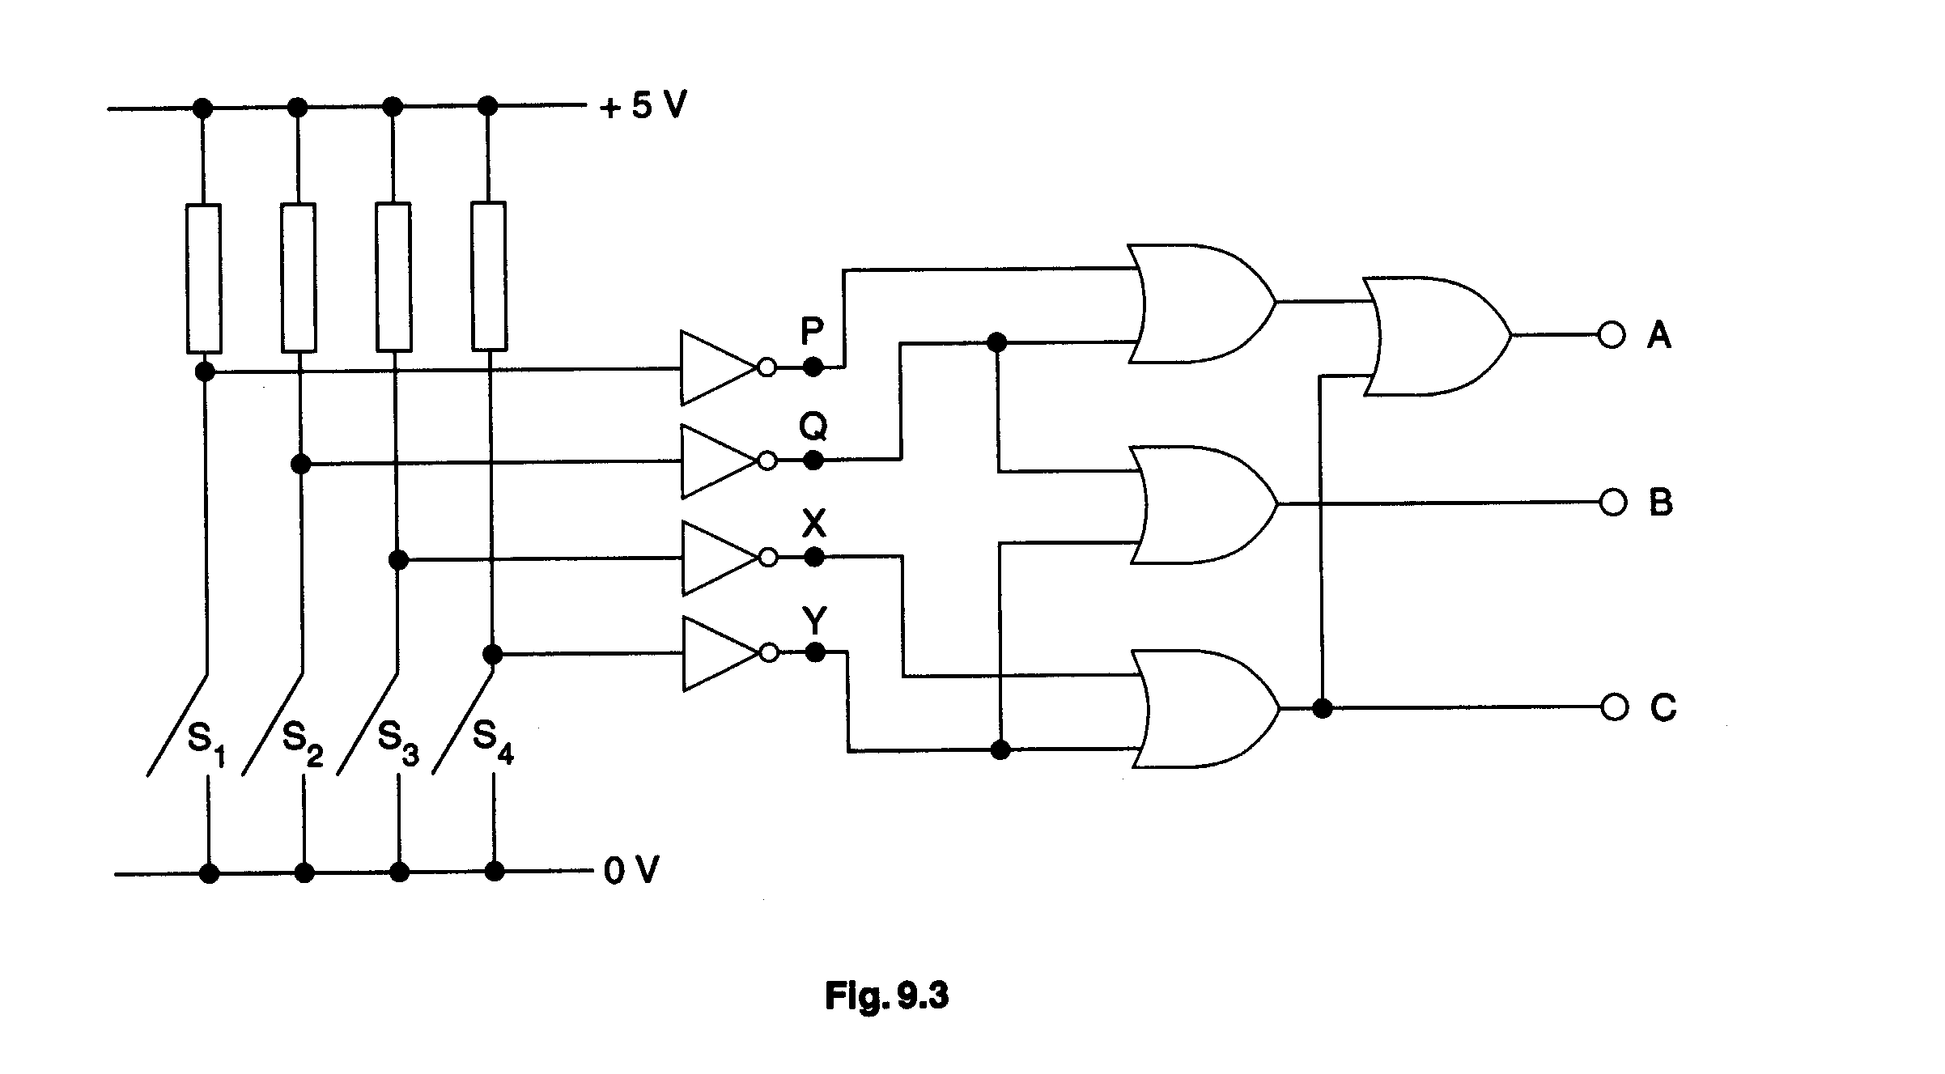
One switch, S₁, S₂, S₃, or S₄, is connected to each door. When a door is closed, the relevant switch closes. Only one door at any one time may be closed. Logic state 1 is given by +5 V and logic state 0 is 0 V.

(i) Write down the logic state

1. at P when S₁ is closed,
2. at A when any one of the doors is closed.

(ii) Complete the truth table of Fig. 9.4 for the circuit of Fig. 9.3.

P | Q | X | Y | B | C
1 | 0 | 0 | 0
0 | 1 | 0 | 0
0 | 0 | 1 | 0
0 | 0 | 0 | 1

(iii) Hence state which of the outputs A, B and C, are at logic state 1 when S₃ is closed.
[7]

Option F

The Physics of Fluids

10 (a) Draw streamlines to illustrate the flow of liquid round a stationary sphere for

(i) laminar flow,

(ii) turbulent flow.
[3]

(b) A small metal sphere has radius r of 1.8 mm and is falling at a constant speed V of 28 mm s⁻¹ through a liquid of density 1800 kg m⁻³. The density of the metal of the sphere is 7700 kg m⁻³.

(i) Draw a diagram to show the forces acting on the sphere as it falls through the liquid.

(ii) Calculate the upthrust on the sphere.

(iii) The sphere is falling through the liquid under conditions of streamline flow. The drag force F on the sphere is given by

$F=6πrηv$,

where η is the viscosity, in kg m⁻¹ s⁻¹, of the liquid.

Calculate the viscosity of the liquid. [7]

(c) A spinning cricket ball is moving through air as illustrated in Fig. 10.1.

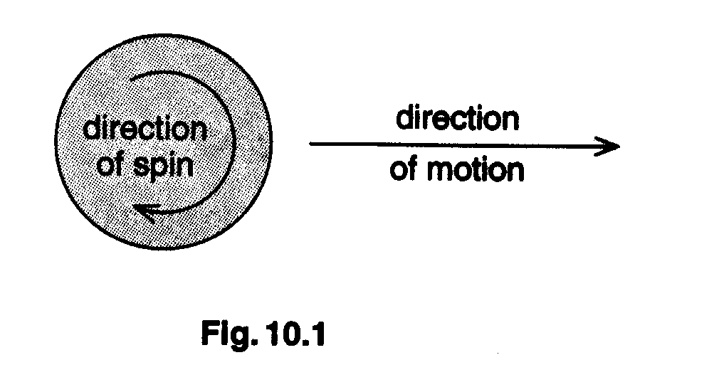

Explain why, and in which direction, the ball is likely to swing. [5]

Option M

Medical Physics

11 (a) (i) Outline the effects of ionising radiation on living matter.

(ii) In some X-ray equipment, an aluminium filter is placed in the X-ray beam between the tube and patient. Suggest why such a filter may be used. [6]

(b) (i) A medical laser operates at a beam power of 20 W. The beam is focused by a convex lens to a spot of diameter 0.14 mm. Calculate the intensity of the light in the focused spot.

(ii) Fig. 11.1 shows the beam incident on three separate layers of skin tissue.

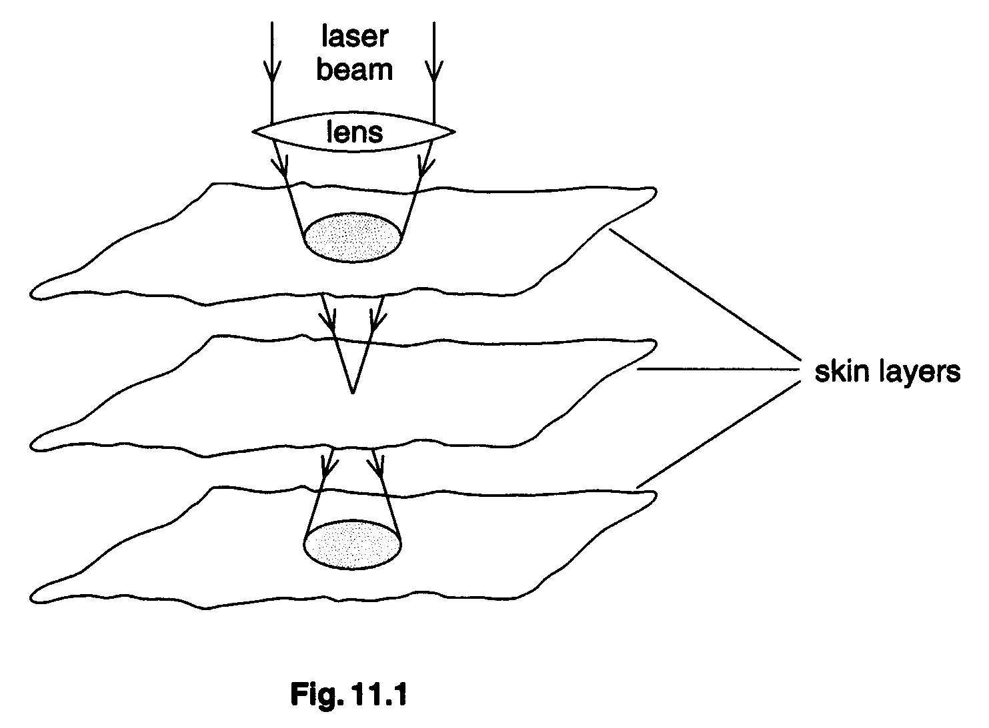

By reference to Fig 11.1, suggest why a laser beam, focused by a lens of short focal length, is likely to be more precise in its effect than one focused using a long focal length lens. [4]

(c) Fig. 11.2 is a graph, with unscaled axes, of the variation with frequency of intensity of sound at the threshold of hearing for a young person with normal hearing.

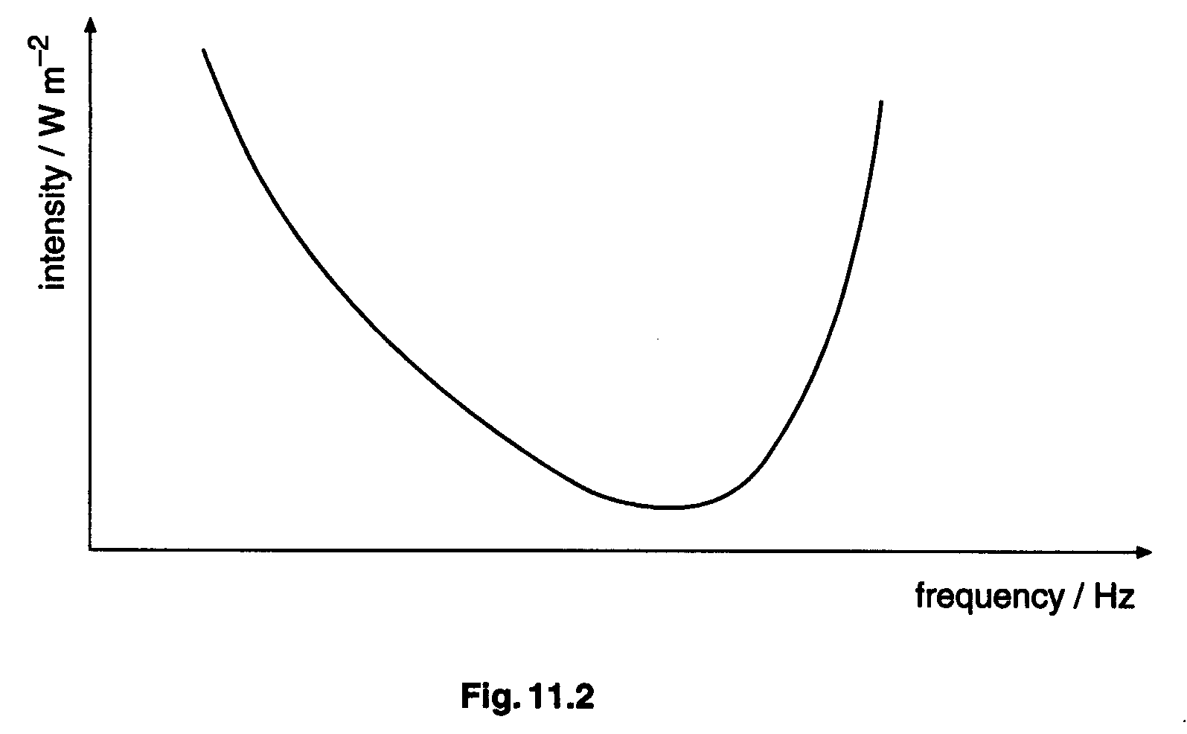

(i) Copy Fig. 11.2 and on it mark

1. the audible range of frequencies of human hearing,

2. the frequency at which the ear is most sensitive.

(ii) A student suggests that the y-axis should be labelled intensity level. Comment on whether this change would affect the shape of the graph. [5]

Option P

Environmental Physics

(a) (i) State what is meant by a fuel.
(ii) Explain why, although fuel supplies are abundant, alternative energy sources are being developed. [3]

(b) (i) The trough-to-crest height of waves on water of density ρ is 2A. The waves have speed v. Show that the average wave power P of waves in a wavefront of length L is given by

$$P=\frac{1}{2}A^{2}ρ\text{gvL}$$
[4]
(ii) Calculate the average maximum power available from a 20 m long wavefront of waves with a trough-to-crest height of 0.9 m and a speed of 3.0 m s⁻¹.

The density of water is 1000 kg m⁻³. [2]

(iii) A wave-powered electricity generator is installed for use by a small community on an island. Suggest two reasons why a back-up diesel generator would be necessary. [2]

(c) Fig. 12.1 shows a block diagram of a coal-fired generating station.

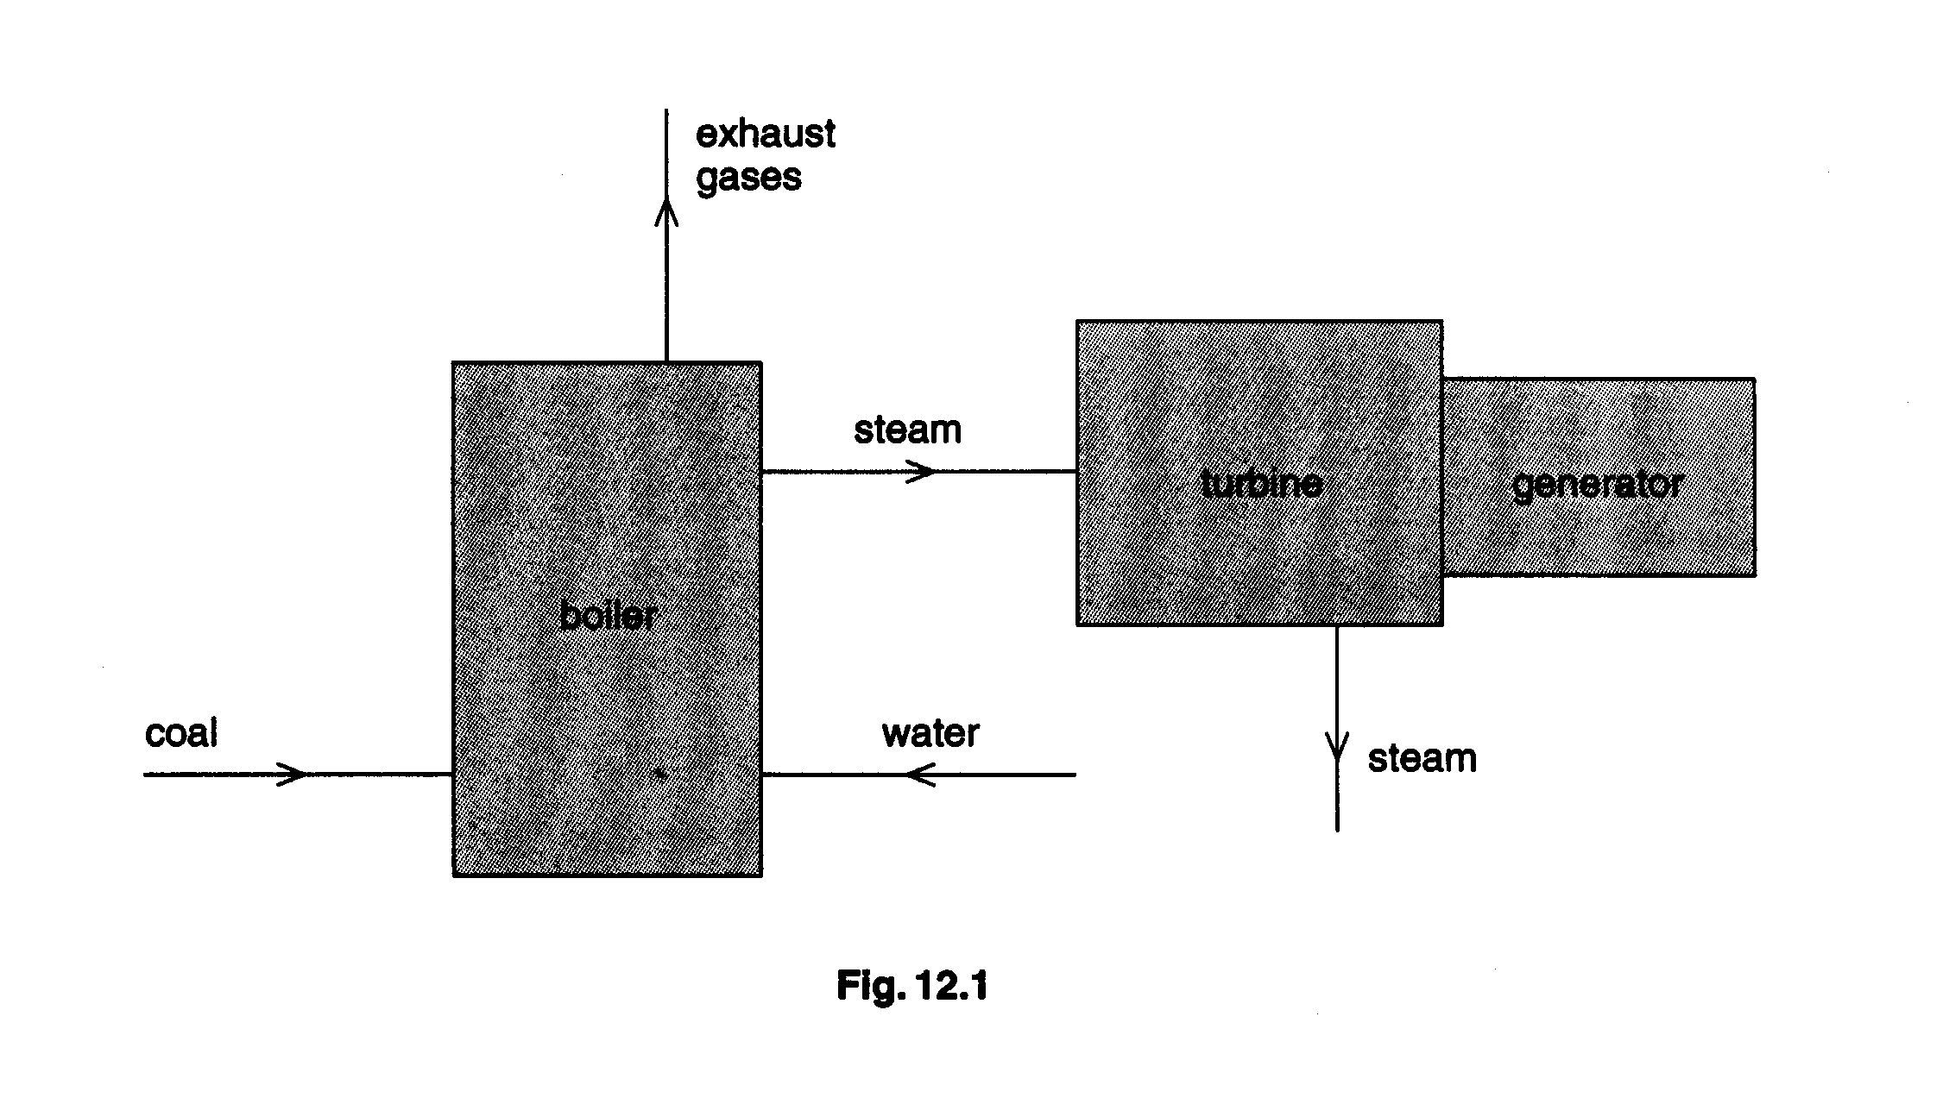
For one particular turbine, steam enters the turbine at 550 ºC and leaves at 120ºC.

(i) Calculate the maximum efficiency of the turbine.

(ii) Suggest one way in which thermal energy in the exhaust gases may be used to improve the overall efficiency of the generating station. [4]

Option T

Telecommunications

13 (a) (i) Explain what is meant by modulation of a wave.

(ii) Distinguish between amplitude modulation (AM) and frequency modulation (FM).

(iii) For national AM radio broadcasts, the range of audio frequencies transmitted is restricted. Suggest one advantage and one disadvantage of this restriction. [6]

(b) Two channels of digital communication are optic fibres and metal cables. Giving numerical estimates wherever possible, compare these two channels of communication, making reference to attenuation and noise. [6]

(c) Suggest why ionospheric reflection as a means of long-distance communication is less reliable than communication via satellites in geostationary orbit. [3]

