Paper 3

SECTION A

Answer any four questions from this Section.

1 In a dynamics experiment, a trolley is accelerated from rest along a horizontal runway as shown in Fig.1.1.
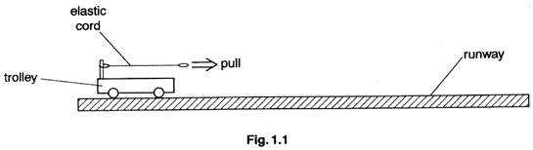

The accelerating force is provided by an elastic cord. One end of the cord is attached to the trolley and the other end is pulled so that the extension of the cord remains constant as the trolley moves along the runway.

The acceleration a of the trolley varies with the extension x of the elastic cord as shown in Fig. 1.2.

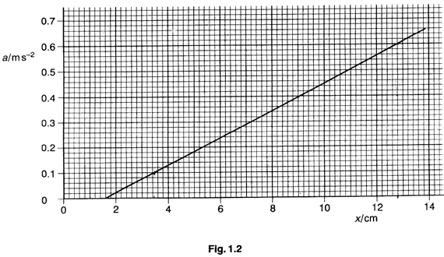

The trolley experiences a constant frictional force when in motion.

(a) Use Fig.1.2 to

(i) determine the extension of the cord required to maintain constant speed of the trolley, giving a brief explanation for your answer,

(ii) show that the increase in extension, beyond that found in (i),to produce an acceleration of 0.60 ms⁻² is 11.2 cm.
[4]

(b) (i) Calculate the force required, in the absence of friction, to cause the trolley of mass 800 g to have an acceleration of 0.60 ms⁻²

(ii) Using your answers to (b)(i) and (a)(ii), determine the spring constant of the elastic cord. Assume that the cord obeys Hooke's law.

(iii) Calculate the frictional force on the trolley.

[5]

(c) In one particular experiment, the extension of the cord is kept constant at 3.5cm. Calculate

(i) the speed of the trolley after it has traveled 1.2 m from rest along the runway,
(ii) the time taken to travel a further 30cm along the runway.
[6]

(d) By reference to Fig. 1.2, state and explain

(i) whether the acceleration of the trolley is proportional to the extension of the cord,

(ii) how it may be concluded that the Hooke's law limit of the cord has not been exceeded.
[5]

2 (a) Define

(i) work,

(ii) power.
[3]

(b) By reference to equations of motion, derive an expression for the kinetic energy E_{K} of an object of mass m moving at speed v. [4]

(c) A car is travelling along a horizontal road with speed v, measured in metres per second. The power P, measured in watts, required to overcome external forces opposing the motion is given by the expression
P = cv+ kv³,

where c and k are constants.

(i) Use base units to obtain an SI unit for the constant k.

(ii) For one particular car, the numerical values, in SI units, of c and of k are 240 and 0.98 respectively. Calculate the power required to enable the car to travel along a horizontal road at 31 ms⁻¹.
[6]

(d) The car in (c) has mass 720 kg. Using your answer to (c)(ii) where appropriate, calculate, for the car travelling at 31 ms⁻¹,

(i) its kinetic energy,

(ii) the magnitude of the external force opposing the motion of the car,

(iii) the work done in overcoming the force in (ii) during a time of 5.0 minutes.
[5]

(e) By reference to your answers to (d), suggest, with a reason, whether it would be worthwhile to develop a system whereby, when the car slows down, its kinetic energy would be stored for re-use when the car speeds up again. [2]

3 (a) Distinguish between a progressive wave and a stationary wave by making reference to
(i) energy transfer,
(ii) amplitude of vibration of neighbouring particles,
(iii) phase angle between particles.
[7]
(b) A horizontal steel wire is fixed at one end and is kept under tension by means of weights suspended over a pulley, as shown in Fig. 3.1

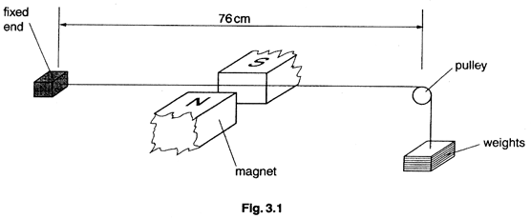
A low-voltage alternating supply of frequency 50 Hz is connected to the wire between the fixed end and the pulley. Magnets are placed near to the centre of the horizontal section of the wire in order to produce a magnetic field at right angles to the wire.

The tension in the wire is gradually increased from a small value, thereby changing the speed with which waves may travel along the wire. Suddenly, the amplitude of vibration of the wire increases to a maximum and then becomes small once more.

(i) Explain why
1. the wire vibrates,
2. the amplitude of vibration is a maximum at one value of the tension. [6]

(ii) The distance between the fixed point and the pulley is 76cm. For the wire vibrating with maximum amplitude,
1. sketch the shape of the stationary wave on the wire,
2. calculate the wavelength of this stationary wave. [2]

(c) The low-voltage power supply in (b) is removed and the ends of the wire are connected to the Y-plates of a cathode-ray oscilloscope (c.r.o.). The wire is plucked at its centre and a sinusoidal trace is observed on the screen of the c.r.o.

By reference to laws of electromagnetic induction, explain why
(i) an e.m.f. is induced between the ends of the wire,
(ii) the e.m.f is alternating. [5]

4 (a) (i) Sketch a graph to show the variation with potential of the charge on an isolated conductor.

(ii) By reference to your graph in (i).
1. define what is meant by capacitance,
2. derive an expression for the energy E stored in a capacitor of capacitance C charged to a potential V
[6]

(b) Four capacitors, each of capacitance 50 μF, are connected as shown in Fig.4.1 to a high voltage supply, a resistor and a switch S.

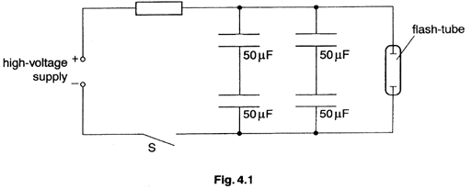

A flash-tube is connected across the combination of capacitors. When S is closed, the capacitors charge up gradually and, when the potential difference across the flash-tube reaches 540V, the capacitors discharge rapidly through the flash-tube. A flash of light is emitted as the capacitors discharge 63% of their energy.

(i) 1. Determine the total capacitance of the arrangement of capacitors.
2. Suggest one advantage of this arrangement compared with a single capacitor of the same total capacitance.
[3]

(ii) The potential difference across the flash-tube creates an electric field in the tube. State two differences between the force due to the electric field on the nucleus and the force due to the electric field on an electron of an atom of xenon gas in the tube. [2]

(iii) Suggest why there is a current in the tube when the potential difference across it is sufficiently large. [2]

(iv) Calculate
1. the energy dissipated in one flash of light,
2. the potential difference across each capacitor immediately after the flash of light has occurred.
[4]

(c) The circuit of Fig.4.2 was designed by a student.

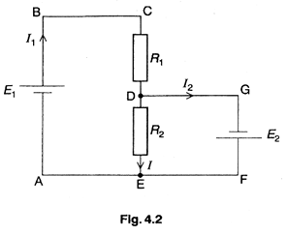

The cells have e.m.f.'s E₁ and E₂ and the currents in the cells are I₁ and I₂ respectively. The resistors have resistances R₁ and R₂ and the current in the resistor of resistance R₂ is I.

Use Kirchhoff's laws to write down expressions in terms of E₁, E₂, R₂, I₁, and I₂ (where appropriate) for

(i) the currents at junction D,

(ii) the circuit loop ABCDEA,

(iii) the circuit loop GFEDG..
[3]

5 (a) (i) Distinguish between the processes of evaporation and of boiling..

(ii) Use the first law of thermodynamics to explain why, when a liquid evaporates or boils, thermal energy must be supplied to the liquid in order to maintain constant temperature.
[6]

(b) The pressure p of an ideal gas of density ρ is related to the mean-square speed <c²> of its molecules by the expression

$p=\frac{1}{3}ρ<c^{2}>$.

(i) State three basic assumptions of the kinetic theory of gases, which lead to a model of an ideal gas. [3]

(ii) Write down the equation of state for an ideal gas. [1]

(iii) Show that the average kinetic energy of a molecule of an ideal gas is proportional to the thermodynamic temperature T. [4]

(c) Free neutrons in the core of a fission reactor are sometimes referred to as a 'neutron gas'. These free (thermal) neutrons may be assumed to behave as molecules of an ideal gas at a temperature of 35 ºC.

(i) Calculate, for a free neutron of mass 1.67 x 10⁻²⁷ kg,

1. its mean kinetic energy,

2. its root-mean-square (r.m.s.) speed.

(ii) Determine the temperature of helium gas, assumed to be an ideal gas, at which helium molecules (each of mass 4 u) would have the same r.m.s. speed as the free neutrons.
[6]

6 (a) Distinguish between a nucleon, a nucleus and a nuclide. [5]

(b) Radon-220 (${}_{\text{86}}^{\text{220}}{}\text{Rn}$) decays spontaneously with a half-life of 56s to form polonium (Po). During this decay, an α-particle and a γ-ray photon are emitted with energies of 6.29 MeV and 0.55 MeV respectively.

(i) Write down a nuclear equation to represent the decay a Radon-220 nucleus. [2]

(ii) Define what is meant by half-life. [2]

(iii) Calculate, for this decay,

1. the mass equivalence of the energy released during the decay,

2. the wavelength of the emitted γ-ray photon.
[5]

(c) The radon in (b) may be found in the air in buildings. For health reasons, the safe limit of activity due to the decay of radon is set at 200 Bq per cubic metre of air. Calculate, for this safe limit,

(i) the number of radon atoms present per cubic metre of air,
(ii) the ratio
$$\frac{\text{number of radon atoms per cubic metre}}{\text{number of air molecules per cubic metre}}$$

given that 1.0 mol of air in the building is contained in 0.024 m³. [4]

(d) Suggest why the presence of radon gas in buildings is of environmental importance. [2]

SECTION B

Answer two questions in this Section.

One question is set on each of the seven optional topics, namely

Option A, Astrophysics and Cosmology1
Option C, The Physics of Materials,
Option E, Electronics,
Option F, The Physics of Fluids,
Option M, Medical Physics,
Option P, Environmental Physics,
Option T, Telecommunications.

You may choose any two of the questions.

Option A

Astrophysics and Cosmology

7 (a) A galaxy has been discovered which is 1 .2 x 10¹⁰ light-years away from Earth.

Briefly describe what is meant by

(i) a galaxy,

(ii) a light-year. [4]

(b) The galaxy in (a) was discovered using an instrument in Earth orbit. Suggest why this galaxy
could not be detected at the surface of the Earth. [3]

(c) A value accepted by some astronomers for the Hubble constant H_{o} is 2.6x 10⁻¹⁸s⁻¹.

(i) Suggest why there is doubt as to the value of the Hubble constant.

(ii) Using the value of H_{o} given above, calculate the critical density of matter in the Universe.

(iii) For the critical density calculated in (ii), estimate the average number density of nucleons in the Universe.

(iv) Suggest the fate of the Universe if the actual mean density exceeds the critical value.
[8]

Option C

The Physics of Materials

8 (a) Explain, with the aid of diagrams where appropriate,

(i) what is meant by a dislocation in a lattice structure,

(ii) why a dislocation in an otherwise perfect lattice moves easily,

(iii) why a large number of dislocations in a material may increase its strength and hardness.
[7]

(b) Some modern cars are constructed with a strong metal cage surrounding the passenger compartment as illustrated in Fig. 8.1.

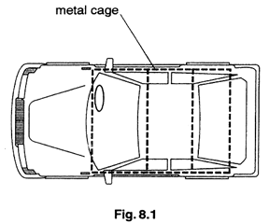

The front and rear sections of the car are designed to be tough but not stiff.

(i) Explain what is meant by a strong material and suggest a suitable metal for the construction of the cage.

(ii) Suggest why

1. the front and rear sections are tough but not stiff,

2. there is little protection for passengers when the car is hit side-on.
[8]

Option E

Electronics

9 (a) Fig. 9.1 shows an inverting amplifier circuit incorporating an ideal operational amplifier (op-amp).

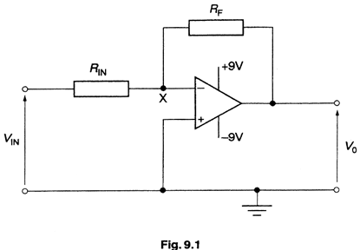

(i) 1. Explain why the potential at point X is approximately 0 V unless the op-amp is saturated.

2. Derive an expression for the gain of the amplifier circuit in terms of the input resistance R_{IN} and the feedback resistance R_{F}.

(ii) In one particular application of the circuit, the gain of the amplifier is -10. State the value of the output voltage V_{o} when the input voltage V_{IN} is

1. +0.1 V,

2. -1.0 V.
[8]

(b) A student designed the circuit of Fig. 9.2 in order to compare two logic states represented by X and Y.

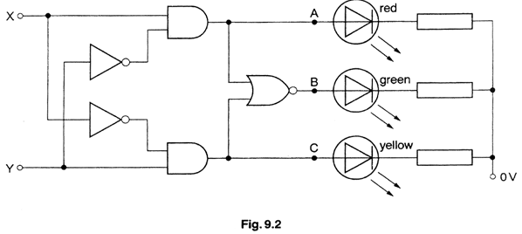

(i) Copy Fig. 9.3 and complete the truth table for the logic outputs A, B and C.

X | Y |  | A | B | C
0 | 0
0 | 1
1 | 0
1 | 1

Fig.9.3

(ii) Hence state which LED, red, green or yellow, will conduct when

1. X < Y,

2. X = Y,

3. X > Y.

(iii) Draw the symbol of the single logic gate which would produce the same output as that detected at B.
[7]

Option F

The Physics of Fluids

10 (a) Outline the necessary conditions for a ship to
(i) float,
(ii) remain stable.
[3]

(b) An incompressible fluid of density ρ moves with streamline flow through a horizontal pipe as indicated in Fig. 10.1.
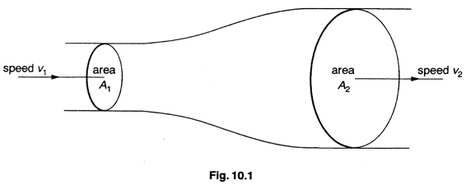
The fluid enters the pipe of area of cross-section A_{l} with speed v₁ and leaves through a cross-sectional area A₂ at speed v₂. The pressure of the fluid on entering the section of pipe is p₁ and on leaving is p₂.

(i) Show that for a section of pipe with uniform cross-sectional area A, where the streamline flow of the fluid has speed v,
1. the mass of fluid flowing per unit time is ρAv,
2. the energy transfer per unit time in the fluid is pAv, where p is the fluid pressure.

(ii) 1. Using the expressions in (i), derive the simplified Bernoulli equation

$p_{1}+\frac{1}{2}{ρv}_{1}^{2}=p_{2}+\frac{1}{2}{ρv}_{2}^{2}$.

2. State one assumption made in deriving the expression in (ii)1.
[8]
(c) The drag force F_{D} on a car moving at speed v through air of density ρ is given by the expression
$F_{D}=\frac{1}{2}C_{D}ρ{\text{Av}}^{2}$,
where A is the effective cross-sectional area of the car and C_{D} is the drag coefficient.

(i) A certain car requires a power of 50 kW to travel along a horizontal road through still air at 100 km h⁻¹. Give a quantitative explanation as to why the power required is considerably greater when travelling into a head-wind of 10 km h⁻¹.

(ii) Suggest two reasons why car manufacturers strive to design cars with a low value for C_{D}.

Option F

Medical Physics

11 (a) Briefly outline one use of each of the following in medical diagnosis.

(i) X-rays
(ii) lasers
[6]

(b) (i) Explain how the eye forms focused images of objects which are at different distances from the eye.

(ii) Estimate the change in optical power of the eye when the eye focuses firstly on a point 30 cm from the eye and then on a distant star.
[5]

(c) (i) Define intensity level for a sound of intensity I.

(ii) A student states that intensity level is a measure of the loudness of a sound. Comment briefly on whether this statement is correct.
[4]

Option P

Environmental Physics

12 (a) (i) Outline the principles of the fission process.

(ii) Suggest two forms of energy into which the nuclear energy of the fission of a single nucleus is converted.

(iii) Briefly describe the purpose of the moderator in a nuclear reactor.

[7]
(b) Fig. 12.1 shows an idealized indicator diagram for a patrol engine.

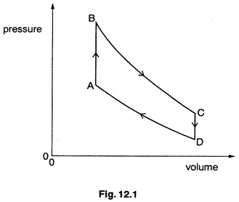

In one particular cycle, 380 J of energy Is supplied when the fuel is burned and 180 J is lost in the exhaust gases.

By reference to Fig. 12.1,
(i) Identify that part of the cycle which represents the burning of the fuel’

(ii) calculate

1. the energy represented by the area of the loop ABCD,

2. the efficiency of the engine.
[4]

(c) Briefly outline two forms of pollution associated with the use of cars, other than exhaust gases and noise. [4]

Option T
Telecommunications

13 (a) An analogue signal is sampled at a frequency of 18 kHz so that it may be transmitted in digital form. Each sample is converted into a 5-bit number, each bit lasting 0.5 μs.

(i) State what is meant by a digital signal.

(ii) Calculate the time interval between the end of one 5-bit number and the start of the next.

(iii) Suggest one use to which the time intervals calculated in (ii) could be put

(iv) The maximum signal frequency which can be transmitted and de-coded successfully is 9 kHz for a sampling rate of 18 kHz. Suggest the effect on the transmitted signal after decoding if the signal to be sampled contains frequencies greater than 9 kHz.
[7]

(b) A transmitter sends out a signal of power 60 mW. The signal is transmitted along a cable of length 140 km having an attenuation per unit length of 2.3 dB km⁻¹. The receiver operates for a minimum signal power at its input of 6.0 μW.

(i) Calculate the loss in signal power along the cable.

(ii) The ratio of two powers P₁ and P₂ Is expressed as a number of decibels (dB) according to

number of dB= l0 lg $\left(\frac{P_{1}}{P_{2}}\right)$.

Calculate the ratio, in dB of
$$\frac{\text{minimum input power to receiver}}{\text{transmitted power}}$$

(iii) Hence determine the minimum number of repeater amplifiers, each of gain 75dB, which must be situated along the cable so that the received signal power is sufficient.
[5]

(c) ‘Satellite TV’ uses geostationary satellites for regional transmissions. Explain briefly what is meant by a geostationary satellite. [31]

